Supplementary Material

Supplementary Figures and Tables

Supplementary Figures
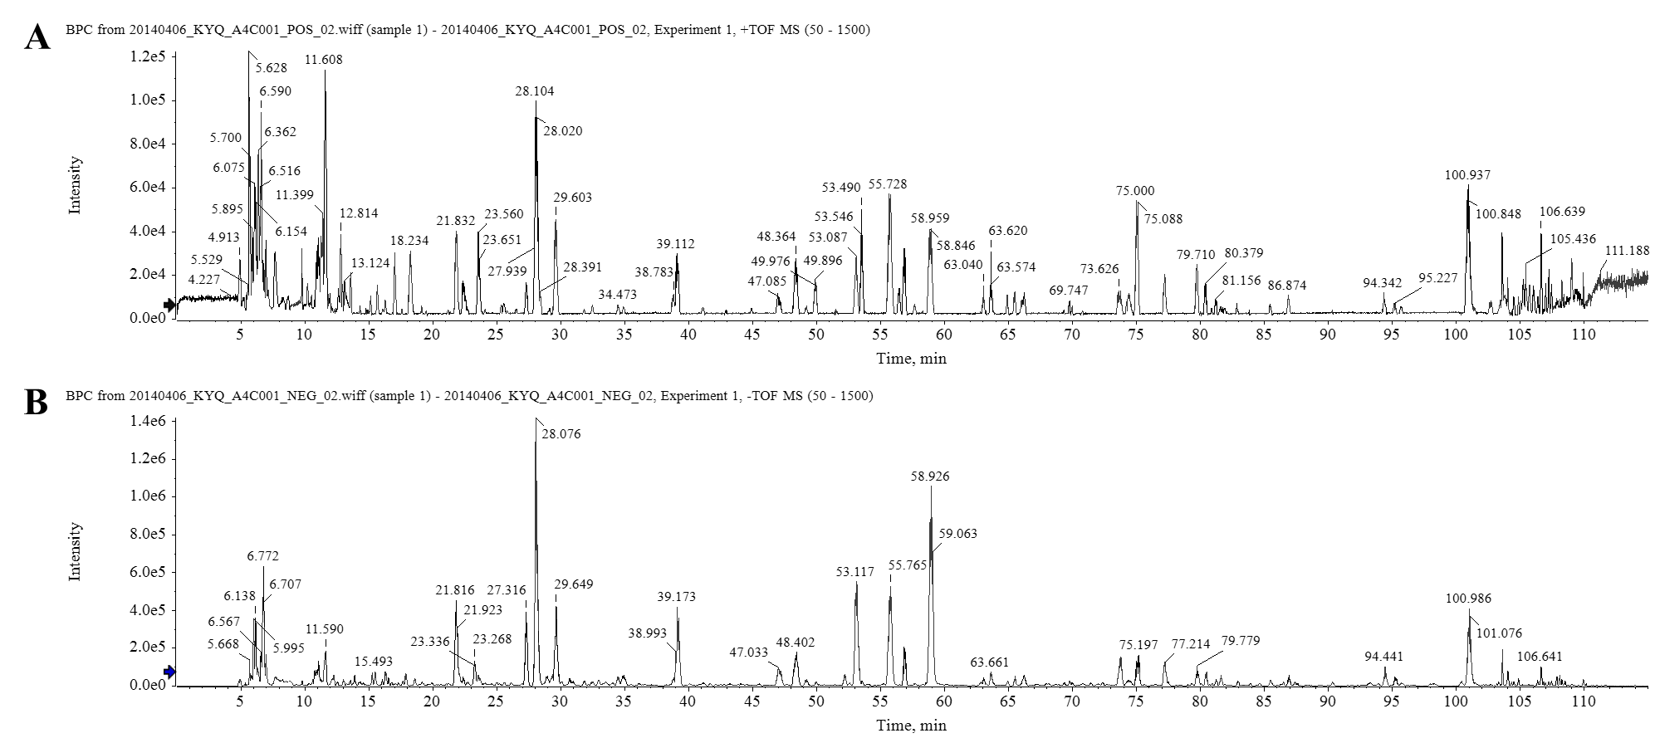
Supplementary Figure 1. Total ion chromatograms of Kouyanqing Granule (KYQG) in positive mode (A) and negative mode (B).

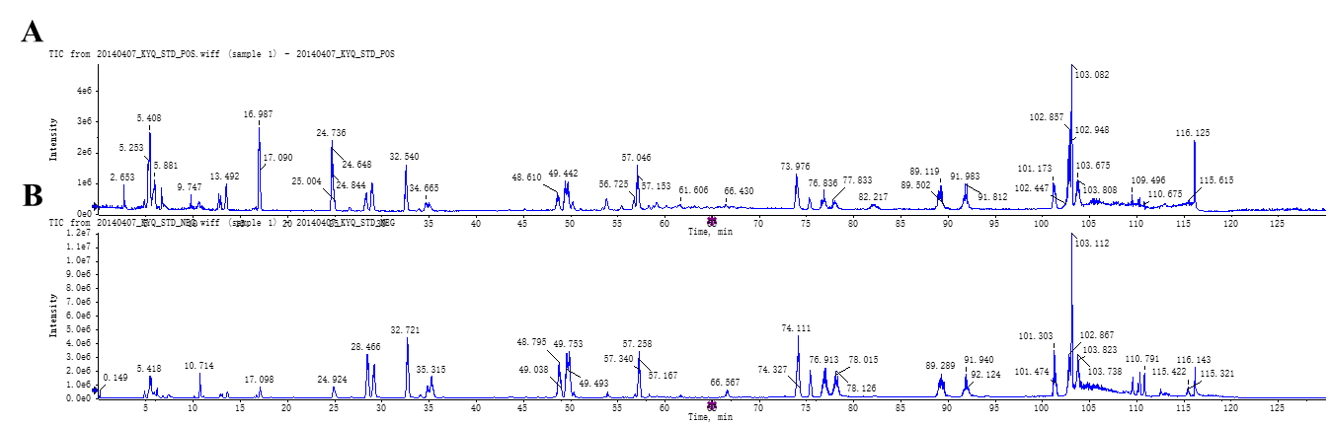
Supplementary Figure 2. Total ion chromatograms of standards in positive mode (A) and negative mode (B).

Supplementary Tables
Supplementary Table 1. The mass spectrum data of standards. The losses are: Glc = glucose moiety.
No. | RT  (min) | Formula | [M+H]+  (Error, ppm) | [M–H]–  (Error, ppm) | MS/MS fragments  (Positive mode) | MS/MS fragments  (Negative mode) | Standard
1 | 5.25 | C₆H₁₄N₂O₂ | 147.1128  （+0.7） |  | 130.0868 [M+H–NH₃]⁺,  84.0828 [M+H–NH₃–HCOOH]⁺,  67.0573 [M+H–2NH₃–HCOOH]⁺ |  | Lysine
2 | 5.55 | C₆H₁₄N₄O₂ | 175.1188  （–0.9） | 173.1057  （+5.1） | 158.0921 [M+H–NH₃]⁺,  130.0976 [M+H–NH₃–CO]⁺,  116.0706 [M+H–CN₃H₅]⁺  70.0676 [M+H–CN₃H₅–HCOOH]⁺,  60.0586 | 156.0766 [M–H–NH₃]–,  131.0828 [M–H–C₃H₆]– | Arginine
4 | 5.87 | C₄H₇NO₄ |  | 132.0323  （+9.1） |  | 115.0045 [M–H–NH₃]–,  88.0410 [M–H–CO₂]–,  71.0151 [M–H– CO₂–NH₃]– | Aspartic acid
6 | 6.18 | C₆H₁₃N₃O₃ | 176.1031  （+0.8） |  | 159.0766 [M+H–NH₃]⁺,  113.0718 [M+H–NH₃–HCOOH]⁺,  70.0677 [M+H–NH₃–CO₂–CH₃NO]⁺ |  | Citrulline
18 | 10.71 | C₇H₄O₆ | 185.0080  （–0.2） | 182.9946  （+6） | 141.0182 [M+H–CO₂]⁺,  97.0294 [M+H–2CO₂]⁺,  71.0151 [M+H–2CO₂–C₂H₂]⁺ | 139.0043 [M–H–CO₂]–,  68.9998 [M–H–C₄H₂O₄]–,  67.0211 [M–H–2CO₂–CO]– | Chelidonic acid
26 | 17.11 | C₉H₁₁NO₂ | 166.0861  （–0.8） | 164.0730  （+7.7） | 120.0813 [M+H–HCOOH]⁺,  103.0552 [M+H–HCOOH–NH₃]⁺ | 147.0454 [M–H–NH₃]–,  103.0555 [M–H–NH₃–CO₂]–,  72.0111 | Phenylalanine
32 | 28.48 | C₁₆H₁₈O₉ | 355.1027  （+1） | 353.0877  （–0.4） | 163.0385 [M+H–C₇H₁₂O₆]⁺,  145.0281 [M+H–C₇H₁₂O₆–H₂O]⁺,  117.0337 [M+H–C₇H₁₂O₆–H₂O–CO]⁺,  89.0392 [M+H–C₇H₁₂O₆–H₂O–2CO]⁺ | 191.0567 [M–H–C₉H₆O₃]– | Chlorogenic acid
35 | 35.26 | C₉H₈O₄ | 181.0409  （–0.7） | 179.0360  （+1.9） | 163.0387 [M+H–H₂O]⁺,  135.0439 [M+H–HCOOH]⁺,  89.398 [M+H–H₂O–CO–HCOOH]⁺ | 135.0455 [M–H–CO₂]– | Caffeic acid
44 | 48.8 | C₂₁H₂₂O₉ | 419.1334  （–0.7） | 417.1185  （–0.1.4） | 257.0808 [M+H–Glc]⁺,  137.0231 [M+H–C₁₄H₁₈O₆]⁺ | 255.0665 [M–H–Glc]–,  135.0096 [M–H–Glc–RAD]–,  119.0512 | Liquiritin
45 | 49.6 | C₂₁H₂₀O₁₂ | 465.1022  （–0.6） | 463.0858  （–3.7） | 303.0490 [M+H–Glc]⁺ | 301.0343 [M–H–Glc]–,  271.0246 [M–Glc–CH₂O]–,  255.0301 [M–H–Glc–O–CH₂O]–,  151.0040 [M–H–Glc–RDA]– | Isoquercitrin
51 | 57.26 | C₃₆H₄₈O₁₉ | 807.2675  （–0.9） | 783.2697  （–2.5） | 807.2675 [M+Na]⁺ | 607.2250 [M–H–C₆H₁₁O₄–CHO]–  193.0506 [M–H–C₂₆H₃₈O₁₅]–,  175.0396 [M–H–C₂₆H₃₈O₁₅–H₂O]– | Angoroside C
56 | 48.8 | C₂₁H₂₂O₉ | 419.1334  （–0.7） | 417.1185  （–1.4） | 257.0808 [M+H–Glc]⁺,  137.0231 [M+H–Glc–C₈H₆O]⁺ | 255.0665 [M–H–Glc]–,  135.0096,  119.0512 [M–H–Glc–C₈H₆O–H₂O]–,  92.0260 [M–H–Glc–C₉H₇O₃]– | Isoliquiritoside
57 | 74.11 | C₂₄H₃₀O₁₁ | 517.1675  （–1.0） | 493.1685  （–6.1） | 369.1170,203.0533 | 345.1167 [M–H–C₉H₇O₂]–,  147.0451 [M–H–C₁₅H₂₂O₉]–,  165.0553,103.0558 | Harpagoside
61 | 75.42 | C₆₅H₁₀₆O₃₂ |  | 1397.6516  （–1.1） |  | 1073.5549 [M–H–2Glc]–,  744.3308 | Macranthoidin B
62 | 76.91 | C₁₅H₁₀O₆ | 287.0553  （+0.8） | 285.0404  （–0.1） | 153.0181 [M+H–C₈H₆O₂]⁺ | 175.00403 [M–H–C₆H₆O₂]–,  133.0305 [M–H–C₇H₄O₄]– | Luteolin
66 | 78.14 | C₁₅H₁₀O₇ |  | 301.0305  （–0.7） |  | 178.9993 [M–H–C₇H₆O₂]–,  151.0044 [M–H–C₈H₆O₃]– | Quercetin
71 | 91.91 | C₁₆H₁₂O₆ | 301.0708  （+0.4） | 299.0563  （–0.6） | 286.0477 [M+H–CH₃]⁺,  258.0530 [M+H–CH₃–CO]⁺,  119.0487,153.0189 | 284.0325 [M–H–CH₃]–,  256.0388 [M–H–CH₃–CO]–,  227.0363 [M–H–CH₃–CO–CHO]– | Diosmetin
76 | 102.9 | C₁₆H₁₂O₄ | 269.0810  （+0.5） | 267.0660  （–1.2） | 253.0551 [M+H–CH₃]⁺,  197.0600 [M–CH₃ –CO–CO]⁺,  181.0649 [M–OCH₃ –CO–CO]⁺ | 252.0427 [M–H–CH₃]–,  223.0407 [M–H–CH₃–CHO]–,  195.0457 [M–H–CH₃–CHO–CO]–,  132.0232 [M–H–C₇H₇O– CO]–,  91.0210 [M–H–C₉H₈O– CO–OH]– | Formononetin

