***Supporting Information***

Antifungal Nafuredin and Epithiodiketopiperazine Derivatives from the Mangrove-Derived Fungus *Trichoderma harzianum* D13

Dong-Lin Zhao1†, Xi-Fen Zhang1†, Rui-Huan Huang1,Dan Wang1,3,Xiao-Qiang Wang1, Yi-Qiang Li1,Cai-Juan Zheng2,Peng Zhang1*, and Cheng-Sheng Zhang1*

1Tobacco Research Institute of Chinese Academy of Agricultural Sciences, Qingdao 266101, People’s Republic of China

2Key Laboratory of Tropical Medicinal Resource Chemistry of Ministry of Education, Hainan Normal University, Haikou 571158, People’s Republic of China

3Plant Protection Station of Shandong Province, Jinan 250100, People’s Republic of China

**\*Correspondence:**Peng Zhang  
zhangpeng@caas.cn

Chengsheng Zhang  
zhchengsheng@126.com

†These authors contributed equally to this work.

**Keywords: Nafuredins, Epithiodiketopiperazines, *Magnaporthe oryzae*, Antifungal activity, *Trichoderma harzianum***

**List of Supporting Information**

**Table S1.** The coordinate for the lowest-energy conformer **1** in ECD calculation

**Table S2.** Gibbs free energies and equilibrium populations of low-energy conformers of **3**

**Table S3.** Cartesian coordinates for the low-energy reoptimized MMFF conformers of **3** at B3LYP/6-31+G(d,p) level of theory in CH3OH

**Figure S1.** 1H NMR (500 MHz, DMSO-*d*6) spectrum of compound **1**

**Figure S2.** 13C NMR (125 MHz, DMSO-*d*6) spectrum of compound **1**

**Figure S3.** HMQC (DMSO-*d*6) spectrum of compound **1**

**Figure S4.** COSY (DMSO-*d*6) spectrum of compound **1**

**Figure S5.** HMBC (DMSO-*d*6) spectrum of compound **1**

**Figure S6.** NOESY (DMSO-*d*6) spectrum of compound **1**

**Figure S7.** HRESIMS spectrum of compound **1**

**Figure S8.** 1H NMR (500 MHz, DMSO-*d*6) spectrum of compound **3**

**Figure S9.** 13C NMR (125 MHz, DMSO-*d*6) spectrum of compound **3**

**Figure S10.** HMQC (DMSO-*d*6) spectrum of compound **3**

**Figure S11.** COSY (DMSO-*d*6) spectrum of compound **3**

**Figure S12.** HMBC (DMSO-*d*6) spectrum of compound **3**

**Figure S13.** 1D NOE (DMSO-*d*6) spectrum of compound **3**

**Figure S14.** 1D NOE (DMSO-*d*6) spectrum of compound **3**

**Figure S15.** HRESIMS spectrum of compound **3**

**Table S1.** The coordinate for the lowest-energy conformer **1** in ECD calculation.

----------------------------------------------------------------------------------

Coordinates (Angstroms)

X Y Z

-----------------------------------------------------------------------------------

C -5.47663100 0.48279700 -1.49027800

C -5.60564000 1.75091100 -0.66082400

C -5.27744800 1.58882300 0.83264000

O -5.14321700 0.36735000 1.36393900

C -5.14146900 -0.86567200 0.58869200

C -5.98046700 -0.73742600 -0.71560600

O -5.21854600 2.56663100 1.53899500

O -6.97671900 2.18266600 -0.73954700

C -3.72921300 -1.34755400 0.41049700

C -2.61549300 -0.68261500 0.75035000

C -1.26831700 -1.20146100 0.57502600

C -0.15591000 -0.52846900 0.90442600

C 1.25266000 -1.02369500 0.73229000

C 1.99373100 -0.14729900 -0.32010900

C 1.99392000 -1.03449000 2.07938200

C 3.40040100 -0.58974500 -0.65605600

C 4.44768300 0.21966200 -0.39865000

C 3.51915000 -1.94719800 -1.30108800

C 5.85603600 -0.02489400 -0.66809400

C 6.83408800 0.85275000 -0.39435300

C 8.29914800 0.65765800 -0.67549600

C 9.14541200 0.73365700 0.61527200

C 8.85434100 -0.37696600 1.62592400

C 8.79034800 1.69439200 -1.70337900

C -5.90030600 -2.01366300 -1.55191400

O -7.35384200 -0.59233400 -0.34040600

H -4.42641700 0.33126400 -1.75413400

H -6.03584300 0.60930900 -2.42155300

H -4.95337600 2.54194000 -1.04420700

H -5.68625400 -1.56359200 1.23146600

H -7.09305100 2.94784000 -0.15910700

H -3.64215200 -2.35062600 -0.00035800

H -2.69908600 0.30185300 1.20450400

H -1.17740700 -2.20076500 0.14852100

H -0.25803000 0.47031600 1.33316600

H 1.20481500 -2.05102400 0.35228400

H 1.38940400 -0.14890000 -1.23699000

H 2.00974800 0.88838600 0.03743500

H 3.02075600 -1.39025200 1.96392700

H 1.48591000 -1.67780400 2.80219800

H 2.04344700 -0.02744500 2.50707200

H 4.23187300 1.18264600 0.06376200

H 2.81546900 -2.04074000 -2.13654600

H 4.51690100 -2.15300000 -1.68740200

H 3.27091700 -2.75052500 -0.59747000

H 6.13418600 -0.97576900 -1.11776800

H 6.56674800 1.80936200 0.06048100

H 8.43506800 -0.34209200 -1.11001400

H 10.20542000 0.70319600 0.33576400

H 8.98788400 1.71329200 1.08551900

H 9.04698400 -1.36526400 1.19542800

H 9.48514300 -0.27701700 2.51388700

H 7.81163300 -0.36085800 1.95346500

H 9.85060700 1.54805100 -1.93221700

H 8.22843300 1.62313100 -2.63806900

H 8.67196400 2.71432900 -1.32227800

H -4.89938100 -2.19267200 -1.94891700

H -6.20545200 -2.88121200 -0.96067300

H -6.59577900 -1.92568100 -2.38839200

H -7.61862000 0.33877800 -0.38855000

H 0.70694300 2.28702900 -0.38699400

-----------------------------------------------------------------------------------

**Table S2.** Gibbs free energies*a* and equilibrium populations*b* of low-energy conformers of **3**.

|  |  |  |
| --- | --- | --- |
| Conformers | In MeOH | |
| *G* | *P* (%) |
| **3-1** | -1181751.9763257 | 18.35 |
| **3-2** | -1181751.88784679 | 15.80 |
| **3-3** | -1181752.12504557 | 23.59 |
| **3-4** | -1181752.13634075 | 24.04 |
| **3-5** | -1181751.97193313 | 18.21 |
| *a*B3LYP/6-31+G(d,p), in kcal/mol. *b*From *G* values at 298.15K. | | |

**Table S3.** Cartesian coordinates for the low-energy reoptimized MMFF conformers of **3** at B3LYP/6-31+G(d,p) level of theory in CH3OH.

|  |  |  |  |  |  |
| --- | --- | --- | --- | --- | --- |
| **3-1** | | Standard Orientation  (Ångstroms) | | | |
| Center number | Atomic number | Atomic Type | X | Y | Z |
| 1. | 6. | 0. | 5.540462 | 0.661167 | 1.888764 |
| 2. | 6. | 0. | 4.361739 | 1.416623 | 1.338704 |
| 3. | 6. | 0. | 4.536404 | 1.680837 | -0.170521 |
| 4. | 6. | 0. | 4.942070 | 0.358286 | -0.875617 |
| 5. | 6. | 0. | 4.946537 | -0.843299 | 0.105799 |
| 6. | 6. | 0. | 5.822034 | -0.490569 | 1.272504 |
| 7. | 8. | 0. | 4.152557 | 0.004720 | -2.020035 |
| 8. | 7. | 0. | 2.754782 | -0.110303 | -1.629627 |
| 9. | 6. | 0. | 2.597029 | -1.276173 | -0.748323 |
| 10. | 6. | 0. | 3.445452 | -1.067483 | 0.533653 |
| 11. | 16. | 0. | 2.845741 | 0.351227 | 1.564721 |
| 12. | 1. | 0. | 5.951346 | 0.470549 | -1.280617 |
| 13. | 8. | 0. | 5.546556 | 2.678046 | -0.302923 |
| 14. | 6. | 0. | 1.117957 | -1.524828 | -0.424089 |
| 15. | 8. | 0. | 0.743004 | -2.628467 | -0.049008 |
| 16. | 7. | 0. | 0.304407 | -0.438978 | -0.594561 |
| 17. | 6. | 0. | -1.073738 | -0.374094 | -0.383117 |
| 18. | 6. | 0. | -1.609068 | 0.964538 | -0.671978 |
| 19. | 8. | 0. | -2.960924 | 1.141933 | -0.518463 |
| 20. | 6. | 0. | -3.798241 | 0.135191 | -0.108891 |
| 21. | 6. | 0. | -3.299371 | -1.146197 | 0.183504 |
| 22. | 6. | 0. | -1.889572 | -1.382501 | 0.030396 |
| 23. | 6. | 0. | -5.157974 | 0.455552 | 0.014182 |
| 24. | 6. | 0. | -6.045603 | -0.553327 | 0.424568 |
| 25. | 6. | 0. | -5.561738 | -1.838692 | 0.720165 |
| 26. | 6. | 0. | -4.212579 | -2.130167 | 0.608987 |
| 27. | 8. | 0. | -7.377317 | -0.308067 | 0.613467 |
| 28. | 6. | 0. | -8.131516 | 0.080327 | -0.544064 |
| 29. | 8. | 0. | -5.624918 | 1.704667 | -0.300716 |
| 30. | 6. | 0. | -5.343014 | 2.725435 | 0.668384 |
| 31. | 8. | 0. | -0.930215 | 1.904796 | -1.032184 |
| 32. | 8. | 0. | 5.438648 | -2.005014 | -0.538281 |
| 33. | 1. | 0. | 6.082345 | 1.030396 | 2.752943 |
| 34. | 1. | 0. | 4.159192 | 2.353310 | 1.859364 |
| 35. | 1. | 0. | 3.582803 | 2.023429 | -0.586098 |
| 36. | 1. | 0. | 6.623070 | -1.168320 | 1.545914 |
| 37. | 1. | 0. | 2.321499 | -0.305819 | -2.531145 |
| 38. | 1. | 0. | 2.950064 | -2.208430 | -1.211306 |
| 39. | 1. | 0. | 3.380893 | -1.977357 | 1.133539 |
| 40. | 1. | 0. | 5.515532 | 3.009151 | -1.210360 |
| 41. | 1. | 0. | 0.744732 | 0.451439 | -0.817647 |
| 42. | 1. | 0. | -1.473434 | -2.358537 | 0.243847 |
| 43. | 1. | 0. | -6.276528 | -2.587027 | 1.044399 |
| 44. | 1. | 0. | -3.844340 | -3.124676 | 0.840513 |
| 45. | 1. | 0. | -9.159920 | 0.204635 | -0.200597 |
| 46. | 1. | 0. | -7.762468 | 1.017679 | -0.965610 |
| 47. | 1. | 0. | -8.097964 | -0.707545 | -1.306573 |
| 48. | 1. | 0. | -5.824337 | 3.632095 | 0.298362 |
| 49. | 1. | 0. | -4.266425 | 2.897494 | 0.758571 |
| 50. | 1. | 0. | -5.763243 | 2.460172 | 1.645125 |
| 51. | 1. | 0. | 5.188255 | -1.931975 | -1.471763 |
| **3-2** | | Standard Orientation  (Ångstroms) | | | |
| Center number | Atom number | Type | X | Y | Z |
| 1. | 6. | 0. | 5.464588 | 0.318129 | 2.084089 |
| 2. | 6. | 0. | 4.306316 | 1.166307 | 1.636072 |
| 3. | 6. | 0. | 4.539300 | 1.695456 | 0.206527 |
| 4. | 6. | 0. | 4.965546 | 0.516932 | -0.710514 |
| 5. | 6. | 0. | 4.937745 | -0.840542 | 0.040368 |
| 6. | 6. | 0. | 5.770663 | -0.705525 | 1.281662 |
| 7. | 8. | 0. | 4.212347 | 0.380199 | -1.924350 |
| 8. | 7. | 0. | 2.802026 | 0.202928 | -1.607043 |
| 9. | 6. | 0. | 2.619577 | -1.102119 | -0.956931 |
| 10. | 6. | 0. | 3.423530 | -1.129208 | 0.369733 |
| 11. | 16. | 0. | 2.783673 | 0.087100 | 1.612408 |
| 12. | 1. | 0. | 5.987054 | 0.692598 | -1.058329 |
| 13. | 8. | 0. | 5.558747 | 2.688195 | 0.294393 |
| 14. | 6. | 0. | 1.134174 | -1.406934 | -0.723665 |
| 15. | 8. | 0. | 0.761615 | -2.560410 | -0.549924 |
| 16. | 7. | 0. | 0.313611 | -0.313081 | -0.726711 |
| 17. | 6. | 0. | -1.065176 | -0.293978 | -0.507700 |
| 18. | 6. | 0. | -1.610581 | 1.070274 | -0.563867 |
| 19. | 8. | 0. | -2.959131 | 1.212006 | -0.352575 |
| 20. | 6. | 0. | -3.786678 | 0.144967 | -0.110018 |
| 21. | 6. | 0. | -3.282969 | -1.166848 | -0.071988 |
| 22. | 6. | 0. | -1.873703 | -1.364438 | -0.275472 |
| 23. | 6. | 0. | -5.146532 | 0.430127 | 0.080048 |
| 24. | 6. | 0. | -6.022177 | -0.638127 | 0.336729 |
| 25. | 6. | 0. | -5.533136 | -1.954414 | 0.378271 |
| 26. | 6. | 0. | -4.189268 | -2.216899 | 0.171320 |
| 27. | 8. | 0. | -7.367712 | -0.445305 | 0.484630 |
| 28. | 6. | 0. | -7.784121 | 0.344184 | 1.608544 |
| 29. | 8. | 0. | -5.609859 | 1.719666 | 0.064483 |
| 30. | 6. | 0. | -5.726027 | 2.310445 | -1.238182 |
| 31. | 8. | 0. | -0.943201 | 2.060251 | -0.785630 |
| 32. | 8. | 0. | 5.453486 | -1.871358 | -0.782702 |
| 33. | 1. | 0. | 5.974806 | 0.524096 | 3.018983 |
| 34. | 1. | 0. | 4.084388 | 1.995970 | 2.308220 |
| 35. | 1. | 0. | 3.604629 | 2.118708 | -0.176067 |
| 36. | 1. | 0. | 6.562982 | -1.424570 | 1.457653 |
| 37. | 1. | 0. | 2.400425 | 0.173885 | -2.543346 |
| 38. | 1. | 0. | 2.990946 | -1.936146 | -1.569101 |
| 39. | 1. | 0. | 3.338996 | -2.130679 | 0.795904 |
| 40. | 1. | 0. | 5.565168 | 3.177743 | -0.538893 |
| 41. | 1. | 0. | 0.748317 | 0.605393 | -0.787786 |
| 42. | 1. | 0. | -1.451912 | -2.360489 | -0.240392 |
| 43. | 1. | 0. | -6.241858 | -2.752703 | 0.569388 |
| 44. | 1. | 0. | -3.816731 | -3.235921 | 0.204488 |
| 45. | 1. | 0. | -8.874308 | 0.370453 | 1.565874 |
| 46. | 1. | 0. | -7.470348 | -0.128463 | 2.547363 |
| 47. | 1. | 0. | -7.383571 | 1.358712 | 1.554176 |
| 48. | 1. | 0. | -6.150828 | 3.303238 | -1.081542 |
| 49. | 1. | 0. | -6.396881 | 1.721090 | -1.873573 |
| 50. | 1. | 0. | -4.746619 | 2.406784 | -1.716298 |
| 51. | 1. | 0. | 5.230341 | -1.634927 | -1.695737 |

|  |  |  |  |  |  |
| --- | --- | --- | --- | --- | --- |
| **3-3** | | Standard Orientation  (Ångstroms) | | | |
| Center number | Atom number | Type | X | Y | Z |
| 1. | 6. | 0. | 5.546091 | 0.669504 | 1.880668 |
| 2. | 6. | 0. | 4.366990 | 1.420513 | 1.327352 |
| 3. | 6. | 0. | 4.542218 | 1.674542 | -0.192423 |
| 4. | 6. | 0. | 4.941945 | 0.354171 | -0.885780 |
| 5. | 6. | 0. | 4.947744 | -0.840427 | 0.104354 |
| 6. | 6. | 0. | 5.826349 | -0.483933 | 1.267096 |
| 7. | 8. | 0. | 4.147110 | -0.007589 | -2.021038 |
| 8. | 7. | 0. | 2.751585 | -0.118485 | -1.626402 |
| 9. | 6. | 0. | 2.594889 | -1.279830 | -0.739580 |
| 10. | 6. | 0. | 3.447043 | -1.063588 | 0.538612 |
| 11. | 16. | 0. | 2.847648 | 0.359485 | 1.564109 |
| 12. | 1. | 0. | 5.946455 | 0.472619 | -1.298832 |
| 13. | 8. | 0. | 5.591413 | 2.604900 | -0.445000 |
| 14. | 6. | 0. | 1.116681 | -1.526328 | -0.410748 |
| 15. | 8. | 0. | 0.740578 | -2.628111 | -0.031385 |
| 16. | 7. | 0. | 0.304042 | -0.439710 | -0.583006 |
| 17. | 6. | 0. | -1.073932 | -0.373232 | -0.372272 |
| 18. | 6. | 0. | -1.607658 | 0.966712 | -0.658045 |
| 19. | 8. | 0. | -2.960237 | 1.143904 | -0.509535 |
| 20. | 6. | 0. | -3.799214 | 0.136568 | -0.104901 |
| 21. | 6. | 0. | -3.301337 | -1.144934 | 0.188593 |
| 22. | 6. | 0. | -1.891251 | -1.381535 | 0.038782 |
| 23. | 6. | 0. | -5.159663 | 0.456229 | 0.012009 |
| 24. | 6. | 0. | -6.048632 | -0.552904 | 0.418562 |
| 25. | 6. | 0. | -5.565698 | -1.838155 | 0.716070 |
| 26. | 6. | 0. | -4.216028 | -2.129273 | 0.610093 |
| 27. | 8. | 0. | -7.381245 | -0.307441 | 0.601559 |
| 28. | 6. | 0. | -8.130412 | 0.076127 | -0.560838 |
| 29. | 8. | 0. | -5.626109 | 1.704874 | -0.305778 |
| 30. | 6. | 0. | -5.349860 | 2.726392 | 0.663988 |
| 31. | 8. | 0. | -0.927260 | 1.908504 | -1.011330 |
| 32. | 8. | 0. | 5.435577 | -2.006114 | -0.534891 |
| 33. | 1. | 0. | 6.090457 | 1.040077 | 2.742975 |
| 34. | 1. | 0. | 4.158375 | 2.354461 | 1.854711 |
| 35. | 1. | 0. | 3.590862 | 2.019352 | -0.611552 |
| 36. | 1. | 0. | 6.627966 | -1.160757 | 1.541049 |
| 37. | 1. | 0. | 2.315098 | -0.315514 | -2.525966 |
| 38. | 1. | 0. | 2.947361 | -2.214596 | -1.197835 |
| 39. | 1. | 0. | 3.385734 | -1.969736 | 1.144414 |
| 40. | 1. | 0. | 5.270706 | 3.486526 | -0.213112 |
| 41. | 1. | 0. | 0.745819 | 0.449074 | -0.809825 |
| 42. | 1. | 0. | -1.475941 | -2.357985 | 0.251962 |
| 43. | 1. | 0. | -6.281586 | -2.586768 | 1.037237 |
| 44. | 1. | 0. | -3.848480 | -3.123853 | 0.842416 |
| 45. | 1. | 0. | -9.160494 | 0.201070 | -0.222661 |
| 46. | 1. | 0. | -7.759948 | 1.012192 | -0.984101 |
| 47. | 1. | 0. | -8.092881 | -0.714460 | -1.320359 |
| 48. | 1. | 0. | -5.830331 | 3.632389 | 0.291193 |
| 49. | 1. | 0. | -4.273852 | 2.899555 | 0.759120 |
| 50. | 1. | 0. | -5.774452 | 2.461328 | 1.638903 |
| 51. | 1. | 0. | 5.191172 | -1.932506 | -1.470018 |

|  |  |  |  |  |  |
| --- | --- | --- | --- | --- | --- |
| **3-4** | | Standard Orientation  (Ångstroms) | | | |
| Center number | Atom number | Type | X | Y | Z |
| 1. | 6. | 0. | 5.442504 | 0.366926 | 2.091016 |
| 2. | 6. | 0. | 4.286711 | 1.200775 | 1.613203 |
| 3. | 6. | 0. | 4.531805 | 1.697437 | 0.164729 |
| 4. | 6. | 0. | 4.965148 | 0.505319 | -0.715294 |
| 5. | 6. | 0. | 4.933934 | -0.833869 | 0.067273 |
| 6. | 6. | 0. | 5.757407 | -0.671594 | 1.311368 |
| 7. | 8. | 0. | 4.220105 | 0.336610 | -1.927523 |
| 8. | 7. | 0. | 2.808774 | 0.164181 | -1.617150 |
| 9. | 6. | 0. | 2.623191 | -1.126510 | -0.940531 |
| 10. | 6. | 0. | 3.417475 | -1.120913 | 0.392489 |
| 11. | 16. | 0. | 2.763049 | 0.119466 | 1.603743 |
| 12. | 1. | 0. | 5.985740 | 0.686213 | -1.060710 |
| 13. | 8. | 0. | 5.590197 | 2.650137 | 0.114781 |
| 14. | 6. | 0. | 1.136748 | -1.427994 | -0.710939 |
| 15. | 8. | 0. | 0.761470 | -2.578397 | -0.523157 |
| 16. | 7. | 0. | 0.317840 | -0.332753 | -0.731094 |
| 17. | 6. | 0. | -1.060450 | -0.307532 | -0.511111 |
| 18. | 6. | 0. | -1.601198 | 1.058425 | -0.572677 |
| 19. | 8. | 0. | -2.949392 | 1.205644 | -0.362597 |
| 20. | 6. | 0. | -3.780205 | 0.142784 | -0.113114 |
| 21. | 6. | 0. | -3.280730 | -1.170377 | -0.067270 |
| 22. | 6. | 0. | -1.872391 | -1.373870 | -0.271572 |
| 23. | 6. | 0. | -5.138964 | 0.433522 | 0.076036 |
| 24. | 6. | 0. | -6.017976 | -0.630084 | 0.340120 |
| 25. | 6. | 0. | -5.533202 | -1.947619 | 0.389960 |
| 26. | 6. | 0. | -4.190323 | -2.215802 | 0.183580 |
| 27. | 8. | 0. | -7.362863 | -0.431708 | 0.487546 |
| 28. | 6. | 0. | -7.775685 | 0.366292 | 1.606692 |
| 29. | 8. | 0. | -5.597666 | 1.724695 | 0.051729 |
| 30. | 6. | 0. | -5.718123 | 2.303505 | -1.255896 |
| 31. | 8. | 0. | -0.930475 | 2.045506 | -0.797292 |
| 32. | 8. | 0. | 5.456045 | -1.881380 | -0.729648 |
| 33. | 1. | 0. | 5.945315 | 0.591373 | 3.025923 |
| 34. | 1. | 0. | 4.049305 | 2.037288 | 2.274777 |
| 35. | 1. | 0. | 3.600924 | 2.112211 | -0.236120 |
| 36. | 1. | 0. | 6.549956 | -1.384946 | 1.508165 |
| 37. | 1. | 0. | 2.413686 | 0.116664 | -2.555382 |
| 38. | 1. | 0. | 3.001452 | -1.973555 | -1.529930 |
| 39. | 1. | 0. | 3.333881 | -2.112670 | 0.840942 |
| 40. | 1. | 0. | 5.259132 | 3.483079 | 0.476110 |
| 41. | 1. | 0. | 0.755660 | 0.583503 | -0.803191 |
| 42. | 1. | 0. | -1.453816 | -2.371071 | -0.231029 |
| 43. | 1. | 0. | -6.244310 | -2.742406 | 0.586737 |
| 44. | 1. | 0. | -3.821167 | -3.235837 | 0.222849 |
| 45. | 1. | 0. | -8.865773 | 0.396871 | 1.564158 |
| 46. | 1. | 0. | -7.463646 | -0.101905 | 2.548333 |
| 47. | 1. | 0. | -7.370962 | 1.378820 | 1.546050 |
| 48. | 1. | 0. | -6.137718 | 3.299670 | -1.106749 |
| 49. | 1. | 0. | -6.394779 | 1.711022 | -1.882149 |
| 50. | 1. | 0. | -4.740770 | 2.390832 | -1.740003 |
| 51. | 1. | 0. | 5.249379 | -1.658396 | -1.650053 |

|  |  |  |  |  |  |
| --- | --- | --- | --- | --- | --- |
| **3-5** | | Standard Orientation  (Ångstroms) | | | |
| Center number | Atom number | Type | X | Y | Z |
| 1. | 6. | 0. | 5.541026 | 0.660835 | 1.888321 |
| 2. | 6. | 0. | 4.362248 | 1.416417 | 1.338595 |
| 3. | 6. | 0. | 4.536638 | 1.680721 | -0.170674 |
| 4. | 6. | 0. | 4.942009 | 0.358200 | -0.875940 |
| 5. | 6. | 0. | 4.946594 | -0.843483 | 0.105406 |
| 6. | 6. | 0. | 5.822411 | -0.490868 | 1.271900 |
| 7. | 8. | 0. | 4.152197 | 0.004752 | -2.020206 |
| 8. | 7. | 0. | 2.754595 | -0.110169 | -1.629435 |
| 9. | 6. | 0. | 2.596900 | -1.276060 | -0.748196 |
| 10. | 6. | 0. | 3.445604 | -1.067581 | 0.533604 |
| 11. | 16. | 0. | 2.846188 | 0.351114 | 1.564906 |
| 12. | 1. | 0. | 5.951203 | 0.470417 | -1.281137 |
| 13. | 8. | 0. | 5.546910 | 2.677787 | -0.303325 |
| 14. | 6. | 0. | 1.117880 | -1.524613 | -0.423638 |
| 15. | 8. | 0. | 0.742907 | -2.628212 | -0.048490 |
| 16. | 7. | 0. | 0.304349 | -0.438730 | -0.594159 |
| 17. | 6. | 0. | -1.073790 | -0.373760 | -0.382651 |
| 18. | 6. | 0. | -1.609067 | 0.964905 | -0.671339 |
| 19. | 8. | 0. | -2.960993 | 1.142270 | -0.517823 |
| 20. | 6. | 0. | -3.798316 | 0.135430 | -0.108586 |
| 21. | 6. | 0. | -3.299455 | -1.145990 | 0.183699 |
| 22. | 6. | 0. | -1.889634 | -1.382210 | 0.030745 |
| 23. | 6. | 0. | -5.158131 | 0.455620 | 0.014261 |
| 24. | 6. | 0. | -6.045736 | -0.553380 | 0.424300 |
| 25. | 6. | 0. | -5.561867 | -1.838787 | 0.719754 |
| 26. | 6. | 0. | -4.212668 | -2.130133 | 0.608801 |
| 27. | 8. | 0. | -7.377493 | -0.308090 | 0.612981 |
| 28. | 6. | 0. | -8.131453 | 0.079435 | -0.545006 |
| 29. | 8. | 0. | -5.625193 | 1.704706 | -0.300585 |
| 30. | 6. | 0. | -5.343477 | 2.725438 | 0.668667 |
| 31. | 8. | 0. | -0.930252 | 1.905212 | -1.031462 |
| 32. | 8. | 0. | 5.438437 | -2.005210 | -0.538853 |
| 33. | 1. | 0. | 6.083148 | 1.029958 | 2.752397 |
| 34. | 1. | 0. | 4.159931 | 2.353101 | 1.859344 |
| 35. | 1. | 0. | 3.582989 | 2.023463 | -0.586002 |
| 36. | 1. | 0. | 6.623514 | -1.168631 | 1.545076 |
| 37. | 1. | 0. | 2.320964 | -0.305447 | -2.530830 |
| 38. | 1. | 0. | 2.949757 | -2.208315 | -1.211342 |
| 39. | 1. | 0. | 3.381086 | -1.977472 | 1.133463 |
| 40. | 1. | 0. | 5.514471 | 3.010253 | -1.210208 |
| 41. | 1. | 0. | 0.744811 | 0.451715 | -0.816872 |
| 42. | 1. | 0. | -1.473434 | -2.358226 | 0.244198 |
| 43. | 1. | 0. | -6.276672 | -2.587227 | 1.043713 |
| 44. | 1. | 0. | -3.844368 | -3.124656 | 0.840175 |
| 45. | 1. | 0. | -9.160112 | 0.203044 | -0.202059 |
| 46. | 1. | 0. | -7.762885 | 1.016960 | -0.966608 |
| 47. | 1. | 0. | -8.096963 | -0.708587 | -1.307323 |
| 48. | 1. | 0. | -5.824714 | 3.632115 | 0.298586 |
| 49. | 1. | 0. | -4.266906 | 2.897444 | 0.759093 |
| 50. | 1. | 0. | -5.763945 | 2.460089 | 1.645278 |
| 51. | 1. | 0. | 5.188044 | -1.932040 | -1.472319 |

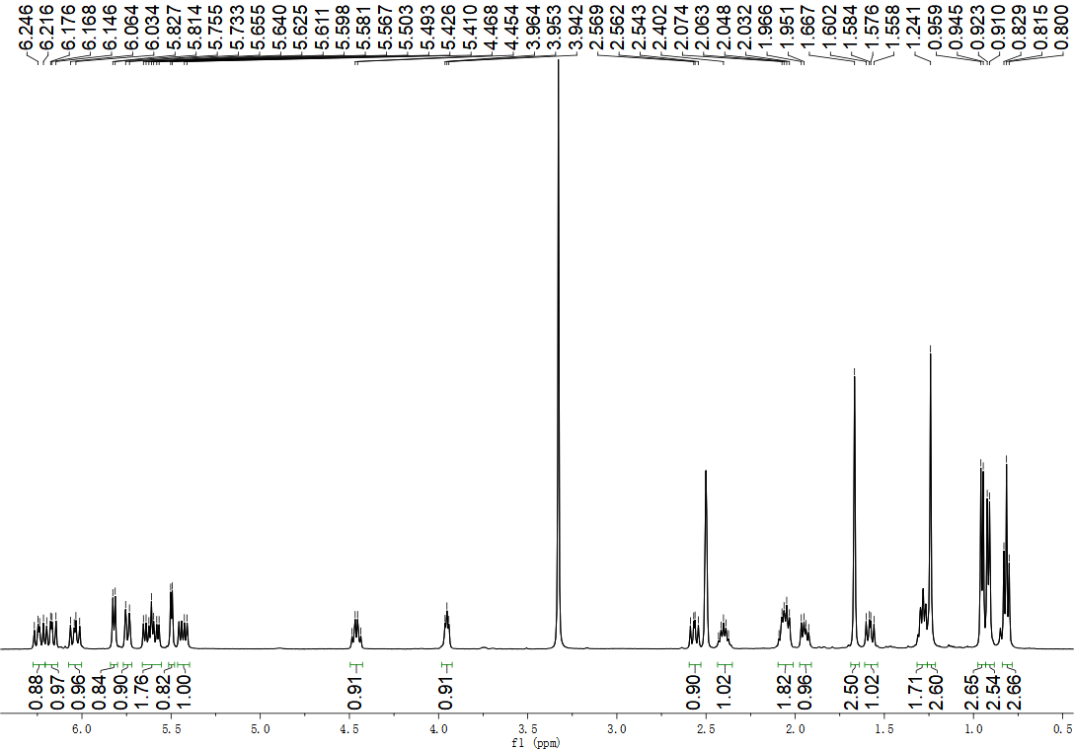

**Figure S1.** 1H NMR (500 MHz, DMSO-*d*6) spectrum of compound **1**

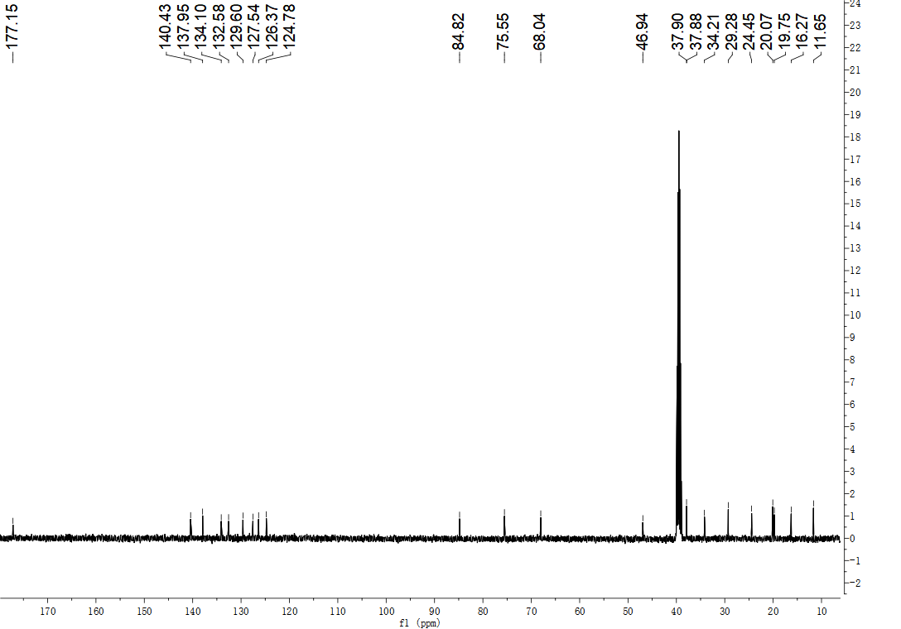

**Figure S2.** 13C NMR (125 MHz, DMSO-*d*6) spectrum of compound **1**

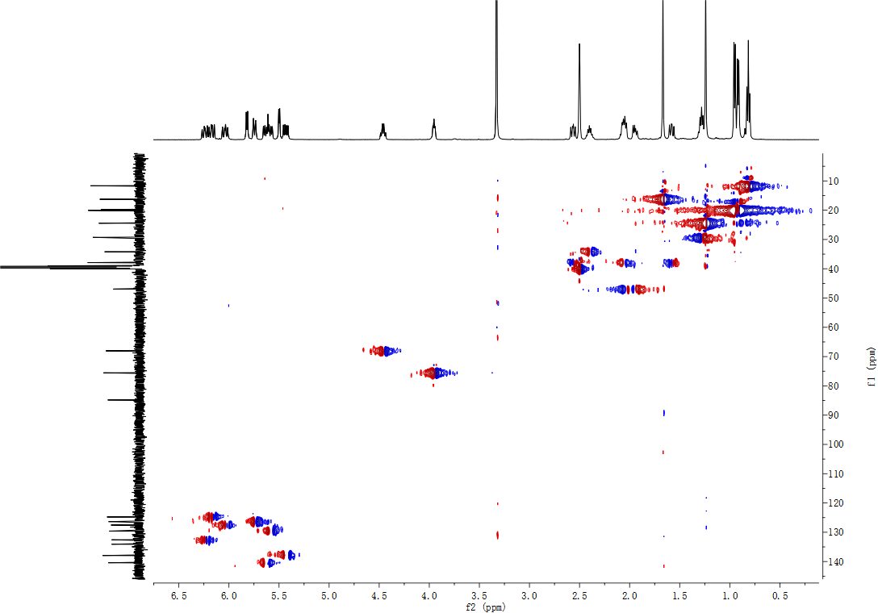

**Figure S3.** HMQC (DMSO-*d*6) spectrum of compound **1**

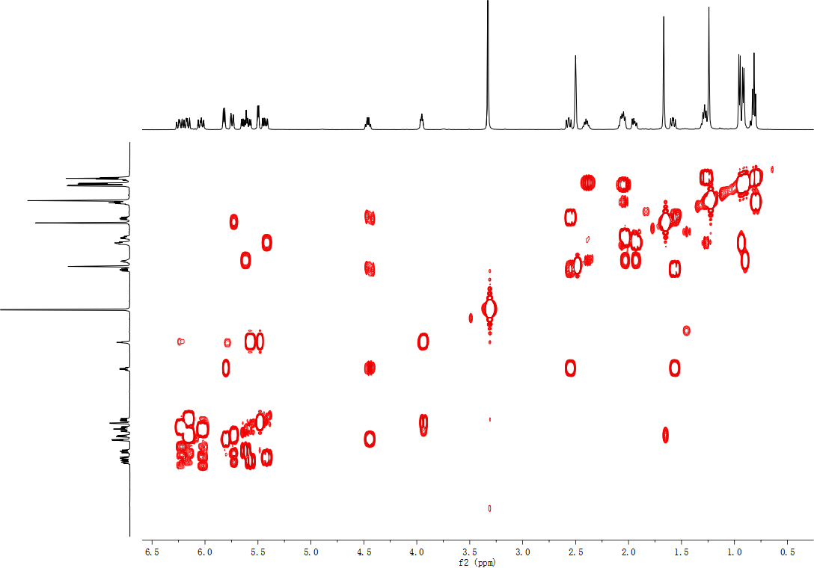

**Figure S4.** COSY (DMSO-*d*6) spectrum of compound **1**

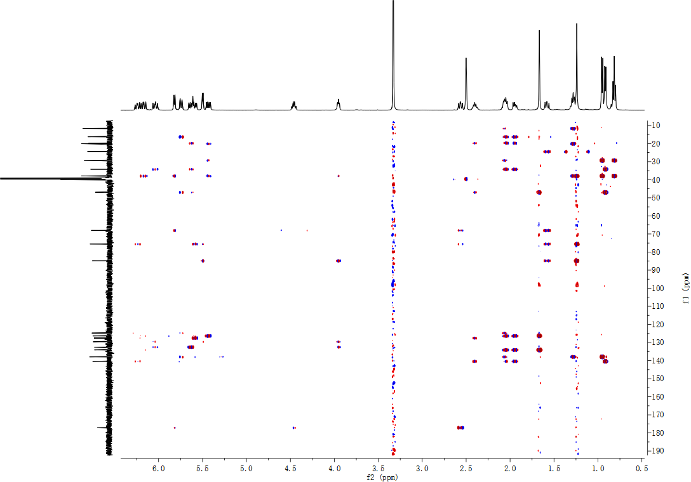

**Figure S5.** HMBC (DMSO-*d*6) spectrum of compound **1**

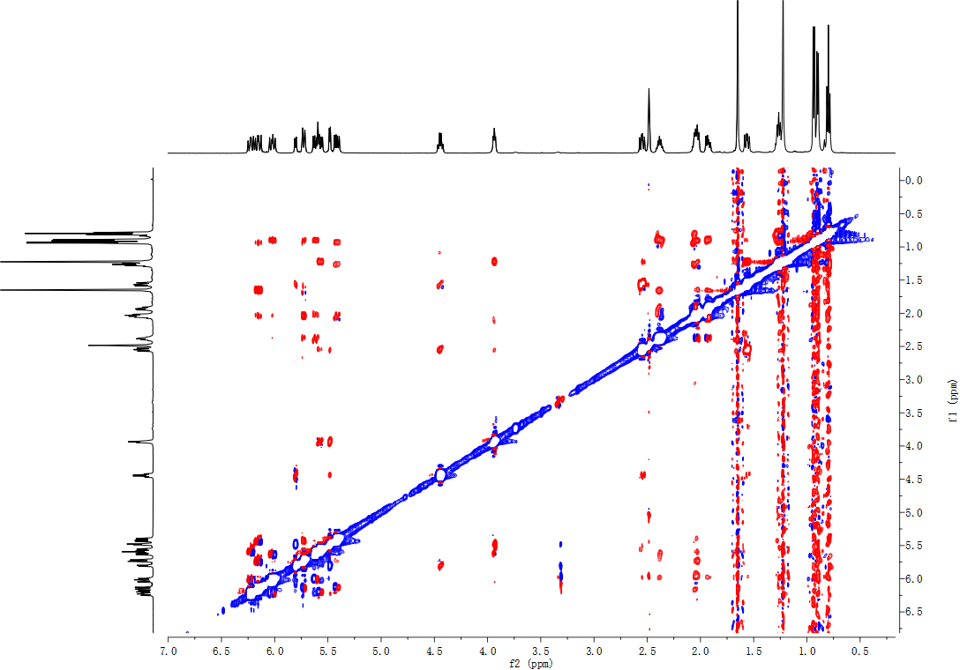

**Figure S6.** NOESY (DMSO-*d*6) spectrum of compound **1**



**Figure S7.** HRESIMS spectrum of compound **1**

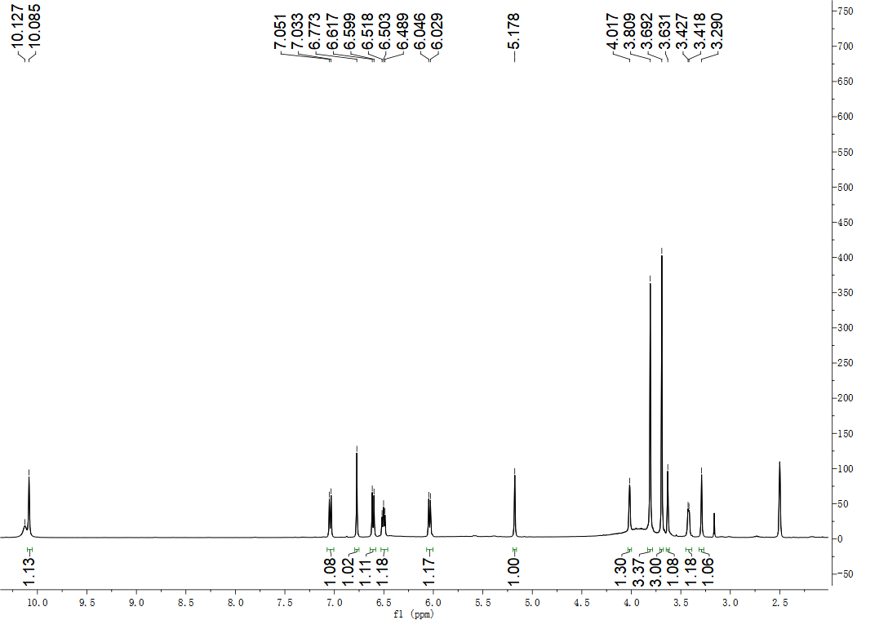

**Figure S8.** 1H NMR (500 MHz, DMSO-*d*6) spectrum of compound **3**

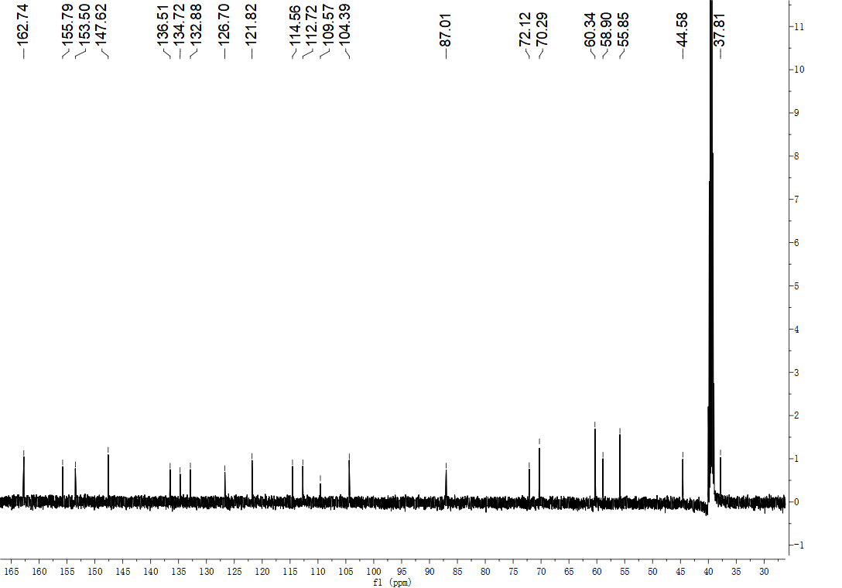

**Figure S9.** 13C NMR (125 MHz, DMSO-*d*6) spectrum of compound **3**

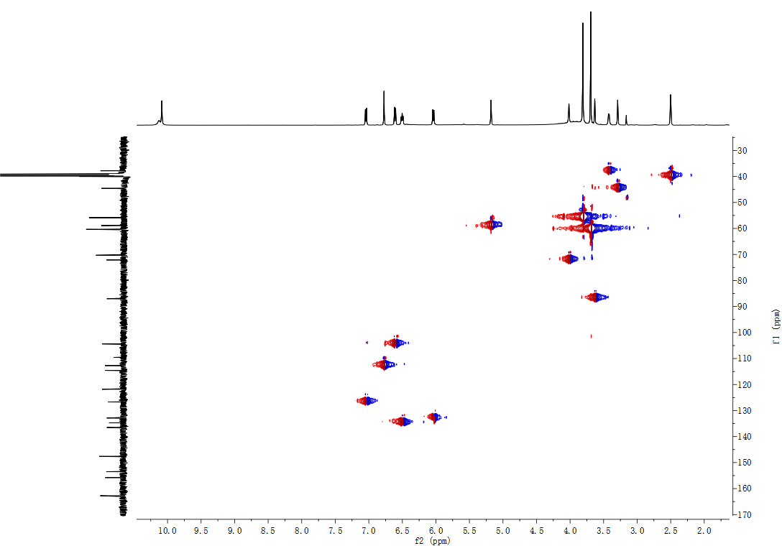

**Figure S10.** HMQC (DMSO-*d*6) spectrum of compound **3**

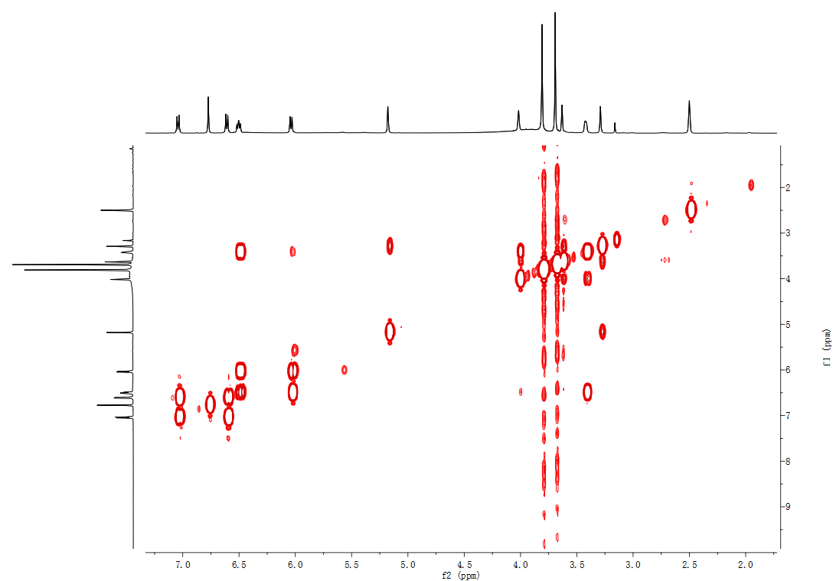

**Figure S11.** COSY (DMSO-*d*6) spectrum of compound **3**

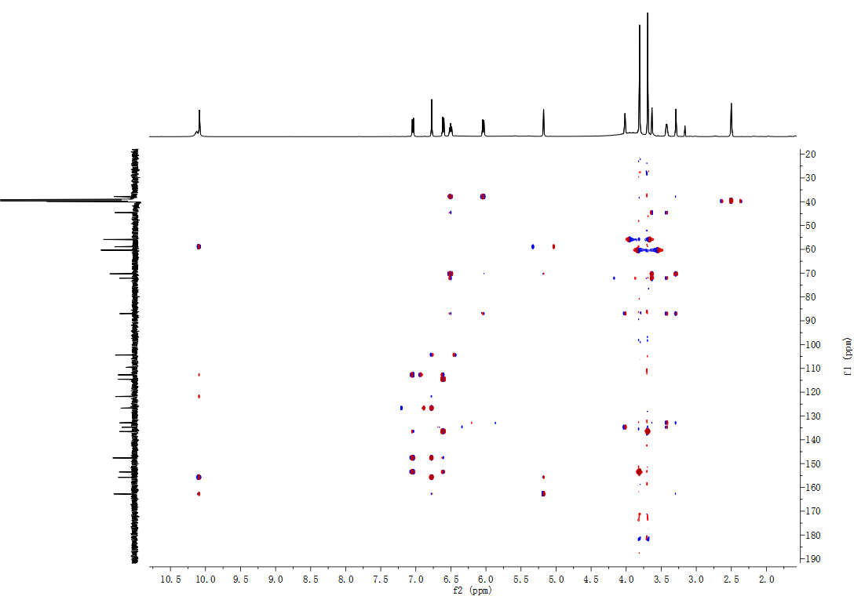

**Figure S12.** HMBC (DMSO-*d*6) spectrum of compound **3**

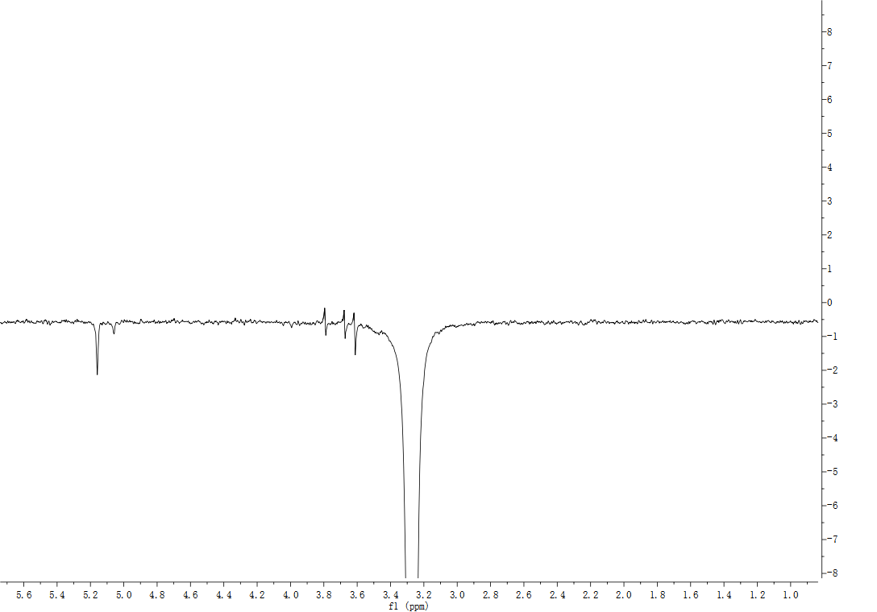

**Figure S13.** 1D NOE (DMSO-*d*6) spectrum of compound **3**

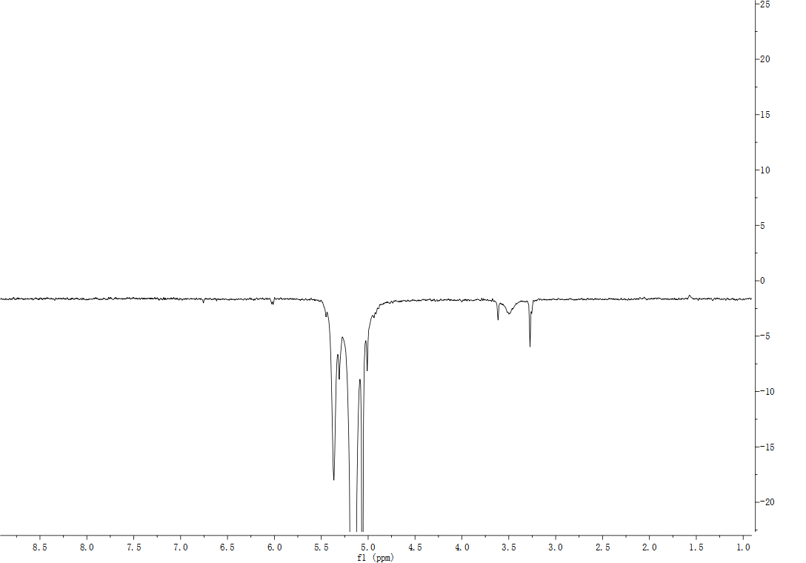

**Figure S14.** 1D NOE (DMSO-*d*6) spectrum of compound **3**

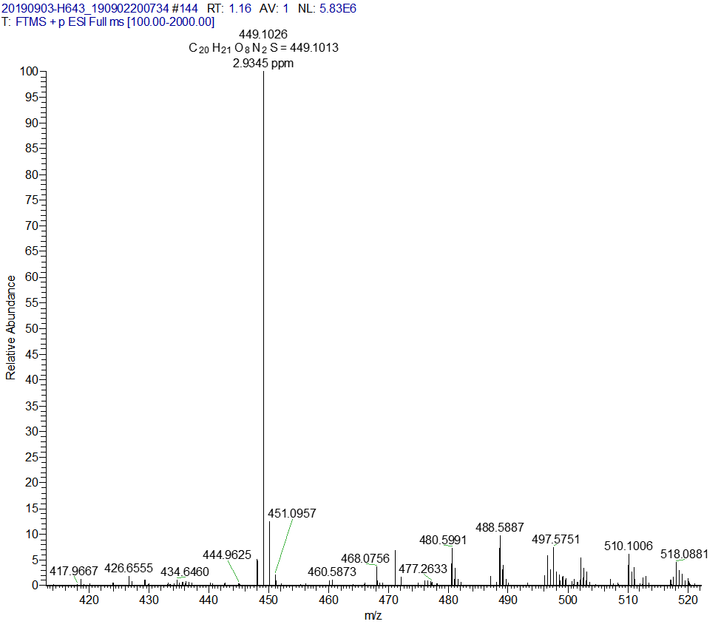

**Figure S15.** HRESIMS spectrum of compound **3**