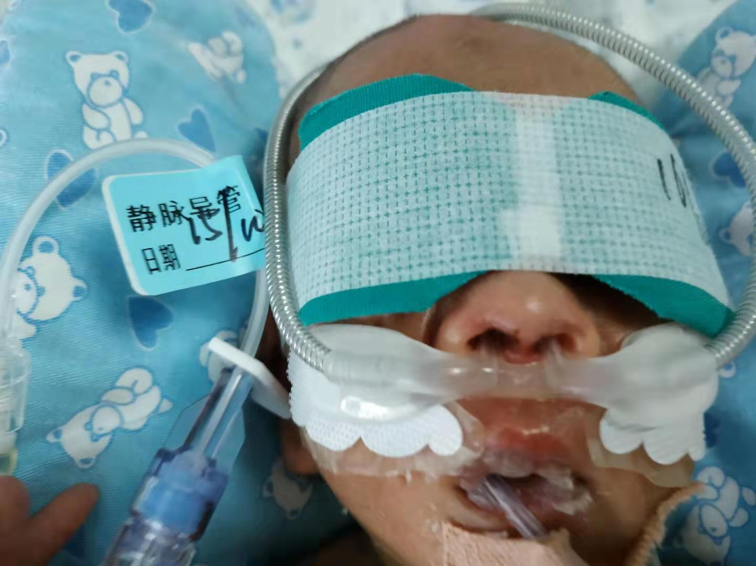Image 1. Nasal injury of an extremely low birth weight preterm infant
Notes: The use of CPAP initially caused nasal injury, now using HHFNC.

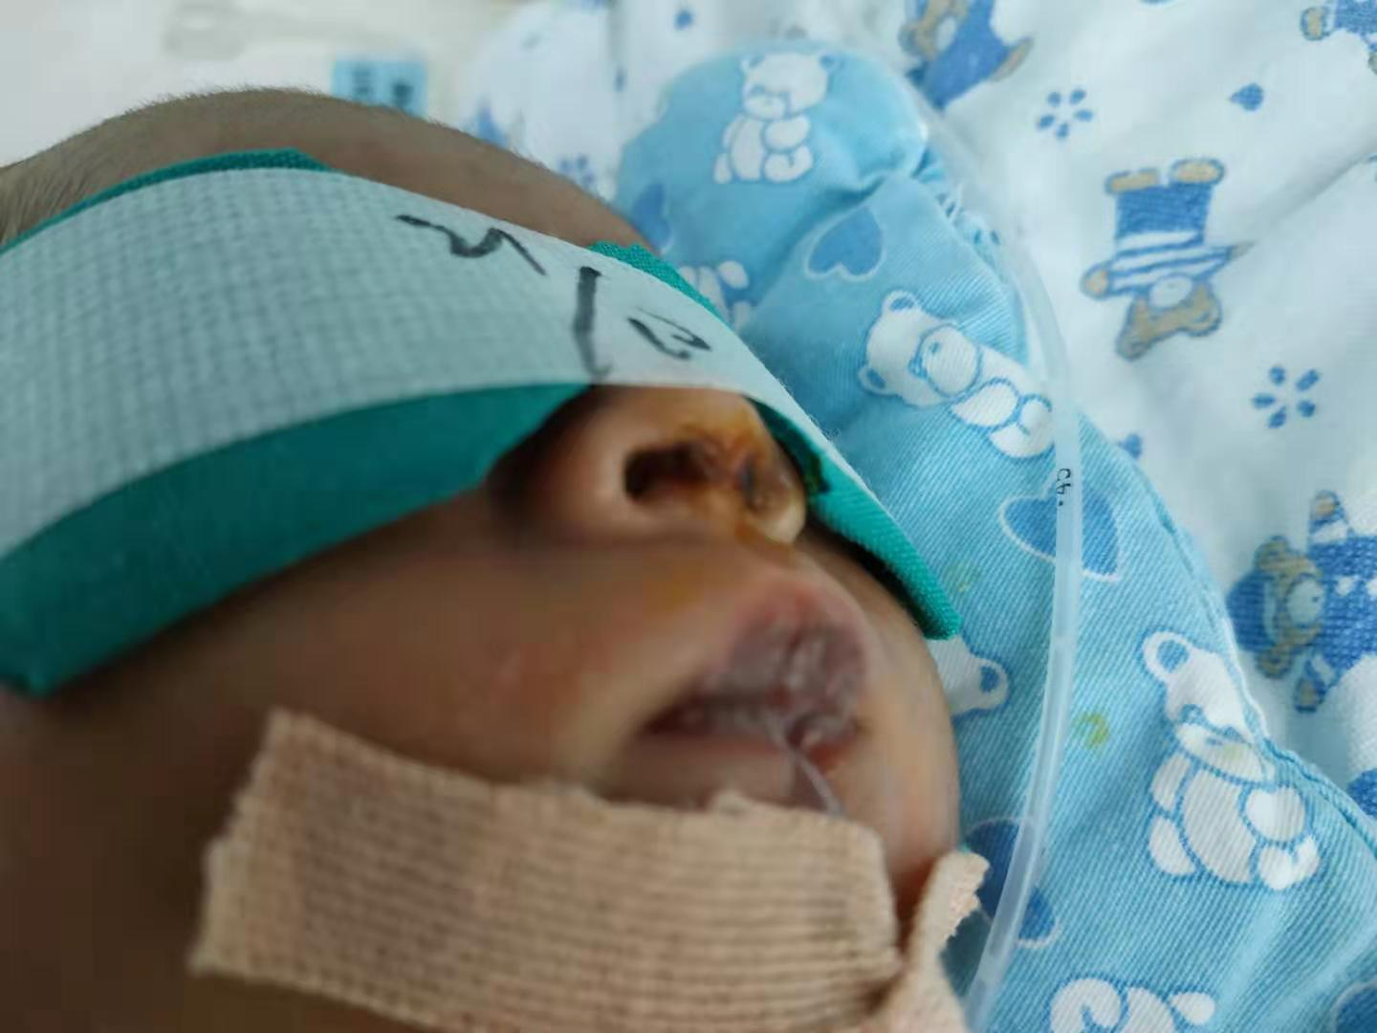Image 2. After the nasal injury has improved of the infant

Image 3. The infant's nasal injury is fully restored (before discharge)
