Supplementary table 1 Risk Factors for Tinnitus in Patients with and without Anxiety Disorder (Anxiety disorder was diagnosed by psychiatrists or non-psychiatrists)
Predictive variables |  | Univariable analysis |  |  | Multivariable analysis
 |  | HR (95% CI) | P value |  | HR (95% CI) | P value
Anxiety |  | 1.86 (1.78-1.94) | <.001 | 1.80 (1.72-1.88) |  | <.001*
Age (<60 = 0, ≥60 = 1) |  | 0.78 (0.47-1.28) | .325
Sex (Female = 1, Male = 0) |  | 0.99 (0.94-1.05) | .730
Comorbidities
 | Hypertension | 1.26 (1.18-1.35 | <.001 | 0.99 (0.91-1.07) |  | .786
 | Diabetes mellitus | 1.27 (1.17-1.37) | <.001 | 1.10 (0.99-1.20) |  | .054
 | Dyslipidemia | 1.52 (1.42-1.64) | <.001 | 1.28 (1.18-1.40) |  | <.001*
 | Coronary artery disease | 1.17 (0.89-1.54) | .266
 | Congestive heart failure | 1.25(1.07-1.46) | .005 |  | 1.08 (0.90-1.29) | .431
 | Chronic lung disease | 1.29 (1.19-1.39) | <.001 |  | 1.10 (1.01-1.20) | .037*
 | Malignant neoplasms | 1.03 (0.82-1.27) | .824
 | Head injury | 1.31 (1.22-1.42) | <.001 |  | 1.16 (1.07-1.26) | .001*
 | Cerebrovascular disease | 1.32 (1.18-1.49) | <.001 |  | 1.13 (0.98-1.29) | .084
Degree of urbanization
 | Urban | Reference |  |  | Reference
 | Suburban | 1.09 (1.03-1.16) | .005 |  | 1.03 (0.96-1.10) | .378
 | Rural | 1.08 (0.99-1.19) | .095 |  | 0.94 (0.85-1.04) | .244
Income group
 | Low income | Reference |  |  | Reference
 | Medium income | 1.15 (1.08-1.22) | <.001 |  | 1.12 (1.05-1.20) | .001*
 | High income | 1.12 (1.02-1.24) | .024 |  | 1.10 (0.99-1.23) | .077
HR: hazard ratio; CI: confidence interval;
*statistical significance

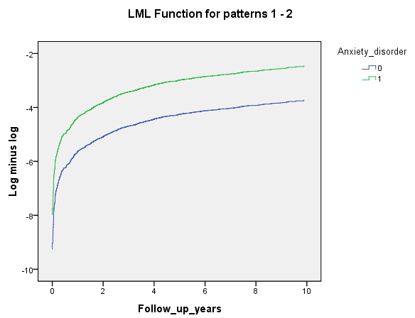

Supplementary figure 1
The log-minus-log survival plot, showing a constant increase in the cumulative hazard rate during the follow-up period.

