Supplementary Table 1 Demographics of 20 third-generation cephalosporin-resistant E. coli or K. pneumoniae carrier and 60 non-carrier with fecal microbiota analysis
Baseline characteristics | 3GC-R carrier  (n=20) | 3GC-R non-carrier  (n=60) | p
Age (year) | 34.5 (32-41.5) | 36 (33-40) | 0.556
Male gender | 8/20 (40.0) | 24 (40.0) | >0.999
Smoking habit | 3/20 (15.0) | 10/59 (16.9) | >0.999
Alcohol consumption | 2/20 (10.0) | 6/58 (10.3) | >0.999
Vegetarian | 0 (0) | 0 (0)
Live in dormitory | 2/20 (10.0) | 10/59 (16.9) | 0.720
Live with family | 15/20 (75.0) | 49/60 (81.7) | 0.530
Number of family member | 4 (2-5) | 4 (2-6) | 0.460
Live with children younger than 7 years of age | 11/20 (55.0) | 22/59 (37.3) | 0.165
Education level
Below elementary school | 0/20 (0) | 1/60 (1.7)
Elementary school | 0/20 (0) | 0/60 (0)
Junior high school | 0/20 (0) | 3/60 (5.0)
Senior high school | 8/20 (40.0) | 12/60 (20.0)
College/university | 10/20 (50.0) | 32/60 (53.3)
Postgraduate | 2/20 (5.0) | 12/60 (20.0)
Income (per month)
<20,000 NTD | 3/19(15.8) | 5/59 (8.5)
20,000-50,000 NTD | 12/19 (63.2) | 40/59 (67.8)
50,000-100,000 NTD | 2/19 (10.5) | 13/59 (22.0)
100,000-200,000 NTD | 0/19 (0) | 1/59 (1.7)
>200,000 NTD | 2/19 (10.5) | 0/59 (0)
Comorbidity
Hypertension | 1/20 (5.0) | 4/60 (6.7)
Chronic hepatitis B | 6/20 (30.0) | 7/60 (11.7)
Gastric or duodenal ulcer | 1/20 (5.0) | 1/60 (1.7)
Diabetes mellitus | 0/20 (0) | 0/60 (0)
Thyroid disease | 0/20 (0) | 5/60 (8.3)
Urolithiasis | 0/20 (0) | 3/60 (5.0)
Asthma | 0/20 (0) | 1/60 (1.7)
Coronary artery disease | 0/20 (0) | 0/60 (0)
Malignancy | 0/20 (0) | 0/60 (0)
Travel abroad in the past year | 7/19 (36.8) | 20/55 (36.4) | 0.970
Japan | 4 | 9
China | 2 | 4
Southeast Asia | 1 | 1
Europe | 0 | 3
Others | 0 | 3
Animal contact in the past year | 6/20 (30.0) | 37/60 (61.7) | 0.014
Family member as HCW | 1/20 (5.0) | 15/60 (25.0) | 0.060
Caring for an inpatient in the past year | 3/20 (15.0) | 10/60 (16.7) | >0.999
ER visit or hospitalization in the past year | 1/20 (5.0) | 0 (0) | 0.250
Outpatient clinic visit in the past year | 16/20 (80.0) | 44/60 (73.3) | 0.551
Frequency of outpatient clinic visits (per year) | 2 (1-12) | 2 (0-4) | 0.525
Employee of the technology company A | 11/20 (55.0) | 14/60 (23.3) | 0.008
Abbreviations: 3GC-R, third-generation cephalosporin-resistant; ER, emergency department; HCWs, health care workers; NTD, new Taiwan dollar.

Supplementary Table 2 Demographics of 44 employees of the technology company A with or without fecal carriage of third-generation cephalosporin-resistant (3GC-R) E. coli or K. pneumoniae

Baseline characteristics | 3GC-R carrier  (n=28) | 3GC-R non-carrier  (n=16) | p
Age (year) | 37 (34-42) | 37 (34-40) | 0.922
Male gender | 4/28 (14.3) | 2/16 (12.5) | 0.999
Smoking habit | 3/28 (10.7) | 4/16 (25.0) | 0.236
Alcohol consumption | 1/28 (3.6) | 3/17 (18.8) | 0.129
Vegetarian | 0/28 (0) | 0/16 (0) | -
Live in dormitory | 1/28 (3.6) | 0/15 (0) | 0.999
Live with family | 26/28 (92.9) | 14/16 | 0.614
Number of family member | 4 (3-6) | 4 (3-6) | 0.202
Live with children younger than 7 years of age | 13/28 (46.4) | 6/16 (37.5) | 0.565
Education level
Below elementary school | 0/28 (0) | 0/16 (0)
Elementary school | 0/28 (0) | 0/16 (0)
Junior high school | 0/28 (0) | 0/16 (0)
Senior high school | 16/28 (57.1) | 9/16 (56.3)
College/university | 10/28 (35.7) | 6/16 (56.3)
Postgraduate | 2/28 (7.1) | 1/16 (6.3)
Income (per month)
<20,000 NTD | 3/28 (10.7) | 0/15 (0)
20,000-50,000 NTD | 23/28 (82.1) | 15/15 (100)
50,000-100,000 NTD | 0/28 (0) | 0/15 (0)
100,000-200,000 NTD | 0/28 (0) | 0/15 (0)
>200,000 NTD | 2/28 (7.1) | 0/15 (0)
Comorbidity
Hypertension | 4/28 (14.3) | 0/16 (0) | 0.280
Chronic hepatitis B | 5/28 (17.9) | 0/16 (0) | 0.141
Gastric or duodenal ulcer | 2/28 (7.1) | 0/16 (0) | 0.526
Diabetes mellitus | 0/28 (0) | 0/16 (0) | -
Thyroid disease | 0/28 (0) | 2/16 (12.5) | 0.127
Urolithiasis | 0/28 (0) | 0/16 (0) | -
Asthma | 0/28 (0) | 0/16 (0) | -
Coronary artery disease | 0/28 (0) | 0/16 (0) | -
Malignancy | 0/28 (0) | 0/16 (0) | -
Travel abroad in the past year | 6/27 (22.2) | 1/13 (7.7) | 0.393
Japan | 4 | 1
China | 0 | 0
Southeast Asia | 2 | 0
Europe | 0 | 0
Others | 0 | 0
Animal contact in the past year | 8/28 (28.9) | 5/16 (31.3) | 0.999
Family member as HCW | 0/28 (0) | 1/16 (6.3) | 0.364
Caring for an inpatient in the past year | 4/28 (14.3) | 1/16 (6.3) | 0.638
ER visit or hospitalization in the past year | 3/28 (10.7) | 0/16 (0) | 0.290
Outpatient clinic visit in the past year | 20/27 (74.1) | 10/16 (62.5) | 0.502
Frequency of outpatient clinic visits (per year) | 2 (0-12) | 2(0-6) | 0.579
Antibiotic use in the past year | 10/28 (35.7) | 1/16 (6.3) | 0.036
Abbreviations: 3GC-R, third-generation cephalosporin-resistant; ER, emergency department; HCWs, health care workers; NTD, new Taiwan dollar.

Supplementary Figure 1. The susceptibility rate of the 74 E. coli to different antimicrobial agents between isolates from employees of the technology company A and other participants. *The susceptibility is significantly lower among employees of the technology company A. (p<0.05)

Supplementary Figure 2. The susceptibility rate of the eight MRSA isolates to different antimicrobial agents (TMP-SMX, trimethoprim-sulfamethoxazole)
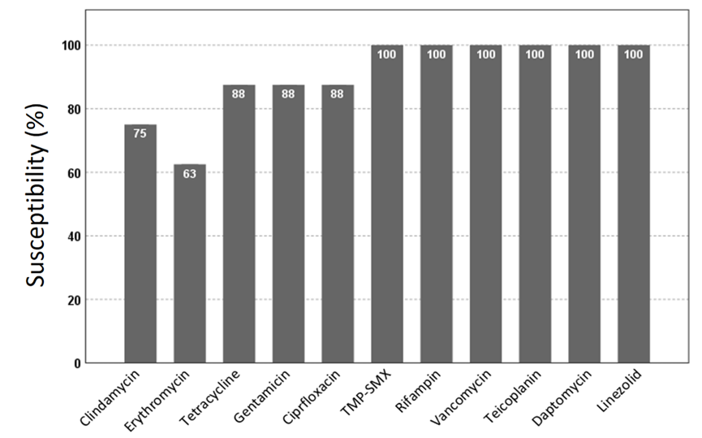

Supplementary Figure 3. Dendrogram of SpeI-digested genomic DNA of (A) third-generation cephalosporin-resistant E. coli from all participants, and (B) third-generation cephalosporin-resistant K. pneumoniae from all participants
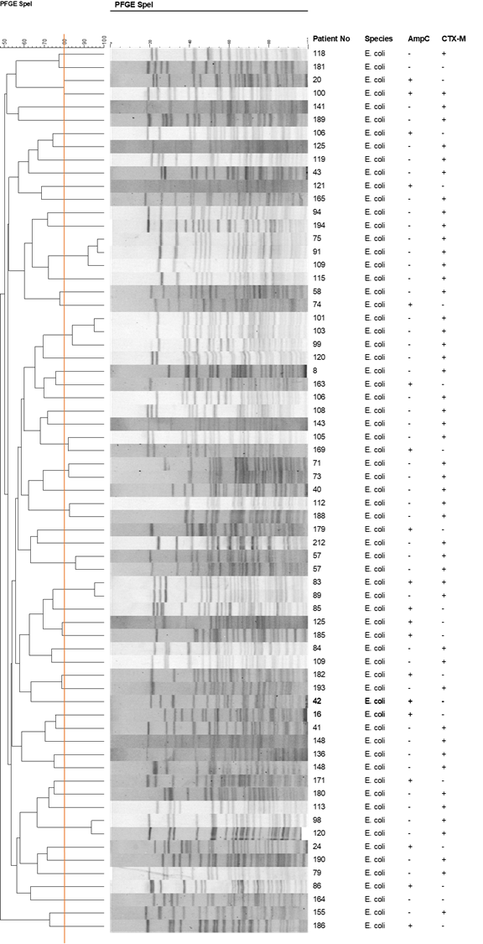
(A)

(B)
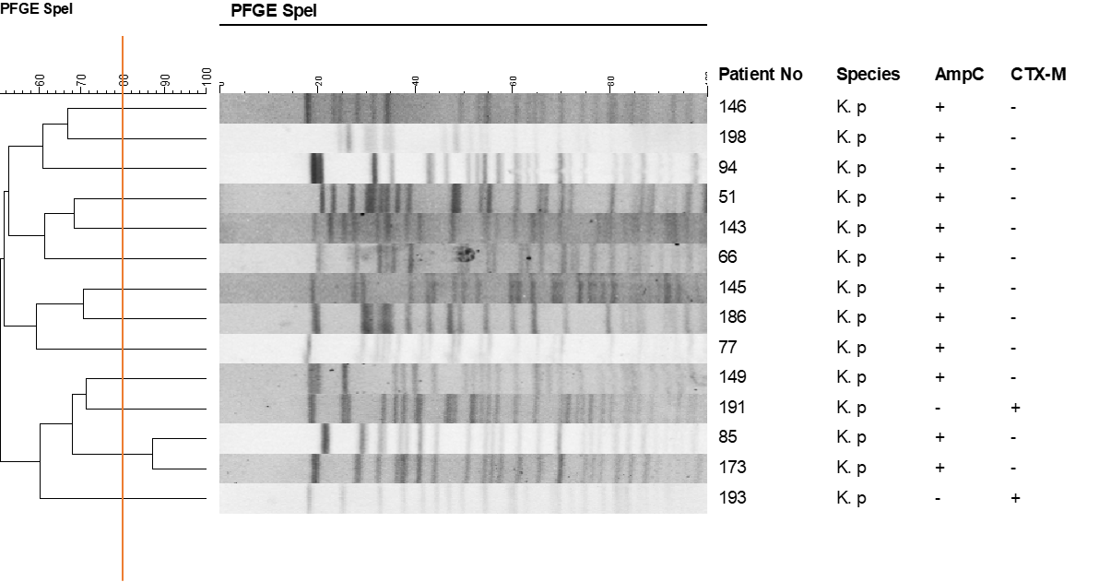

Supplementary Figure 4. Dendrogram of SpeI-digested genomic DNA of (A) third-generation cephalosporin-resistant E. coli from employees of the technology company A, and (B) third-generation cephalosporin-resistant K. pneumoniae from employees of the technology company A

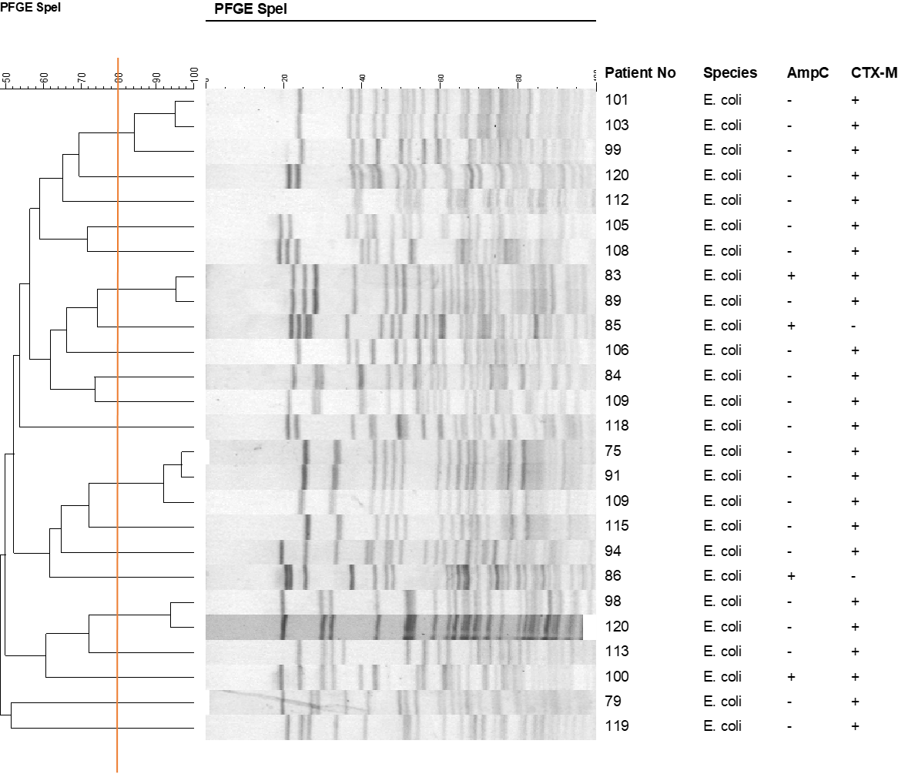
(A)

(B)
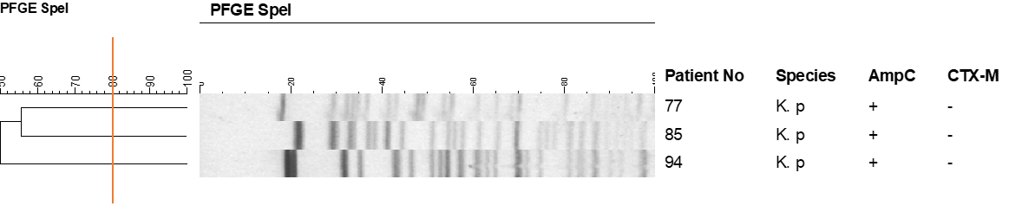

Supplementary Figure 5. Dendrogram of SmaI-digested genomic DNA of the eight Methicillin-resistant Staphylococcus aureus isolates

