Supplementary Material

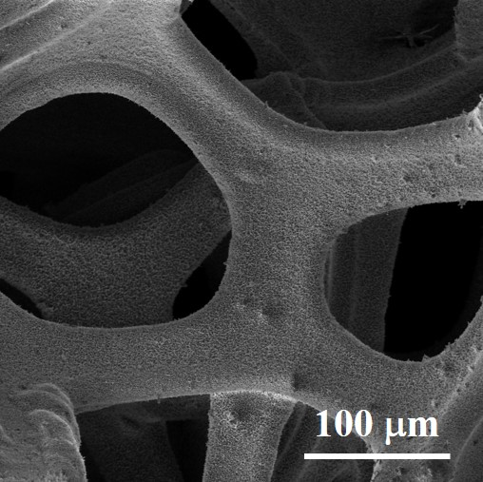
Supplementary Figure 1. SEM image of the nickel foam after reaction.

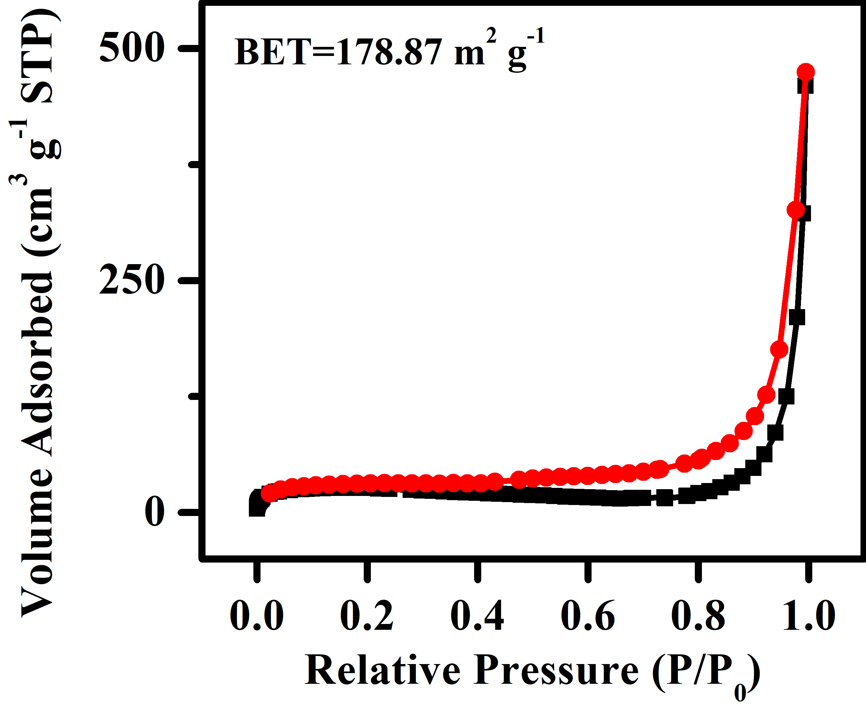
Supplementary Figure 2. N₂ adsorption isotherms of the Ni,Cu-MOF sample.
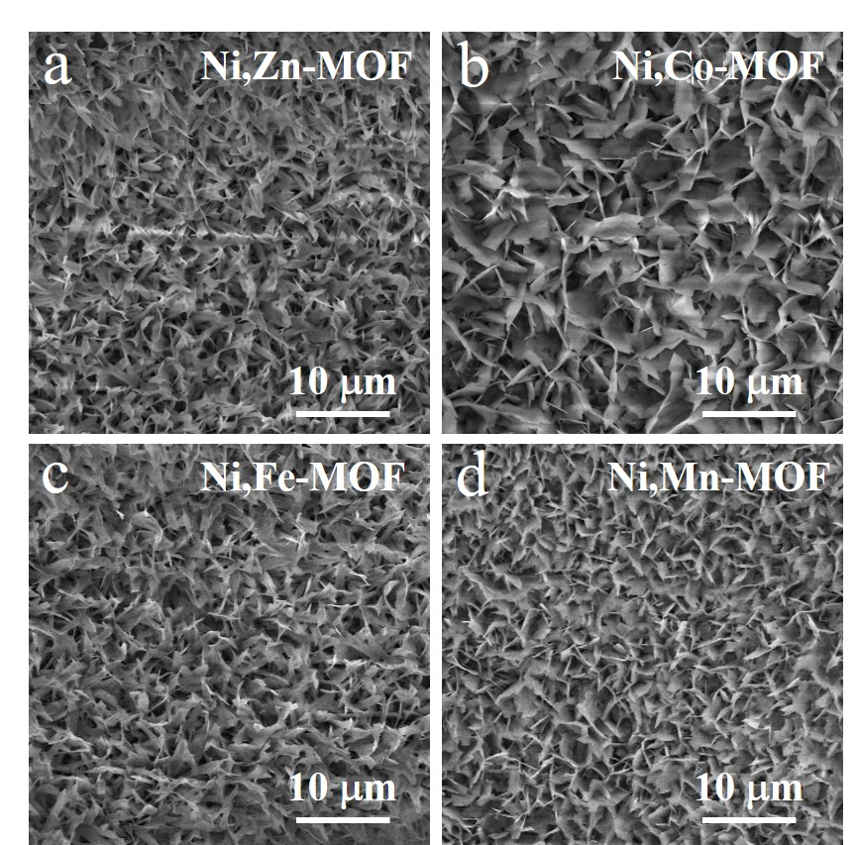
Supplementary Figure 3. The SEM images of the Ni,Zn-MOF, Ni,Co-MOF, Ni,Fe-MOF and Ni,Mn-MOF samples.

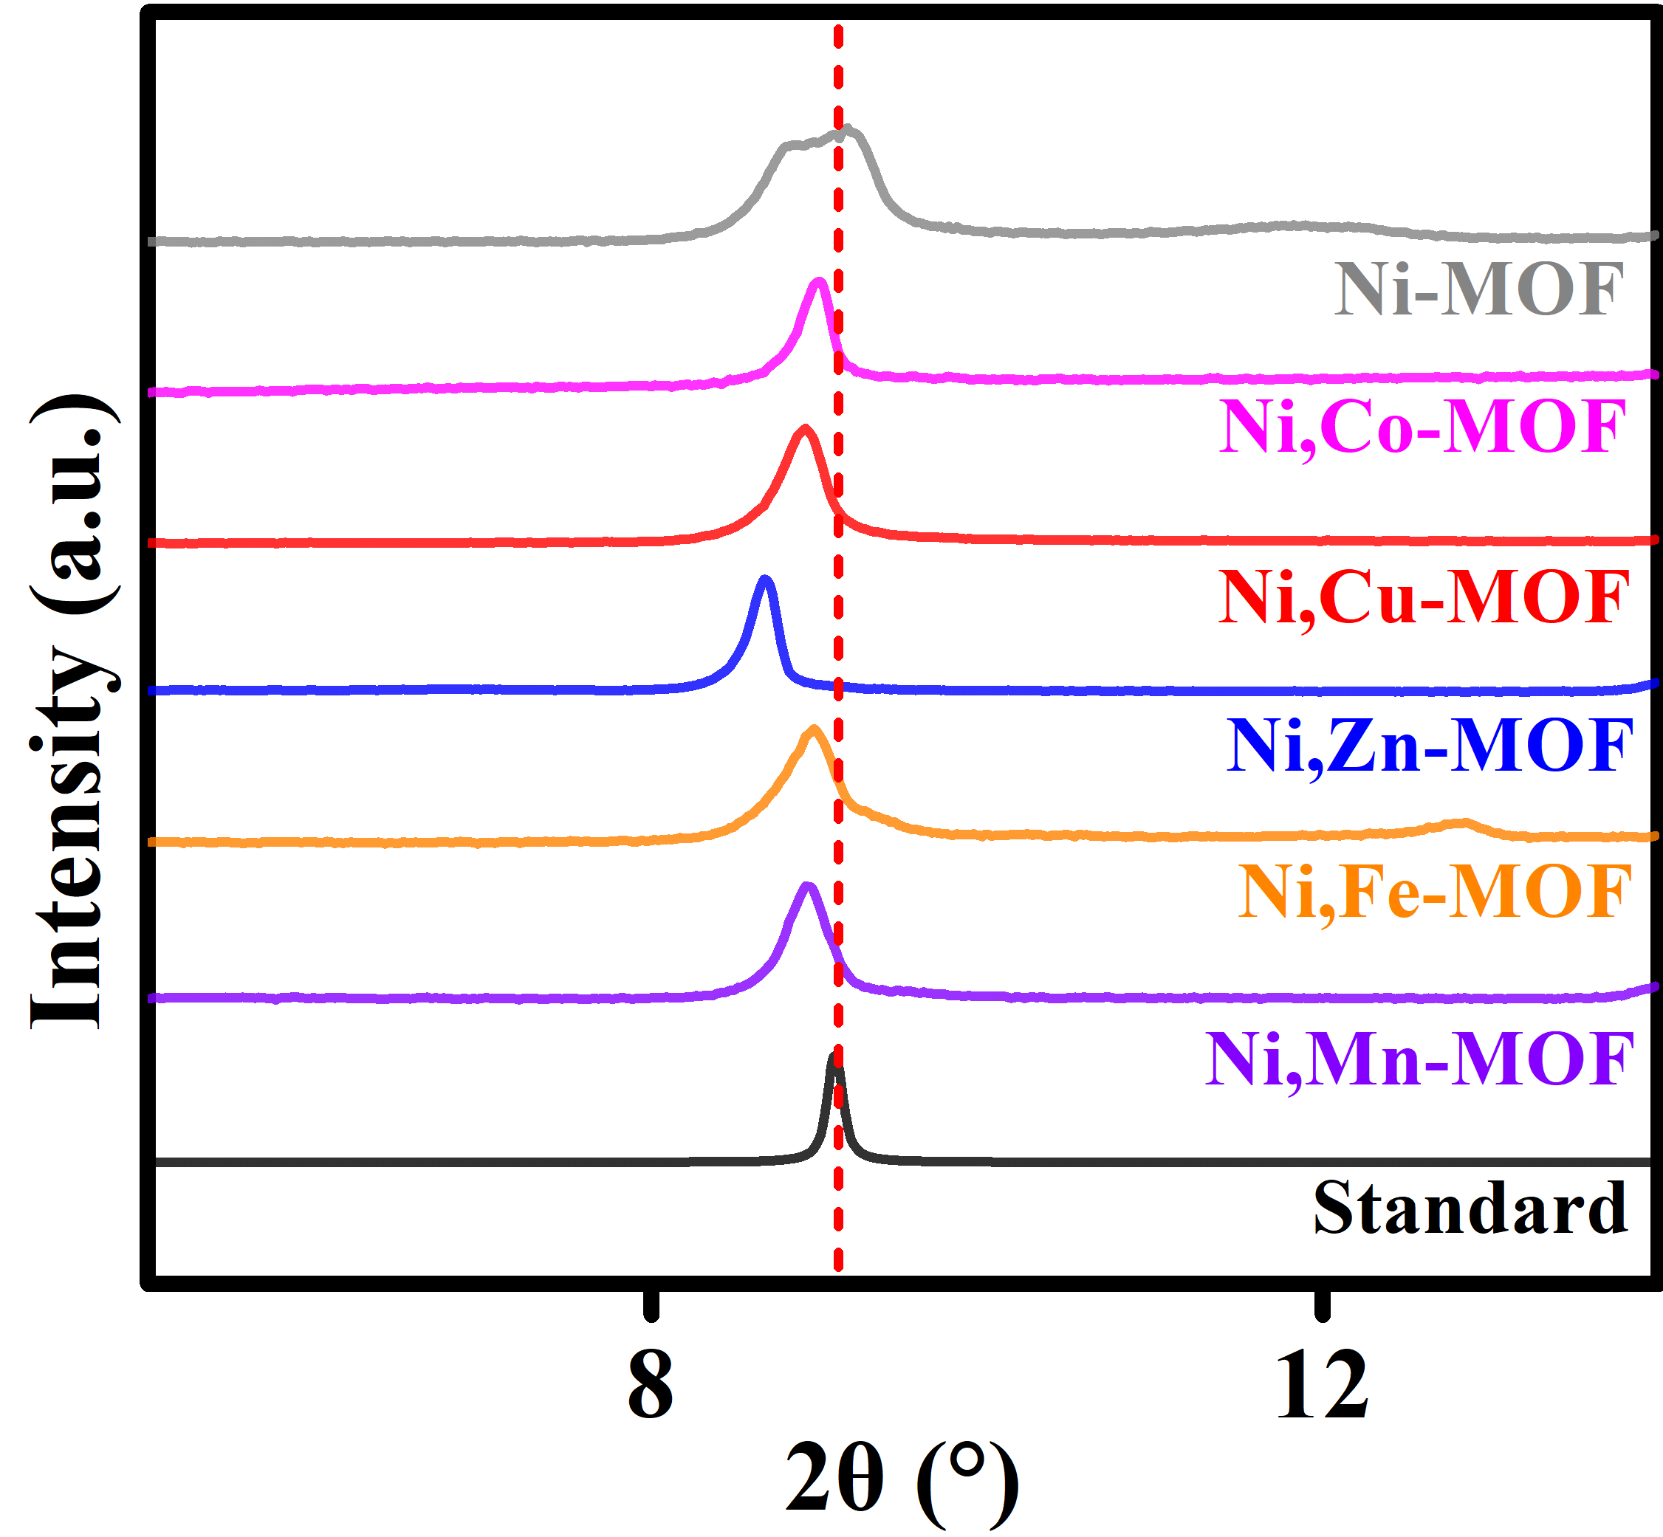
Supplementary Figure 4. Magnification of the XRD patterns of all samples.

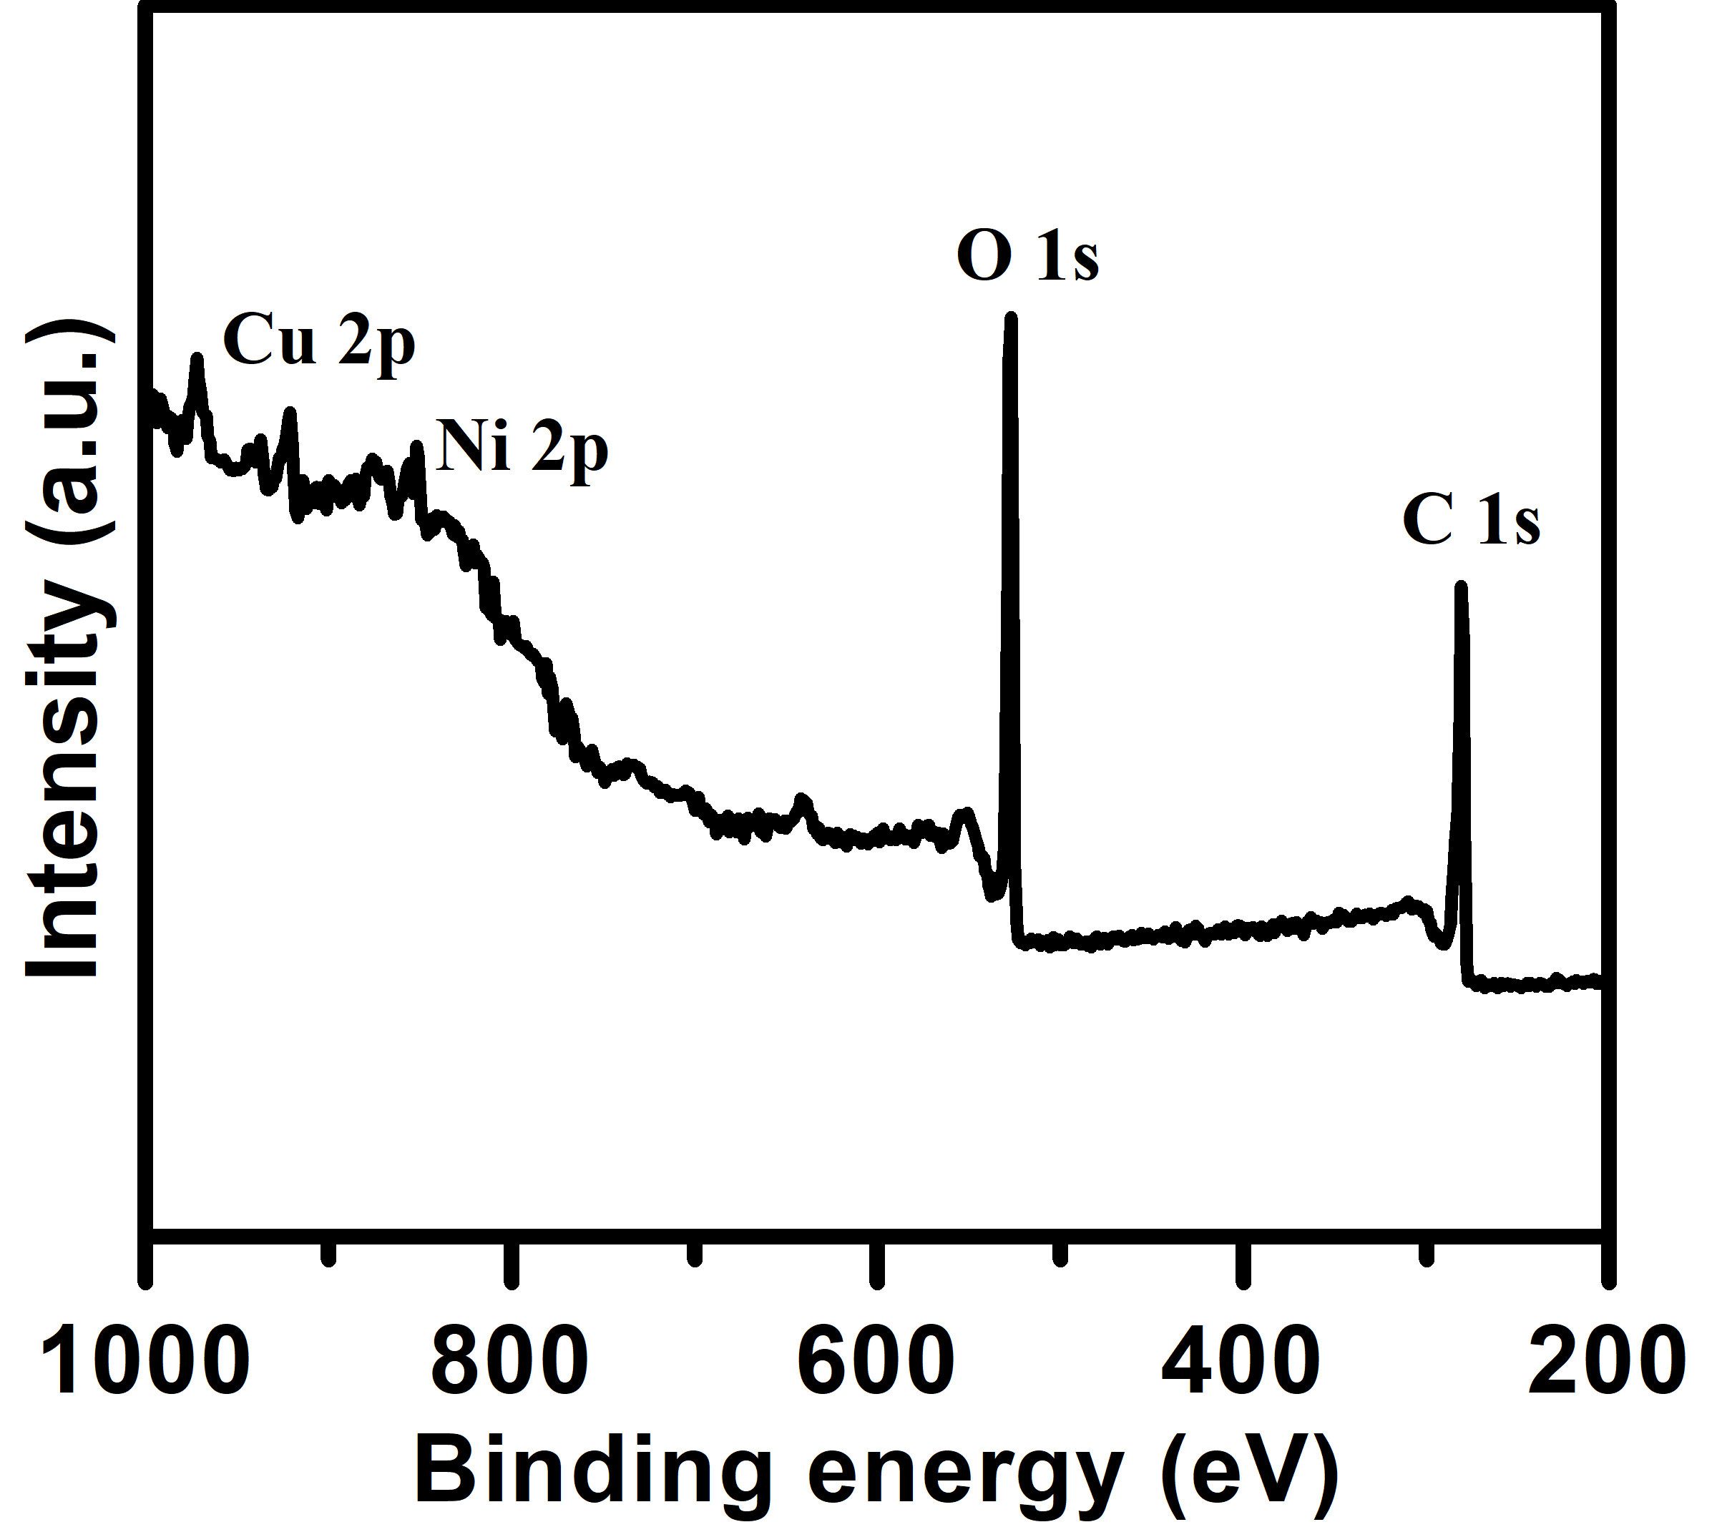
Supplementary Figure 5. The XPS survey spectra of the Ni,Cu-MOF sample

.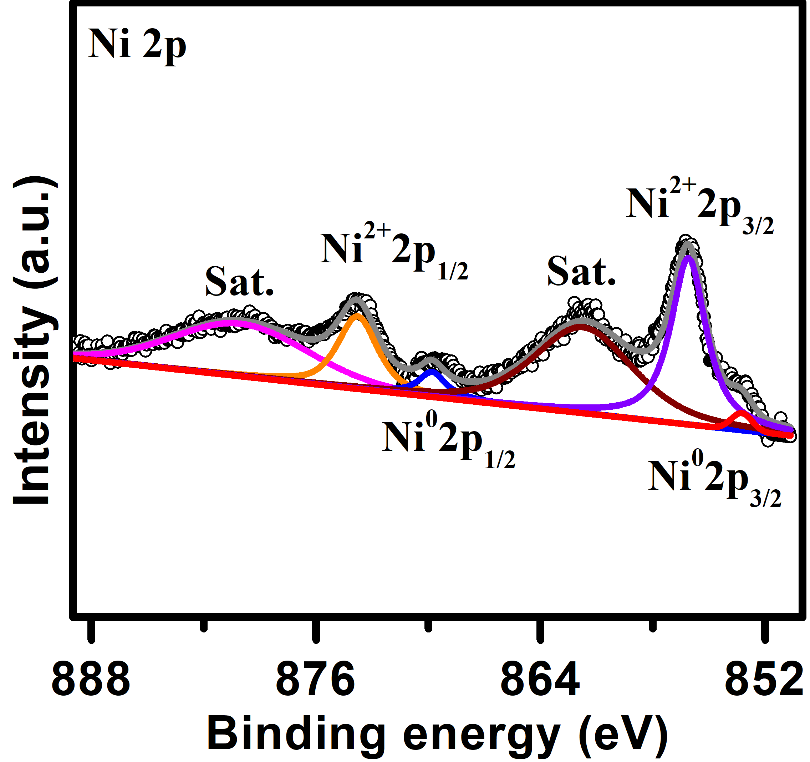
Supplementary Figure 6. High-resolution XPS spectra of Ni 2p for nickel foam.
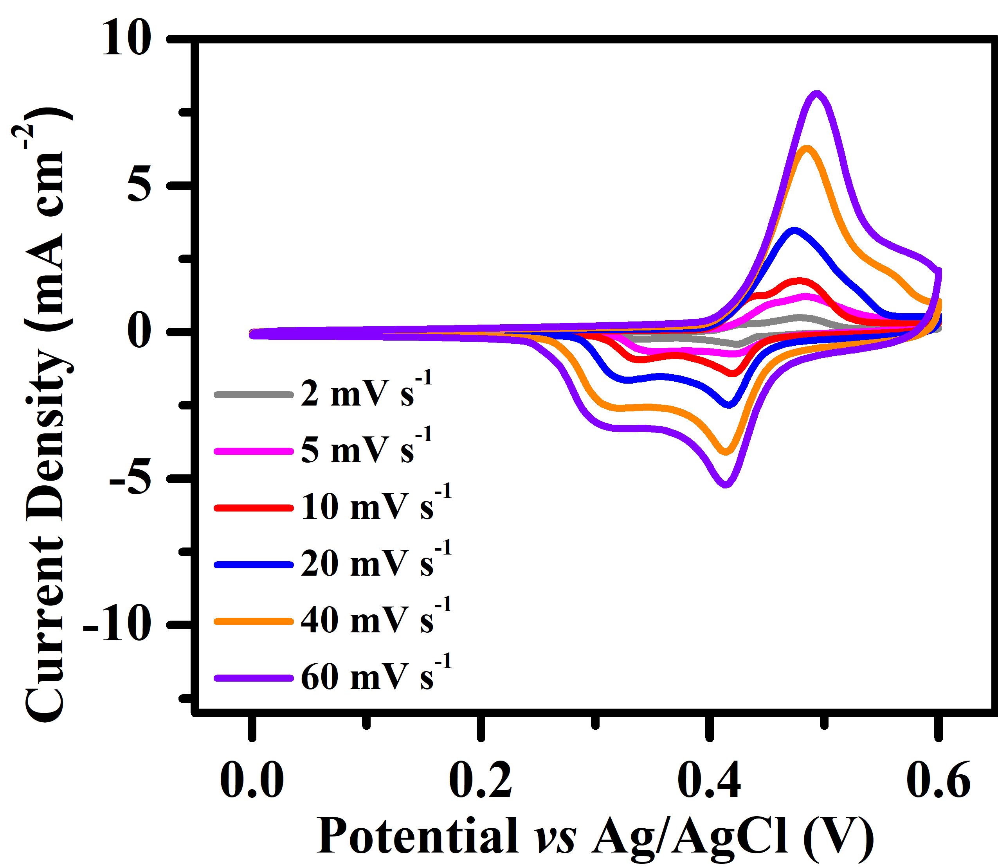.
Supplementary Figure 7. CV curves of nickel foam in the potential range from 0 to 0.6 V at the scan rate from 2 mV s⁻¹ to 60 mV s⁻¹.

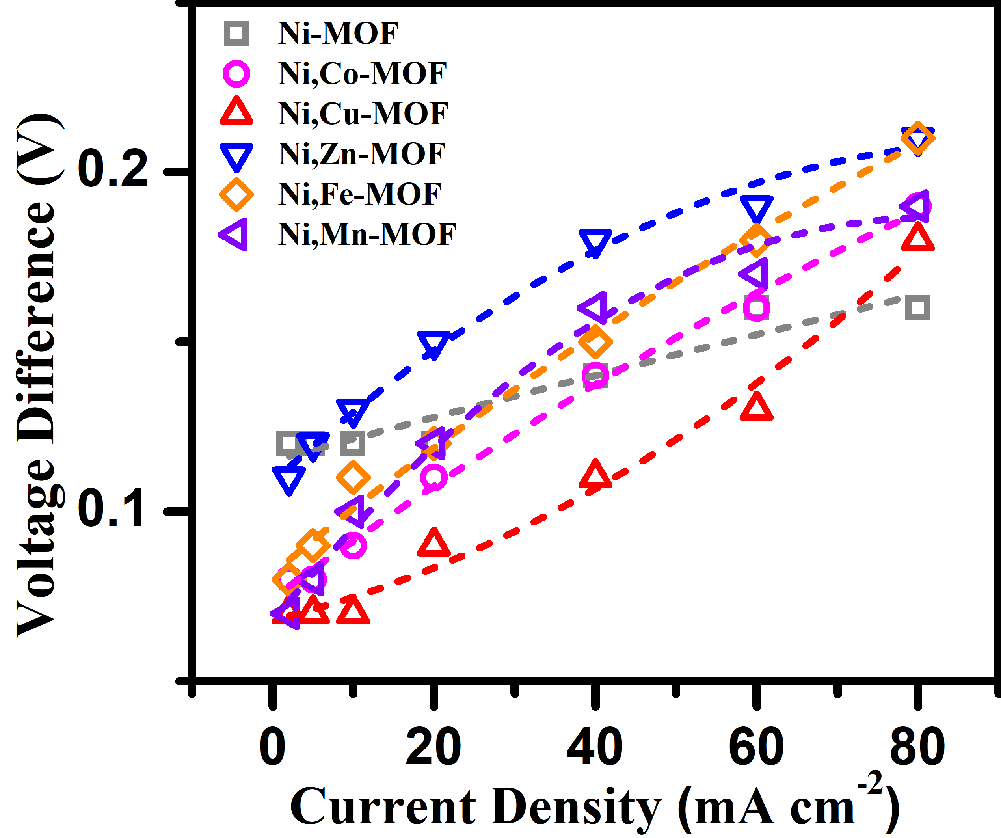
Supplementary Figure 8. The voltage difference between the charging and discharging platforms of all samples in three-electrode system.

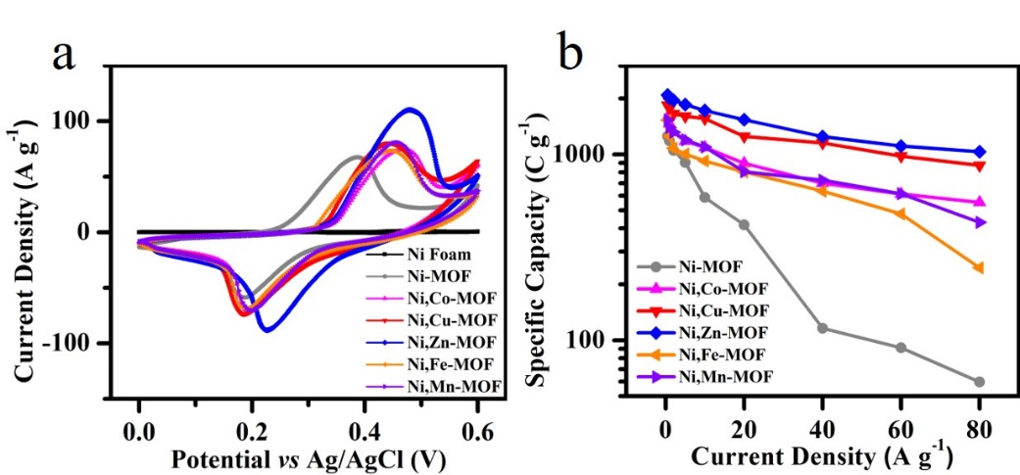
Supplementary Figure 9. (a) CV curves based on the mass of the Ni foam, Ni-MOF, Ni,Co-MOF, Ni,Cu-MOF, Ni,Zn-MOF, Ni,Fe-MOF and Ni,Mn-MOF, respectively. (b) Rate performance of all samples.

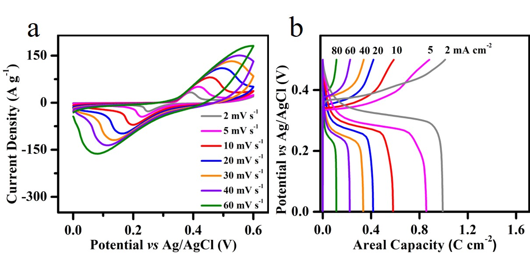
Supplementary Figure 10. (a) CV curves of the Ni-MOF. (b) Charge–discharge curves from 2 mA cm⁻² to 80 mA cm⁻².

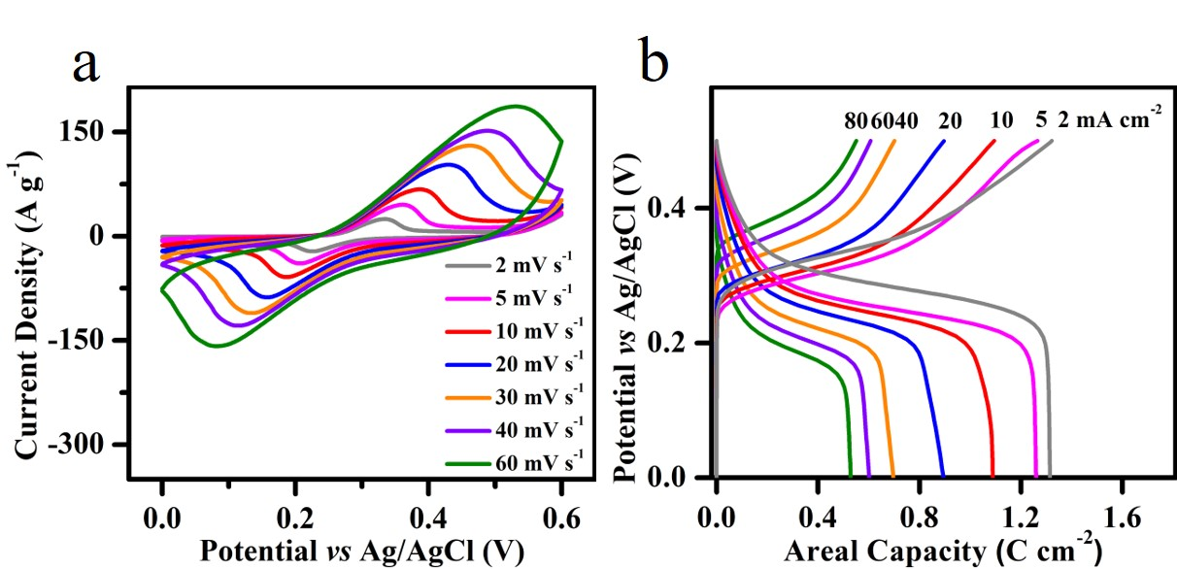
Supplementary Figure 11. (a) CV curves of the Ni,Co-MOF. (b) Charge–discharge curves from 2 mA cm⁻² to 80 mA cm⁻².

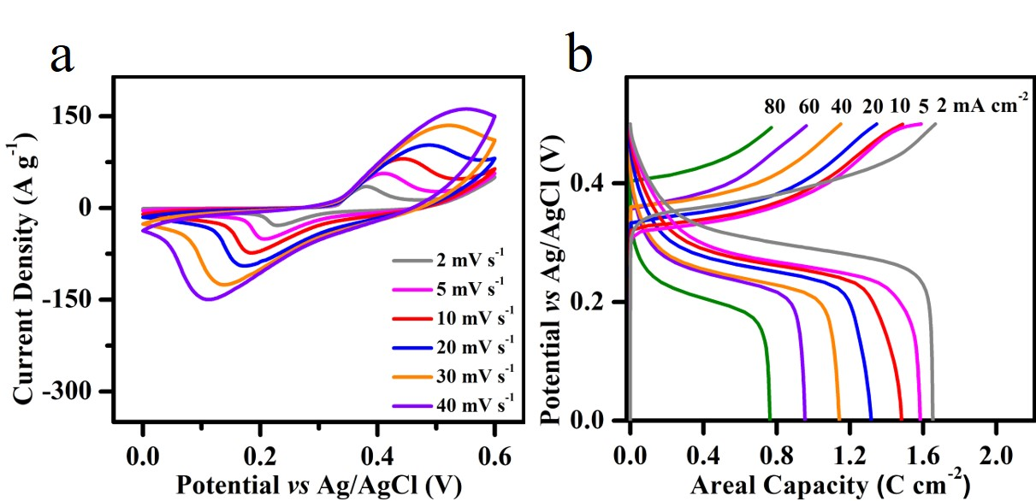
Supplementary Figure 12. (a) CV curves of the Ni,Cu-MOF. (b) Charge–discharge curves from 2 mA cm⁻² to 80 mA cm⁻².

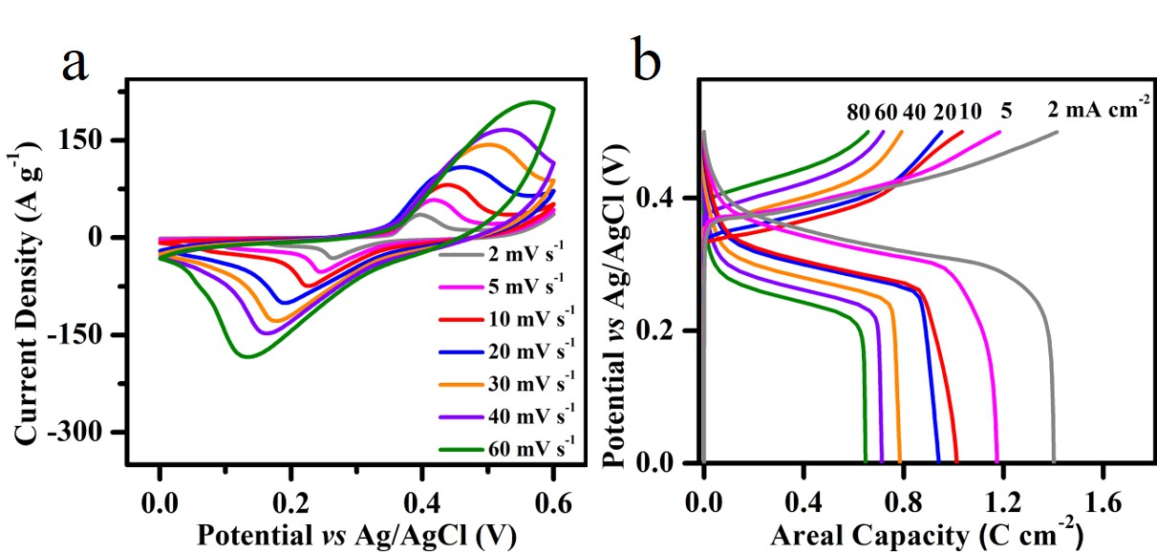
Supplementary Figure 13. (a) CV curves of the Ni,Zn-MOF. (b) Charge–discharge curves from 2 mA cm⁻² to 80 mA cm⁻².

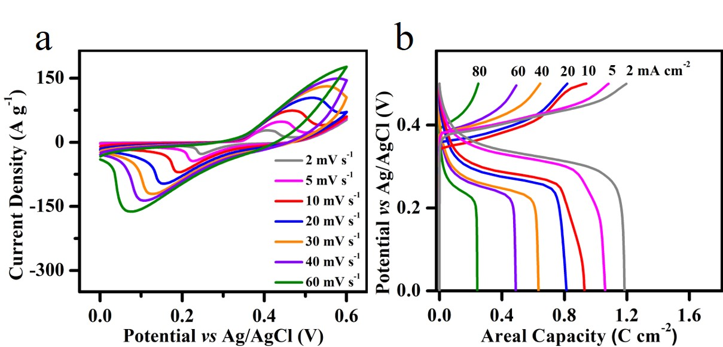
Supplementary Figure 14. (a) CV curves of the Ni,Fe-MOF. (b) Charge–discharge curves from 2 mA cm⁻² to 80 mA cm⁻².

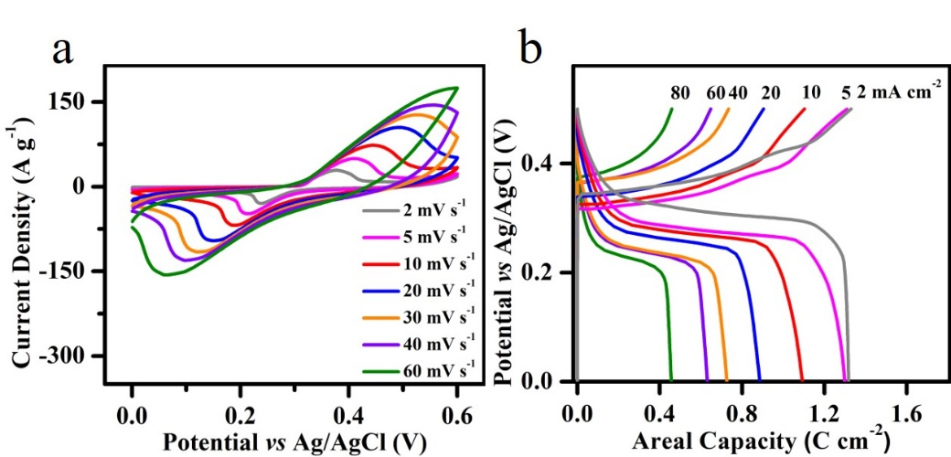
Supplementary Figure 15. (a) CV curves of the Ni,Mn-MOF. (b) Charge–discharge curves from 2 mA cm⁻² to 80 mA cm⁻².

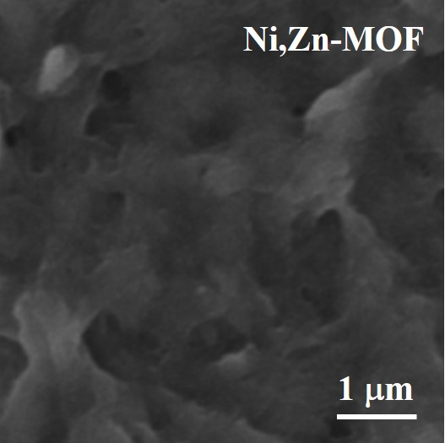
Supplementary Figure 16. The SEM image of the Ni,Zn-MOF electrode after cycling test.
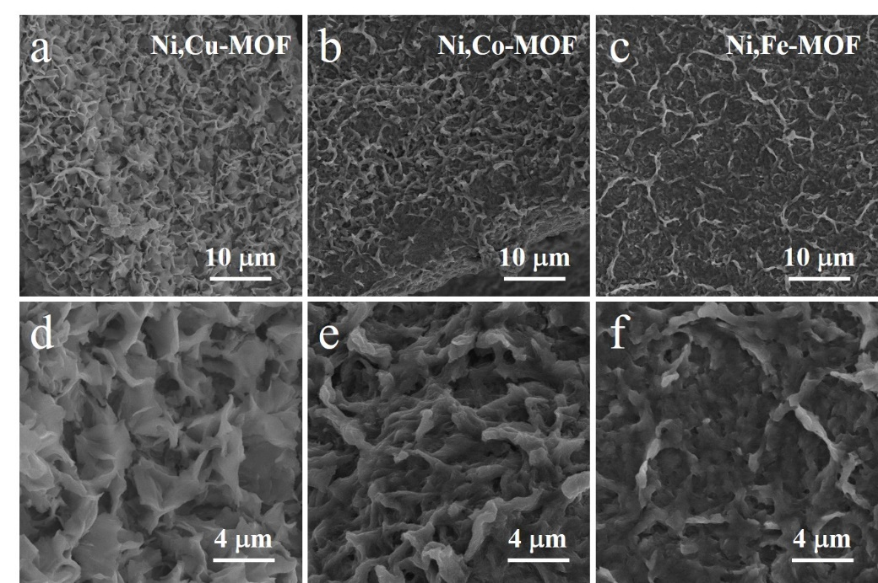
Supplementary Figure 17. The SEM images of the Ni,Cu-MOF, Ni,Co-MOF and Ni,Fe-MOF electrode after cycling test.

