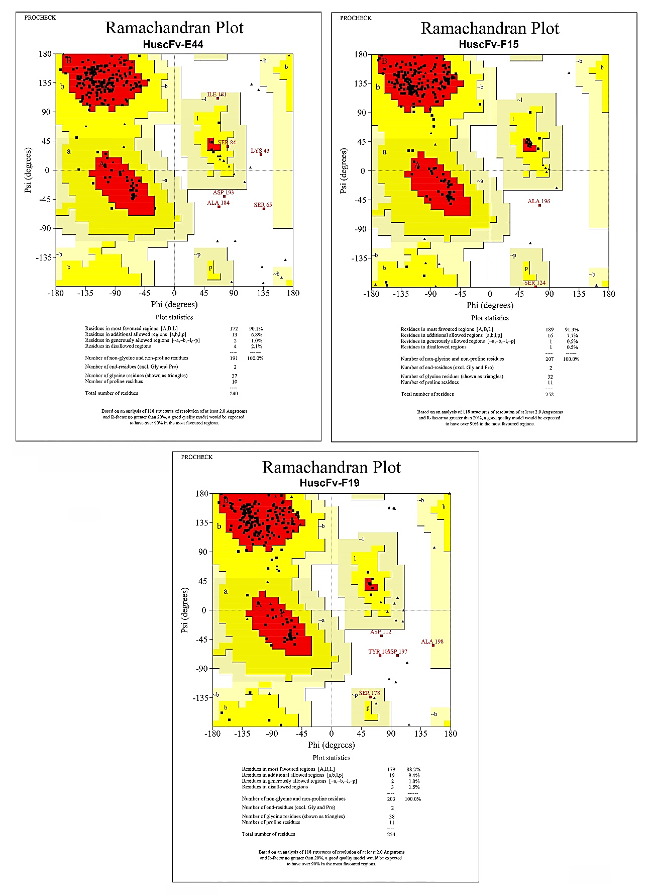
Supplementary Material
SUPPLEMENTARY FIGURE S1 ⏐ Ramachandran plots of the modeled HuscFv-E44, HuscFv-F15 and HuscFv-F19. The most favored regions, additional allowed regions, generously allowed regions and disallowed regions are colored in red, yellow, light yellow and white, respectively.
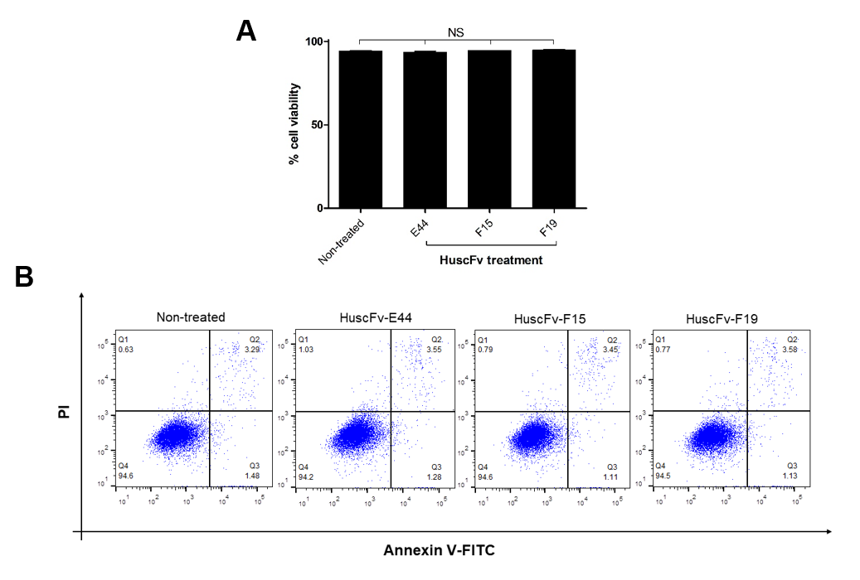
SUPPLEMENTARY FIGURE S2⏐ Biocompatibility of HuscFvs on HeLa cells demonstrated as the percentage of cell viability after treatment with HuscFvs for 24 h. (A) The bar graph represents mean ± SD of the percent viability of HeLa cells (n=3). (B) Density plots of flow cytometric analysis showing Annexin V/PI stained HuscFv-treated HeLa cells compared with non-treated cells (cells in medium alone) (representative experiment). Percent viable cells (Q4), early apoptotic cells (Q3), late apoptotic cells (Q2) and necrotic cells (Q1).
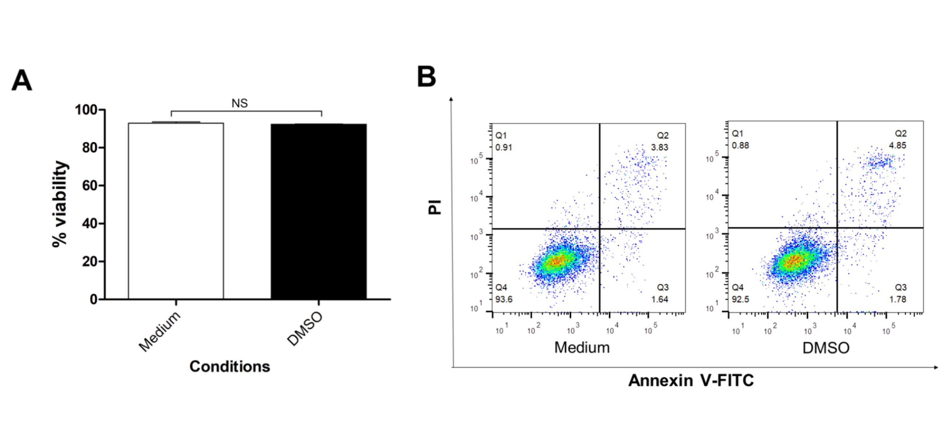SUPPLEMENTARY FIGURE S3⏐ Percent viability of HeLa cells after exposure to medium containing 0.25% DMSO or medium alone. (A) The bar graph represents mean ± SD of the percent HeLa cell viability of both groups. There was no difference (NS) in viability of the cells in medium alone and medium containing the DMSO (p > 0.05). (B) Representative of density plots of flow cytometric analysis showing Annexin V/PI stained HeLa cells of both groups.
SUPPLEMENTARY TABLE S1 ⏐ The percentages of overlapping structures between the RS2-1G9 (2NTF) and the HuscFvs-E44, HuscFv-F15, and HuscFv-F19.
Proteins | Percent overlapped structure | RMSD | Fragment score | Topology score | Number of identical residues
2NTF-HuscFv-E44 | 90.83 | 1.53 | 0.96 | 0.52 | 93
2NTF-HuscFv-F15 | 89.29 | 1.51 | 0.96 | 0.54 | 103
2NTF-HuscFvF19 | 88.58 | 1.37 | 0.96 | 0.52 | 102

