Supporting information

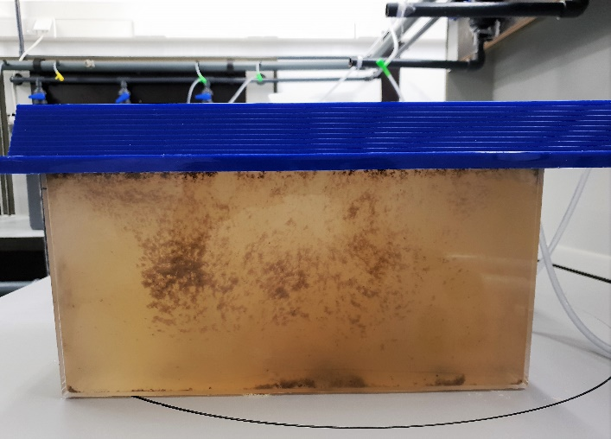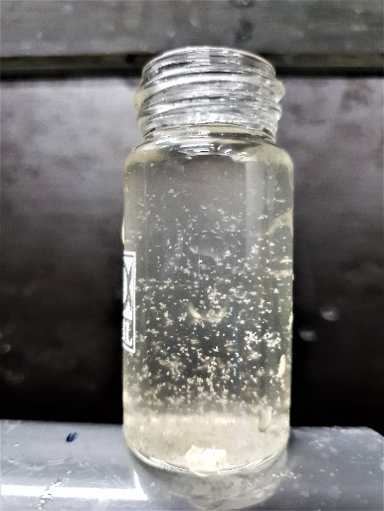
Figure S1 Biofloc enriched suspension in seawater

Table S1 Specific primers and their sequence used for reverse transcriptase real-time PCR

Gene | Function |  | Primer sequence (5’ – 3’) | Product size (bp) | References
Flagella-related motility genes
flaA | Polar flagellin | F | CTGCGGGTCTTCAAATCTC | 205 | Yang and Defoirdt 2015
 |  | R | GTTAGTGGTCTCGTTCATTGC
fliS | Polar flagellin specific chaperone | F | CTCCGCACAAAGTCATTCAA | 224 | Yang and Defoirdt 2015
 |  | R | CAATGTCACCACCATCTTCC
cheR | Chemotaxis protein | F | ATGCGATGACGACTAACGA | 174 | Yang and Defoirdt 2015
 |  | R | ACGCTTGGCAATAAACCTG
Marker gene indicate presence of non-virulent AHPND Vibrio parahaemolyticus phenotype
AlkPhoX | Alkaline phosphatase PhoX | F | GAACAAGATCGTATTGGTG | 254 | Kumar et al., 2020
 |  | R | CCAAACGCACAACCTTC
Virulent AHPND plasmid (responsible for toxin production)
PirB^{VP} | Encodes PirB^{VP} toxin | F | ACTAGGCAAGGCTCATAAATATGACG | 102 | Han et al. 2015
 |  | R | ATTGCTTCAGGTCCATTGGCAATAA
ORF-14 | Copy number of the pVA1 plasmid | F | GGCTCTTTCATAGGTGGTGTCATTC | 103 | Han et al. 2015
 |  | R | CGACTACTATGCCGTTGAGTTGAAG
Reference gene
toxR | Endogenous control | F | AATCCATGGATTCCACGCGTTATTT | 103 | Han et al. 2015
 |  | R | CACCAATCTGACGGAACTGAGATTC
rpoA | RNA polymerase A submit (rpoA) (endogenous control) | F | CGTAGCTGAAGGCAAAGATGA | 197 | Yang and Defoirdt 2015
 |  | R | AAGCTGGAACATAACCACGA

