Table S1. The annotated gene IDs at the PROG1 locus in different species.
Species | Gene ID | Genome version
O. sativa | Os07g0153600 | IRGSP-1.0
O. rufipogon | ORUFI07G03100.1 | PRJEB4137
O. nivara | ONIVA07G01430.1 | AWHD00000000
O. longistaminata | Olong01m10014772.1 | Oryza_longistaminata_v1.0
O. barthii | OBART07G03450.1 | ABRL00000000
O. glaberrima | - | AGI1.1
O. meridionalis | OMERI07G02110.1 | Oryza_meridionalis_v1.3
O. glumaepatula | OGLUM07G02740.1 | ALNU02000000
O. punctata | OPUNC07G03350.1 | AVCL00000000
O. brachyantha | OB07G12600.1 | Oryza_brachyantha.v1.4b
B. distachyon | Bradi1g58540.1 | v1.0

Table S2. Mutations in O. sativa, O. longistaminata, O. glumaepatula and O. punctata compared to O. rufipogon PROG1.
Species | Number of non-synonymous substitution | Number of inframe deletion | Number of inframe insertion
O. sativa | 1 | 0 | 0
O. longistaminata | 13 | 2 | 2
O. glumaepatula | 13 | 1 | 2
O. punctata | 44 | 4 | 2

Table S3. Expression level of PROG1-homologous sequences in 22 transcriptomes of O. sativa, O. longistaminata, O. nivara, O. barthii and O. punctata.
Species | Tissues | ACTIN1 | PROG1
O. sativa | Callus | 203.166 | 0
 | Booting panicles | 289.039 | 0
 | Seeding shoot | 31.1715 | 0
 | Tillering leaf | 2.62667 | 0
 | Flowering panicle | 15.9779 | 0
 | Filling leaf | 5.27607 | 0
 | Filling panicle | 33.4219 | 0
O. longistaminata | Rhizome | 69.2818 | 0
 | Rhizome-tips | 274.981 | 5.192
 | Stem | 205.696 | 0
 | Stem-tips | 165.639 | 0
 | Stamens | 707.297 | 4.621
 | Pistils | 126.281 | 0
 | Hybrid stamens | 670.686 | 0
 | Hybrid pistils | 175.543 | 0
O. nivara | Leaf | 22.582 | 0
 | Panicle | 354.586 | 0
O. bathii | Leaf | 33.823 | 0
 | Panicle | 263.633 | 0.091
O. punctata | panicle | 296.896 | 0
 | root | 15.5774 | 0
Numbers represent the FPKM value.

Table S4. Expression levels of PROG1-homologous sequences in 14 transcriptomes of the outgroup species B. distachyon and O. brachyantha.
Species | Tissues | ACTIN1 | PROG1
B. distachyon | Bd21 20 Day Leaves | 17.6588 | 0
 | Bd21 Early Inflorescence | 546.674 | 0
 | Bd21 Emerging Inflorescence | 492.518 | 0
 | Bd21 Pistil | 315.595 | 0
 | Bd21 Embryo 25 Days After Pollination | 132.553 | 0
 | Bd21 Seed 5 Days After Pollination | 531.068 | 0
 | Bd21 Anther | 3978.08 | 0.354033
 | Bd21 Seed 10 Days After Pollination | 302.519 | 0
 | Bd21 Endosperm 25 Days After Pollination | 68.1136 | 0
 | Bd21 20 Day Leaves | 17.919 | 0
 | Bd21 Embryo 25 Days After Pollination | 275.037 | 0.717164
O. brachyantha | Oryza brachyantha IRGC101232 | 210.22 | 0
 | Oryza brachyantha IRGC101232 | 54.595 | 0
Numbers represent the FPKM value.
Table S5. Information list of Oryza species used in this study.
Oryza species | Accession NO. | Source | Plant architecture
O.rufipogon | Acc.80433 | India | prostrate
O.rufipogon | Acc.80742 | Myanmar | prostrate
O.rufipogon | Acc.81801 | Indonesia | prostrate
O.rufipogon | Acc.81976 | Indonesia | prostrate
O.rufipogon | Acc.81984 | Laos | Semi-prostrate
O.rufipogon | Acc.81986 | Cambodia | Semi-prostrate
O.rufipogon | Acc.81994 | Papua New Guinea | prostrate
O.rufipogon | Acc.82011 | India | prostrate
O.rufipogon | Acc.82040 | Thailand | prostrate
O.rufipogon | Acc.100639 | Taiwan | Semi-prostrate
O.rufipogon | Acc.103308 | Taiwan | Semi-prostrate
O.rufipogon | Acc.105832 | Thailand | Semi-erect
O.rufipogon | Acc.106133 | India | Semi-prostrate
O.rufipogon | Acc.106138 | India | Semi-prostrate
O.rufipogon | Acc.106340 | Myanmar | prostrate
O.rufipogon | Acc.80570 | India | prostrate
O.rufipogon | Acc.102159 | Thailand | Semi-prostrate
O.rufipogon | AYTY9602 | Thailand | Semi-prostrate
O.rufipogon | PCR9607 | Thailand | Semi-erect
O.rufipogon | Acc.105832 | Bgo2,1998 gkanlaus | prostrate
O.rufipogon | Acc.106138 | Bgo2,1999 gkanlaus | Semi-prostrate
O.rufipogon | Acc.106138 | Bgo2,2001 gkanlaus | prostrate
O.nivara | Acc.80581 | India | Semi-prostrate
O.nivara | Acc.80611 | India | prostrate
O.nivara | Acc.80625 | India | prostrate
O.nivara | Acc.80681 | India | Semi-prostrate
O.nivara | Acc.81867 | India | Semi-prostrate
O.nivara | Acc.80696 | India | Semi-prostrate
O.barthii | Acc.100921 |  | Semi-prostrate
O.barthii | Acc.100927 | Sierra Lenone | prostrate
O.barthii | Acc.100933 | Sudan | Semi-prostrate
O.barthii | Acc.100936 | Niger | Semi-prostrate
O.barthii | Acc.101051 | Africa | Semi-prostrate
O.barthii | Acc.101196 | Cameroom | prostrate
O.barthii | Acc.103895 | Senegal | Semi-prostrate
O.barthii | Acc.104061 | Niger | Semi-prostrate
O.barthii | Acc.104102 | Chad | Semi-prostrate
O.barthii | Acc.104132 | Cameroom | Semi-prostrate
O.barthii | Acc.104284 | Mali | Semi-prostrate
O.barthii | Acc.104103 | Chad | Semi-prostrate
O.barthii | Acc.105507 | Mali | prostrate
O.glumaepatula | Acc.100894 | Cuba | Semi-prostrate
O.glumaepatula | Acc.103812 | Brazil | Semi-prostrate
O.glumaepatula | Acc.105661 | Brazil | Semi-prostrate
O.meridionalis | Acc.103322 | Australia | Semi-prostrate
O.meridionalis | Acc.104498 | Australia | Semi-prostrate
O.meridionalis | Acc.105298 | Australia | Semi-prostrate
O.punctata | Acc.100892 |  | Semi-prostrate
——indicate that samples which have no Accession NO.

Table S6. Fu and Li’s test on the PROG1 gene using O. rufipogon population data [17] with 4 species as outgroups.
Outgroup | D test statistics | P value | F test statistics | P value
O. sativa | 1.7408 | P < 0.02 | 2.61434 | P < 0.02
O. longistaminata | 1.71654 | P < 0.02 | 2.5738 | P < 0.02
O. glumaepatula | 1.76324 | P < 0.02 | 2.65162 | P < 0.02
O. punctata | 1.66162 | P < 0.05 | 2.48101 | P < 0.02

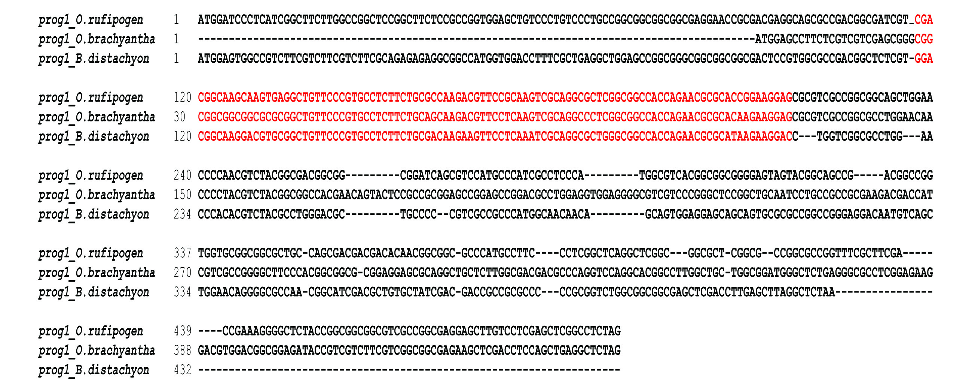
Figure S1. Alignment of the DNA sequence of the PROG1 locus in O. rufipogon, O. brachyantha and B. distachyon. Except for the C2H2 motif, which is marked with red, no obvious homology was identified.
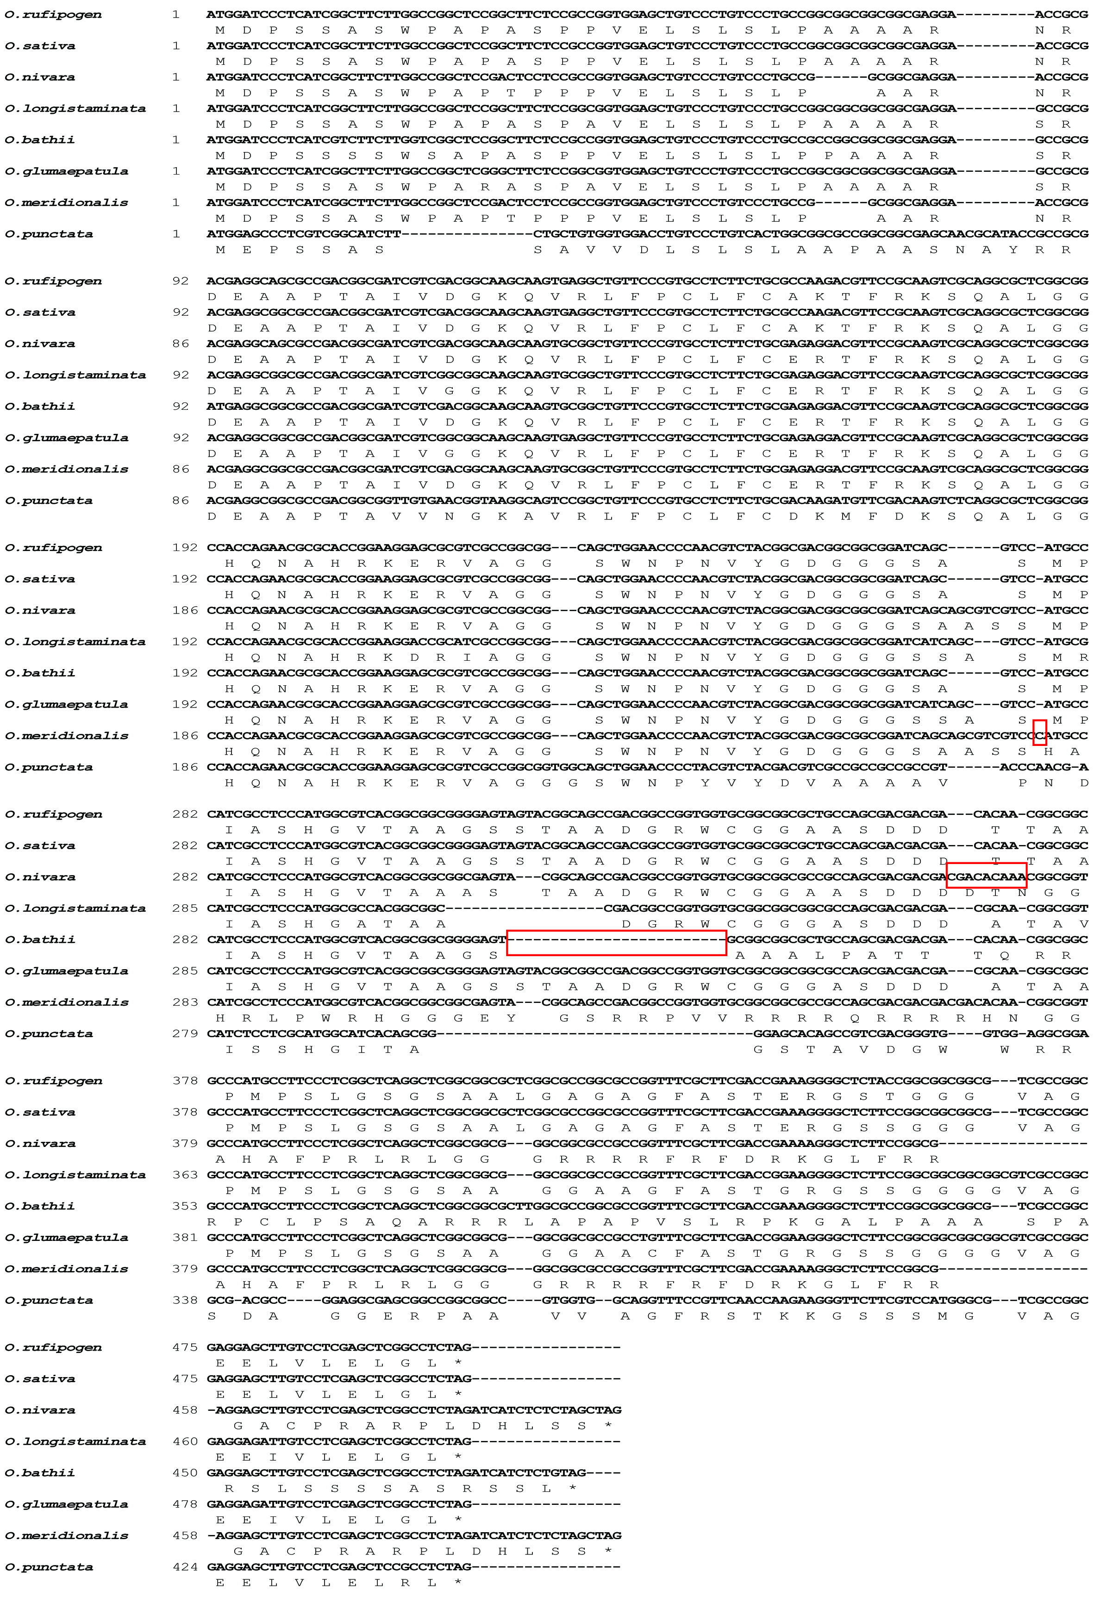
Figure S2. Alignment of DNA sequences and putative peptide sequences of the PROG1 locus in 8 Oryza species. The red blocks represent the frameshift insertions in O. meridionalis and O. nivara and the deletion in O. barthii.

Figure S3. 8 C2H2 genes including PROG1 in the RICE PLANT ARCHITECTURE DOMESTICATION (RPAD) locus stemmed from one proto-PROG1 gene.

