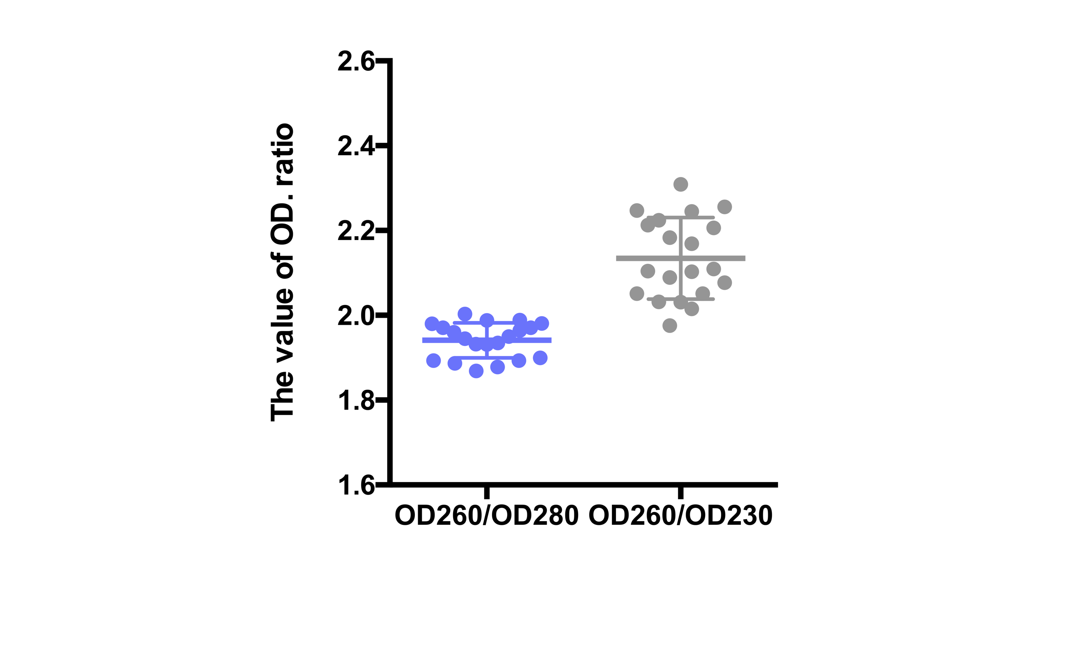
Supplementary materials

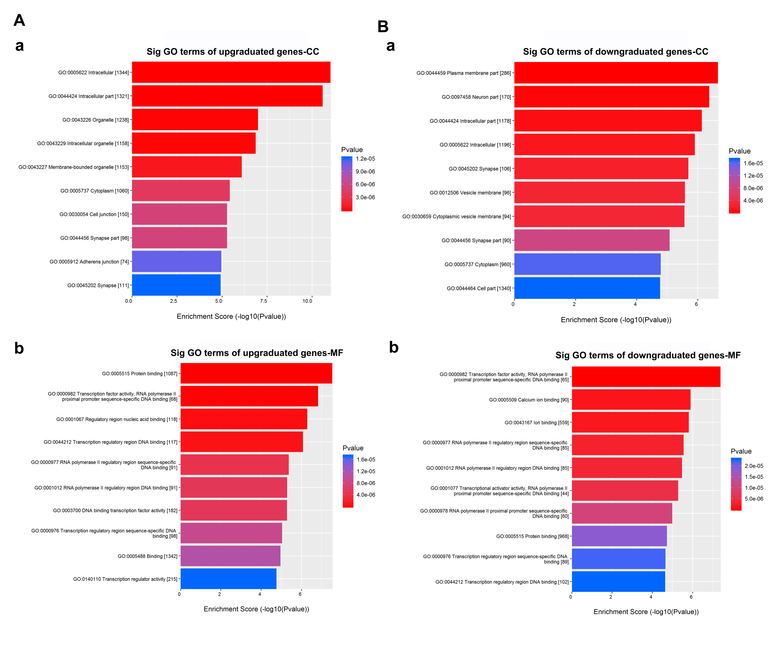
Figure 1. Validation of serum samples’ RNA quality. (A) OD260/OD280 ratios should be between 1.8 and 2.1, OD260/OD230 ratios should be more than 1.8.
Figure 2. Gene ontology (GO) enrichment analysis for top 5 upregulated and downregulated circRNAs. (A) GO enrichment analysis for upregulated circRNAs target genes in terms of cellular components (CC) and molecular functions (MF). (B) GO enrichment analysis for upregulated circRNAs target genes in terms of cellular components (CC) and molecular functions (MF).
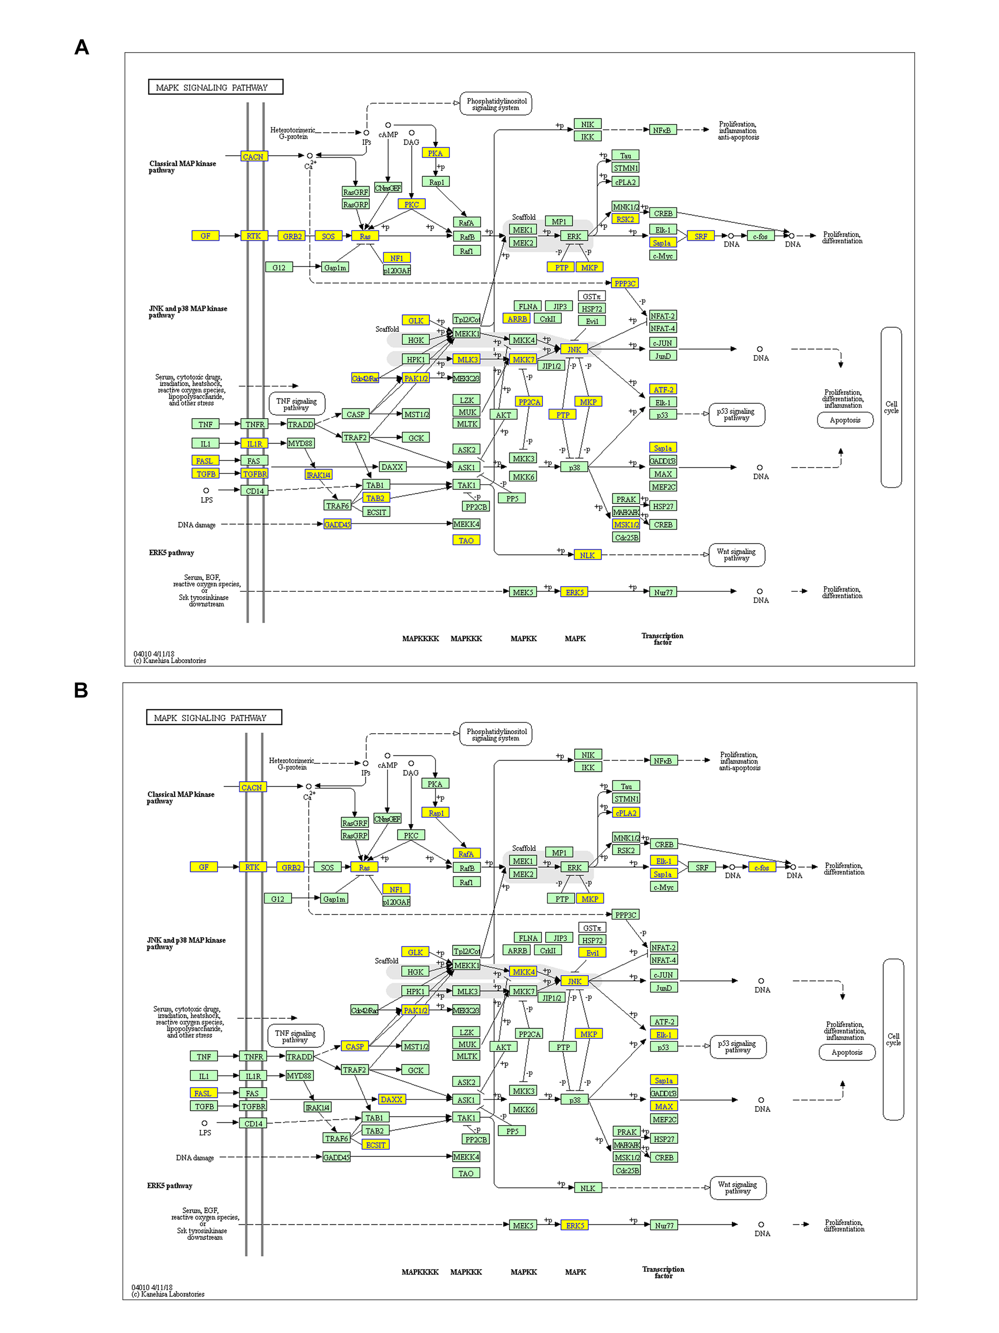
Figure 3. MAPK signaling pathway analysis for predicted circRNAs. (A) MAPK signaling pathway analysis for upregulated expressed circRNAs. (B) MAPK signaling pathway analysis for downregulated expressed circRNAs. The image was obtained from KEGG (http://www.kegg.jp/kegg/kegg1.html).

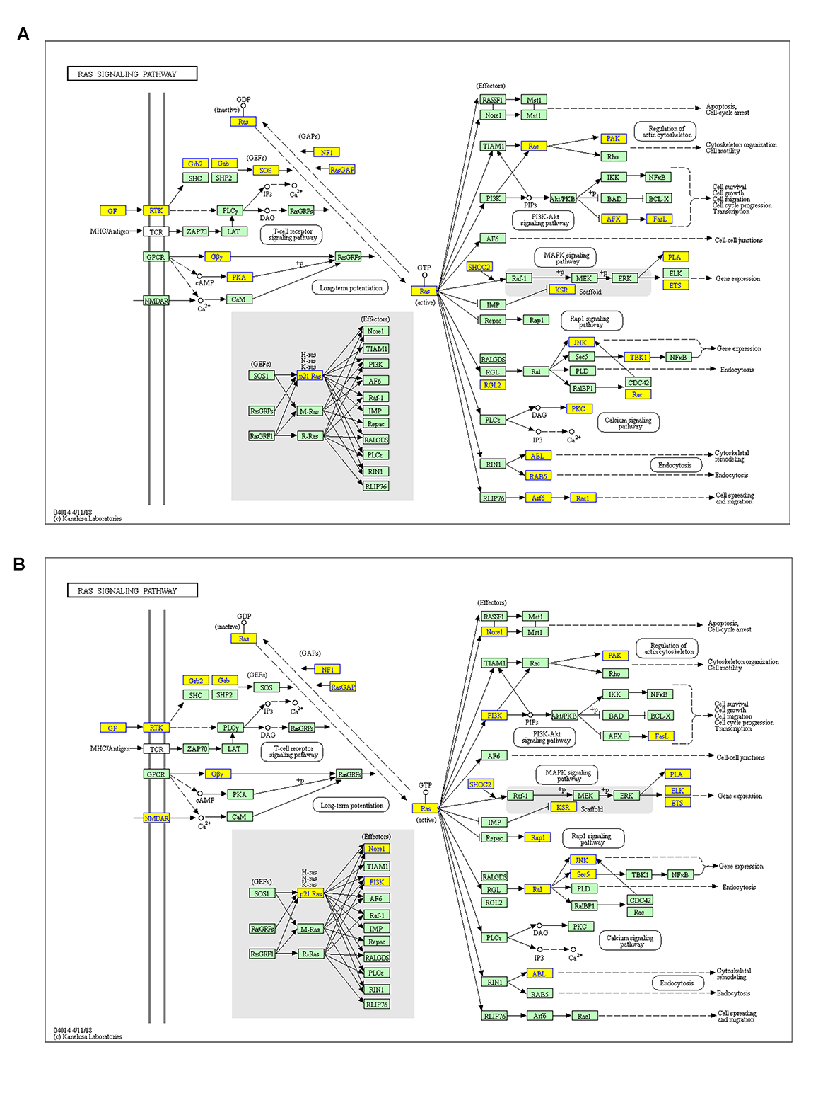
Figure 4. RAS signaling pathway analysis for predicted circRNAs. (A) RAS signaling pathway analysis for upregulated expressed circRNAs. (B) RAS signaling pathway analysis for downregulated expressed circRNAs. The image was obtained from KEGG (http://www.kegg.jp/kegg/kegg1.html).

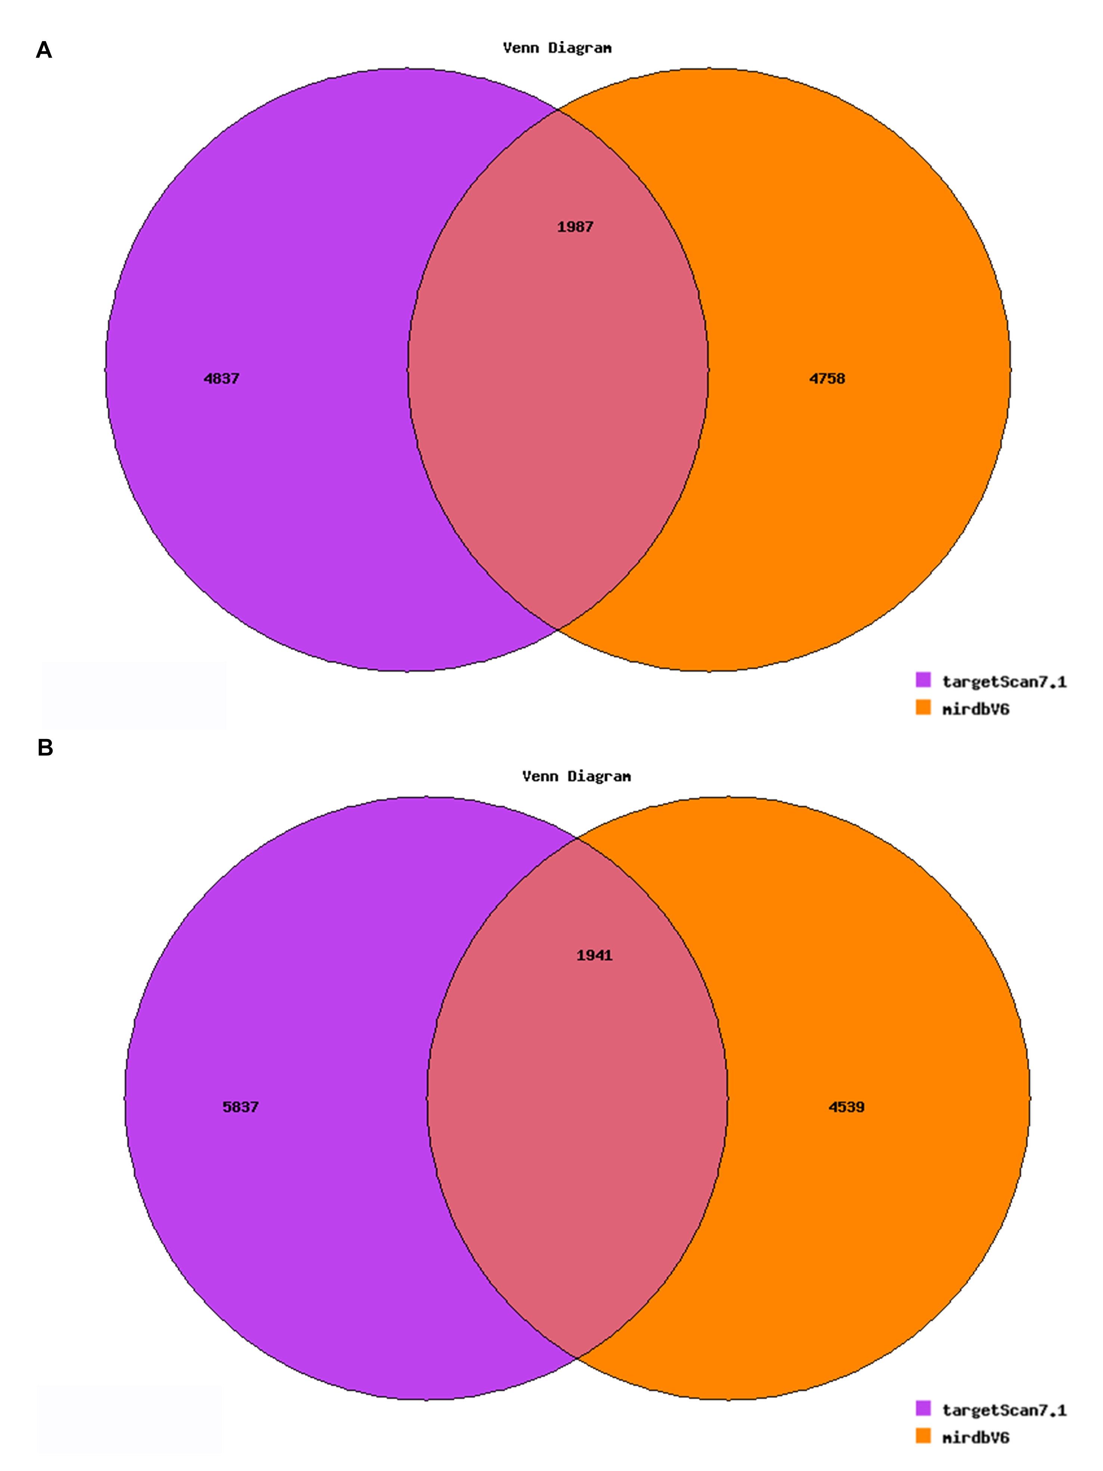

Figure 5. Venn plot for predicting the number of mRNA target genes based on targetscan7.1 and mirdbV5. (A) Top 5 upregulated circRNA target genes. (B) Top 5 downregulated circRNA target genes.

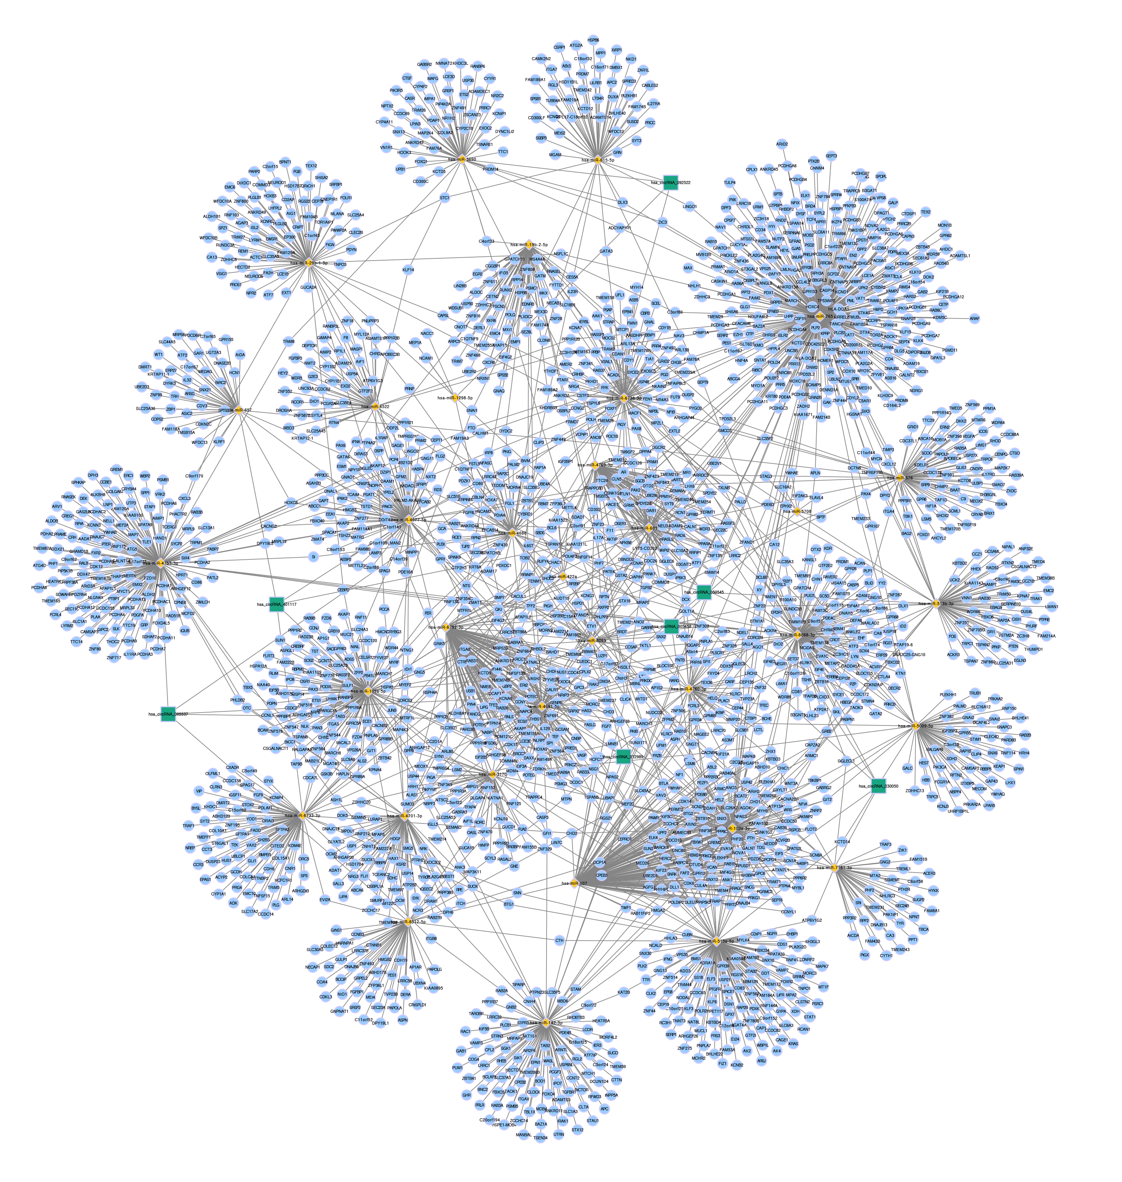
Figure 6. The representative circRNA-miRNA-mRNA network and sequence-pairing predictions for predicted circRNAs and miRNAs.

