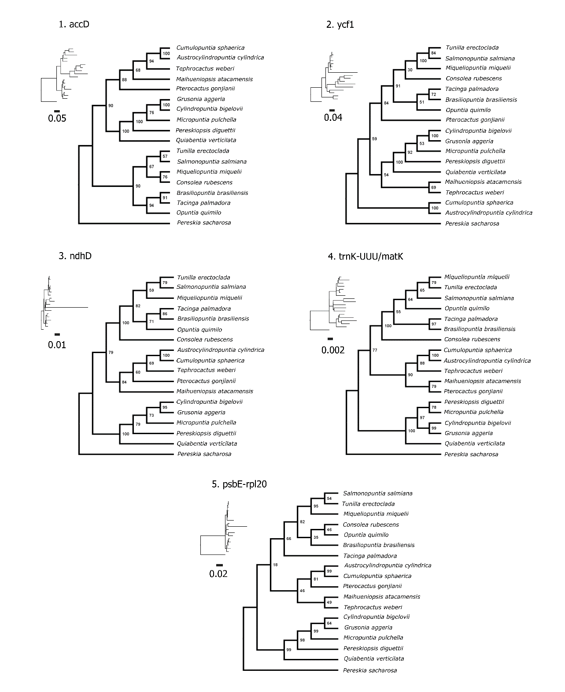
Supplementary Material
Supplementary Figure 1. Maximum likelihood phylogenetic tree from RAxML analyses based on individual top 10 markers, transformed in cladogram with the phylogram represented in small size with substitution rate scaled.

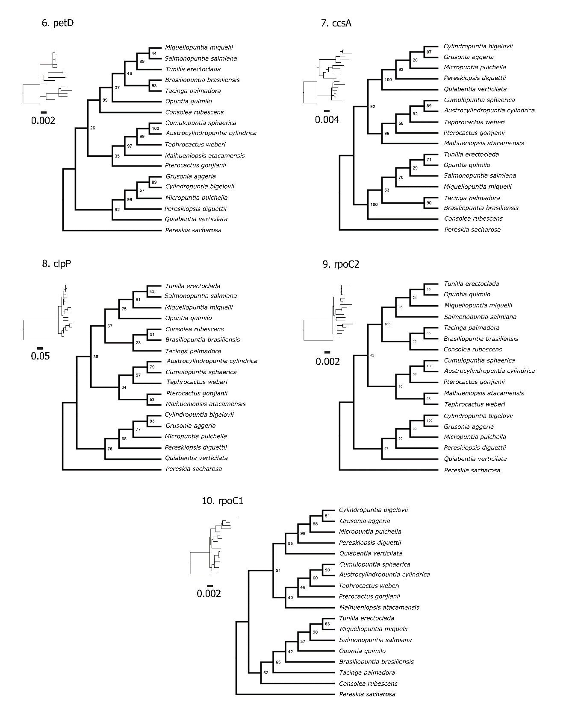
Supplementary Figure 2. Maximum likelihood phylogenetic tree from RAxML analyses based on individual top 10 markers, transformed in cladogram with the phylogram represented in small size with substitution rate scaled.

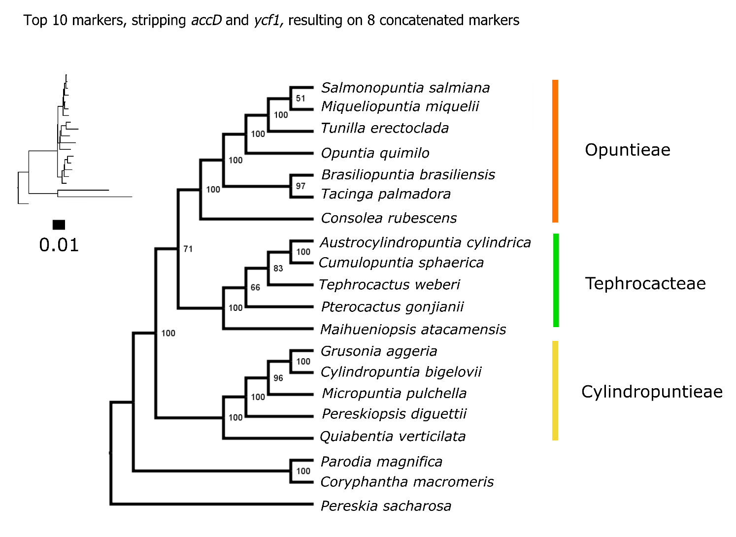
Supplementary Figure 3. Maximum likelihood phylogenetic tree from RAxML analysis based on top 10 markers concatenated, stripping pseudogenes accD and ycf1.

Table S1. Taxa sampled in this study, raw and post–quality control read numbers, GC content and voucher information. Vouchers contain collector name, number and herbarium repository in parentheses or the accession number from the Desert Botanical Garden Living collection (https://dbg.org/research-conservation/living-collections/).
Taxon | Raw Read Nº | Read Nº Post-QC | %GC | Voucher
Austrocylindropuntia cylindrica | 7724354 | 7362548 | 37.4 | Baker19306 (ASU)
Brasiliopuntia brasiliensis | 5624110 | 5360990 | 39.6 | Köhler 412 (ICN)
Consolea rubescens | 6227612 | 6038548 | 37.4 | Majure 3320 (FLAS)
Coryphantha macromeris | 8294236 | 7997166 | 40.6 | Majure 7128 (FLAS)
Cumulopuntia sphaerica | 8245847 | 8106104 | 37.6 | DBG1993-0190
Cylindropuntia bigelovii | 16876574 | 16431880 | 39.2 | Baker 18286 (ASU)
Grusonia aggeria | 16876574 | 16084111 | 39.5 | Majure 5651 (DES)
Maihueniopsis atacamensis | 17489908 | 17322547 | 37.4 | DBG1993-0194
Micropuntia pulchella | 20219350 | 19863298 | 39 | Majure 6095 (DES)
Miqueliopuntia miquelii | 15182404 | 15065674 | 37.6 | DBG1993-0205
Opuntia quimilo | 16137088 | 15814820 | 38.5 | DBG2011-0114
Parodia magnifica | 5792409 | 5786100 | 38.3 | DBG1993-0275
Pereskia sacharosa | 8781612 | 8526372 | 38.4 | DBG2014-2153
Pereskiopsis diguettii | 8789752 | 8650470 | 38 | DBG2018-0128
Pterocactus gonjianii | 9941712 | 9809046 | 38.9 | DBG1997-0260
Quiabentia verticillata | 9223832 | 8893090 | 38.1 | Kimnach 2803 (HNT)
Salmonopuntia salmiana | 6667776 | 6425092 | 38.8 | Köhler 515 (ICN)
Tacinga palmadora | 18511428 | 18182592 | 39.2 | DBG1997-0392
Tephrocactus weberi | 13461630 | 13300339 | 37.8 | DBG2012-0428
Tunilla erectoclada | 6935606 | 6675910 | 37.8 | DBG2018-0144

Table S2. Reference-guide assemblies of Opuntioideae taxa to the Opuntia quimilo plastome, with the number of reads mapped to the Opuntia quimilo plastome, genome coverage, consensus sequence length (bp), GC content (%) and GenBank accession.
Taxon | Chloroplast
 | Reads Mapped | Genome Coverage | Consensus Sequence Length | %GC | GenBank Submission
Austrocylindropuntia cylindrica | 551,356 | 642 | 127,734 | 36.3 | MT369946
Brasiliopuntia brasiliensis | 386,272 | 449 | 128,560 | 36.1 | MT369945
Consolea rubescens | 191,291 | 221 | 128,464 | 36.2 | MT369944
Coryphantha macromeris | 817,912 | 982 | 128,341 | 36.2 | MT369943
Cumulopuntia sphaerica | 333,795 | 393 | 127,844 | 36 | MT369942
Cylindropuntia bigelovii | 1,159,529 | 1355 | 128,307 | 36.3 | MT369941
Grusonia aggeria | 1,307,477 | 1534 | 127,410 | 36.2 | MT369940
Maihueniopsis atacamensis | 661,251 | 775 | 128,476 | 36.2 | MT369939
Micropuntia pulchella | 1,189,650 | 1404 | 127,876 | 36.1 | MT369938
Miqueliopuntia miquelii | 544,818 | 638 | 128,543 | 36.1 | MT369937
Parodia magnifica | 810,368 | 954 | 127,406 | 36.2 | MT369936
Pereskia sacharosa | 919,347 | 1075 | 128,319 | 35.9 | MT369935
Pereskiopsis diguettii | 449,688 | 523 | 126,925 | 36 | MT369934
Pterocactus gonjianii | 481,070 | 552 | 127,885 | 35.8 | MT369933
Quiabentia verticillata | 170,524 | 197 | 128,319 | 36.3 | MT369932
Salmonopuntia salmiana | 392,127 | 453 | 128,810 | 36.1 | MT369931
Tacinga palmadora | 598,318 | 699 | 129,181 | 36.1 | MT369930
Tephrocactus weberi | 548,088 | 632 | 128,302 | 36.1 | MT369929
Tunilla erectoclada | 202,807 | 236 | 128,352 | 36.1 | MT369928

Table S3. Summary statistics for all chloroplast markers. Markers are ranked by phylogenetic information based on a weighed mean of relative values of number of variable sites (weight = 1), mean bootstrap (weight = 2) and distance to the full plastid tree (weight = 3).
 | Bp | Aligned_bp | Variable | PIS | Distance | Bootstrap..Mean. | Rank
accD.cds | 1876 [1489-1927] | 1953 | 966 | 586 | 10 | 88 | 0.808798
ycf1.cds | 1565 [1414-1615] | 1650 | 958 | 429 | 8 | 76 | 0.757296
ndhD.cds | 1421 [1410-1421] | 1421 | 210 | 52 | 6 | 79 | 0.702738
trnK-UUU.NON-CDS | 2570 [2564-2572] | 2573 | 173 | 45 | 8 | 82 | 0.676375
psbE-rpl20.SPACER | 1731 [1714-1736] | 1739 | 242 | 68 | 8 | 77 | 0.663841
petD.cds | 1265 [1257-1272] | 1274 | 69 | 27 | 8 | 75 | 0.645312
ccsA.cds | 1008 [1007-1011] | 1011 | 110 | 49 | 8 | 73 | 0.643744
clpP.cds | 359 [356-362] | 362 | 112 | 64 | 8 | 70 | 0.636547
rpoC2.cds | 4101 [4101-4101] | 4101 | 165 | 47 | 8 | 69 | 0.628225
rpoC1.cds | 2468 [2467-2469] | 2469 | 86 | 35 | 8 | 69 | 0.624994
ycf4-cemA.SPACER | 752 [736-755] | 757 | 72 | 27 | 8 | 67 | 0.615349
rps2.cds | 729 [726-729] | 729 | 77 | 24 | 10 | 71 | 0.593808
rbcL-atpB.SPACER | 765 [746-768] | 768 | 122 | 27 | 12 | 79 | 0.588864
rpoB.cds | 3231 [3231-3231] | 3231 | 149 | 50 | 10 | 67 | 0.585827
psbB-clpP.SPACER | 547 [525-553] | 556 | 100 | 41 | 10 | 67 | 0.583404
petA.cds | 963 [963-963] | 963 | 50 | 18 | 8 | 59 | 0.582963
psbB.cds | 1527 [1527-1527] | 1527 | 39 | 17 | 10 | 68 | 0.580687
ycf2.cds | 6065 [5933-6110] | 6145 | 1995 | 619 | 24 | 89 | 0.571429
ycf3-trnS.SPACER | 804 [790-805] | 805 | 67 | 22 | 14 | 82 | 0.56304
rps3.cds | 657 [657-657] | 657 | 47 | 16 | 10 | 63 | 0.561692
petN-psbM.SPACER | 1135 [1130-1136] | 1137 | 79 | 23 | 12 | 71 | 0.557825
matK.cds | 1530 [1524-1530] | 1530 | 104 | 27 | 12 | 68 | 0.547666
ycf3.cds | 2306 [2288-2324] | 2328 | 119 | 29 | 14 | 77 | 0.546198
ndhC-rbcL.SPACER | 716 [705-717] | 718 | 103 | 13 | 8 | 49 | 0.544164
rpoA.cds | 1015 [1008-1020] | 1020 | 103 | 56 | 12 | 64 | 0.540493
trnT-psbD.SPACER | 1022 [1008-1024] | 1025 | 57 | 16 | 10 | 57 | 0.53922
ndhE-psaC.SPACER | 318 [315-328] | 328 | 70 | 26 | 14 | 75 | 0.537899
ccsA-trnL.SPACER | 85 [85-85] | 85 | 20 | 7 | 10 | 57 | 0.536796
trnV-UAC.NON-CDS | 394 [325-400] | 402 | 193 | 102 | 14 | 68 | 0.532145
rpl32-ndhF.SPACER | 813 [775-826] | 832 | 354 | 154 | 14 | 63 | 0.52742
rrn23.NON-CDS | 2838 [2834-2844] | 2844 | 89 | 29 | 12 | 62 | 0.525732
psaB.cds | 2217 [2217-2217] | 2217 | 58 | 19 | 12 | 61 | 0.519294
rps16.cds | 676 [672-683] | 683 | 53 | 18 | 12 | 61 | 0.519025
trnF-ndhJ.SPACER | 561 [510-567] | 583 | 247 | 124 | 16 | 72 | 0.517336
accD-psaI.SPACER | 599 [591-601] | 601 | 83 | 37 | 12 | 57 | 0.50916
rpoB-trnC.SPACER | 1102 [1091-1108] | 1109 | 130 | 51 | 14 | 65 | 0.507178
trnQ-rps16.SPACER | 650 [623-655] | 656 | 118 | 38 | 14 | 62 | 0.492441
atpA.cds | 1524 [1524-1524] | 1524 | 61 | 19 | 10 | 44 | 0.491338
petA-psbJ.SPACER | 1066 [1045-1072] | 1074 | 146 | 63 | 14 | 58 | 0.484191
atpF-atpH.SPACER | 423 [412-425] | 425 | 41 | 15 | 12 | 51 | 0.480764
trnD-trnY.SPACER | 363 [349-364] | 364 | 34 | 11 | 12 | 50 | 0.475942
rpl22.cds | 543 [543-543] | 543 | 54 | 20 | 12 | 48 | 0.470875
ndhH.cds | 1175 [1154-1175] | 1175 | 176 | 22 | 12 | 45 | 0.460177
ycf1-rpl32.SPACER | 131 [111-137] | 146 | 124 | 78 | 14 | 50 | 0.458268
rps4.cds | 606 [606-606] | 606 | 57 | 21 | 14 | 54 | 0.457901
trnS-psbZ.SPACER | 365 [365-365] | 365 | 22 | 10 | 12 | 44 | 0.453201
trnL-UAA.NON-CDS | 973 [952-986] | 990 | 233 | 123 | 16 | 54 | 0.449651
petL-trnS.SPACER | 553 [497-556] | 563 | 197 | 56 | 16 | 58 | 0.446592
rps15-ycf1.SPACER | 773 [766-774] | 775 | 296 | 129 | 18 | 61 | 0.441769
atpB.cds | 1497 [1497-1497] | 1497 | 65 | 18 | 16 | 57 | 0.432615
trnV-rps12.SPACER | 1352 [1339-1353] | 1353 | 173 | 16 | 12 | 38 | 0.432344
petB.cds | 1370 [1368-1372] | 1372 | 44 | 12 | 14 | 47 | 0.429261
cemA.cds | 690 [690-690] | 690 | 36 | 11 | 14 | 46 | 0.425246
rpl33-psaJ.SPACER | 461 [450-462] | 462 | 43 | 12 | 16 | 55 | 0.423509
rpl16.cds | 1465 [1450-1477] | 1480 | 107 | 31 | 18 | 62 | 0.419128
infA.cds | 261 [259-264] | 264 | 57 | 27 | 16 | 52 | 0.416312
atpF.cds | 1304 [1300-1310] | 1311 | 63 | 14 | 16 | 52 | 0.412812
ndhF.cds | 1718 [1697-1718] | 1718 | 346 | 17 | 14 | 42 | 0.411881
rps16-trnK.SPACER | 461 [456-464] | 464 | 36 | 6 | 14 | 41 | 0.405174
petL.cds | 114 [113-114] | 114 | 20 | 9 | 16 | 47 | 0.392739
rpl20-rps18.SPACER | 314 [290-320] | 321 | 94 | 15 | 16 | 46 | 0.390609
psbD.cds | 1080 [1080-1080] | 1080 | 15 | 7 | 16 | 46 | 0.388455
rpl2.cds | 828 [828-828] | 828 | 43 | 16 | 16 | 45 | 0.387133
psbK-trnQ.SPACER | 338 [336-340] | 340 | 24 | 7 | 14 | 36 | 0.386716
atpH-atpI.SPACER | 695 [694-695] | 695 | 25 | 8 | 14 | 34 | 0.379495
psbA.cds | 1062 [1062-1062] | 1062 | 37 | 11 | 18 | 52 | 0.37629
ndhC.cds | 341 [340-341] | 341 | 67 | 9 | 14 | 33 | 0.376019
trnC-petN.SPACER | 560 [555-561] | 561 | 24 | 6 | 16 | 42 | 0.373205
ndhE.cds | 324 [308-324] | 324 | 109 | 12 | 20 | 60 | 0.370807
trnP-trnW.SPACER | 177 [176-177] | 177 | 18 | 8 | 16 | 41 | 0.369998
rps11.cds | 417 [417-417] | 417 | 35 | 15 | 16 | 40 | 0.368137
trnI-GAU.NON-CDS | 1022 [1021-1022] | 1022 | 23 | 7 | 18 | 50 | 0.367722
trnE-trnT.SPACER | 699 [683-710] | 729 | 147 | 74 | 22 | 64 | 0.366768
psaJ-trnP.SPACER | 413 [400-416] | 416 | 100 | 11 | 18 | 48 | 0.361308
clpP-trnG.SPACER | 201 [200-204] | 206 | 63 | 38 | 18 | 46 | 0.361088
psaI-ycf4.SPACER | 304 [303-304] | 304 | 28 | 9 | 18 | 47 | 0.357025
trnK-psbA.SPACER | 228 [228-228] | 228 | 27 | 8 | 16 | 37 | 0.355017
psbM-trnD.SPACER | 871 [866-877] | 877 | 43 | 13 | 18 | 45 | 0.350611
trnG-UCC.NON-CDS | 756 [752-762] | 762 | 48 | 16 | 20 | 52 | 0.341922
psbI-psbK.SPACER | 349 [346-351] | 351 | 54 | 19 | 20 | 51 | 0.338984
rps2-rpoC2.SPACER | 237 [234-237] | 237 | 8 | 4 | 16 | 33 | 0.338958
rbcL.cds | 1509 [1509-1509] | 1509 | 55 | 15 | 20 | 50 | 0.334162
atpI.cds | 744 [744-744] | 744 | 21 | 6 | 16 | 31 | 0.332006
psbE.cds | 309 [309-309] | 309 | 15 | 5 | 16 | 31 | 0.331737
rrn16-trnV.SPACER | 226 [225-226] | 226 | 34 | 17 | 18 | 39 | 0.329216
psaA.cds | 2301 [2301-2301] | 2301 | 55 | 15 | 18 | 39 | 0.328678
trnF-GAA.NON-CDS | 240 [240-240] | 240 | 23 | 9 | 18 | 39 | 0.327062
rps18.cds | 423 [399-425] | 425 | 82 | 33 | 22 | 56 | 0.325766
cemA-petA.SPACER | 265 [265-265] | 265 | 20 | 6 | 18 | 38 | 0.322509
rpl14.cds | 366 [366-366] | 366 | 41 | 10 | 18 | 37 | 0.319841
rpl32.cds | 199 [199-200] | 200 | 61 | 23 | 18 | 36 | 0.319596
ndhD-ccsA.SPACER | 217 [212-222] | 222 | 51 | 17 | 22 | 55 | 0.317713
atpE-trnM.SPACER | 289 [282-291] | 291 | 39 | 24 | 18 | 35 | 0.31612
ndhK.cds | 192 [192-192] | 192 | 22 | 5 | 18 | 36 | 0.314749
atpE.cds | 402 [402-402] | 402 | 17 | 6 | 18 | 35 | 0.311273
trnL-ndhG.SPACER | 230 [214-240] | 240 | 113 | 57 | 22 | 50 | 0.309756
psaA-ycf3.SPACER | 471 [451-478] | 482 | 65 | 25 | 20 | 42 | 0.306892
rpl4-rps8.SPACER | 164 [159-170] | 170 | 18 | 9 | 18 | 33 | 0.30459
psbZ-trnG.SPACER | 365 [359-370] | 370 | 28 | 7 | 22 | 51 | 0.300039
trnG-trnfM.SPACER | 231 [224-232] | 232 | 20 | 5 | 20 | 41 | 0.297761
atpA-atpF.SPACER | 69 [67-69] | 69 | 11 | 7 | 18 | 31 | 0.296561
psbC-trnS.SPACER | 254 [251-257] | 257 | 15 | 10 | 20 | 39 | 0.291617
rpl33.cds | 204 [204-204] | 204 | 12 | 3 | 18 | 28 | 0.284248
ndhA.cds | 1624 [1607-1629] | 1631 | 192 | 51 | 24 | 52 | 0.279917
ndhJ-ndhK.SPACER | 139 [120-143] | 143 | 21 | 5 | 20 | 36 | 0.279035
rpl20.cds | 512 [503-512] | 512 | 36 | 11 | 18 | 26 | 0.278911
rps14.cds | 303 [303-303] | 303 | 16 | 9 | 24 | 54 | 0.276099
rrn16.NON-CDS | 1491 [1490-1491] | 1491 | 45 | 13 | 20 | 33 | 0.269953
petB-psbH.SPACER | 228 [227-228] | 228 | 18 | 5 | 18 | 24 | 0.269805
trnS-psbI.SPACER | 181 [180-189] | 189 | 29 | 9 | 22 | 42 | 0.266869
psbC.cds | 1422 [1422-1422] | 1422 | 36 | 7 | 20 | 32 | 0.264592
rpl2-rps19.SPACER | 181 [180-182] | 182 | 25 | 6 | 20 | 32 | 0.264323
rpl36-rps11.SPACER | 128 [127-130] | 130 | 8 | 2 | 18 | 22 | 0.261507
trnA-UGC.NON-CDS | 887 [878-887] | 887 | 18 | 7 | 24 | 49 | 0.256834
psbA-trnH.SPACER | 332 [322-338] | 343 | 98 | 44 | 24 | 45 | 0.251815
trnL-trnF.SPACER | 239 [239-239] | 239 | 18 | 6 | 22 | 38 | 0.25108
rps18-rpl33.SPACER | 330 [304-340] | 347 | 157 | 81 | 24 | 42 | 0.250541
trnV-accD.SPACER | 148 [134-150] | 150 | 97 | 28 | 22 | 34 | 0.242023
trnS-rps4.SPACER | 355 [345-355] | 355 | 25 | 6 | 22 | 34 | 0.236099
ycf4.cds | 549 [549-549] | 549 | 19 | 5 | 22 | 33 | 0.232085
ndhB.cds | 2165 [2141-2165] | 2165 | 252 | 72 | 24 | 37 | 0.229391
ycf2-trnI.SPACER | 144 [129-146] | 147 | 58 | 17 | 22 | 31 | 0.227825
psbT-psbB.SPACER | 165 [164-165] | 165 | 11 | 5 | 20 | 22 | 0.2266
psaC-ndhD.SPACER | 94 [77-95] | 95 | 11 | 5 | 20 | 21 | 0.222855
rps8.cds | 405 [405-405] | 405 | 23 | 6 | 22 | 30 | 0.221118
atpH.cds | 265 [263-266] | 266 | 9 | 3 | 22 | 29 | 0.216565
psbK.cds | 189 [189-189] | 189 | 12 | 4 | 22 | 28 | 0.213089
psaC.cds | 246 [246-246] | 246 | 15 | 5 | 24 | 35 | 0.203861
ndhJ.cds | 334 [327-334] | 334 | 65 | 6 | 22 | 25 | 0.202391
trnI-rrn16.SPACER | 293 [287-293] | 293 | 36 | 28 | 22 | 22 | 0.197079
ndhF-trnN.SPACER | 355 [339-360] | 360 | 64 | 7 | 24 | 33 | 0.196909
rps15.cds | 380 [373-381] | 381 | 24 | 3 | 24 | 32 | 0.192087
petG.cds | 200 [198-201] | 201 | 10 | 2 | 22 | 22 | 0.190078
rps7.cds | 504 [503-504] | 504 | 38 | 9 | 24 | 31 | 0.189957
trnT-trnL.SPACER | 648 [636-650] | 652 | 138 | 20 | 24 | 29 | 0.185428
trnN-trnR.SPACER | 598 [598-599] | 599 | 37 | 7 | 26 | 39 | 0.183666
ndhD-ndhI.SPACER | 239 [230-239] | 239 | 95 | 15 | 24 | 26 | 0.172846
petG-petL.SPACER | 83 [83-83] | 83 | 19 | 4 | 24 | 25 | 0.166139
rps4-trnT.SPACER | 403 [397-407] | 407 | 24 | 6 | 24 | 24 | 0.162932
trnT-GGU.NON-CDS | 72 [72-74] | 74 | 5 | 2 | 22 | 14 | 0.160116
psbZ.cds | 189 [189-189] | 189 | 4 | 2 | 24 | 23 | 0.158109
trnS-GGA.NON-CDS | 87 [87-87] | 87 | 9 | 3 | 24 | 22 | 0.154633
psbF.cds | 120 [120-120] | 120 | 4 | 1 | 22 | 12 | 0.152356
trnM-trnV.SPACER | 63 [56-63] | 63 | 13 | 1 | 22 | 12 | 0.152356
psaJ.cds | 129 [128-129] | 129 | 7 | 2 | 24 | 20 | 0.146873
rrn5-rrn4.5.SPACER | 257 [248-257] | 257 | 14 | 2 | 24 | 20 | 0.146873
rps19.cds | 150 [150-150] | 150 | 16 | 6 | 26 | 29 | 0.145944
trnfM-rps14.SPACER | 152 [152-152] | 152 | 18 | 5 | 26 | 29 | 0.145675
rpl16-rpl4.SPACER | 144 [144-148] | 148 | 7 | 4 | 26 | 29 | 0.145406
rpoA-petD.SPACER | 147 [147-147] | 147 | 28 | 19 | 24 | 18 | 0.14396
petD-petB.SPACER | 212 [210-214] | 214 | 8 | 2 | 24 | 19 | 0.143128
rps14-psaB.SPACER | 125 [125-125] | 125 | 12 | 7 | 24 | 18 | 0.140729
rps8-infA.SPACER | 100 [92-100] | 100 | 34 | 14 | 26 | 27 | 0.140607
rpoC2-rpoC1.SPACER | 144 [144-144] | 144 | 9 | 4 | 24 | 18 | 0.139921
psaI.cds | 111 [111-111] | 111 | 5 | 3 | 24 | 18 | 0.139652
psbJ.cds | 123 [123-123] | 123 | 3 | 2 | 24 | 17 | 0.135637
trnW-petG.SPACER | 139 [139-139] | 139 | 11 | 2 | 24 | 16 | 0.131892
psbL.cds | 126 [118-127] | 127 | 10 | 1 | 24 | 16 | 0.131623
ndhK-ndhC.SPACER | 53 [48-53] | 53 | 9 | 1 | 26 | 24 | 0.125871
trnR-ACG.NON-CDS | 74 [73-74] | 74 | 3 | 1 | 24 | 12 | 0.116642
atpI-rps2.SPACER | 189 [189-189] | 189 | 8 | 2 | 24 | 11 | 0.113166
petN.cds | 153 [153-153] | 153 | 4 | 2 | 24 | 11 | 0.113166
trnN-GUU.NON-CDS | 72 [72-72] | 72 | 2 | 1 | 24 | 11 | 0.112896
trnG-trnR.SPACER | 140 [140-140] | 140 | 13 | 3 | 26 | 20 | 0.111428
rps3-rpl16.SPACER | 229 [226-231] | 231 | 14 | 1 | 24 | 10 | 0.109151
rps12.cds | 954 [954-955] | 955 | 27 | 6 | 26 | 19 | 0.108491
psbN.cds | 132 [132-132] | 132 | 5 | 2 | 24 | 9 | 0.105675
rrn5.NON-CDS | 121 [120-121] | 121 | 4 | 1 | 24 | 9 | 0.105406
rpl23-rpl2.SPACER | 144 [140-144] | 144 | 13 | 2 | 24 | 8 | 0.10193
ndhI-ndhA.SPACER | 31 [30-37] | 37 | 7 | 1 | 24 | 8 | 0.10166
psbH.cds | 242 [242-242] | 242 | 11 | 1 | 24 | 8 | 0.10166
ndhB-trnL.SPACER | 528 [512-530] | 530 | 120 | 20 | 28 | 23 | 0.091527
ndhG.cds | 380 [380-380] | 380 | 48 | 6 | 26 | 13 | 0.086019
psbN-psbT.SPACER | 60 [60-60] | 60 | 3 | 1 | 26 | 13 | 0.084673
rpoC1-rpoB.SPACER | 26 [26-26] | 26 | 9 | 3 | 28 | 22 | 0.083205
trnR-atpA.SPACER | 101 [100-101] | 101 | 29 | 1 | 26 | 11 | 0.077182
ndhA-ndhH.SPACER | 81 [81-81] | 81 | 4 | 4 | 26 | 9 | 0.070499
rpl23.cds | 191 [189-191] | 191 | 18 | 2 | 26 | 9 | 0.069961
psbH-psbN.SPACER | 86 [86-86] | 86 | 10 | 1 | 26 | 9 | 0.069691
ndhH-rps15.SPACER | 102 [90-102] | 102 | 12 | 1 | 26 | 8 | 0.065946
psbI.cds | 111 [111-111] | 111 | 3 | 1 | 26 | 8 | 0.065946
trnR-rrn5.SPACER | 256 [255-257] | 257 | 16 | 1 | 28 | 15 | 0.056449
trnL-ycf2.SPACER | 142 [136-142] | 142 | 42 | 7 | 28 | 14 | 0.054319
rpl36.cds | 123 [123-123] | 123 | 10 | 1 | 28 | 12 | 0.045213
trnC-GCA.NON-CDS | 71 [71-71] | 71 | 4 | 1 | 28 | 12 | 0.045213
trnI-rpl23.SPACER | 106 [105-106] | 106 | 11 | 2 | 26 | 2 | 0.043743
trnY-GUA.NON-CDS | 123 [123-123] | 123 | 6 | 1 | 26 | 2 | 0.043474
psbJ-psbL.SPACER | 103 [103-103] | 103 | 5 | 0 | 26 | 1 | 0.03946
rrn23-trnA.SPACER | 149 [146-149] | 149 | 5 | 0 | 26 | 1 | 0.03946
rps11-rpoA.SPACER | 71 [71-71] | 71 | 9 | 2 | 28 | 10 | 0.037992
trnT-UGU.NON-CDS | 73 [73-73] | 73 | 4 | 1 | 26 | 0 | 0.035984
psbT.cds | 108 [108-108] | 108 | 4 | 1 | 28 | 9 | 0.033977
ndhI.cds | 271 [271-271] | 271 | 24 | 1 | 28 | 8 | 0.030232
rps7-ndhB.SPACER | 228 [224-228] | 228 | 38 | 0 | 28 | 2 | 0.007491
rrn4.5-rrn23.SPACER | 99 [98-99] | 99 | 5 | 0 | 28 | 1 | 0.003745
trnL-UAG.NON-CDS | 80 [80-80] | 80 | 1 | 0 | 28 | 1 | 0.003745
trnM-CAU.NON-CDS | 150 [150-150] | 150 | 7 | 0 | 28 | 1 | 0.003745
trnV-GAC.NON-CDS | 72 [72-72] | 72 | 2 | 0 | 28 | 1 | 0.003745
trnY-trnE.SPACER | 52 [52-52] | 52 | 2 | 0 | 28 | 1 | 0.003745
psbM.cds | 105 [105-105] | 105 | 1 | 0 | 28 | 0 | 0
rrn4.5.NON-CDS | 103 [99-103] | 103 | 4 | 0 | 28 | 0 | 0

Table S4. Summary statistics for the top 10 markers with suitable size for PCR amplification. Markers are ranked by phylogenetic information based on a weighed mean of relative values of number of variable sites (weight = 1), mean bootstrap (weight = 2) and distance to the full plastid tree (weight = 3).
 | Bp | Aligned_bp | Variable | PIS | Distance | Bootstrap..Mean.
clpP.cds | 359 [356-362] | 362 | 112 | 64 | 8 | 70
ycf4-cemA.SPACER | 752 [736-755] | 757 | 72 | 27 | 8 | 67
rps2.cds | 729 [726-729] | 729 | 77 | 24 | 10 | 71
rbcL-atpB.SPACER | 765 [746-768] | 768 | 122 | 27 | 12 | 79
psbB-clpP.SPACER | 547 [525-553] | 556 | 100 | 41 | 10 | 67
petA.cds | 963 [963-963] | 963 | 50 | 18 | 8 | 59
ycf3-trnS.SPACER | 804 [790-805] | 805 | 67 | 22 | 14 | 82
rps3.cds | 657 [657-657] | 657 | 47 | 16 | 10 | 63
ndhC-rbcL.SPACER | 716 [705-717] | 718 | 103 | 13 | 8 | 49
ndhE-psaC.SPACER | 318 [315-328] | 328 | 70 | 26 | 14 | 75

