Supplementary Material

Quantification and Characterization of Nanoparticulate Zinc in an Urban Watershed
Shaun Bevers¹, Manuel David Montaño^{2, *}, Laya Rybicki¹, Thilo Hofmann³, Frank von der Kammer³, James F. Ranville¹
¹Deparment of Chemistry, Colorado School of Mines, Golden, CO, USA
²Department of Environmental Sciences, Western Washington University, Bellingham, WA, USA
³Centre for Microbiology and Environmental Systems, University of Vienna, Vienna, Austria

Table S1 Typical running instrument conditions for ICP-MS
Table S2 Total metal data from ICP-OES and anion data from IC (concentrations in mg/L)
Table S3 Concentrations of Zn (µg/L) per Fraction for sp-ICP-Q-MS settling experiments.
Table S4 Concentrations of Zn (µg/L) per Fraction for sp-ICP-QMS filtration experiments.
Figure S1 Hydrographs for selected sampling locations A) West Clear Creek, B) West Sand Creek, C) South South Platte, D) Cherry Creek at Denver, CO, E) North South Platte, F) Cherry Creek below Cherry Creek Lake

Figure S2 Turbidity plotted against various metal concentrations.
Figure S3 Size Histograms for sp-ICP-QMS measurements of raw samples.

Table S1 Typical running instrument conditions for ICP-MS
ICP-QMS (NexION 300D ICP-MS)
Instrument Parameter | Value
Nebulizer Gas Flow | 0.86 – 0.98 ml/min
Sample Flow Rate | 0.3 ml/min
Spray Chamber | Quartz cyclonic
ICP RF Power | 1600 W
Dwell time | 100 μs
Transport efficiency | 6-10%
Analytes | ¹⁹⁷Au, ⁶⁴Zn
Analysis Time | 60 s
Sample Flow Rate | 0.3 ml/min

ICP-TOFMS (icpTOF 2R)
Instrument Parameter | Value
Nebulizer Gas Flow | 0.85 – 1.0 ml/min
Sample Flow Rate | 0.28 ml/min
Spray Chamber | Quartz cylconic
ICP RF Power | 1550 W
Dwell time | 3 ms
Transport efficiency | 7-15%
Analytes | ²⁷Al, ²⁸Si, ⁴⁸Ti, ⁵⁵Mn, ⁵⁶Fe, ⁵⁷Fe, ⁵⁸Ni, ⁶⁰Ni, ⁶³Cu, ⁶⁴Zn, ⁶⁵Cu, ⁶⁶Zn, ⁶⁸Zn, ¹¹⁰Cd, ¹¹¹Cd, ¹¹²Cd, ¹¹³Cd, ¹¹⁴Cd, ¹⁹⁷Au, ²⁰⁶Pb, ²⁰⁷Pb, ²⁰⁸Pb
Analysis Time | 60 s
Sample Flow Rate | 0.3 ml/min

Table S2 Total metal data from ICP-OES and anion data from IC (concentrations in mg/L)
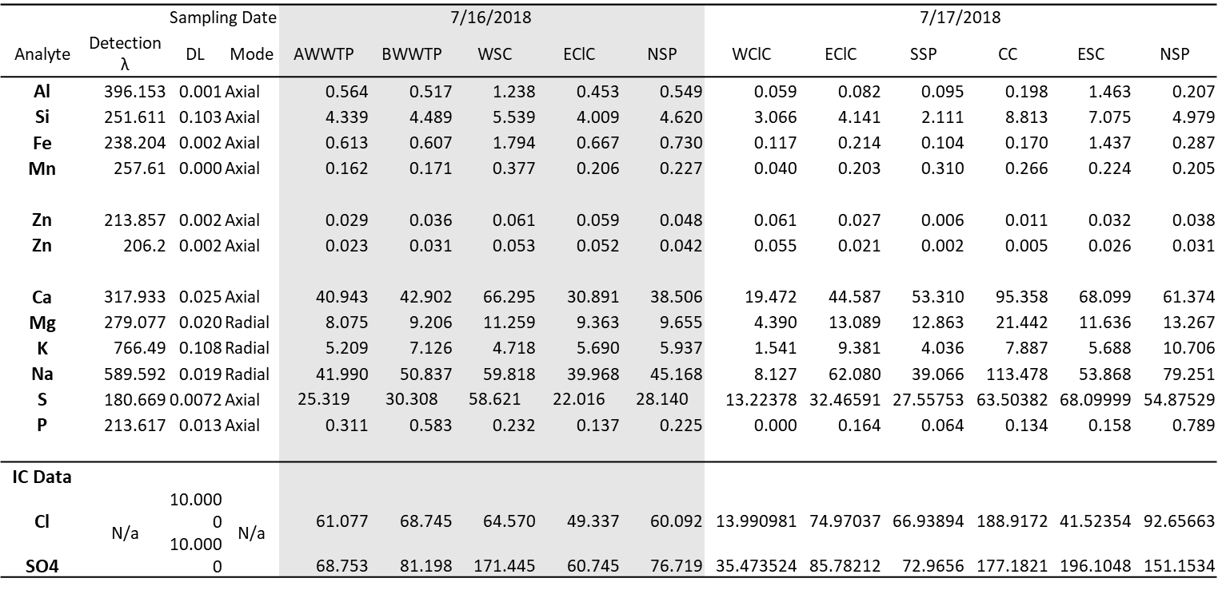

Table S3 Concentrations of Zn (µg/L) per Fraction for sp-ICP-Q-MS settling experiments.
 | Fraction
Site | Dissolved | Colloidal | Particulate | Total
Cherry Creek | 0.42 | 0.36 | 0.39 | 1.17
E. Clear Creek (7/16) | 3.95 | 6.16 | 3.19 | 13.29
E. Clear Creek (7/17) | 5.21 | 1.42 | 1.77 | 8.40
N. South Platte (7/16) | 3.86 | 4.49 | 2.80 | 11.15
N. South Platte (7/17) | 1.55 | 6.61 | 5.56 | 13.72
AWWTP | 1.74 | 2.81 | 1.78 | 6.33
BWWTP | 5.18 | 2.69 | 1.34 | 9.21
E. Sand Creek | 0.33 | 13.15 | 6.41 | 19.88
W. Sand Creek | 0.91 | 6.28 | 6.71 | 13.90
S. South Platte | 0.23 | 0.08 | 1.52 | 1.83
W. Clear Creek | 1.93 | 16.62 | 4.63 | 23.19

Table S4 Concentrations of Zn (µg/L) per Fraction for sp-ICP-QMS filtration experiments.
 | Fraction
Site | Dissolved | Resolved Nanoparticulate | Unresolved Nanoparticulate | Total
Cherry Creek | 0.42 | 0.10 | 0.65 | 1.17
E. Clear Creek (7/16) | 3.95 | 0.90 | 8.45 | 13.29
E. Clear Creek (7/17) | 5.21 | 0.50 | 2.69 | 8.40
N. South Platte (7/16) | 3.86 | 0.01 | 7.28 | 11.15
N. South Platte (7/17) | 1.55 | 0.26 | 11.91 | 13.72
AWTTP | 1.74 | 0.42 | 4.17 | 6.33
BWTTP | 5.18 | 0.40 | 3.63 | 9.21
W. Sand Creek | 0.33 | 1.05 | 18.51 | 19.88
E. Sand Creek | 0.91 | 1.41 | 11.58 | 13.90
W. Clear Creek | 1.93 | 0.52 | 20.74 | 23.19
S. South Platte | 0.23 | 0.17 | 1.43 | 1.83

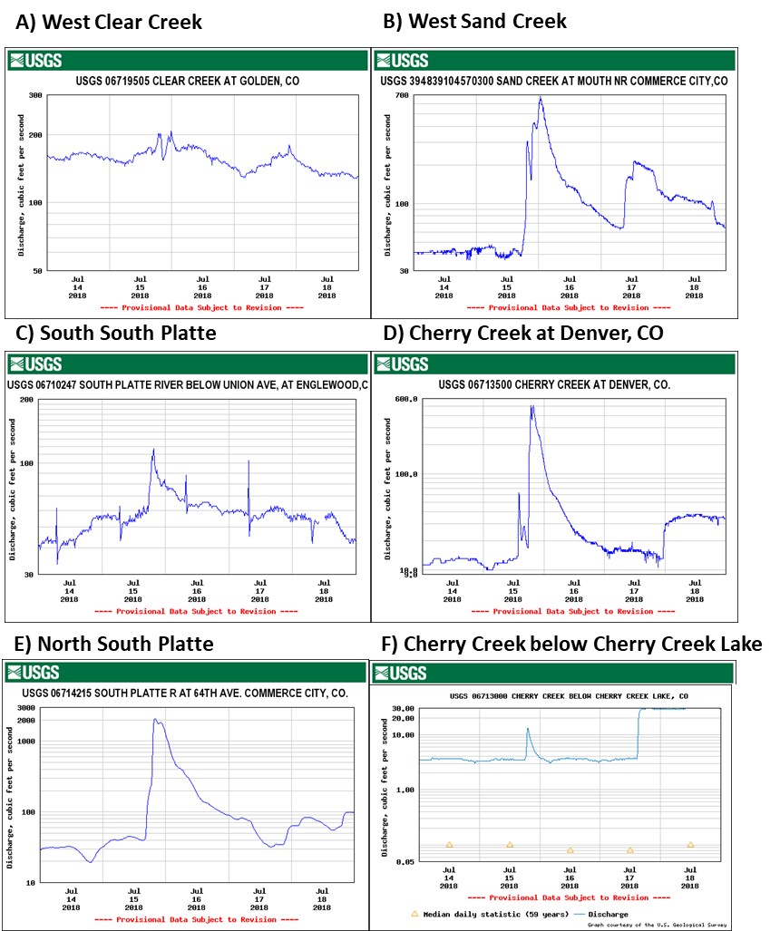

Figure S1 Hydrographs for selected sampling locations A) West Clear Creek, B) West Sand Creek, C) South South Platte, D) Cherry Creek at Denver, CO, E) North South Platte, F) Cherry Creek below Cherry Creek Lake

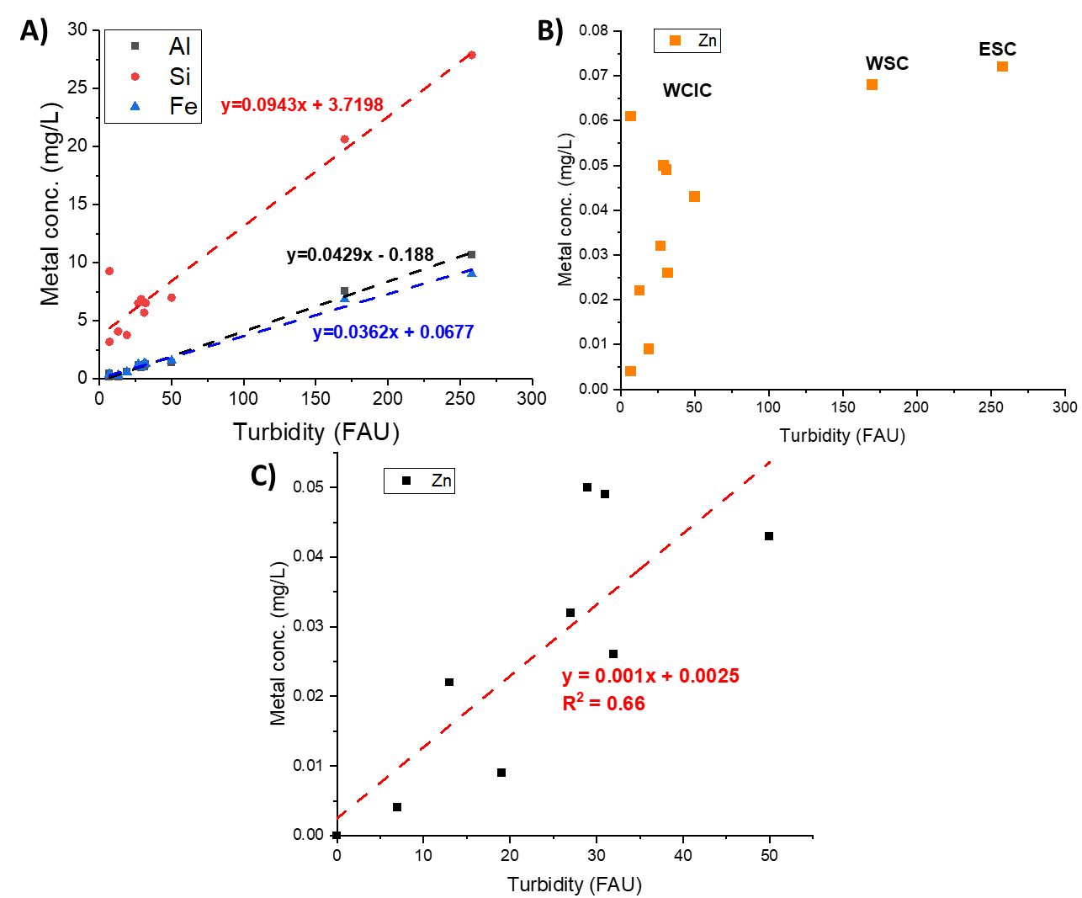

Figure S2 Turbidity plotted against various metal concentrations. A) Turbidity plotted against aluminum, silicon, and iron for all sample sites B) Turbidity plotted against zinc for all sample sites A) Turbidity plotted against zinc for all sample sites excluding WClC, ESC, and WSC due to high flow conditions.

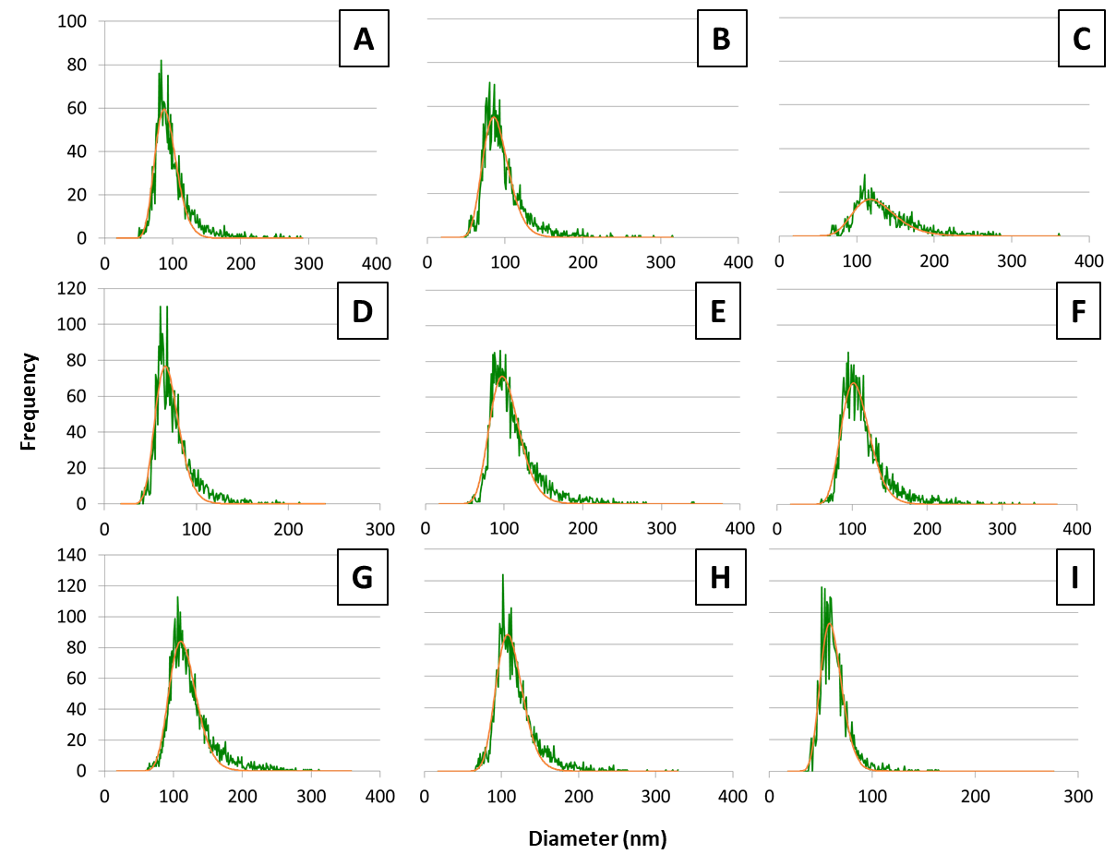
Figure S3 Size Histograms for sp-ICP-QMS measurements of raw samples. Panels correspond to sites: A. AWWTP; B. BWWTP; C. WClC; D. SSP; E. NSP (7/16); F. EClC (7/16); G. WSC; H. ESC; I. CC. Histograms for EClC (7/17) and NSP (7/17) not shown. Diameter calculated by conversion of detected particle mass to a spherical metal Zn particle (ρ = 7.14g/cm³).

