Supplementary Material

Overview of hydro-morphological and water quality characteristics of the side arms in the Danube Floodplain National Park (DFNP)
The investigated side arms show distinct hydro-morphological differences. Johler Arm experiences the most frequent surface water connection, followed by Orth and Regelsbrunn. Whereas the most recently reconnected Johler Arm is open to the Danube River at its full width, the narrow culvert into the side arm system Regelsbrunn was constructed in a very technical manner (Supplementary Figure 1). Orth has rather natural inlets, but they do not extend over the whole channel width. Regelsbrunn has gentle bars and the inundated area is increasing steadily with increasing discharge; Orth is dominated by steep erosion banks and its inundated area increases rapidly after the water level reaches bankfull (compare with Supplementary Figure 2). Johler Arm has less pronounced erosion banks than Orth, but steeper banks than Regelsbrunn. The inlets and outlets of Röthelstein and Spittelauer Arm are completely blocked, meaning that with average discharge the oxbows are groundwater fed until the Danube discharge exceeds an annual flood. The restored inflow in Schönau was completed in 2004, and consists of a bed sill, which allows inundation slightly above MQ (Supplementary Figure 1).
Furthermore, these hydro-morphological differences are reflected in differing TP retention capacities in times of surface water connection. Johler Arm, completely reconnected at full width, shows the highest TP retention in response to incoming TP load, despite experiencing the highest hydraulic load of all side arms. TP retention in Johler Arm is followed by Orth and Regelsbrunn, which shows no response (Supplementary Table 1). The difference in surface water connectivity (d a⁻¹), morphology and TP retention capacity of the respective side arms led to their assignment to three connectivity classes (Supplementary Table 2). This classification scheme was used by the statistical model to estimate nutrient retention in the remaining side arms to be reconnected without water quality measurements.
In the reconnection scenario (ALL), all side arms are reconnected at a Danube discharge below 1000 m³s⁻¹ for 365 to 287 days in a wet (2002) and dry (2003) year, respectively. Johler Arm is already connected at lower water levels and therefore shows slightly increased connectivity (Supplementary Table 3)

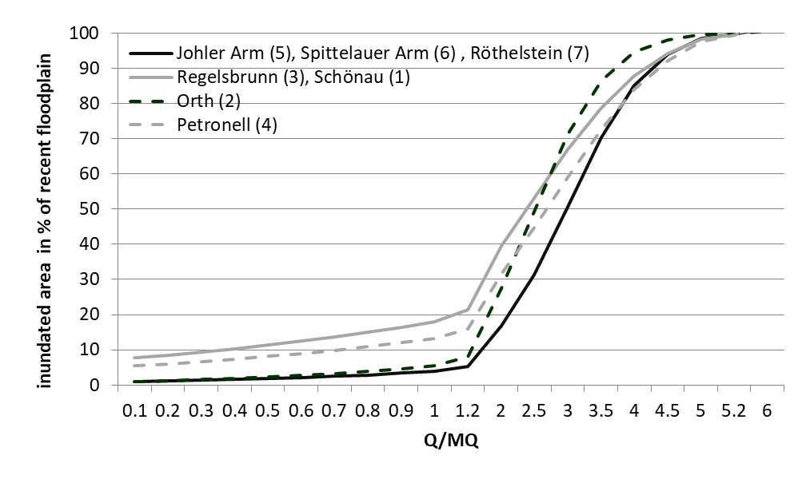
Figure 2: Share of inundated floodplain of the recent floodplain (100% inundation at HQ30 event). The ratio of Q (discharge) and MQ (average discharge) of the Danube is considered.

Supplementary Table 1. Results of single linear regression analyses between TP_{dc} (mg m⁻³ m⁻¹) and incoming TP concentration (mg m⁻³) and discharge (m³ s⁻¹) in three differently connected side arms.
System | Variables | Intercept | a | R² | p
Johler Arm | TP | -0.039 | 0.00097 | 0.81 | <0.001
Orth | TP | -0.029 | 0.00032 | 0.75 | <0.001
Regelsbrunn | TP | 0 | 0 | 0 | n.s.
Johler Arm | Q side arm | -0.004 | 0.00160 | 0.50 | 0.007
Orth | Q side arm | -0.203 | 0.00092 | 0.36 | 0.017
Regelsbrunn | Q side arm | 0 | 0 | 0 | n.s.

Supplementary Table 2. Assignment of connectivity classes by hydro-morphological characteristics including the ratio of the width of the inlet structure to the mean channel width at the beginning of surface water connection (W_{inlet}/W_{side arm}) and days of connection in an average hydrological year (2015). These characteristics in other side arms were applied to estimate TP retention after complete reconnection using the multivariate adaptive regression spline model (earth) (Milborrow, 2015).
W_{inlet}/W_{side arm} | Connection [days in 2015] | Connectivity class | Description | R² (earth)
0.7-1 | >300 | high | Width of inlet at connection approximately equal to water body, frequent connection (Johler Arm: ~1) | R² = 0.79
0.3-0.7 | 90-300 | medium | Width of inlet at connection half of water body, intermediate connection (Orth: 0.54) | R² = 0.98
0-0.3 | <90 | low | Width of inlet at connection much narrower than water body, rather poorly connected (Regelsbrunn: 0.17) | Intercept-model TP dc m⁻¹ = 0.00035 mg m⁻³ m⁻¹ (R² = 0)

Supplementary Table 3. Start of connection of side arm systems with the Danube for the scenarios and the number of days connected for the current state (CUR) and after reconnection (ALL) in a wet and dry hydrological year.
Side arm system  (ID number) | Start of connection  [m³ s⁻¹ of Danube discharge] |  | Days of connection for the years WET / DRY  [d a⁻¹]
 | CUR | ALL | CUR | ALL
Schönau (1) | 1994 | 980 | 235 / 72 | 365 / 287
Orth (2) | 1758 | 980 | 289 / 125 | 365 / 287
Regelsbrunn (3) | 2100 | 980 | 208 / 52 | 365 / 287
Petronell (4) | 2689 | 980 | 98 / 16 | 365 / 287
Johler Arm (5) | 916.6 | 916.6 | 365 / 311 | 365 / 311
Spittelauer Arm (6) | 3618 | 980 | 33 / 7 | 365 / 287
Röthelstein (7) | 3518 | 980 | 41 / 8 | 365 / 287

Calculation of transported nutrient loads into the floodplains
For the semi-empirical model, nutrient concentration proxies were used to calculate daily incoming nutrient loads into the floodplain. For TP, seasonal and discharge-related proxies were used. This is the median, based on monthly concentration measurements in FW31000187 Wildungsmauer for the period 2001-2017 (https://wasser.umweltbundesamt.at/h2odb/). For NO₃-N, monthly concentrations were calculated as the median of NO₃-N concentration measurements in FW31000187 Wildungsmauer for the period 2000-2017.
Supplementary Table 4. Seasonal concentration proxies dependent on discharge for the calculation of daily TP loads entering the floodplain.  Season/Hydrology TP [mg l⁻¹]  Winter>MQ 0.072  Summer>MQ 0.052  Summer>MQ 0.047  Winter<MQ 0.058 | Supplementary Table 5. Monthly concentration proxies for the calculation of daily NO₃-N loads entering the floodplain  Month NO₃-N [mg l⁻¹]  January 2.86  February 2.93  March 2.62  April 2.18  May 1.25  June 1.46  July 1.33  August 1.39  September 1.53  October 1.79  November 2.05  December 2.52

Monthly nutrient retention values
In the following section, detailed monthly retention values for the seven investigated side arm systems in the respective implementation scenarios and model years are presented (Supplementary Figures 3 and 4). It is clearly visible that the statistical model follows discharge patterns, whereas the semi-empirical model follows primarily the hydraulic load. The greatest discrepancy is generally in larger systems in times of elevated discharges in the ALL scenario for TP.
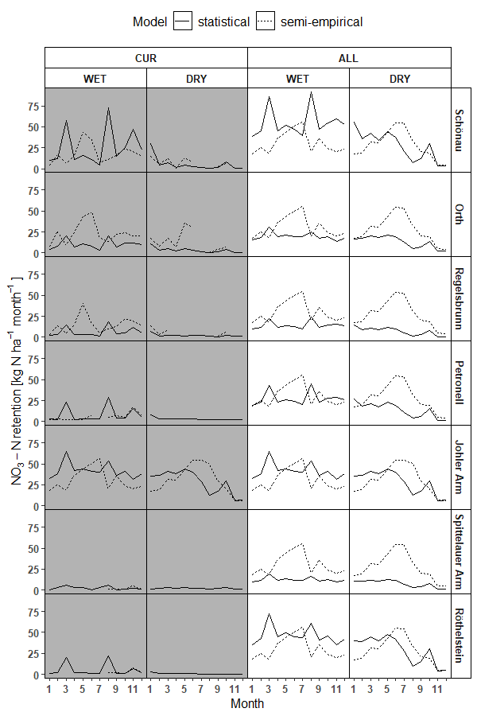
Supplementary Figure 3. Model comparison for monthly areal NO₃-N retention rates in the respective side arms and implementation scenarios.
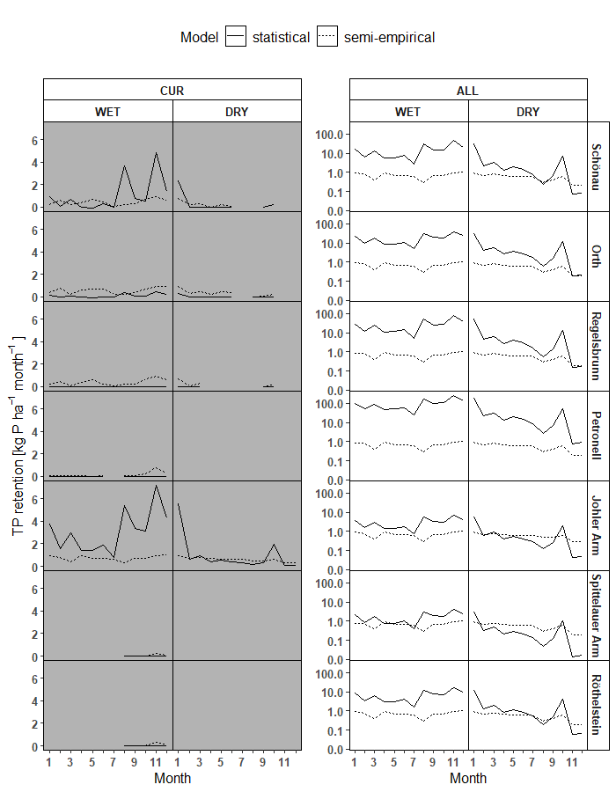
Supplementary Figure 4. Model comparison for monthly areal total phosphorus retention rates in the respective side arms. For visualization purposes, a comparison of the models for TP in the ALL scenario is displayed separately on a log scale.

Literature study of nitrogen and phosphorus retention rates and efficiency in temperate floodplains
Literature values for phosphorus (20 publications) and nitrogen retention (17 publications) in floodplains located in the temperate climate zone are compiled in Supplementary Tables 6 and 7. Absolute rates (kg ha⁻¹a⁻¹) and retention efficiencies (%) vary considerably, probably due to different quantification methods, hydrology, nutrient loads, scales and climatic factors. Phosphorus retention ranges between -5 and 260 kg P ha⁻¹a⁻¹ and nitrogen retention ranges between 2.7 and 680 kg N ha⁻¹a⁻¹. In the case of phosphorus, release is also reported by Hoffmann et al. (2011, 2012).
Supplementary Table 6. Selected literature values for phosphorus retention of floodplains in the temperate climatic zone. Method states the quantification of different P-retention mechanisms: sedimentation (S), plant uptake (P), mass balances (M) and meso-scale models (Mo) or not stated (n.s.).
Author(s) | System, River | Region | Method | P-fraction | P-retention  (kg P ha⁻¹a⁻¹) | P  (%)
Hoffmann et al. (2009) | Nagbøl Å restored floodplain | DK | M | TP | 0.9 | 11
Hoffmann et al. (2009) | Hjarup Bæk restored floodplain | DK | M | TP | 12 | 42
Hoffmann et al. (2011) | Brede floodplain restored | DK | M | TP | -5
Hoffmann et al. (2012) | Egescov floodplain | DK | M | TP | -0.15-0.08 | -25-6
Hoffmann et al. (2012) | Stor Å floodplain | DK | M | TP | -0.9 - -0.33 | -127- -22
Jordan et al. (2003) | Restored wetland receiving agricultural runoff | USA | M | TP | 7.6 | 27
Klimo (1985) in Penka et al. (1985) | Floodplain forest | CZ | P | TP | 18
Kronvang et al. (1999) | Gjern river streambed | DK | M | TP | 37–83
Kronvang et al. (2002) | Gjern floodplain (single floods) | DK | S, M | TP | 11.8-65 | 2.7-5.4
Kronvang et al. (2007) | Gjern floodplain | DK | S, M | TP | 73 | 4.1
Kronvang et al. (2007) | Skjern floodplain (restored - single floods) | DK | S, M | TP | 12 | 4
Kronvang et al. (2007) | Odense floodplain (restored - single floods) | DK | S, M | TP | 24 | 5.1
Kronvang et al. (2007) | Brede floodplain (restored - single floods) | DK | S, M | TP | 36 | 7
Lowrance et al. (1984) | Riparian buffer Little River | USA | M, P | TP | 1.7 | 30
Scholz et al. (2012) | Floodplains of large rivers | DE | Mo | TP |  | 11-48
Mitsch et al. (2000) | Selected wetlands | USA, AUS, NZ | M | TP | 4-75
Mitsch et al. (2008) | Diversion Wetland steady flow | USA | M | TP | 29
Mitsch et al. (2008) | Diversion Wetland, pulse flow | USA | M | TP | 45
Natho (2013) | Floodplains Rhein, Main, Elbe | DE | Mo | TP | <1-28
Noe and Hupp (2005) | Decoupled coastal floodplains | USA | S | TP | 2.2-3.5 | 8
Noe and Hupp (2005) | Connected coastal floodplains | USA | S | TP | 4.4-41.3 | 10
Olde Venterink et al. (2003) | Ijsel | NL | M | TP |  | 20-45
Olde Venterink et al. (2006) | Floodplain forest Waal und Ijsel | NL | S, P | TP | 34
Olde Venterink et al. (2006) | Floodplain pond Waal und Ijsel | NL | S, P | TP | 260
Olde Venterink et al. (2006) | Reed belt Waal und Ijsel | NL | S, P | TP | 95
Peterjohn and Correll (1984) | Floodplain forest Rhode river | USA | M | TP | 2.9 | 80
Richardson (1990) | Floodplain forest | USA | n.s. | TP | 1.5
Van Oorschot (1996) | Flooded meadow | UK | M | TP | 17.4
Yates and Sheridan (1983) | Floodplain forest Little river | USA | M | SRP | 0.09 | 37

Supplementary Table 7. Selected literature values for nitrogen retention of floodplains in the temperate climatic zone. Method states the quantification of different N-retention mechanisms: sedimentation (S), denitrification (D), plant uptake (P), mass balances (M) and meso-scale models (Mo) or not stated (n.s.).
Author(s) | System, River | Region | Method | N-fraction | N-Retention  (kg N ha⁻¹ a⁻¹) | N  (%)
Andreasson-Gren and Groth (1995) | Danube floodplains | EUR | M | n.s. | 100
Hoffmann et al. (2011) | Brede floodplain restored 1995 | DK | M | NO₃-N | 92 | 71
Hoffmann et al. (2011) | Brede floodplain restored 1999-2000 | DK | M | NO₃-N | 141 | 95
Hoffmann et al. (2012) | Egescov floodplain | DK | M | NO₃-N | 23-104 | 41-90
Hoffmann et al. (2012) | Stor Å floodplain | DK | M | NO₃-N | 150-219 | 26-32
Jansson et al. (1994) | Flooded meadow | SW | D | NO₃-N | 250-680
Jordan et al. (2003) | Restored wetland receiving agricultural runoff | USA | M | NO₃-N | 12 | 52
Klimo (1985) in Penka et al. (1985) | Floodplain forest | CZ | P | TN | 224
Kronvang et al. (1999) | Gjern river streambed | DK | M | Organic N | 72–161
Lowrance et al. (1984) | Little river floodplain | USA | M | TN | 51.8 | 68
Scholz et al. (2012) | Floodplains of large rivers | DE | Mo | TN |  | 7-9
Mitsch et al. (2000) | Selected wetlands | USA, AUS, NZ | M | NO₃-N | 30-670
Mitsch et al. (2005) | Diversion Wetland, Mississippi | USA | M | NO₃-N | 460 | 39-92
Mitsch et al. (2005) | Diversion Wetland, Olentangy | USA | M | NO₃-N | 390 | 35
Mitsch et al. (2008) | Diversion Wetland, pulse flow | USA | M | NO₃-N | 150 | 47
Mitsch et al. (2008) | Diversion Wetland, steady flow | USA | M | NO₃-N | 80 | 64
Natho (2013) | Floodplains Rhein, Main, Elbe | DE | Mo | NO₃-N | 100-400
Noe and Hupp (2005) | Decoupled coastal floodplains | USA | S | TN | 35-48 | 8
Noe and Hupp (2005) | Connected coastal floodplains | USA | S | TN | 42-134 | 9
Olde Venterink et al. (2006) | Floodplain forest Waal und Ijsel | NL | D, P, S | TN | 90
Olde Venterink et al. (2006) | Reed belt Waal und Ijsel | NL | D, P, S | TN | 236
Olde Venterink et al. (2006) | Floodplain pond Waal und Ijsel | NL | D, P, S | TN | 570
Peterjohn and Correll (1984) | Rhode river floodplain | USA | M | NO₃-N | 2.7
Richardson (1990) | Floodplain forest | USA | n.s. | TN | 38-52

References
Andreasson-Gren, I., & Groth, K. (1995). Economic evaluation of Danube floodplains. Unpublished report, WWF International, Gland, Switzerland.
Hoffmann, C. C., Heiberg, L., Audet, J., Schonfeldt, B., Fuglsang, A., Kronvang, B., . . . Jensen, H. S. (2012). Low phosphorus release but high nitrogen removal in two restored riparian wetlands inundated with agricultural drainage water. Ecological Engineering, 46, 75-87. doi:10.1016/j.ecoleng.2012.04.039
Hoffmann, C. C., Kjaergaard, C., UuSupplementary Kamppa, J., Hansen, H. C. B., & Kronvang, B. (2009). Phosphorus Retention in Riparian Buffers: Review of Their Efficiency. Journal of Environmental Quality, 38(5), 1942-1955. doi:10.2134/jeq2008.0087
Hoffmann, C. C., Kronvang, B., & Audet, J. (2011). Evaluation of nutrient retention in four restored Danish riparian wetlands. Hydrobiologia, 674(1), 5-24. doi:10.1007/s10750-011-0734-0
Jansson, M., Andersson, R., Berggren, H., & Leonardson, L. (1994). Wetlands and Lakes as Nitrogen Traps. Ambio, 23(6), 320-325.
Jordan, T. E., Whigham, D. F., Hofmockel, K. H., & Pittek, M. A. (2003). Nutrient and sediment removal by a restored wetland receiving agricultural runoff. J Environ Qual, 32(4), 1534-1547. doi:10.2134/jeq2003.1534
Kronvang, B., Andersen, I. K., Hoffmann, C. C., Pedersen, M. L., Ovesen, N. B., & Andersen, H. E. (2007). Water exchange and deposition of sediment and phosphorus during inundation of natural and restored lowland floodplains. Water Air and Soil Pollution, 181(1-4), 115-121. doi:10.1007/s11270-006-9283-y
Kronvang, B., Falkum, Ø., Svendsen, L., & Laubel, A. (2002). Deposition of sediment and phosphorus during overbank flooding. Internationale Vereinigung für theoretische und angewandte Limnologie: Verhandlungen, 28(3), 1289-1293.
Kronvang, B., Hoffmann, C. C., Svendsen, L. M., Windolf, J., Jensen, J. P., & Dørge, J. (1999). Retention of nutrients in river basins. Aquatic Ecology, 33(1), 29-40.
Lowrance, R., Todd, R., Fail, J., Hendrickson, O., Leonard, R., & Asmussen, L. (1984). Riparian Forests as Nutrient Filters in Agricultural Watersheds. Bioscience, 34(6), 374-377. doi:Doi 10.2307/1309729
Milborrow, S. (2015). Earth: Multivariate adaptive regression splines. R package version 4.0.
Mitsch, W. J., Day, J. W., Zhang, L., & Lane, R. R. (2005). Nitrate-nitrogen retention in wetlands in the Mississippi river basin. Ecological Engineering, 24(4), 267-278. doi:10.1016/j.ecoleng.2005.02.005
Mitsch, W. J., Horne, A. J., & Nairn, R. W. (2000). Nitrogen and phosphorus retention in wetlands-ecological approaches to solving excess nutrient problems. Ecological Engineering, 14(1-2), 1-7.
Mitsch, W. J., Zhang, L., Fink, D. F., Hernandez, M. E., Altor, A. E., Tuttle, C. L., & Nahlik, A. M. (2008). Ecological engineering of floodplains. Ecohydrology and Hydrobiology, 8(2-4), 139-147.
Natho, S. (2013). Modelling nutrient retention in floodplains. Dissertation.
Noe, G. B., & Hupp, C. R. (2005). Carbon, nitrogen, and phosphorus accumulation in floodplains of Atlantic Coastal Plain rivers, USA. Ecological Applications, 15(4), 1178-1190. doi:Doi 10.1890/04-1677
Olde Venterink, H., Vermaat, J. E., Pronk, M., Wiegman, F., van der Lee, G. E., van den Hoorn, M. W., . . . Verhoeven, J. T. (2006). Importance of sediment deposition and denitrification for nutrient retention in floodplain wetlands. Applied Vegetation Science, 9(2), 163-174.
Olde Venterink, H., Wiegman, F., Van der Lee, G. E., & Vermaat, J. E. (2003). Role of active floodplains for nutrient retention in the river Rhine. J Environ Qual, 32(4), 1430-1435. doi:10.2134/jeq2003.1430
Penka, M., Vyskot, M., Klimo, E., & Vasicek, F. (1985). Floodplain Forest Ecosystem: I. Before Water Management Measures: Elsevier.
Peterjohn, W. T., & Correll, D. L. (1984). Nutrient Dynamics in an Agricultural Watershed - Observations on the Role of a Riparian Forest. Ecology, 65(5), 1466-1475. doi:Doi 10.2307/1939127
Richardson, C. J. (1990). Biogeochemical cycles: regional. Wetlands and shallow continental water bodies, 1, 259-279.
Scholz, M., Mehl, D., Schulz-Zunkel, C., Kasperidus, H. D., Born, W., & Henle, K. (2012). Ökosystemfunktionen von Flussauen. Analyse und Bewertung von Hochwasserretention, Nährstoffrückhalt, Kohlenstoffvorrat, Treibhausgasemissionen und Habitatfunktion. Naturschutz und Biologische Vielfalt, 124(2).
Yates, P., & Sheridan, J. M. (1983). Estimating the Effectiveness of Vegetated Floodplains Wetlands as Nitrate-Nitrite and Orthophosphorus Filters. Agriculture Ecosystems & Environment, 9(3), 303-314. doi:Doi 10.1016/0167-8809(83)90104-4

