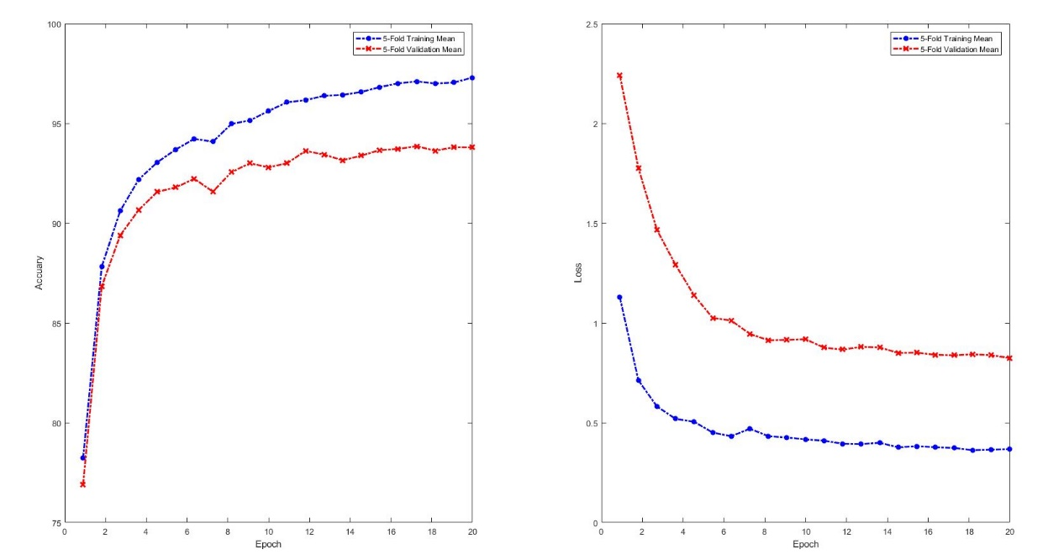
(b)
(a)
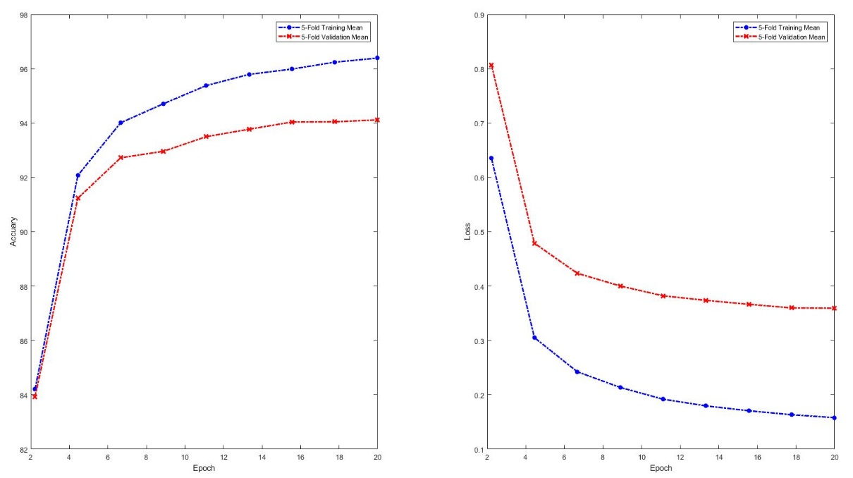
(d)
(c)
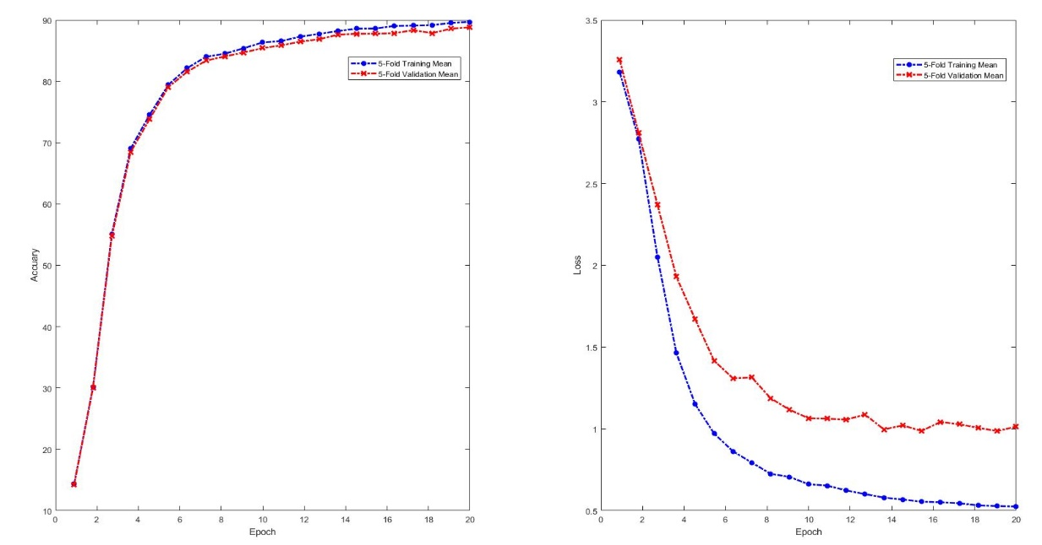
(f)
(e)
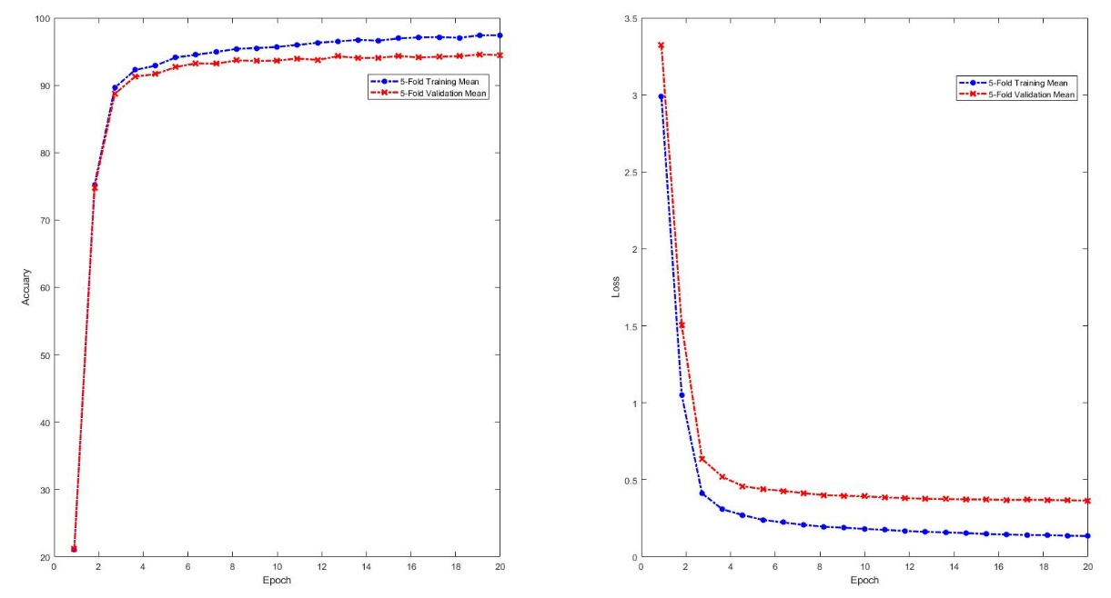
(g)
(h)
Supplement 1. Learning curves and accuracy of predicting cancer types using four GCNN models. The red curves denote the results of the validation data while the blue curves represent the training data in each figure. (a, c, e, and g) Prediction accuracy of training and validation of the co-expression GCNN model, co-expression + singleton GCNN model, PPI GCNN model, and PPI + singleton GCNN model, respectively. (b, d, f, and h) The loss function of training and validation of the co-expression GCNN model, co-expression + singleton GCNN model, PPI GCNN model, and PPI + singleton GCNN model, respectively.
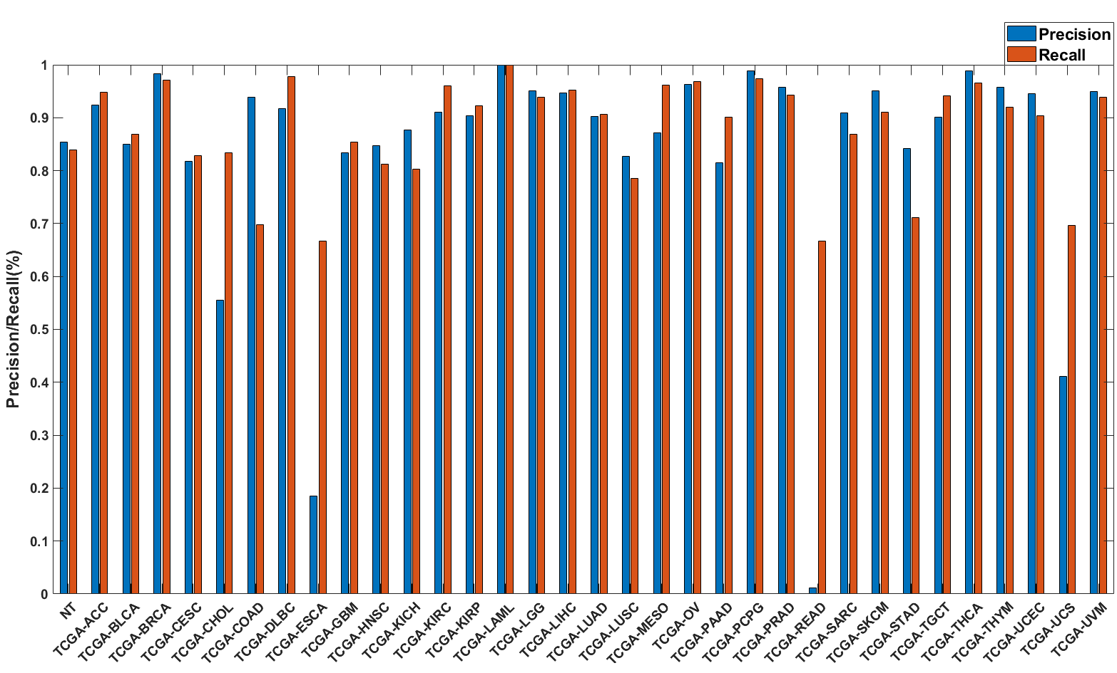
Supplement 2. Precision (blue) and recall (red) of the PPI GCNN models trained with combined 33 different cancer types, plus a group of normal tissues from different origins in TCGA collection (NT).
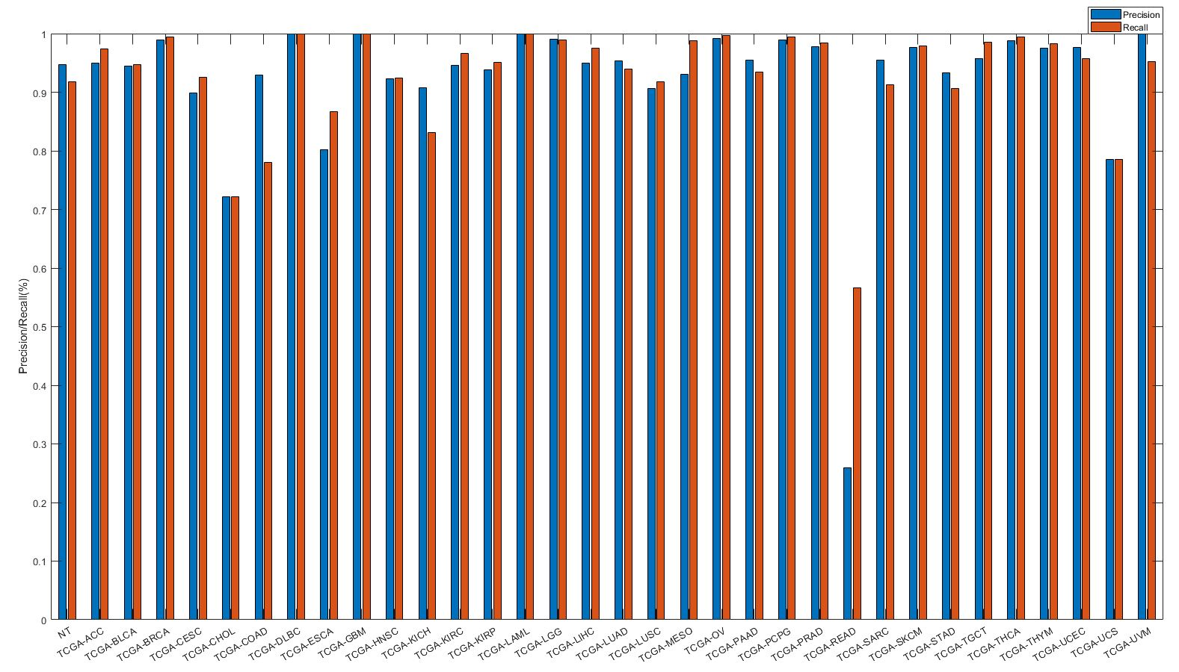
Supplement 3. Precision (blue) and recall (red) of the PPI + Singleton GCNN models trained with combined 33 different cancer types plus NT group.
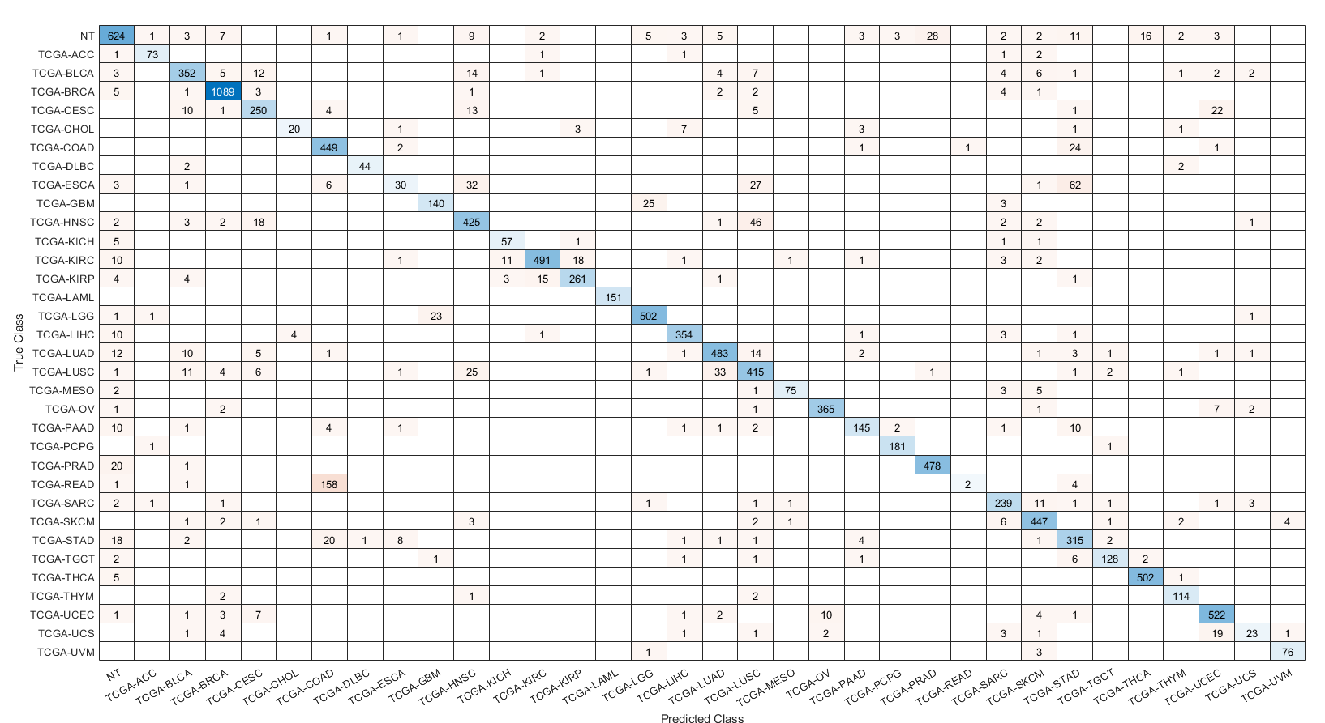
Supplement 4. Confusion matrices of all samples predicted by the PPI model with combined 33 different cancer types and normal samples.
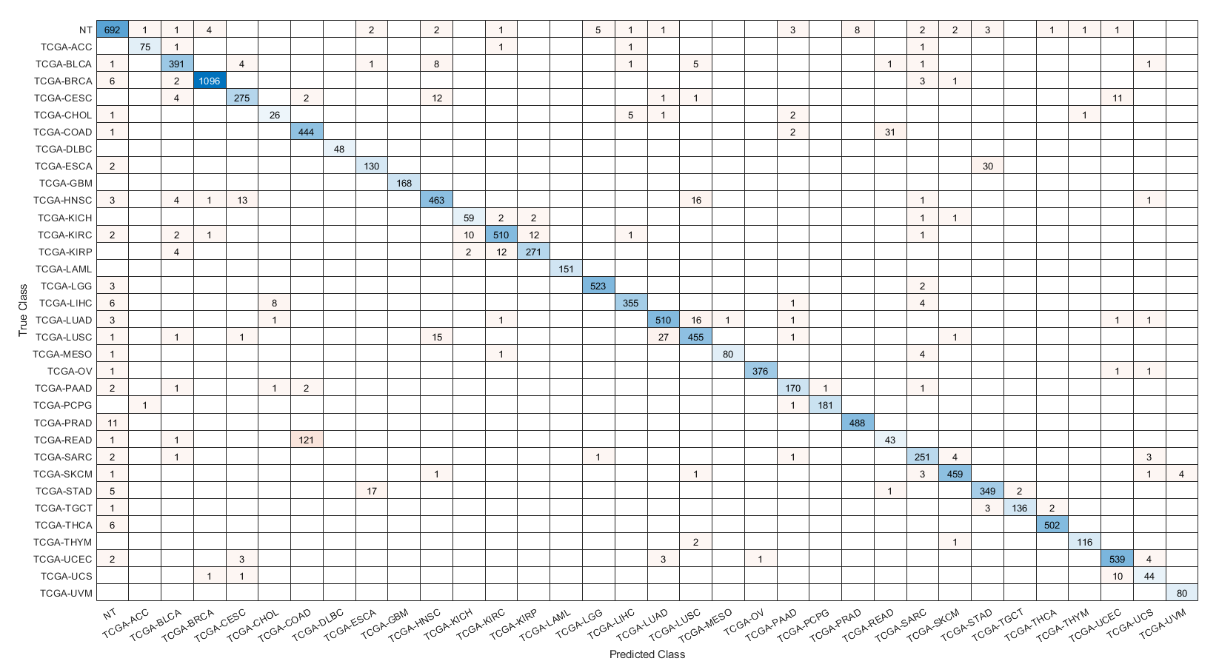
Supplement 5. Confusion matrices of all samples predicted by the PPI + Singleton GCNN model with combined 33 different cancer types and normal samples.

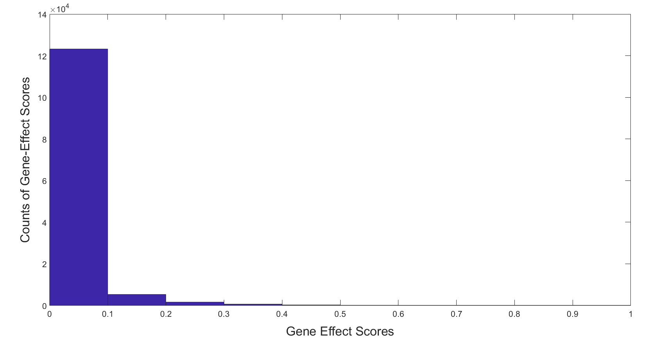
Supplement 6. Histogram of all gene-effect scores calculated by in silico gene perturbation with co-expression GCNN model. The X-axis denotes the range of gene-effect scores while the Y-axis indicates the number of gene-effect scores within that range. There is a total of 131,444 scores for the co-expression genes (3866 genes by 34 classes).

