SUPPLEMENTAL MATERIAL

Figure S1. Flowchart for population selection

Figure S2. The association between baseline CRF and changes in cardiometabolic risk factors modified by baseline BMI

Figure S3. The association between change in BMI/PBF and changes in cardiometabolic risk factors modified by baseline BMI/PBF

Figure S4. The association between changes in CRF and changes in systolic and diastolic blood pressure modified by baseline CRF

Figure S5. The association between change in CRF and changes in fasting glucose modified by the change in PBF

Table S1. P values for interaction between intervention and BMI, percent body fat, and cardiorespiratory fitness for changes in cardiometabolic risk factors

Table S2. P values for interaction between sex and BMI, percent body fat, and cardiorespiratory for changes in cardiometabolic risk factors

Table S3. Differences between children who included and those who were lost to follow-up in the analysis

Table S4. Changes in cardiometabolic risk factors associated with baseline and changes in waist circumference

Table S5. Changes in cardiometabolic risk factors associated with baseline and changes in cardiorespiratory fitness in the control group

Table S6. Changes in cardiometabolic risk factors associated with baseline and changes in BMI in the control group

Table S7. Changes in cardiometabolic risk factors associated with baseline and changes in PBF in the control group

Figure S1. Flowchart for population selection

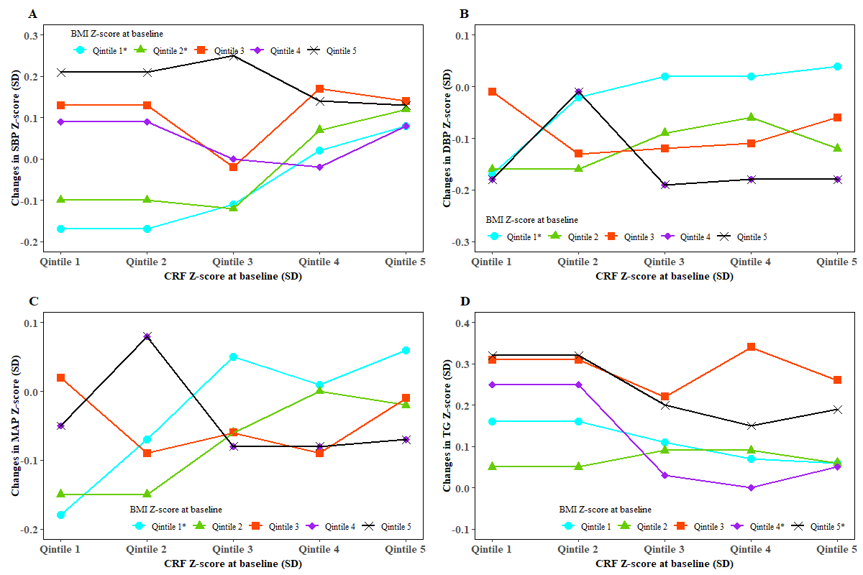
Figure S2. The association between baseline CRF and changes in cardiometabolic risk factors modified by baseline BMI
GLM was used to test whether the association between baseline CRF and changes in CMR factors was modified by baseline BMI. Children within classes in school as clustering effects and characteristics of the individuals including age, sex, grade, intervention, corresponding cardiometabolic risk factor, physical activity, total energy intake at baseline, birthweight, household income, mother’s education, father’s education, mother’s BMI, and father’s BMI as fixed effects were adjusted for. We did the analysis for all the CMR factors and only present those with significant moderation in this figure.
*indicates a significant trend for changes in CMR factors with baseline CRF in the specific quintiles of BMI at baseline.

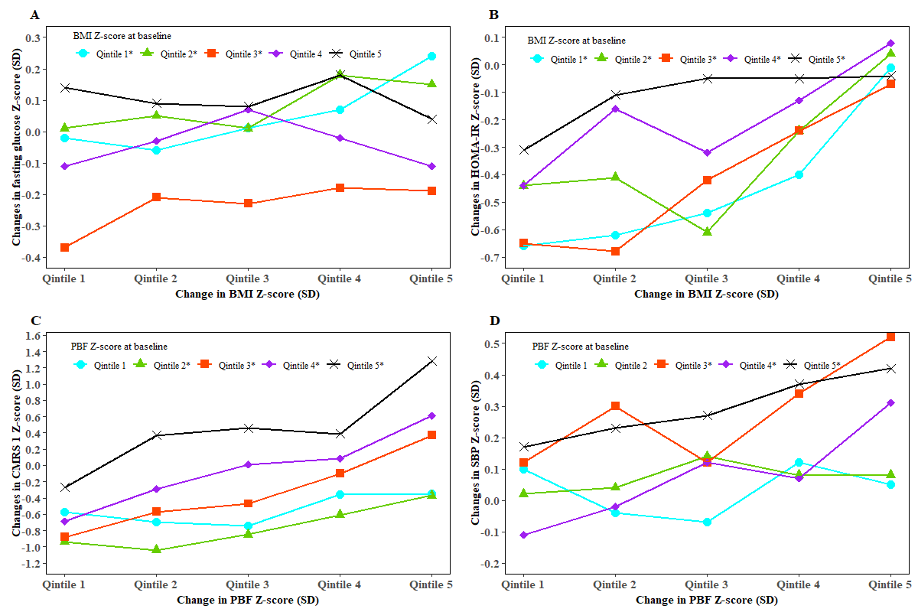
Figure S3. The association between change in BMI/PBF and changes in cardiometabolic risk factors modified by baseline BMI/PBF
GLM was used to test whether the association between change in BMI/PBF and changes in CMR factors was modified by baseline BMI/PBF. Children within classes in school as clustering effects and characteristics of the individuals including age, sex, grade, intervention, corresponding cardiometabolic risk factor, physical activity, total energy intake at baseline, birthweight, household income, mother’s education, father’s education, mother’s BMI, and father’s BMI as fixed effects were adjusted for. We did the analysis for all the CMR factors and only present those with significant moderation in this figure.
*indicates a significant trend for changes in CMR factors with changes in BMI/PBF in the specific quintiles of BMI/PBF at baseline.

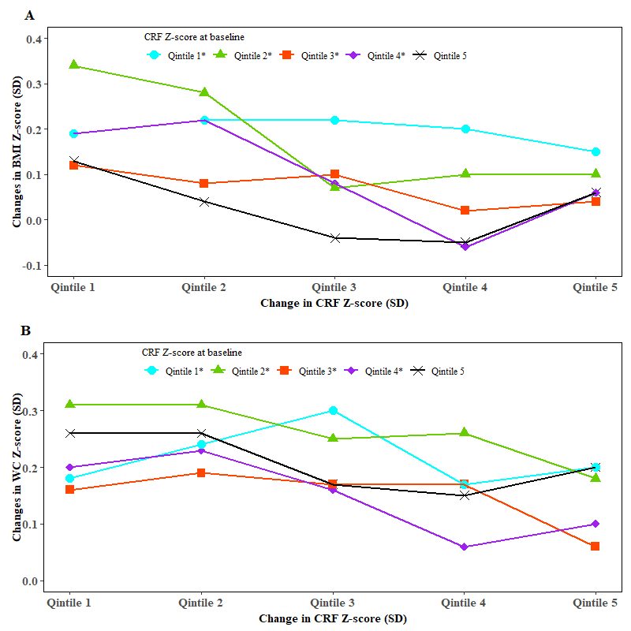

Figure S4. The association between changes in CRF and changes in systolic and diastolic blood pressure modified by baseline CRF
GLM was used to test whether the association between changes in CRF and changes in BMI and WC was modified by baseline CRF. Children within classes in school as clustering effects and characteristics of the individuals including age, sex, grade, intervention, corresponding cardiometabolic risk factor, physical activity, total energy intake at baseline, birthweight, household income, mother’s education, father’s education, mother’s BMI, and father’s BMI as fixed effects were adjusted for. We did the analysis for all the CMR factors and only present those with significant moderation in this figure.
*indicates a significant trend for changes in BMI and WC with changes in CRF in the specific quintiles of CRF at baseline.

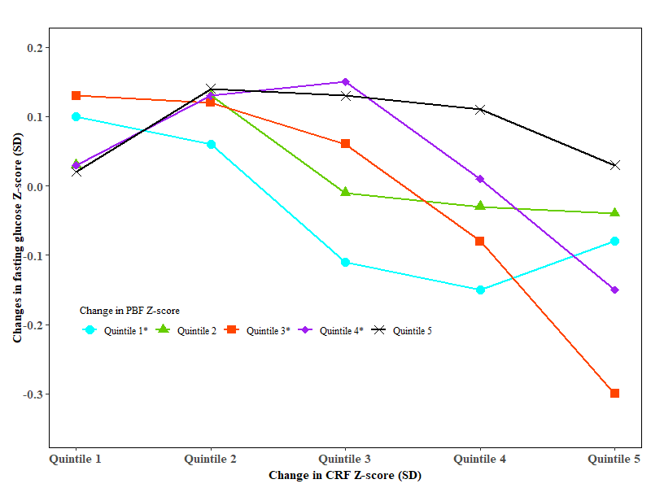

Figure S5. The association between change in CRF and changes in fasting glucose modified by the change in PBF
GLM was used to test whether the association between change in CRF and change in fasting glucose was modified by the change in PBF. Children within classes in school as clustering effects and characteristics of the individuals including age, sex, grade, intervention, corresponding cardiometabolic risk factor, physical activity, total energy intake at baseline, birthweight, household income, mother’s education, father’s education, mother’s BMI, and father’s BMI as fixed effects were adjusted for. We did the analysis for all the CMR factors and only present those with significant moderation in this figure.
*indicates a significant trend for changes in fasting glucose with the change in CRF in the specific quintiles of change in PBF.

Table S1. P values for interaction between intervention and BMI, percent body fat, and cardiorespiratory fitness for changes in cardiometabolic risk factors*
Changes in CMR factors | P interaction for intervention and BMI† | P interaction for intervention and PBF | P interaction for intervention and CRF
BMI |  | 0.0474 | 0.6829
WC | 0.2794 | 0.3259 | 0.5370
PBF | 0.3220 |  | 0.1900
SBP | 0.0061 | 0.1799 | 0.5781
DBP | 0.0003 | 0.0946 | 0.1956
MAP | 0.0002 | 0.0890 | 0.2397
TC | 0.6183 | 0.3409 | 0.2496
HDL-C | 0.6432 | 0.1334 | 0.0021
LDL-C | 0.3356 | 0.0025 | 0.0003
Log TG | 0.4038 | 0.6392 | 0.3830
Fasting glucose | 0.0575 | 0.9454 | 0.7188
Insulin | 0.0076 | 0.8382 | 0.0340
HOMA-IR | 0.0100 | 0.8772 | 0.0300
CMRS 1 | 0.0080 | 0.6986 | 0.2346
CMRS 2 | 0.1257 | 0.9118 | 0.0773

BMI, body mass index; CMR, cardiometabolic risk; CRF, cardiorespiratory fitness; DBP, diastolic blood pressure; HDL-C, high-density lipoprotein cholesterol; HOMA-IR, homeostatic model assessment of insulin resistance; LDL-C, low-density lipoprotein cholesterol; MAP, mean arterial pressure; SBP, systolic blood pressure; TC, total cholesterol; TG, triglyceride.
*GLM was used to test the interaction between intervention and percent body fat, and cardiorespiratory fitness for changes in cardiometabolic risk factors adjusted for children within classes in school as clustering effects and characteristics of the individuals including age, sex, grade, corresponding CMR factor at baseline, physical activity, total energy intake, birthweight, household income, mother’s education, father’s education, mother’s BMI, and father’s BMI as fixed effects.
†We used Benjamin-Hochberg procedure was used to control the false discovery rate at level 5% for multiple comparisons with the P-value cut-off point of significance was 0.02, 0.003, and 0.01 for intervention and BMI, intervention and PBF, and intervention and CRF, respectively.
Table S2. P values for interaction between sex and BMI, percent body fat, and cardiorespiratory for changes in cardiometabolic risk factors
Changes in CMR factors | P interaction for intervention and BMI | P interaction for intervention and PBF | P interaction for intervention and CRF
BMI |  | <0.0001 | 0.0532
WC | <0.0001 | <0.0001 | 0.1064
PBF | 0.0012 |  | 0.0007
SBP | 0.2612 | 0.4368 | 0.7829
DBP | 0.5356 | 0.2277 | 0.3979
MAP | 0.4571 | 0.4506 | 0.4827
TC | 0.6058 | 0.8651 | 0.5287
HDL-C | 0.2705 | 0.3343 | 0.6555
LDL-C | 0.9251 | 0.4913 | 0.9333
TG | 0.3041 | 0.4150 | 0.2886
Fasting glucose | 0.1483 | 0.1710 | 0.0051
Insulin | 0.4798 | 0.4306 | 0.5499
HOMA-IR | 0.6292 | 0.4297 | 0.3718
CMRS 1 | 0.2572 | 0.1112 | 0.3822
CMRS 2 | 0.6342 | 0.8668 | 0.4287
BMI, body mass index; CMR, cardiometabolic risk; CRF, cardiorespiratory fitness; DBP, diastolic blood pressure; HDL-C, high-density lipoprotein cholesterol; HOMA-IR, homeostatic model assessment of insulin resistance; LDL-C, low-density lipoprotein cholesterol; MAP, mean arterial pressure; SBP, systolic blood pressure; TC, total cholesterol; TG, triglyceride.
*GLM was used to test the interaction between intervention and percent body fat, and cardiorespiratory fitness for changes in cardiometabolic risk factors adjusted for children within classes in school as clustering effects and characteristics of the individuals including age, sex, grade, corresponding CMR factor at baseline, physical activity, total energy intake, birthweight, household income, mother’s education, father’s education, mother’s BMI, and father’s BMI as fixed effects.
†We used Benjamin-Hochberg procedure was used to control the false discovery rate at level 5% for multiple comparisons with the P-value cut-off point of significance was 0.01, 0.0067, and 0.0067 for sex and BMI, sex and PBF, and sex and CRF, respectively.

Table S3. Differences between children who included and those who were lost to follow-up in the analysis
 | All | Included in  the analysis | Lost to  follow-up | P-value*
Age (years) | 9.06±1.40† | 9.06±1.39 | 9.06±1.43 | 0.99
BMI (kg/m²) | 17.08±3.21 | 17.09±3.16 | 17.02±3.37 | 0.42
WC (cm) | 57.74±8.88 | 57.76±8.93 | 57.68±8.73 | 0.75
% body fat mass | 23.94±4.92 | 24.01±4.87 | 23.73±5.07 | 0.0355
SBP (mm Hg) | 98.86±11.15 | 99.36±11.05 | 97.28±11.33 | <0.0001
DBP (mm Hg) | 62.31±9.22 | 62.83±9.11 | 60.68±9.35 | <0.0001
MAP (mm Hg) | 74.48±9.08 | 74.99±8.96 | 72.86±9.25 | <0.0001
Total cholesterol (mmol/L) | 4.11±0.80 | 4.15±0.81 | 4.00±0.76 | <0.0001
HDL (mmol/L) | 1.49±0.31 | 1.48±0.30 | 1.55±0.33 | <0.0001
LDL (mmol/L) | 2.23±0.62 | 2.26±0.62 | 2.13±0.62 | <0.0001
TG (mmol/L) | 0.82±0.44 | 0.82±0.45 | 0.80±0.41 | 0.0502
Fasting glucose (mmol/L) | 4.58±0.54 | 4.55±0.53 | 4.67±0.55 | <0.0001
Log insulin | 1.64±0.61 | 1.66±0.60 | 1.56±0.62 | <0.0001
Log HOMA-IR | 0.08±1.00 | 0.10±0.99 | -0.02±1.02 | <0.0001
CMRS 1 | 0.01±2.78 | 0.08±2.77 | -0.23±2.79 | <0.0001
CMRS 2 | -0.04±2.10 | 0.08±2.09 | -0.44±2.10 | <0.0001
Physical activity (MET/week) | 1346.35±584.90 | 1356.28±595.23 | 1309.00±542.96 | 0.0220
Energy (kcal/day) | 655.25±649.86 | 630.01±631.19 | 738.65±701.85 | <0.0001
50 M*8 shuttle run (second) | 128.65±18.64 | 128.55±18.12 | 129.61±23.23 | 0.19
51 M*8 shuttle run (Z-score) | 0.02±1.07 | 0.02±1.04 | 0.06±1.35 | 0.33
Grade |  |  |  | 0.28
One | 1536(19.9)‡ | 1151(19.6) | 385(20.8)
Two | 1713(22.2) | 1307(22.3) | 406(22.0)
Three | 1691(21.9) | 1288(21.9) | 403(21.8)
Four | 1767(22.9) | 1341(22.8) | 426(23.1)
Five | 1010(13.1) | 782(13.3) | 228(12.3)
Birth weight |  |  |  | 0.25
<2500 g | 206(2.7) | 147(2.5) | 59(3.2)
2500-3999 g | 4536(58.8) | 3559(60.6) | 977(52.9)
≥4000 g | 474(6.1) | 369(6.3) | 105(5.7)
Missing | 2501(32.4) | 1794(30.6) | 707(38.3)
Mother's BMI |  |  |  | 0.87
<24 kg/m² | 4398(57.0) | 3439(58.6) | 959(51.9)
24-27.9 kg/m² | 893(11.6) | 692(11.8) | 201(10.9)
≥28 kg/m² | 124(1.6) | 100(1.7) | 24(1.3)
Missing | 2302(29.8) | 1638(27.9) | 664(35.9)
Father's BMI |  |  |  | 0.32
<24 kg/m² | 3048(39.5) | 2372(40.4) | 676(36.6)
24-27.9 kg/m² | 1899(24.6) | 1478(25.2) | 421(22.8)
≥28 kg/m² | 468(6.1) | 381(6.5) | 87(4.7)
Missing | 2302(29.8) | 1638(27.9) | 664(35.9)
Mother's education |  |  |  | 0.0226
<7 years | 488(6.3) | 353(6.0) | 135(7.3)
7-12 years | 3366(43.6) | 2643(45.0) | 723(39.1)
≥13 years | 1473(19.1) | 1165(19.9) | 308(16.7)
Missing | 2390(31.0) | 1708(29.1) | 682(36.9)
Father's education |  |  |  | 0.91
<7 years | 297(3.8) | 212(3.6) | 85(4.6) | 0.91
7-12 years | 3369(43.7) | 2667(45.4) | 702(38.0) | 0.91
≥13 years | 1668(21.6) | 1291(22.0) | 377(20.4) | 0.91
Missing | 2383(30.9) | 1699(28.9) | 684(37.0)
Household income per month |  |  |  | 0.0009
<750 RMB | 611(7.9) | 456(7.8) | 155(8.4)
751-1500 RMB | 1661(21.5) | 1288(21.9) | 373(20.2)
1501-2500 RMB | 1447(18.8) | 1121(19.1) | 326(17.6)
≥2501 RMB | 1556(20.2) | 1263(21.5) | 293(15.9)
Missing | 2442(31.6) | 1741(29.7) | 701(37.9)
Intervention |  |  |  | 0.0071
No | 3773(48.9) | 2920(49.8) | 853(46.2)
Yes | 3944(51.1) | 2949(50.2) | 995(53.8)
BMI, body mass index; CMR, cardiometabolic risk; CRF, cardiorespiratory fitness; DBP, diastolic blood pressure; HDL-C, high-density lipoprotein cholesterol; HOMA-IR, homeostatic model assessment of insulin resistance; LDL-C, low-density lipoprotein cholesterol; MAP, mean arterial pressure; SBP, systolic blood pressure; TC, total cholesterol; TG, triglyceride.
*T-test was used to test the difference of continuous variables between boys and girls and Chi-square for categorical variables.
†All such data were mean ± standard deviation.
‡All such data were frequency (percentage).

Table S4. Changes in cardiometabolic risk factors associated with baseline and changes in waist circumference
 | WC Z-score at baseline |  |  |  | Change in WC Z-score
 | Participants | Age- and sex-adjusted β | Multivariable-adjusted β† |  | Participants | Age- and sex-adjusted β | Multivariable-adjusted β†
Change in BMI | 5758 | 0.4265(0.3976,0.4554)‡ | 0.4211(0.3923,0.4499)‡ |  | 5737 | 0.5584(0.5337,0.5830)‡ | 0.6441(0.6225,0.6656)‡
Change in PBF | 5604 | 0.2689(0.2445,0.2933)‡ | 0.2612(0.2362,0.2862)‡ |  | 5582 | 0.3902(0.3529,0.4274)‡ | 0.4538(0.4180,0.4897)‡
Change in SBP | 5735 | 0.2838(0.2584,0.3092)‡ | 0.2810(0.2535,0.3084)‡ |  | 5710 | 0.2017(0.1509,0.2525)‡ | 0.2366(0.1872,0.2860)‡
Change in DBP | 5742 | 0.1883(0.1632,0.2135)‡ | 0.1784(0.1512,0.2056)‡ |  | 5717 | 0.1280(0.0767,0.1793)‡ | 0.1418(0.0907,0.1930)‡
Change in MAP | 5733 | 0.2470(0.2217,0.2723)‡ | 0.2389(0.2116,0.2663)‡ |  | 5708 | 0.1670(0.1159,0.2182)‡ | 0.1920(0.1417,0.2422)‡
Change in TC | 5440 | -0.0219(-0.0406,-0.0033)‡ | -0.0252(-0.0454,-0.0049)‡ |  | 5348 | 0.0801(0.0412,0.1190)‡ | 0.0698(0.0305,0.1090)‡
Change in HDL-C | 5432 | -0.2330(-0.2601,-0.2059)‡ | -0.2124(-0.2417,-0.1831)‡ |  | 5340 | -0.2327(-0.2895,-0.1759)‡ | -0.2325(-0.2881,-0.1768)‡
Change in LDL-C | 5442 | -0.0030(-0.0248,0.0188) | -0.0058(-0.0293,0.0177) |  | 5350 | 0.1748(0.1295,0.2201)‡ | 0.1661(0.1208,0.2113)‡
Change in TG | 5445 | 0.2194(0.1971,0.2418)‡ | 0.2102(0.1859,0.2345)‡ |  | 5353 | 0.3117(0.2653,0.3581)‡ | 0.3172(0.2716,0.3628)‡
Change in fasting glucose | 5443 | -0.0158(-0.0351,0.0034) | -0.0127(-0.0336,0.0083) |  | 5351 | 0.0792(0.0388,0.1196)‡ | 0.0736(0.0328,0.1143)‡
Change in insulin | 4952 | 0.4347(0.3899,0.4795)‡ | 0.4160(0.3683,0.4637)‡ |  | 4869 | 0.2751(0.1922,0.3580)‡ | 0.3332(0.2523,0.4140)‡
Change in HOMA-IR | 4947 | 0.4031(0.3605,0.4457)‡ | 0.3871(0.3415,0.4326)‡ |  | 4864 | 0.2764(0.1964,0.3563)‡ | 0.3251(0.2469,0.4032)‡
Change in CMRS‡ | 4948 | 1.2593(1.1780,1.3406)‡ | 1.2090(1.1238,1.2942)‡ |  | 4948 | 1.5771(1.4443,1.7099)‡ | 1.6491(1.5281,1.7701)‡

BMI, body mass index; CMR, cardiometabolic risk; CRF, cardiorespiratory fitness; DBP, diastolic blood pressure; HDL-C, high-density lipoprotein cholesterol; HOMA-IR, homeostatic model assessment of insulin resistance; LDL-C, low-density lipoprotein cholesterol; MAP, mean arterial pressure; SBP, systolic blood pressure; TC, total cholesterol; TG, triglyceride.

*Changes in CMR factors and cardiorespiratory fitness were calculated by subtracting the results at baseline from those at follow-up.

†GLM was used to estimate multivariable-adjusted β and 95% CIs of cardiometabolic risk factors associated with waist circumference. Multivariable-adjusted analysis was adjusted for children within classes in school as clustering effects and characteristics of individuals including age, sex, corresponding CMR factor at baseline, puberty, grade, intervention, BMI, physical activity, energy intake, birthweight, household income, mother’s education, father’s education, mother’s BMI, and father’s BMI as fixed effects.

‡ Indicates significant associations. Benjamin-Hochberg procedure was used to control the false discovery rate at level 5% for multiple comparisons with the P-value cut-off point of significance was 0.0385, 0.0385, 0.05, and 0.05 for age- and sex-adjusted analysis (baseline WC), multivariable-adjusted analysis (baseline WC), age- and sex-adjusted analysis (change in WC), and multivariable-adjusted analysis (change in WC), respectively.

Table S5. Changes in cardiometabolic risk factors associated with baseline and changes in cardiorespiratory fitness in the control group
 | Baseline CRF (Z-score) |  |  |  | Change in CRF (Z-score)*
 | Participants | Age- and sex-adjusted | Multivariable-adjusted† |  | Participants | Age- and sex-adjusted | Multivariable-adjusted†
Change in BMI | 2880 | -0.0640 (-0.0864,-0.0415)‡ | -0.0605 (-0.0828,-0.0383)‡ |  | 2334 | -0.0358 (-0.0554,-0.0161)‡ | -0.0515 (-0.0712,-0.0317)‡
Change in WC | 2870 | -0.0662 (-0.0865,-0.0458)‡ | -0.0543 (-0.0740,-0.0345)‡ |  | 2326 | -0.0057 (-0.0235,0.0120) | -0.0211 (-0.0385,-0.0037)‡
Change in PBF | 2805 | -0.0483 (-0.0772,-0.0194)‡ | -0.0351 (-0.0636,-0.0066)‡ |  | 2265 | -0.0052 (-0.0299,0.0196) | -0.0223 (-0.0478,0.0033)
Change in SBP | 2878 | -0.0623 (-0.1016,-0.0231)‡ | 0.0325 (-0.0081,0.0731) |  | 2334 | -0.0161 (-0.0531,0.0210) | -0.0056 (-0.0440,0.0328)
Change in DBP | 2878 | -0.0425 (-0.0816,-0.0033)‡ | 0.0200 (-0.0207,0.0608) |  | 2334 | -0.0026 (-0.0399,0.0347) | 0.0027 (-0.0362,0.0415)
Change in MAP | 2876 | -0.0507 (-0.0902,-0.0112)‡ | 0.0292 (-0.0117,0.0700) |  | 2332 | -0.0074 (-0.0451,0.0302) | -0.0006 (-0.0396,0.0383)
Change in TC | 2728 | -0.0218 (-0.0500,0.0064) | -0.0328 (-0.0631,-0.0026) |  | 2199 | -0.0194 (-0.0446,0.0059) | -0.0352 (-0.0620,-0.0085)‡
Change in HDL-C | 2726 | 0.0785 (0.0388,0.1182)‡ | -0.0013 (-0.0429,0.0404) |  | 2198 | 0.0592 (0.0233,0.0952)‡ | 0.0597 (0.0222,0.0971)‡
Change in LDL-C | 2730 | -0.0903 (-0.1214,-0.0593)‡ | -0.0971 (-0.1300,-0.0642)‡ |  | 2200 | -0.0508 (-0.0809,-0.0207)‡ | -0.0849 (-0.1162,-0.0535)‡
Change in log TG | 2733 | -0.0730 (-0.1071,-0.0389)‡ | 0.0060 (-0.0295,0.0415) |  | 2203 | -0.0480 (-0.0775,-0.0184)‡ | -0.0497 (-0.0803,-0.0191)‡
Change in fasting glucose | 2731 | 0.0219 (-0.0076,0.0514) | 0.0105 (-0.0211,0.0422) |  | 2201 | -0.0431 (-0.0708,-0.0154)‡ | -0.0487 (-0.0781,-0.0193)‡
Change in log insulin | 2466 | -0.0303 (-0.0922,0.0317) | 0.0657 (0.0023,0.1291) |  | 1984 | 0.0212 (-0.0374,0.0799) | 0.0412 (-0.0194,0.1018)
Change in HOMA-IR | 2464 | -0.0289 (-0.0882,0.0305) | 0.0640 (0.0030,0.1251) |  | 1982 | 0.0101 (-0.0458,0.0661) | 0.0286 (-0.0293,0.0866)
Change in CMRS | 2475 | -0.2619 (-0.3631,-0.1607)‡ | -0.0405 (-0.1397,0.0586) |  | 2009 | -0.1531 (-0.2385,-0.0677)‡ | -0.1729 (-0.2584,-0.0874)‡

BMI, body mass index; CMR, cardiometabolic risk; CRF, cardiorespiratory fitness; DBP, diastolic blood pressure; HDL-C, high-density lipoprotein cholesterol; HOMA-IR, homeostatic model assessment of insulin resistance; LDL-C, low-density lipoprotein cholesterol; MAP, mean arterial pressure; SBP, systolic blood pressure; TC, total cholesterol; TG, triglyceride.

*Changes in CMR factors and cardiorespiratory fitness were calculated by subtracting the results at baseline from those at follow-up.

†GLM was used to estimate multivariable-adjusted β and 95% CIs of cardiometabolic risk factors associated with cardiorespiratory fitness. Multivariable-adjusted analysis was adjusted for children within classes in school as clustering effects and characteristics of individuals including age, sex, corresponding CMR factor at baseline, puberty, grade, intervention, BMI, physical activity, energy intake, birthweight, household income, mother’s education, father’s education, mother’s BMI, and father’s BMI as fixed effects.

‡ Indicates significant associations. Benjamin-Hochberg procedure was used to control the false discovery rate at level 5% for multiple comparisons with the P-value cut-off point of significance was 0.0357, 0.0179, 0.0214, and 0.0286 for age- and sex-adjusted analysis (baseline CRF), multivariable-adjusted analysis (baseline CRF), age- and sex-adjusted analysis (change in CRF), and multivariable-adjusted analysis (change in CRF), respectively.

Table S6. Changes in cardiometabolic risk factors associated with baseline and changes in BMI in the control group
 | Baseline BMI (Z-score) |  |  |  | Change in BMI (Z-score)*
 | Participants | Age- and sex-adjusted | Multivariable-adjusted† |  | Participants | Age- and sex-adjusted | Multivariable-adjusted†
Change in WC* | 2870 | 0.1924(0.1519,0.2329)‡ | 0.1811(0.1409,0.2214)‡ |  | 2858 | 0.4853(0.4570,0.5136)‡ | 0.5942(0.5671,0.6213)‡
Change in PBF | 2805 | 0.2107(0.1733,0.2480)‡ | 0.2001(0.1615,0.2387)‡ |  | 2804 | 0.8326(0.7894,0.8757)‡ | 0.8453(0.8034,0.8871)‡
Change in SBP | 2878 | 0.2699(0.2318,0.3080)‡ | 0.2677(0.2259,0.3095)‡ |  | 2864 | 0.2247(0.1574,0.2920)‡ | 0.2611(0.1952,0.3271)‡
Change in DBP | 2878 | 0.1886(0.1515,0.2256)‡ | 0.1763(0.1357,0.2169)‡ |  | 2864 | 0.1139(0.0467,0.1811)‡ | 0.1347(0.0681,0.2014)‡
Change in MAP | 2876 | 0.2384(0.2006,0.2763)‡ | 0.2293(0.1880,0.2706)‡ |  | 2862 | 0.1648(0.0971,0.2325)‡ | 0.1962(0.1296,0.2628)‡
Change in TC | 2728 | -0.0183(-0.0450,0.0084) | -0.0207(-0.0504,0.0089) |  | 2691 | 0.0847(0.0348,0.1346)‡ | 0.0832(0.0328,0.1336)‡
Change in HDL-C | 2726 | -0.1985(-0.2359,-0.1610)‡ | -0.1851(-0.2265,-0.1437)‡ |  | 2689 | -0.1977(-0.2675,-0.1280)‡ | -0.1898(-0.2589,-0.1207)‡
Change in LDL-C | 2730 | 0.0024(-0.0272,0.0321) | -0.0163(-0.0486,0.0160) |  | 2693 | 0.1205(0.0655,0.1755)‡ | 0.1111(0.0565,0.1657)‡
Change in log TG | 2733 | 0.2162(0.1838,0.2485)‡ | 0.2082(0.1724,0.2441)‡ |  | 2696 | 0.2969(0.2369,0.3568)‡ | 0.2994(0.2406,0.3582)‡
Change in fasting glucose | 2731 | -0.0408(-0.0686,-0.0129)‡ | -0.0349(-0.0658,-0.0041)‡ |  | 2694 | 0.0151(-0.0374,0.0676) | 0.0128(-0.0402,0.0657)
Change in log insulin | 2466 | 0.3484(0.2831,0.4138)‡ | 0.3473(0.2771,0.4175)‡ |  | 2431 | 0.2843(0.1784,0.3902)‡ | 0.3310(0.2264,0.4356)‡
Change in HOMA-IR | 2464 | 0.3186(0.2567,0.3805)‡ | 0.3192(0.2524,0.3860)‡ |  | 2429 | 0.2708(0.1690,0.3725)‡ | 0.3118(0.2111,0.4125)‡
Change in CMRS | 2475 | 1.0579(0.9422,1.1736)‡ | 1.0003(0.8780,1.1227)‡ |  | 2467 | 1.0472(0.8702,1.2241)‡ | 1.2293(1.0623,1.3963)‡

BMI, body mass index; CMR, cardiometabolic risk; CRF, cardiorespiratory fitness; DBP, diastolic blood pressure; HDL-C, high-density lipoprotein cholesterol; HOMA-IR, homeostatic model assessment of insulin resistance; LDL-C, low-density lipoprotein cholesterol; MAP, mean arterial pressure; SBP, systolic blood pressure; TC, total cholesterol; TG, triglyceride.

*Changes in CMR factors were calculated by subtracting the results at baseline from those at follow-up.

†GLM was used to estimate multivariable-adjusted β and 95% CIs of cardiometabolic risk factors associated with percent body fat. Multivariable-adjusted analysis was adjusted for children within classes in school as clustering effects and characteristics of individuals including age, sex, corresponding CMR factor at baseline, puberty, grade, intervention, BMI, physical activity, energy intake, birthweight, household income, mother’s education, father’s education, mother’s BMI, and father’s BMI as fixed effects.

‡ Indicates significant associations. Benjamin-Hochberg procedure was used to control the false discovery rate at level 5% for multiple comparisons with the P-value cut-off point of significance was 0.0346, 0.0423, 0.0385, and 0.0423 for age- and sex-adjusted analysis (baseline PBF), multivariable-adjusted analysis (baseline PBF), age- and sex-adjusted analysis (change in PBF), and multivariable-adjusted analysis (change in PBF), respectively.
Table S7. Changes in cardiometabolic risk factors associated with baseline and changes in PBF in the control group
 | Baseline PBF (Z-score) |  |  |  | Change in PBF (Z-score)
 | Participants | Age- and sex-adjusted | Multivariable-adjusted |  | Participants | Age- and sex-adjusted | Multivariable-adjusted
Change in BMI | 2856 | 0.0193(-0.0074,0.0459) | 0.0088(-0.0183,0.0359) |  | 2804 | 0.3790(0.3581,0.3998)‡ | 0.4255(0.4044,0.4467)‡
Change in WC | 2845 | 0.0879(0.0640,0.1117)‡ | 0.0777(0.0536,0.1018)‡ |  | 2783 | 0.1905(0.1654,0.2157)‡ | 0.2587(0.2330,0.2844)‡
Change in SBP | 2853 | 0.1887(0.1525,0.2249)‡ | 0.1822(0.1427,0.2216)‡ |  | 2790 | 0.0761(0.0223,0.1300)‡ | 0.1458(0.0907,0.2008)‡
Change in DBP | 2853 | 0.1252(0.0893,0.1610)‡ | 0.1124(0.0735,0.1513)‡ |  | 2790 | 0.0707(0.0172,0.1241)‡ | 0.1139(0.0591,0.1687)‡
Change in MAP | 2851 | 0.1605(0.1243,0.1968)‡ | 0.1497(0.1104,0.1890)‡ |  | 2788 | 0.0816(0.0277,0.1356)‡ | 0.1388(0.0837,0.1940)‡
Change in TC | 2706 | 0.0175(-0.0084,0.0434) | 0.0185(-0.0098,0.0467) |  | 2623 | 0.0608(0.0221,0.0994)‡ | 0.0812(0.0411,0.1213)‡
Change in HDL-C | 2704 | -0.1667(-0.2028,-0.1306)‡ | -0.1528(-0.1922,-0.1134)‡ |  | 2621 | -0.0220(-0.0759,0.0319) | -0.0713(-0.1267,-0.0159)‡
Change in LDL-C | 2708 | 0.0153(-0.0137,0.0442) | -0.0069(-0.0380,0.0242) |  | 2625 | 0.0192(-0.0231,0.0615) | 0.0361(-0.0071,0.0793)
Change in log TG | 2711 | 0.1913(0.1601,0.2226)‡ | 0.1834(0.1493,0.2175)‡ |  | 2628 | 0.1135(0.0670,0.1599)‡ | 0.1885(0.1413,0.2356)‡
Change in fasting glucose | 2709 | -0.0483(-0.0751,-0.0215)‡ | -0.0462(-0.0756,-0.0168)‡ |  | 2626 | -0.0475(-0.0876,-0.0075)‡ | -0.0609(-0.1025,-0.0193)‡
Change in log insulin | 2448 | 0.2378(0.1792,0.2964)‡ | 0.2410(0.1784,0.3036)‡ |  | 2371 | 0.2154(0.1340,0.2968)‡ | 0.3214(0.2375,0.4052)‡
Change in HOMA-IR | 2446 | 0.2195(0.1636,0.2753)‡ | 0.2224(0.1625,0.2823)‡ |  | 2369 | 0.1906(0.1122,0.2689)‡ | 0.2892(0.2083,0.3700)‡
Change in CMRS | 2458 | 0.6168(0.5200,0.7135)‡ | 0.5660(0.4642,0.6677)‡ |  | 2414 | 0.2544(0.1227,0.3860)‡ | 0.5184(0.3850,0.6518)‡

BMI, body mass index; CMR, cardiometabolic risk; CRF, cardiorespiratory fitness; DBP, diastolic blood pressure; HDL-C, high-density lipoprotein cholesterol; HOMA-IR, homeostatic model assessment of insulin resistance; LDL-C, low-density lipoprotein cholesterol; MAP, mean arterial pressure; SBP, systolic blood pressure; TC, total cholesterol; TG, triglyceride.
*Changes in CMR factors were calculated by subtracting the results at baseline from those at follow-up.

†GLM was used to estimate multivariable-adjusted β and 95% CIs of cardiometabolic risk factors associated with percent body fat. Multivariable-adjusted analysis was adjusted for children within classes in school as clustering effects and characteristics of individuals including age, sex, corresponding CMR factor at baseline, puberty, grade, intervention, BMI, physical activity, energy intake, birthweight, household income, mother’s education, father’s education, mother’s BMI, and father’s BMI as fixed effects.

‡ Indicates significant associations. Benjamin-Hochberg procedure was used to control the false discovery rate at level 5% for multiple comparisons with the P-value cut-off point of significance was 0.0423, 0.0423, 0.0462, and 0.05 for age- and sex-adjusted analysis (baseline PBF), multivariable-adjusted analysis (baseline PBF), age- and sex-adjusted analysis (change in PBF), and multivariable-adjusted analysis (change in PBF), respectively.

