Supplementary Material

Abbreviations: cGAS: Cyclic GMP-AMP synthase; cGAMP: Cyclic AMP-GMP; CDX2: Caudal Type Homeobox 2; CFSE: carboxyfluorescein succinimidyl ester; CTLA-4: Cytotoxic T-lymphocyte associated protein 4; CXCL5: C-X-C motif chemokine ligand 5; DAF-FM DA: 3-Amino-4-aminomethyl-2’,7’-difluorescenin, diacetate; DAPI: 4’,6-diamidino-2-phenylindole; DCFH-DA: 2’,7’-dichlorodihydrofluorescein diacetate; DCs: dendritic cells; EGFR: epidermal growth factor receptor; EMT: epithelial-mesenchymal transition; GSK-3β: glycogen synthase kinase 3β; IFNs: interferons; IHC: immunohistochemistry; IF: immunofluorescence; IRF3: Interferon regulatory Factor 3; MDSC: myeloid-derived suppressor cells; M-MDSCs: monocytic MDSCs; PMN-MDSCs: polymorphonuclear MDSCs; NO: nitric oxide; PD1: Programmed cell death protein 1; ROS: reactive oxygen species; SDS-PAGE: sodium dodecyl sulfate-polyacrylamide gel electrophoresis; STING: stimulator of interferon genes protein; TAMs: tumor associated macrophages

Table S1: Primer sequences:
Gene Name | Forward/ Reverse | Primer Sequence
GAPDH | Forward | 5′-CCAGCCCAGCAAGGATACTG-3′
 | Reverse | 5′-GGTATTCGAGAGAAGGGAGGGC-3′
IFN-β | Forward | 5′-TCCGAGCAGAGATCTTCAGGAA-3′
 | Reverse | 5′-TGCAACCACCACTCATTCTGAG-3′
IFN-γ | Forward | 5′-AGCAACAGCAAGGCGAAAA-3′
 | Reverse | 5′-CTGGACCTGTGGGTTGTTGA-3′
IL-2 | Forward | 5′-TCAGCAACTGTGGTGGACTT-3′
 | Reverse | 5′-ACATTTTTGAGCCCTTGGGG-3′
N-cadherin | Forward | 5′-ACAGTGGCCACCTACAAAGG-3′
 | Reverse | 5′-CCGAGATGGGGTTGATAATG-3′
Twist | Forward | 5′-GACGAGCTGGACTCCAAGAT-3′
 | Reverse | 5′-CCATCCTCCAGACCGAGAAG-3′
Snail | Forward | 5′-CCTCCCTGTCAGATGAGGAC-3′
 | Reverse | 5′-CCAGGCTGAGGTATTCCTTG-3′
Vimentin | Forward | 5′-GAGAACTTTGCCGTTGAAGC-3′
 | Reverse | 5′-GCTTCCTGTAGGTGGCAATC-3′
E-cadherin | Forward | 5′-TTGCACCGGTCGACAAAGGAC-3′
 | Reverse | 5′-TGGATTCCAGAAACGGAGGCC-3′

Table S2: Antibodies list:
Antibody | Source of primary mAb
CDX2 | Cell Signaling Technology, Danvers, MA, USA
E-cadherin | Cell Signaling Technology, Danvers, MA, USA
Vimentin | Cell Signaling Technology, Danvers, MA, USA
Ki-67 | Abcam, Cambridge, UK
CD8 | Abcam, Cambridge, UK
CD11b | Abcam, Cambridge, UK
Ly6G | Abcam, Cambridge, UK

Figure S1: The metastatic foci in the lung tissues.
The B16F10 cells (2 × 10⁵ cells) were intravenously injected into the tail of C57BL/6J and STING deficiency mice to generate metastatic foci in the lung. The tumor metastasis nodes of B16F10 mice were measured and shown as follow. (**P<0.01).
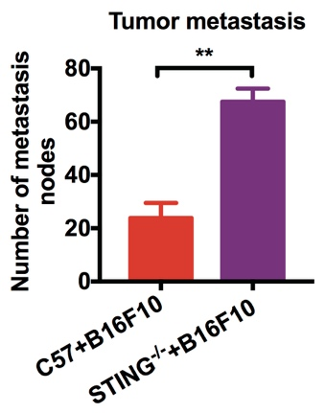
Figure S1: the metastatic foci in the lung tissues
Figure S2: The expressions of cytokines in liver tissues.
The expression of TNF-α, IL-2, IFN-γ and IFN-β in liver tissues was detected by RT-PCR. (*P<0.05, **P<0.01).
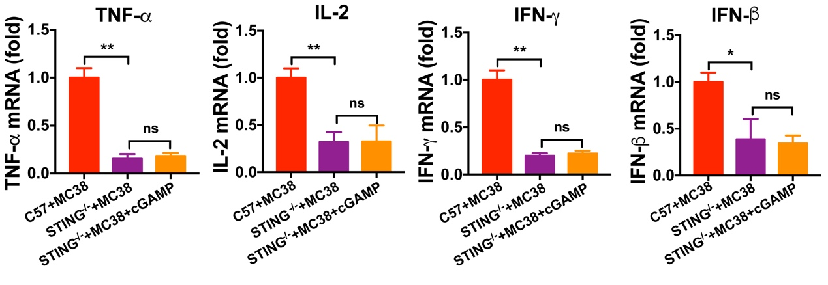
Figure S2: The expressions of cytokines in liver tissues

Figure S3: The expression of cytokines in liver tissues of CT26 tumor bearing metastatic mice.
The expression of cytokines in liver tissues of CT26 tumor bearing metastatic mice were quantified by RT-PCR. (**P<0.01, ##P<0.01).
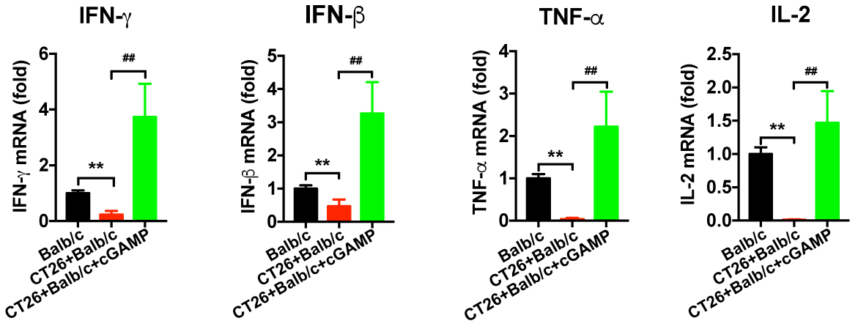
Figure S3: The expression of cytokines in liver tissues

