Supplemental data
Figure S1
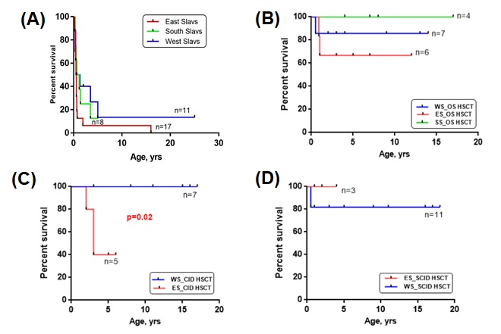
Figure S1. Overall survival displayed as Kaplan–Meier survival curve of WS, ES and SS patient groups without HSCT (A) and comparison of survival WS, ES, SS patients with OS (B), with CID (C), with SCID (D) after HSCT

