Supplementary material for manuscript Identifying functional impacts of heat-resistant fungi on boreal forest recovery after wildfire
Authors: Nicola J Day, Steven G Cumming, Kari E. Dunfield, Jill F Johnstone, Michelle C Mack, Kirsten A Reid, Merritt R Turetsky, Xanthe J Walker, Jennifer L Baltzer

Supplementary figures
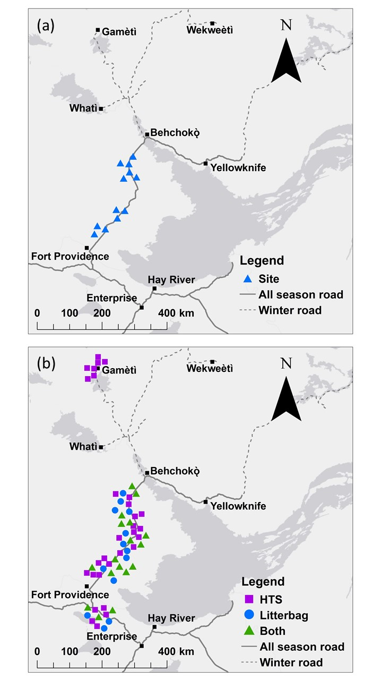
Fig. S1. Locations of plots in boreal forest stands of black spruce and jack pine on the Taiga Plains in the Northwest Territories, Canada. Maps show (a) locations of 12 plots from which soils were collected for culturing of heat-resistant fungi (blue triangles), and (b) locations of 30 plots where litterbags of black spruce and birch were located for in situ decomposition rates (blue circles), where high-throughput sequencing was conducted (purple squares), and where there were both litterbags and high-throughput sequencing occurred (n=17). Points are jittered to mitigate overlap but were at least 100 m from the road. See Fig. 1 for burn scars. Note that litterbags were at a total of 30 plots and high-throughput sequencing were at a total of 47 plots. There were three quadrats at each plot.

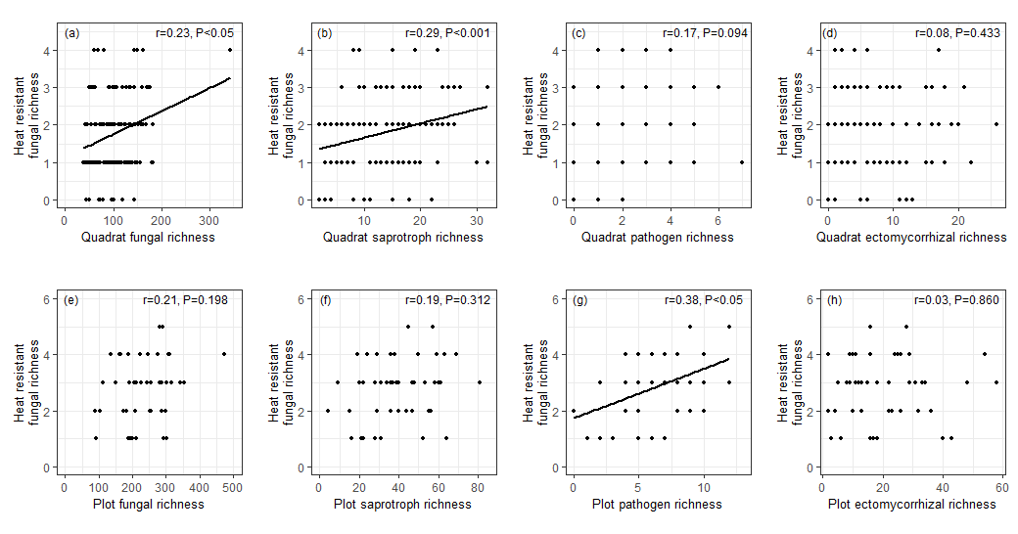Fig. S2. Correlations between measures of fungal richness and heat resistant fungal richness for (a) quadrat total fungal richness, (b) quadrat fungal saprotroph richness, (c) quadrat plant pathogen richness, (d) quadrat ectomycorrhizal richness, and (e) plot total fungal richness, (f) plot fungal saprotroph richness, (g) plot fungal plant pathogen richness, and (h) plot ectomycorrhizal richness. Information is based on matching Sanger sequences of the isolated heat-resistant fungal taxa with operational taxonomic units from high throughput sequencing (Illumina, MiSeq) sequences at 47 plots at 97% similarity. Operational taxonomic units to functions were assigned using FUNGuild. Spearman’s correlation coefficients (r) and false discovery rate-corrected P-values are shown. For (a) and (e) the direction and significance of relationships are unchanged when the outlier is removed. There were three quadrats at each plot.

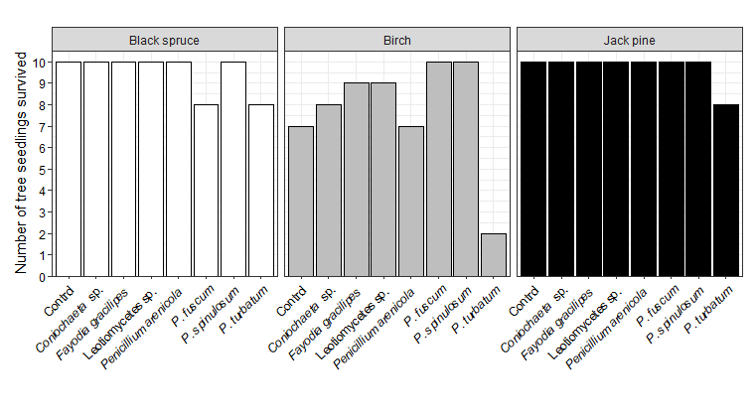
Fig. S3. Survival of seedlings of black spruce, birch, and jack pine inoculated with seven heat-resistant fungal taxa in growth chamber experiment over 10 weeks. There were 10 replicates for each plant-fungal combination at the beginning of the experiment. Control is the uninoculated treatment.

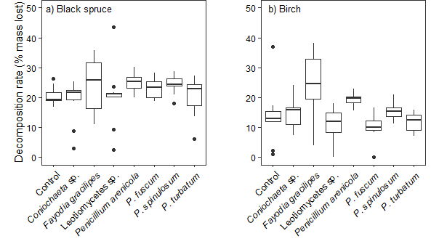
Fig. S4. Boxplots of raw data showing saprotrophic activity of seven heat-resistant fungal taxa, as measured by decomposition rates measured as mass lost of (a) black spruce and (b) birch litter over 10 weeks incubation in controlled conditions.

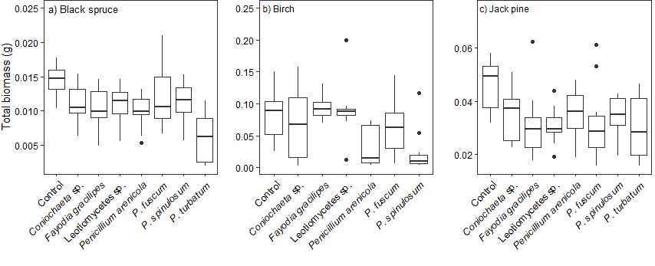
Fig. S5. Boxplots of raw data showing effects of seven heat-resistant fungi on seedling total biomass of (a) black spruce, (b) birch, and (c) jack pine in growth chamber over 10 weeks.
Fig. S6. Boxplot for in situ litter decomposition study showing percent mass lost for birch and black spruce litter after 12 months (40 litterbags at 8 plots) and 24 months (150 litterbags at 30 plots) in burned boreal forests in the Northwest Territories, Canada.

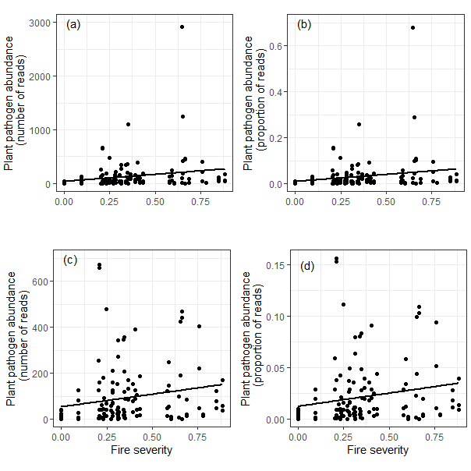
Fig. S7. Relationships between fire severity and fungal pathogen relative abundance in terms of number of reads (a) & (c) and proportion of reads (b) & (d) for 47 plots in burned boreal forests of the Northwest Territories, Canada. (c) and (d) show the relationships with very large values removed. Fungal pathogens were determined from high throughput sequencing data and linking operational taxonomic units to function using FUNGuild. Fire severity is measured as proportion soil organic layer combusted. Fire severity of zero denotes unburned plots. Spearman correlation coefficients: (a) r=0.21; (b) r=0.21; (c) r=0.20; (d) r=0.20.

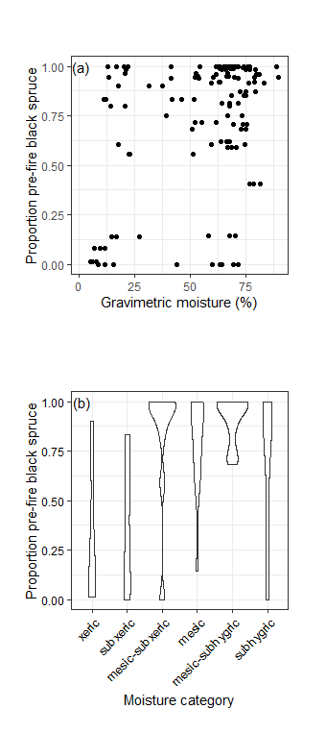
Fig. S8. Relationships between (a) gravimetric soil moisture (%) and (b) moisture category and proportion pre-fire black spruce stems at 47 plots in boreal forests of the Northwest Territories, Canada. Plot locations are the same as where soil fungal communities were characterised by high throughput sequencing. Gravimetric soil moisture was measured from a point sample in 2015 in the top 5 cm of soil and calculated from wet and dry weights. Moisture category was assessed for each plot in the field according to soil drainage and landscape position, with xeric as the driest and subhygric as the wettest.

Supplementary tables

Table S1. Mean, minimum, and maximum values for environmental and fire variables for the high throughput sequencing study (47 plots), the in situ decomposition study (30 plots), and where heat-resistant fungi were cultured from soils (12 plots) in boreal forests, Northwest Territories, Canada. The 12 plots where heat-resistant fungi were isolated were nested within the 47 plots where high throughput sequencing was done. 17 plots where the in situ decomposition study took place overlapped with the 47 high throughput sequencing plot (Fig. S1). Mean annual temperature is based on gridded data and was only downloaded for the 30 plots for the in situ decomposition study.
 | High throughput sequencing plots (n=47) | In situ decomposition plots (n=30) | Heat-resistant fungal isolations (n=12)
Stand type (proportion of pre-fire stems black spruce) | 0.75 (0, 1) | 0.70 (0, 1) | 0.64 (0.01, 0.95)
Stand age (years) | 108 (58, 232) | 112 (70, 232) | 91.6 (71, 145)
Fire severity (Proportion soil organic layer combusted) | 0.34 (0, 0.88) | 0.52 (0.09, 1) | 0.45 (0.23, 0.85)
Mean annual temperature in 2017 (ºC) | N/A | -2.0 (-2.7, -1.1) | N/A

Table S2. Sequenced fungal isolates that were cultured from heat-treated soils from burned boreal forest stands, Northwest Territories, Canada. Isolate code is the unique identifier used in this study. Identification is the fungal taxon based on sequences and morphology. Genbank accession is the code associated with the sequence deposited in genbank. DAOMC is the number associated with the culture in the Canadian Collection of Fungal Cultures. Closest genbank and max identity are shown. Species hypotheses and blast results from the UNITE database are shown (UNITE Community 2017). OTU is the operational taxonomic unit that was the closest match between the Sanger sequences from the cultured fungi and that of the Illumina sequences at 47 plots at 97% similarity. The F. gracilipes sequence matched two OTUs equally. *denotes isolates used in the incubation and growth chamber experiments
Isolate code | Identification | Genbank accession | DAOMC | Unite SH | Reference sequence | E value | Percent identity | OTU
*PENtur_ZF46-18B_HRF1 | Penicillium turbatum | MN410596 | 251861 | SH1529984.08FU | EF434072 | 0.0 | 100.00 | 898562
PENtur_ZF20-11A_HRF5 | Penicillium turbatum | MN410599 | 251863 | SH1529984.08FU | EF434072 | 0.0 | 99.82 | 898562
PENtur_ZF20-11B_HRF10 | Penicillium turbatum | MN410603 | 251862 | SH1529984.08FU | AF034454 | 0.0 | 99.82 | 898562
*FAYgra_ZF46-35C_HRF2 | Fayodia gracilipes | MN410597 | 251855 | SH1553066.08FU | KC176299 | 0.0 | 100.00 | 210980, 847195
*PENfus_ZF20-11B_HRF3 | Penicillium fuscum | MN410598 | 251865 | SH1529988.08FU | KJ508319 | 0.0 | 99.82 | 982916
PENfus_ZF46-18A_HRF11 | Penicillium fuscum | MN410604 | 251868 | SH1529988.08FU | KJ508319 | 0.0 | 99.64 | 982916
PENfus_ZF46-35B_HRF13 | Penicillium fuscum | MN410605 | 251866 | SH1529988.08FU | AF033411 | 0.0 | 100.00 | 982916
*PENspi_ZF46-18B_HRF8 | Penicillium spinulosum | MN410601 | 251858 | SH1529988.08FU | LN901135 | 0.0 | 99.64 | 715550
*PENare_ZF20-34C_HRF9 | Penicillium arenicola | MN410602 | 251859 | SH1532429.08FU | GU092963 | 0.0 | 99.82 | 385200
*CONsp_ZF20-11B_HRF7 | Coniochaeta sp. | MN410600 | 251857 | SH1645174.08FU | KJ188672 | 0.0 | 98.82 | 947267
*LEOsp_ZF46-18C_HRF14 | Leotiomycetes sp. | MN410606 | 251856 | SH1564438.08FU | EU292368 | 0.0 | 99.81 | 253574

Table S3. Assessment of colonisation of sterilised birch and black spruce litter by seven heat-resistant fungal taxa after incubation for 10 weeks. Colonisation was assessed at the end of the experiment from fungal growth from surface-disinfected litter on potato dextrose agar over 7 days.
 | Litter colonised? i.e. fungal growth observed?
Fungal taxon | Black spruce | Birch
Coniochaeta sp. | Yes | No
Fayodia gracilipes | Yes | Yes
Leotiomycetes sp. | No | No
Penicillium arenicola | Yes | Yes
P. fuscum | Yes | Yes
P. spinulosum | Yes | Yes
P. turbatum | Yes | Yes

Table S4. Model summaries from linear models assessing decomposition of birch and black spruce litter inoculated with seven heat-resistant fungi in incubation experiments over 10 weeks. Coefficient estimates for each fungal taxon are relative to uninoculated controls. Significant effects (P<0.05) are in bold. SE: standard error of the mean.
Plant | Fungus | Estimate | SE | t | P
Black spruce | Intercept (control) | 0.08 | 0.01 | 10.16 | <0.001
 | Coniochaeta sp. | -0.01 | 0.01 | -0.51 | 0.611
 | Fayodia gracilipes | 0.01 | 0.01 | 1.32 | 0.192
 | Leotiomycetes sp. | 0.00 | 0.01 | 0.03 | 0.977
 | Penicillium arenicola | 0.02 | 0.01 | 1.53 | 0.129
 | P. fuscum | 0.01 | 0.01 | 0.90 | 0.374
 | P. spinulosum | 0.02 | 0.01 | 1.36 | 0.179
 | P. turbatum | 0.00 | 0.01 | -0.02 | 0.987
Birch | Intercept (control) | 0.04 | 0.01 | 5.60 | <0.001
 | Coniochaeta sp. | 0.01 | 0.01 | 1.31 | 0.194
 | Fayodia gracilipes | 0.05 | 0.01 | 5.04 | <0.001
 | Leotiomycetes sp. | 0.00 | 0.01 | 0.02 | 0.988
 | Penicillium arenicola | 0.03 | 0.01 | 3.17 | <0.01
 | P. fuscum | 0.00 | 0.01 | -0.31 | 0.759
 | P. spinulosum | 0.02 | 0.01 | 1.68 | 0.098
 | P. turbatum | 0.00 | 0.01 | 0.35 | 0.728

Table S5. Summary of Tukey-Kramer post-hoc analyses to test differences between effects of each heat-resistant fungal taxon on decomposition rates of black spruce and birch litter in incubation experiments over 10 weeks. Significant contrasts (P<0.05) are in bold. SE: standard error of the mean.
Litter species | Contrast | Estimate | SE | Z | P
Black spruce | Coniochaeta sp. - F. gracilipes | -5.21 | 2.85 | -1.83 | 0.601
 | Coniochaeta sp. - Leotiomycetes sp. | -1.54 | 2.85 | -0.54 | 0.999
 | Coniochaeta sp. - P. arenicola | -5.83 | 2.85 | -2.05 | 0.451
 | Coniochaeta sp. - P. fuscum | -4.01 | 2.85 | -1.41 | 0.855
 | Coniochaeta sp. - P. spinulosum | -5.33 | 2.85 | -1.87 | 0.572
 | Coniochaeta sp. - P. turbatum | -1.41 | 2.85 | -0.49 | 1.000
 | F. gracilipes - Leotiomycetes sp. | 3.67 | 2.85 | 1.29 | 0.904
 | F. gracilipes - P. arenicola | -0.62 | 2.85 | -0.22 | 1.000
 | F. gracilipes - P. fuscum | 1.20 | 2.85 | 0.42 | 1.000
 | F. gracilipes - P. spinulosum | -0.12 | 2.85 | -0.04 | 1.000
 | F. gracilipes - P. turbatum | 3.80 | 2.85 | 1.33 | 0.887
 | Leotiomycetes sp. - P. arenicola | -4.29 | 2.85 | -1.51 | 0.805
 | Leotiomycetes sp. - P. fuscum | -2.47 | 2.85 | -0.87 | 0.989
 | Leotiomycetes sp. - P. spinulosum | -3.79 | 2.85 | -1.33 | 0.888
 | Leotiomycetes sp. - P. turbatum | 0.13 | 2.85 | 0.05 | 1.000
 | P. arenicola - P. fuscum | 1.82 | 2.85 | 0.64 | 0.998
 | P. arenicola - P. spinulosum | 0.50 | 2.85 | 0.18 | 1.000
 | P. arenicola - P. turbatum | 4.42 | 2.85 | 1.55 | 0.779
 | P. fuscum - P. spinulosum | -1.32 | 2.85 | -0.46 | 1.000
 | P. fuscum - P. turbatum | 2.60 | 2.85 | 0.91 | 0.985
 | P. spinulosum - P. turbatum | 3.92 | 2.85 | 1.37 | 0.869
Birch | Coniochaeta sp. - F. gracilipes | -9.81 | 2.48 | -3.96 | <0.01
 | Coniochaeta sp. - Leotiomycetes sp. | 3.41 | 2.55 | 1.34 | 0.885
 | Coniochaeta sp. - P. arenicola | -4.88 | 2.48 | -1.97 | 0.502
 | Coniochaeta sp. - P. fuscum | 4.26 | 2.48 | 1.72 | 0.675
 | Coniochaeta sp. - P. spinulosum | -0.97 | 2.48 | -0.39 | 1.000
 | Coniochaeta sp. - P. turbatum | 2.53 | 2.48 | 1.02 | 0.972
 | F. gracilipes - Leotiomycetes sp. | 13.22 | 2.55 | 5.19 | <0.001
 | F. gracilipes - P. arenicola | 4.93 | 2.48 | 1.99 | 0.491
 | F. gracilipes - P. fuscum | 14.07 | 2.48 | 5.68 | <0.001
 | F. gracilipes - P. spinulosum | 8.84 | 2.48 | 3.57 | <0.01
 | F. gracilipes - P. turbatum | 12.34 | 2.48 | 4.98 | <0.001
 | Leotiomycetes sp. - P. arenicola | -8.29 | 2.55 | -3.26 | <0.05
 | Leotiomycetes sp. - P. fuscum | 0.85 | 2.55 | 0.33 | 1.000
 | Leotiomycetes sp. - P. spinulosum | -4.38 | 2.55 | -1.72 | 0.676
 | Leotiomycetes sp. - P. turbatum | -0.88 | 2.55 | -0.34 | 1.000
 | P. arenicola - P. fuscum | 9.14 | 2.48 | 3.69 | <0.01
 | P. arenicola - P. spinulosum | 3.92 | 2.48 | 1.58 | 0.763
 | P. arenicola - P. turbatum | 7.41 | 2.48 | 2.99 | 0.056
 | P. fuscum - P. spinulosum | -5.23 | 2.48 | -2.11 | 0.409
 | P. fuscum - P. turbatum | -1.73 | 2.48 | -0.70 | 0.997
 | P. spinulosum - P. turbatum | 3.50 | 2.48 | 1.41 | 0.853

Table S6. Summary from linear models assessing total biomass and root-shoot ratio of birch, black spruce, and jack pine inoculated with seven heat-resistant fungi in growth chamber over 10 weeks. Coefficient estimates for each fungus are relative to uninoculated controls. All but two birch seedlings died when inoculated with Penicillium turbatum so this effect was not included in the model. Significant effects (P<0.05) are in bold, based on corrected values for multiple tests on the same experimental units. Black spruce coefficients are presented to 3 d.p. due to seedlings being very small. SE: standard error of the mean.
 |  | Total biomass |  |  |  | Root-shoot
Plant | Fungus | Estimate | SE | t | P | Estimate | SE | t | P
Black spruce | Intercept (control) | 0.014 | 0.001 | 14.39 | <0.001 | 0.71 | 0.09 | 7.51 | <0.001
 | Coniochaeta sp. | -0.004 | 0.001 | -2.47 | <0.05 | -0.08 | 0.13 | -0.63 | 0.654
 | Fayodia gracilipes | -0.004 | 0.001 | -3.06 | <0.01 | -0.07 | 0.13 | -0.52 | 0.692
 | Leotiomycetes sp. | -0.003 | 0.001 | -2.39 | <0.05 | -0.10 | 0.13 | -0.78 | 0.588
 | Penicillium arenicola | -0.005 | 0.001 | -3.24 | <0.01 | -0.26 | 0.13 | -1.96 | 0.096
 | P. fuscum | -0.002 | 0.002 | -1.51 | 0.217 | 0.00 | 0.14 | -0.01 | 0.994
 | P. spinulosum | -0.003 | 0.001 | -2.27 | 0.053 | -0.05 | 0.13 | -0.39 | 0.748
 | P. turbatum | -0.008 | 0.002 | -5.52 | <0.001 | -0.15 | 0.14 | -1.08 | 0.415
Birch | Intercept (control) | 0.08 | 0.02 | 5.04 | <0.001 | 0.63 | 0.09 | 6.81 | <0.001
 | Coniochaeta sp. | -0.01 | 0.02 | -0.50 | 0.766 | -0.05 | 0.13 | -0.37 | 0.766
 | Fayodia gracilipes | 0.01 | 0.02 | 0.55 | 0.766 | -0.06 | 0.13 | -0.47 | 0.766
 | Leotiomycetes sp. | 0.01 | 0.02 | 0.41 | 0.766 | 0.04 | 0.12 | 0.30 | 0.766
 | Penicillium arenicola | -0.05 | 0.02 | -2.07 | 0.153 | 0.08 | 0.13 | 0.58 | 0.766
 | P. fuscum | -0.02 | 0.02 | -0.80 | 0.766 | -0.06 | 0.12 | -0.46 | 0.766
 | P. spinulosum | -0.06 | 0.02 | -2.69 | <0.05 | 0.08 | 0.12 | 0.63 | 0.766
Jack pine | Intercept (control) | 0.05 | 0.00 | 13.59 | <0.001 | 1.11 | 0.08 | 14.55 | <0.001
 | Coniochaeta sp. | -0.01 | 0.00 | -2.38 | <0.05 | 0.07 | 0.11 | 0.67 | 0.676
 | Fayodia gracilipes | -0.01 | 0.00 | -3.02 | <0.05 | -0.09 | 0.11 | -0.81 | 0.612
 | Leotiomycetes sp. | -0.02 | 0.00 | -3.15 | <0.05 | -0.05 | 0.11 | -0.47 | 0.730
 | Penicillium arenicola | -0.01 | 0.00 | -2.26 | <0.05 | -0.03 | 0.11 | -0.31 | 0.784
 | P. fuscum | -0.01 | 0.00 | -2.96 | <0.05 | -0.10 | 0.11 | -0.93 | 0.573
 | P. spinulosum | -0.01 | 0.00 | -2.44 | <0.05 | 0.03 | 0.11 | 0.28 | 0.784
 | P. turbatum | -0.02 | 0.01 | -3.12 | <0.01 | -0.06 | 0.11 | -0.49 | 0.730

Table S7. Summary of Tukey-Kramer post-hoc analyses to test differences between effects of each heat-resistant fungal taxon on total biomass of black spruce, birch, and jack pine seedlings in growth chamber experiments over 10 weeks. Significant contrasts (P<0.05) are in bold. SE: standard error of the mean.
Seedling species | Contrast | Estimate | SE | Z | P
Black spruce | Coniochaeta sp. - F. gracilipes | 0.00 | 0.00 | 0.58 | 0.999
 | Coniochaeta sp. - Leotiomycetes sp. | 0.00 | 0.00 | -0.08 | 1.000
 | Coniochaeta sp. - P. arenicola | 0.00 | 0.00 | 0.77 | 0.995
 | Coniochaeta sp. - P. fuscum | 0.00 | 0.00 | -0.82 | 0.992
 | Coniochaeta sp. - P. spinulosum | 0.00 | 0.00 | -0.20 | 1.000
 | Coniochaeta sp. - P. turbatum | 0.00 | 0.00 | 3.19 | 0.031
 | F. gracilipes - Leotiomycetes sp. | 0.00 | 0.00 | -0.67 | 0.998
 | F. gracilipes - P. arenicola | 0.00 | 0.00 | 0.18 | 1.000
 | F. gracilipes - P. fuscum | 0.00 | 0.00 | -1.37 | 0.871
 | F. gracilipes - P. spinulosum | 0.00 | 0.00 | -0.79 | 0.994
 | F. gracilipes - P. turbatum | 0.00 | 0.00 | 2.64 | 0.143
 | Leotiomycetes sp. - P. arenicola | 0.00 | 0.00 | 0.85 | 0.990
 | Leotiomycetes sp. - P. fuscum | 0.00 | 0.00 | -0.74 | 0.996
 | Leotiomycetes sp. - P. spinulosum | 0.00 | 0.00 | -0.12 | 1.000
 | Leotiomycetes sp. - P. turbatum | 0.00 | 0.00 | 3.27 | 0.024
 | P. arenicola - P. fuscum | 0.00 | 0.00 | -1.54 | 0.784
 | P. arenicola - P. spinulosum | 0.00 | 0.00 | -0.97 | 0.978
 | P. arenicola - P. turbatum | 0.00 | 0.00 | 2.46 | 0.211
 | P. fuscum - P. spinulosum | 0.00 | 0.00 | 0.63 | 0.999
 | P. fuscum - P. turbatum | 0.01 | 0.00 | 3.80 | 0.004
 | P. spinulosum - P. turbatum | 0.01 | 0.00 | 3.38 | 0.017
Birch | Coniochaeta sp. - F. gracilipes | -0.02 | 0.02 | -1.06 | 0.939
 | Coniochaeta sp. - Leotiomycetes sp. | -0.02 | 0.02 | -0.95 | 0.964
 | Coniochaeta sp. - P. arenicola | 0.04 | 0.02 | 1.64 | 0.656
 | Coniochaeta sp. - P. fuscum | 0.01 | 0.02 | 0.29 | 1.000
 | Coniochaeta sp. - P. spinulosum | 0.05 | 0.02 | 2.25 | 0.268
 | F. gracilipes - Leotiomycetes sp. | 0.00 | 0.02 | 0.17 | 1.000
 | F. gracilipes - P. arenicola | 0.06 | 0.02 | 2.62 | 0.121
 | F. gracilipes - P. fuscum | 0.03 | 0.02 | 1.39 | 0.807
 | F. gracilipes - P. spinulosum | 0.07 | 0.02 | 3.28 | 0.018
 | Leotiomycetes sp. - P. arenicola | 0.06 | 0.02 | 2.60 | 0.126
 | Leotiomycetes sp. - P. fuscum | 0.03 | 0.02 | 1.30 | 0.851
 | Leotiomycetes sp. - P. spinulosum | 0.07 | 0.02 | 3.33 | 0.015
 | P. arenicola - P. fuscum | -0.03 | 0.02 | -1.45 | 0.777
 | P. arenicola - P. spinulosum | 0.01 | 0.02 | 0.45 | 0.999
 | P. fuscum - P. spinulosum | 0.04 | 0.02 | 2.08 | 0.362
Jack pine | Coniochaeta sp. - F. gracilipes | 0.00 | 0.00 | 0.64 | 0.998
 | Coniochaeta sp. - Leotiomycetes sp. | 0.00 | 0.00 | 0.77 | 0.995
 | Coniochaeta sp. - P. arenicola | 0.00 | 0.00 | -0.12 | 1.000
 | Coniochaeta sp. - P. fuscum | 0.00 | 0.00 | 0.58 | 0.999
 | Coniochaeta sp. - P. spinulosum | 0.00 | 0.00 | 0.06 | 1.000
 | Coniochaeta sp. - P. turbatum | 0.00 | 0.01 | 0.88 | 0.988
 | F. gracilipes - Leotiomycetes sp. | 0.00 | 0.00 | 0.13 | 1.000
 | F. gracilipes - P. arenicola | 0.00 | 0.00 | -0.76 | 0.995
 | F. gracilipes - P. fuscum | 0.00 | 0.00 | -0.07 | 1.000
 | F. gracilipes - P. spinulosum | 0.00 | 0.00 | -0.58 | 0.999
 | F. gracilipes - P. turbatum | 0.00 | 0.01 | 0.27 | 1.000
 | Leotiomycetes sp. - P. arenicola | 0.00 | 0.00 | -0.89 | 0.987
 | Leotiomycetes sp. - P. fuscum | 0.00 | 0.00 | -0.19 | 1.000
 | Leotiomycetes sp. - P. spinulosum | 0.00 | 0.00 | -0.70 | 0.997
 | Leotiomycetes sp. - P. turbatum | 0.00 | 0.01 | 0.15 | 1.000
 | P. arenicola - P. fuscum | 0.00 | 0.00 | 0.70 | 0.997
 | P. arenicola - P. spinulosum | 0.00 | 0.00 | 0.18 | 1.000
 | P. arenicola - P. turbatum | 0.01 | 0.01 | 0.99 | 0.976
 | P. fuscum - P. spinulosum | 0.00 | 0.00 | -0.51 | 1.000
 | P. fuscum - P. turbatum | 0.00 | 0.01 | 0.33 | 1.000
 | P. spinulosum - P. turbatum | 0.00 | 0.01 | 0.82 | 0.992

Table S8. Assessment of colonisation of roots of birch and black spruce that had been inoculated by seven heat-resistant fungal taxa after 10 weeks of seedling growth. Colonisation was assessed at the end of the experiment from fungal growth from surface-disinfected litter on potato dextrose agar over 7 days.
 | Fungal growth observed? i.e. roots colonised?
Fungal taxon | Black spruce | Birch | Jack pine
Coniochaeta sp. | No | Yes | Yes
Fayodia gracilipes | No | No | No
Leotiomycetes sp. | No | Yes | Yes
Penicillium arenicola | Yes | Yes | Yes
P. fuscum | No | Yes | No
P. spinulosum | No | No | Yes
P. turbatum | No | Yes | No

Table S9. Summaries from linear mixed effects models assessing fire and forest stand drivers of in situ litter decomposition rates of birch and black spruce in litterbags over 24 months at 30 plots in burned boreal forests, Northwest Territories, Canada. Standardised values for the predictors are shown. Plot was the random effect (black spruce SD: 2.27; birch SD 3.77). Significant effects (P<0.05) are in bold. SE: standard error of the mean.
Litter | Predictor | Estimate | SE | t | P
Black spruce | Intercept | 33.99 | 0.54 | 62.93 | <0.001
 | Fire severity | -0.13 | 0.62 | -0.21 | 0.837
 | Stand age | 1.68 | 0.76 | 2.21 | <0.05
 | Stand type | 0.45 | 0.65 | 0.70 | 0.492
 | Mean annual temperature | 0.61 | 0.84 | 0.72 | 0.475
Birch | Intercept | 45.25 | 0.60 | 75.08 | <0.001
 | Fire severity | 0.50 | 0.69 | 0.72 | 0.478
 | Stand age | 0.70 | 0.85 | 0.83 | 0.417
 | Stand type | 1.65 | 0.72 | 2.27 | <0.05
 | Mean annual temperature | -0.02 | 0.93 | -0.02 | 0.989

Table S10. Summary of mixed effect models assessing plot moisture category as a predictor of in situ decomposition rates of birch and black spruce after 24 months at 30 plots in burned boreal forests, Northwest Territories, Canada. Moisture category was the predictor with the driest category, xeric, as the reference level. Plot was the random effect (black spruce SD: 4.20; birch SD 4.20). SE: standard error of the mean.
Litter species | Moisture category | Estimate | SE | t | P
Black spruce | Intercept (Xeric) | 31.26 | 1.63 | 19.16 | <0.001
 | Subxeric | 3.28 | 3.05 | 1.07 | 0.293
 | Mesic-subxeric | 3.39 | 2.04 | 1.67 | 0.109
 | Mesic | 2.25 | 2.14 | 1.05 | 0.303
 | Mesic-subhygric | 4.04 | 2.31 | 1.75 | 0.093
 | Subhygric | 4.44 | 3.05 | 1.46 | 0.158
Birch | Intercept (Xeric) | 42.47 | 1.75 | 24.21 | <0.001
 | Subxeric | 4.83 | 3.28 | 1.47 | 0.154
 | Mesic-subxeric | 2.58 | 2.19 | 1.18 | 0.249
 | Mesic | 2.97 | 2.30 | 1.29 | 0.210
 | Mesic-subhygric | 4.02 | 2.48 | 1.62 | 0.119
 | Subhygric | 2.32 | 3.28 | 0.71 | 0.487

Table S11. Summary of Tukey-Kramer post hoc contrasts for moisture category as a predictor of in situ decomposition rates of black spruce and birch litter after 24 months at 30 plots in burned boreal forests, Northwest Territories, Canada.
Litter species | Contrast | Estimate | SE | t | P
Black spruce | Xeric - Subxeric | -3.28 | 3.05 | -1.07 | 0.887
 | Xeric -Mesic-subxeric | -3.39 | 2.04 | -1.67 | 0.565
 | Xeric - Mesic | -2.25 | 2.14 | -1.05 | 0.895
 | Xeric - Mesic-subhygric | -4.04 | 2.31 | -1.75 | 0.513
 | Xeric - Subhygric | -4.44 | 3.05 | -1.46 | 0.694
 | Subxeric - Mesic-subxeric | -0.12 | 2.85 | -0.04 | 1.000
 | Subxeric - Mesic | 1.03 | 2.93 | 0.35 | 0.999
 | Subxeric - Mesic-subhygric | -0.76 | 3.05 | -0.25 | 1.000
 | Subxeric - Subhygric | -1.16 | 3.65 | -0.32 | 1.000
 | Mesic-subxeric - Mesic | 1.14 | 1.85 | 0.62 | 0.989
 | Mesic-subxeric - Mesic-subhygric | -0.65 | 2.04 | -0.32 | 1.000
 | Mesic-subxeric - Subhygric | -1.05 | 2.85 | -0.37 | 0.999
 | Mesic – Mesic-subhygric | -1.79 | 2.14 | -0.84 | 0.958
 | Mesic - Subhygric | -2.19 | 2.93 | -0.75 | 0.974
 | Mesic-subhygric - Subhygric | -0.40 | 3.05 | -0.13 | 1.000
Birch | Xeric - Subxeric | -4.83 | 3.28 | -1.47 | 0.685
 | Xeric -Mesic-subxeric | -2.58 | 2.19 | -1.18 | 0.841
 | Xeric - Mesic | -2.97 | 2.30 | -1.29 | 0.788
 | Xeric - Mesic-subhygric | -4.02 | 2.48 | -1.62 | 0.595
 | Xeric - Subhygric | -2.32 | 3.28 | -0.71 | 0.979
 | Subxeric - Mesic-subxeric | 2.25 | 3.07 | 0.73 | 0.976
 | Subxeric - Mesic | 1.86 | 3.15 | 0.59 | 0.991
 | Subxeric - Mesic-subhygric | 0.81 | 3.28 | 0.25 | 1.000
 | Subxeric - Subhygric | 2.51 | 3.92 | 0.64 | 0.987
 | Mesic-subxeric - Mesic | -0.38 | 1.98 | -0.19 | 1.000
 | Mesic-subxeric - Mesic-subhygric | -1.43 | 2.19 | -0.65 | 0.985
 | Mesic-subxeric - Subhygric | 0.27 | 3.07 | 0.09 | 1.000
 | Mesic – Mesic-subhygric | -1.05 | 2.30 | -0.46 | 0.997
 | Mesic - Subhygric | 0.65 | 3.15 | 0.21 | 1.000
 | Mesic-subhygric - Subhygric | 1.70 | 3.28 | 0.52 | 0.995

Table S12. Mean values (±SD) for carbon, nitrogen, and C:N ratio for dried, non-autoclaved litter and autoclaved litter of birch and black spruce. Values are based on three samples of each litter type. Samples were homogenised and ground to a fine powder. Up to 2 mg was weighed into tin capsules. Measurements were taken using a Perkin Elmer 2400 CHNS Analyser, (Guelph, ON, Canada) with acetanilide standards.
 | C |  | N |  | C:N
Litter species | Non-autoclaved | Autoclaved | Non-autoclaved | Autoclaved | Non-autoclaved | Autoclaved
Birch | 46.6 ± 1.1 | 46.6 ± 2.54 | 1 ± 0.09 | 0.87 ± 0.06 | 46.7 ± 2.97 | 53.4 ± 1.5
Black spruce | 46.6 ± 1.81 | 49 ± 0.44 | 0.76 ± 0.02 | 0.72 ± 0.03 | 61.1 ± 3.59 | 68.1 ± 2.35

