Supplementary Material
Table S1. Sampling conditions, location and water chemistry parameters for each sample in the Antarctica
Sampling site | Sampling dates  (local time) | Latitude / Longitude | Temp.  (ºC) | Salinity  (PSU) | DOC (μM) | DON (μM) | DOC/  DON
OS1 | Apr. 14, 2018 | 62.036ºS / 56.23ºW | 0.7165 | 34.165 | 54.1 ± 3.8 | 24.0 ± 0.5 | 2.26
OS2 | Apr. 17, 2018 | 62.125ºS / 56.13ºW | 0.8524 | 34.162 | 65.0 ± 3.6 | 33.2 ± 0.5 | 1.96
FJ1 | May 01, 2018 | 62.205ºS / 58.74ºW | 0.1173 | 33.889 | 63.8 ± 0.6 | 30.5 ± 0.2 | 2.09
FJ2 | Apr. 30, 2018 | 62.214ºS / 58.77ºW | 0.2887 | 34.042 | 51.7 ±3.8 | 30.6 ± 1.0 | 1.69
FJ3 | Apr. 30, 2018 | 62.218ºS / 58.79ºW | 0.1839 | 34.038 | 48.9 ± 0.2 | 29.9 ± 1.5 | 1.63
FJ4 | Apr. 29, 2018 | 62.230ºS / 58.84ºW | 0.2666 | 34.012 | 38.8 ± 4.6 | 23.5 ± 1.4 | 1.65

Supplementary Tables

Table S2. Optical properties for each sample in the Antarctica
DOM characteristics |  |  | Sampling sites
Contents (unit) | Description |  | OS1 | OS2 | FJ1 | FJ2 | FJ3 | FJ4
CDOM (m⁻¹) | - |  | 0.00 | 0.31±0.03 | 0.97±0.01 | 0.79±0.12 | 0.39±0.02 | 0.57±0.06
Peak A (%) | Terrestrial humic-like |  | 22.5 | 31.0 | 31.2 | 29.5 | 32.1 | 34.0
Peak M (%) | Marine humic-like |  | 22.6 | 30.0 | 27.5 | 29.7 | 31.6 | 32.7
Peak C (%) | Humic-like |  | 19.8 | 18.7 | 17.7 | 17.8 | 18.4 | 18.4
Peak B (%) | Protein-like (Tyrosine) |  | 17.2 | 7.4 | 11.0 | 7.8 | 9.0 | 7.4
Peak T (%) | Protein-like (Tryptophane) |  | 18.0 | 12.9 | 12.5 | 15.3 | 9.0 | 7.5
FI | Fluorescence index |  | 1.08 | 1.05 | 0.97 | 1.03 | 0.90 | 1.16
HIX | Humified index |  | 0.63 | 0.59 | 0.65 | 0.45 | 0.70 | 0.49
BIX | Biological index |  | 0.37 | 0.76 | 0.68 | 0.76 | 0.73 | 0.74
(continued)
DOM characteristics |  |  | Sampling sites
Contents (unit) | Description |  | OS1 | OS2 | FJ1 | FJ2 | FJ3 | FJ4
Lipid (%) | Lipid-like |  | 39.2 | 39.2 | 36.9 | 37.4 | 35.2 | 39.2
Proteins (%) | Proteins-like |  | 13.1 | 11.8 | 9.7 | 10.9 | 10.7 | 9.3
Carbo (%) | Carbohydrate-like |  | 1.7 | 1.8 | 2.4 | 2.5 | 2.5 | 2.3
UH (%) | Unsaturated Hydrocarbon-like |  | 33.7 | 30.9 | 29.7 | 28.6 | 32.0 | 26.5
Lignin (%) | Lignin-like |  | 4.3 | 5.4 | 4.8 | 5.1 | 3.4 | 5.0
Tannins (%) | Tannins-like |  | 2.0 | 2.7 | 4.5 | 3.8 | 4.9 | 4.7
CAS (%) | Condensed Aromatic Structures |  | 6.1 | 8.3 | 11.9 | 11.7 | 11.2 | 13.1

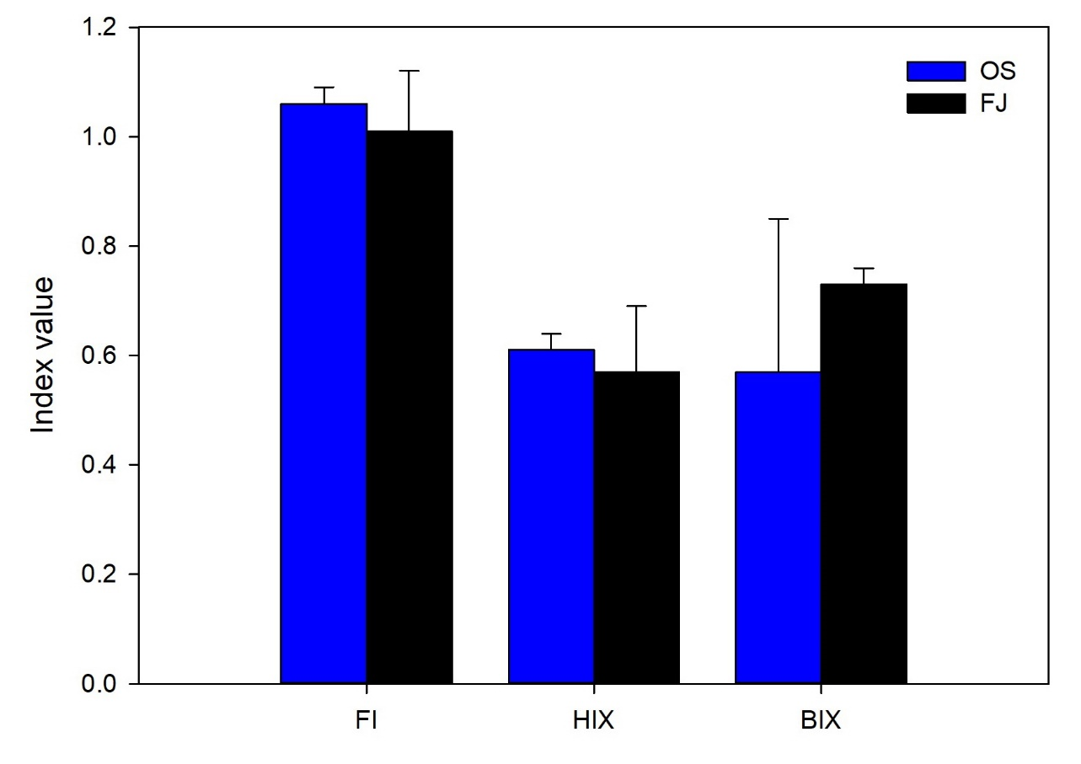
Supplementary Figure 1. Fluorescence indices (FI: fluorescence index, HIX: humification index and BIX: biological index). Error bars refer to the standard deviation. The average HIX values for the OS and FJ areas were both less than 10, indicating that the DOM was relatively not degraded by microorganisms. DOM in aquatic environments can be divided into labile and refractory types. The latter has double bonds and aromatic structures that are not easily decomposed by microorganisms, of which humic substances are representative (Hur et al., 2006). Therefore, there are two possibilities: either that degradation is slow due to a high proportion of DOM input from terrestrial sources (McKnight et al., 2001), or that the DOM has been freshly produced via plant biomass or animal waste (Birdwell and Engel, 2010). The FI and BIX from the EEM analysis are indicators of the origin of the DOM (McKnight et al., 2001). The FI values of the OS and FJ areas were all lower than 1.4, indicating that the DOM in those sites more likely resulted from terrestrial sources than microorganisms. Additionally, according to the BIX values being between 0.6 and 1.0, it is estimated that the DOM includes both oceanic biological and terrestrial origins.

Supplementary Figures
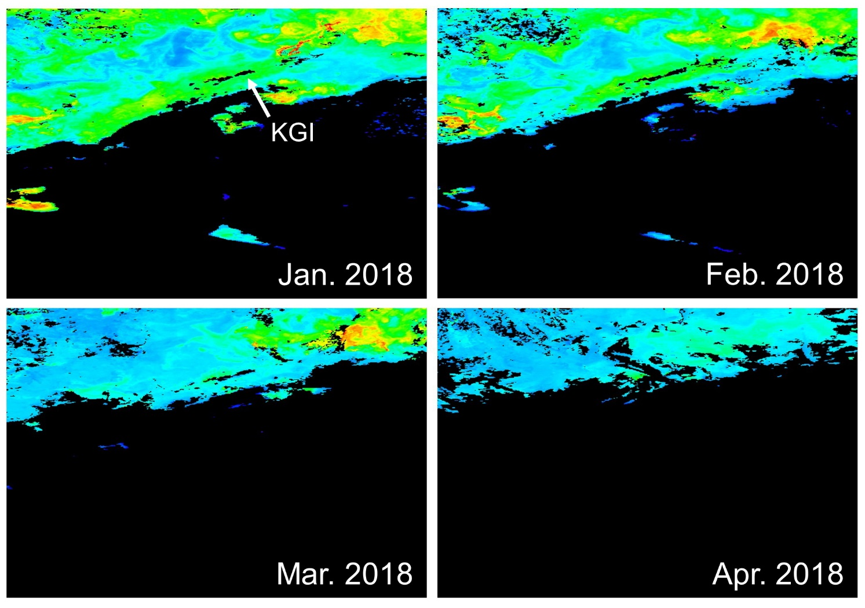
Supplementary Figure 2. The average chlorophyll-a distributions at each month. The colors indicate the concentrations of chlorophyll-a recorded by the satellite (MODIS Aqua). The arrow points to King George Island (KGI). Image credit: NASA Ocean Color (https://oceancolor.gsfc.nasa.gov/).

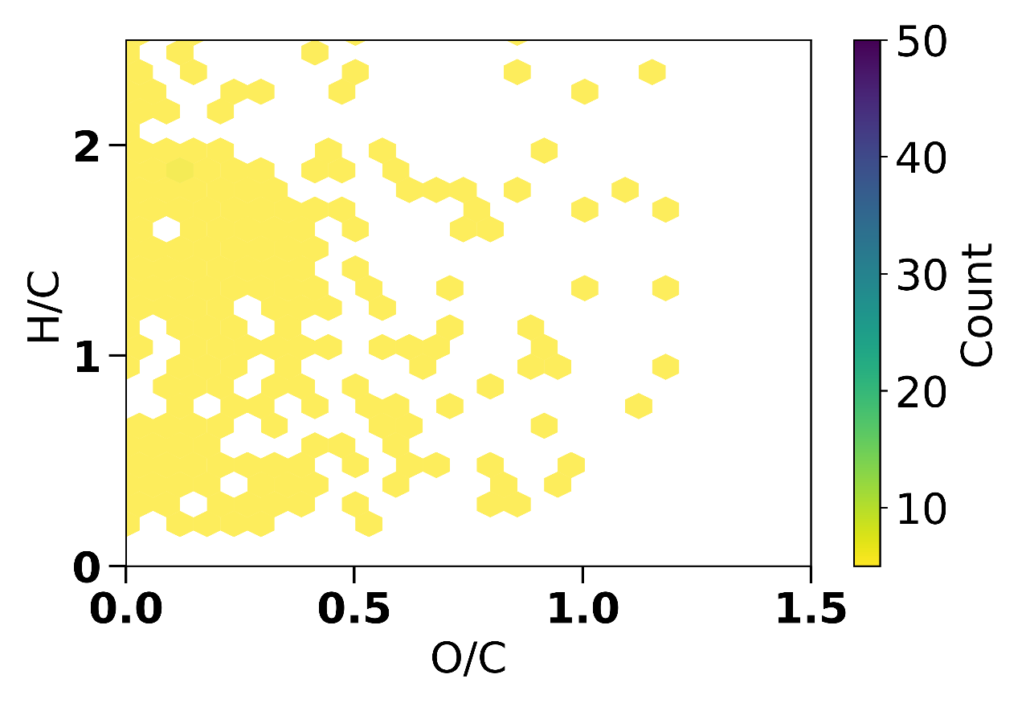
Supplementary Figure 3. The van Krevelen diagram of Milli-Q water (18Mohm) in the range of 100–900 m/z. Ultrapure laboratory water was analyzed using LC-Orbitrap-MS under the same operational conditions with seawater samples. In addition, the number of molecular formulae of ultrapure laboratory water was subtracted from that of seawater samples, which were represented in Fig. 4b and Table S2.

