Supplementary Material

Supplementary Figure 1. The figure legends are required to have the same font as the main text, 12 point normal Times New Roman, single spaced. Please use a single paragraph for each legend and prepare the figures keeping in mind the PDF layout.

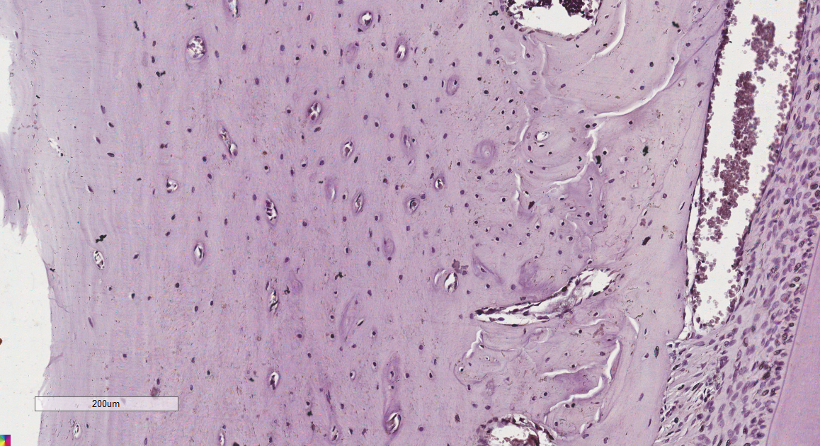
Supplementary Figure 1. Representative cut of the control group in the 20x objective. The brown areas represent the staining of β-catenin by the chromogen. Contra-staining: Hematoxylin.
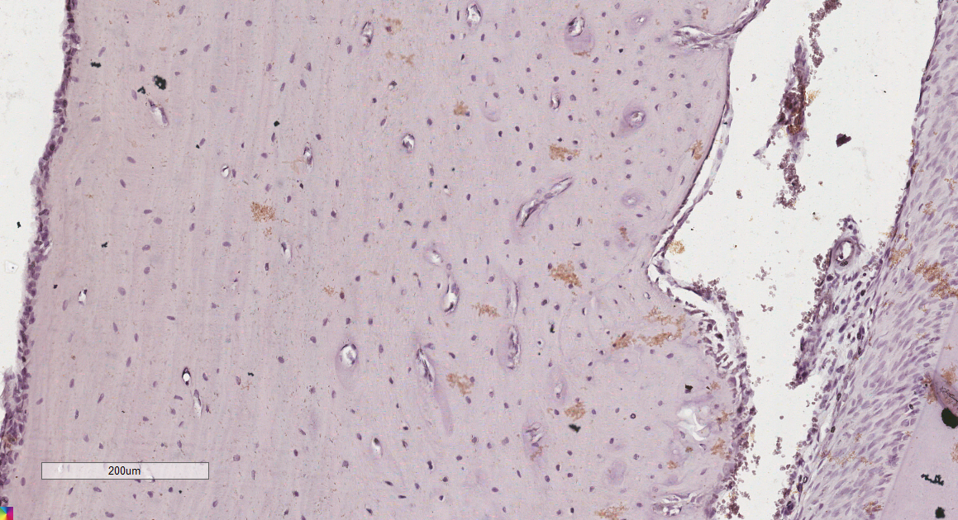
Supplementary Figure 2. Representative cut of the 5 days group in the 20x objective. The brown areas represent the staining of β-catenin by the chromogen. Contra-staining: Hematoxylin.
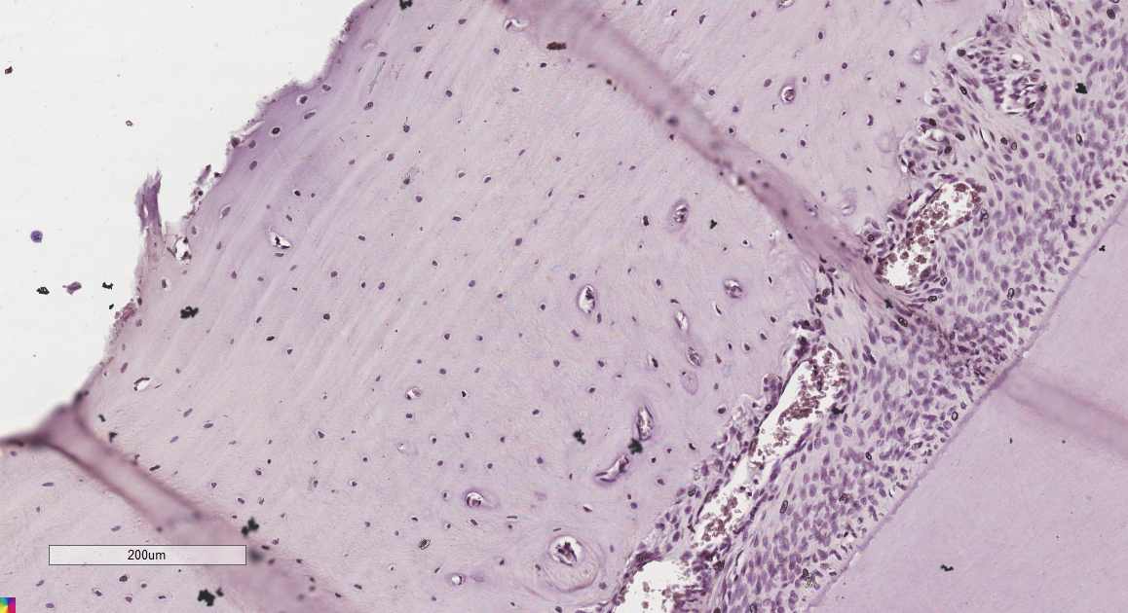
Supplementary Figure 3. Representative cut of the 7 days group in the 20x objective. The brown areas represent the staining of β-catenin by the chromogen. Contra-staining: Hematoxylin.
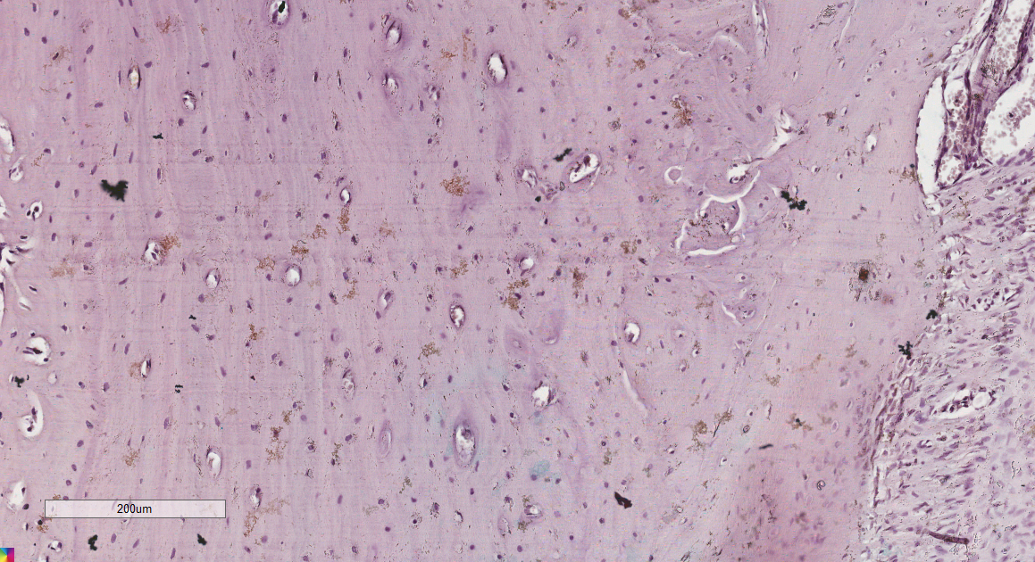
Supplementary Figure 4. Representative cut of the 14 days group in the 20x objective. The brown areas represent the staining of β-catenin by the chromogen. Contra-staining: Hematoxylin.

