A Virtual Reality Simulation of Drug Users' Everyday Life: the Effect of Supported Sensorimotor Contingencies on Empathy
Maria Christofi, Despina Michael-Grigoriou, Christos Kyrlitsias

Supplementary Material - Table 1:
Additional views from the various scenes

Figure S1. Additional views from Scene 1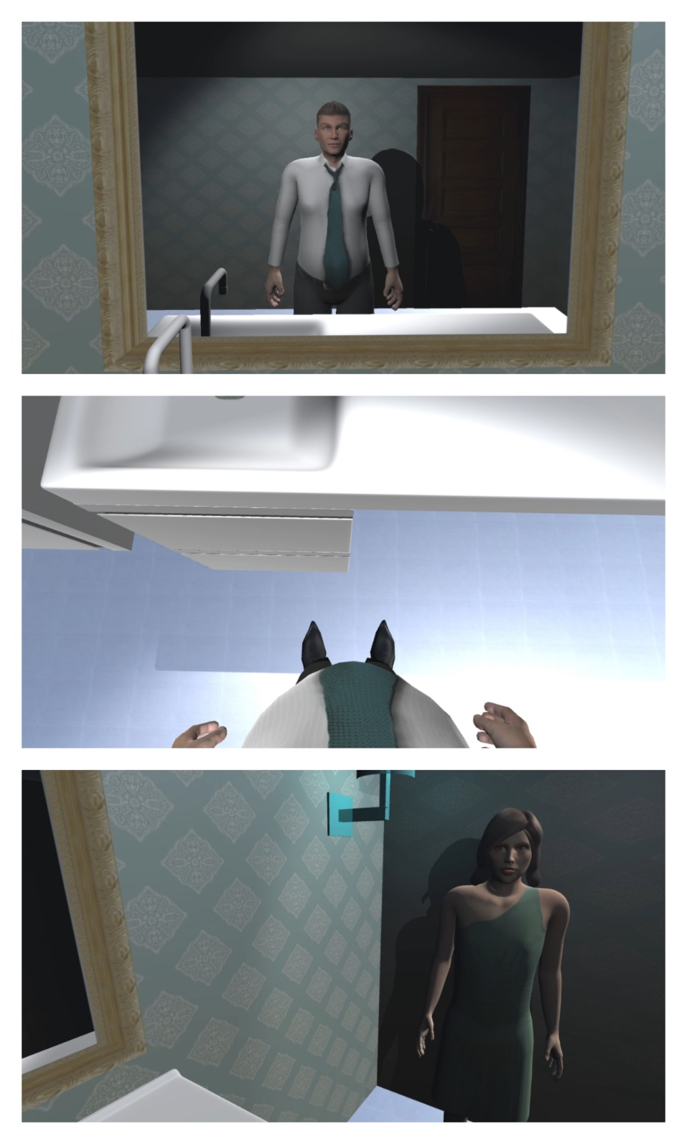

Figure S2. Additional views from Scene 2
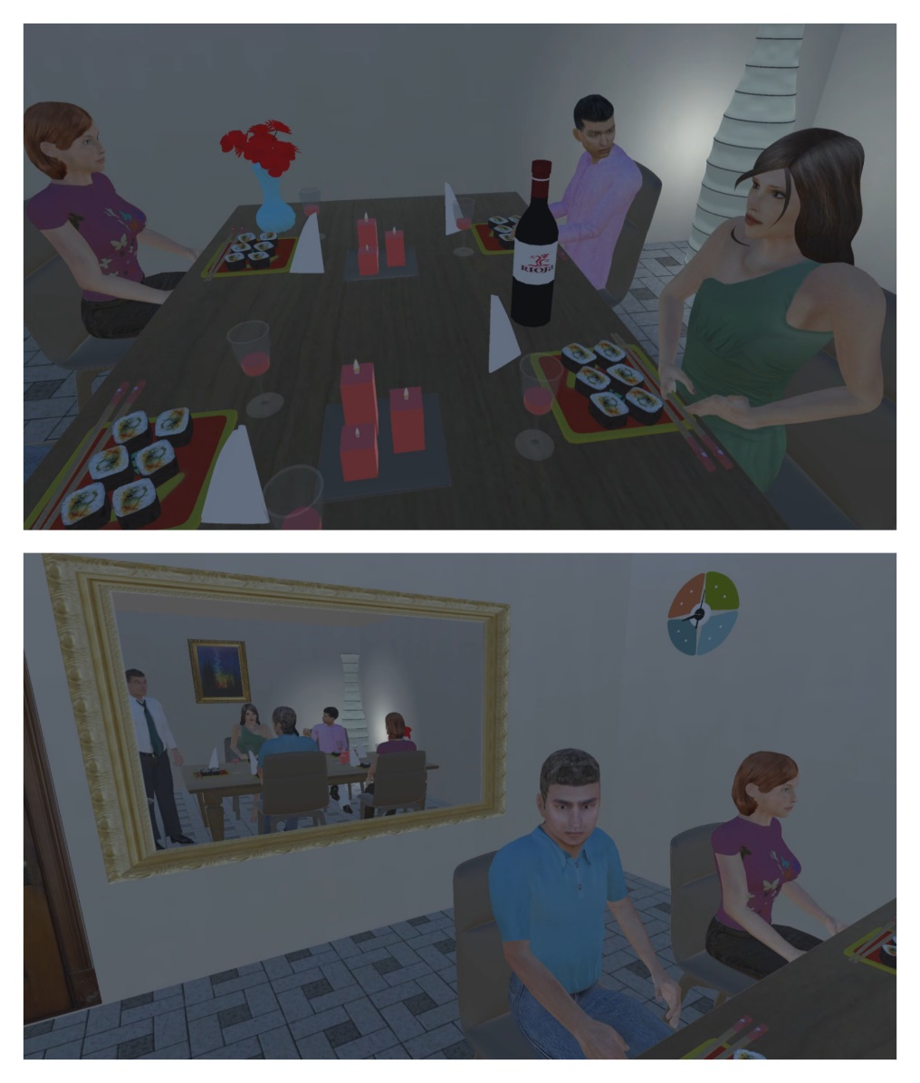
Figure S3. Additional views from Scene 3

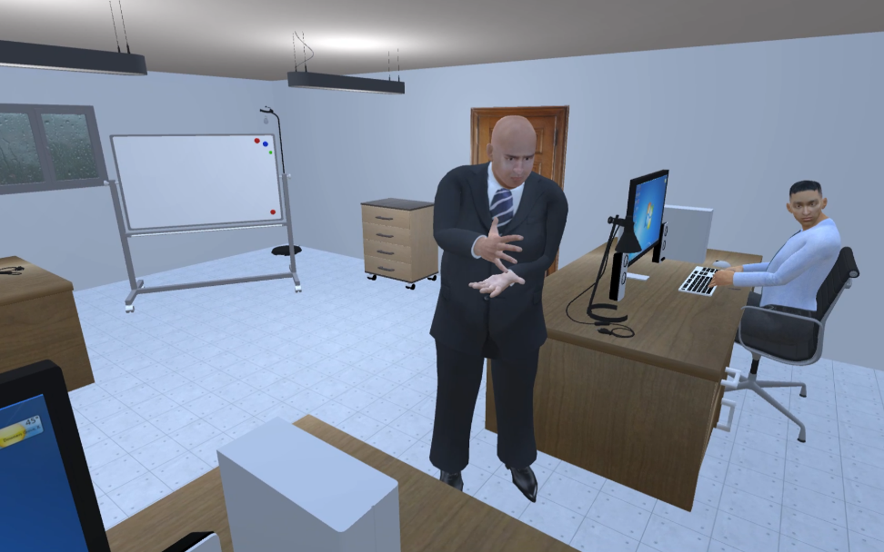
Figure S4. Additional views from Scene 4
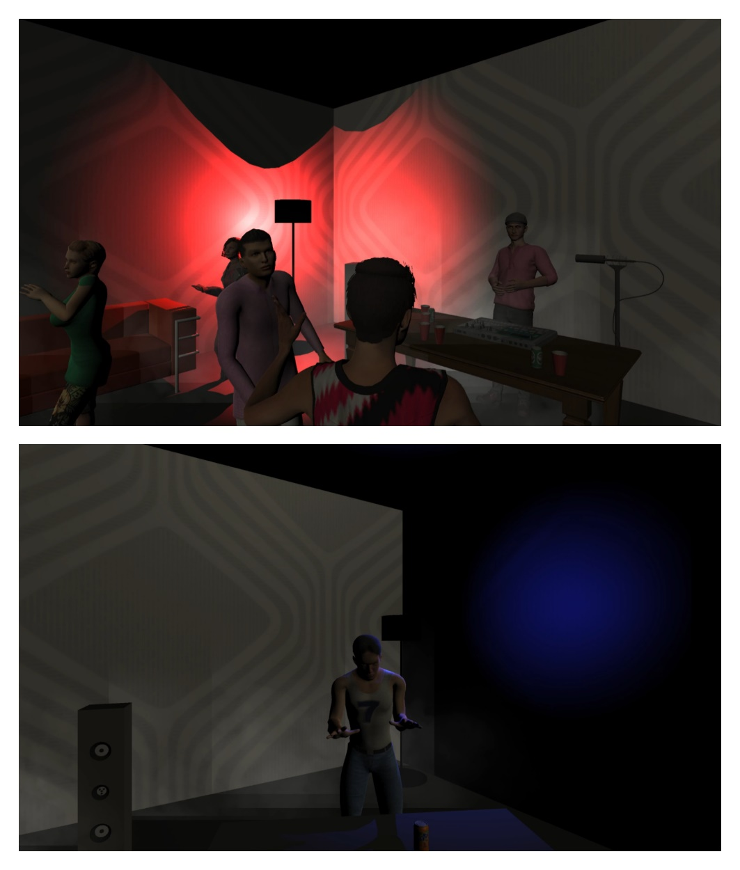

Figure S5. Additional views from Scene 5
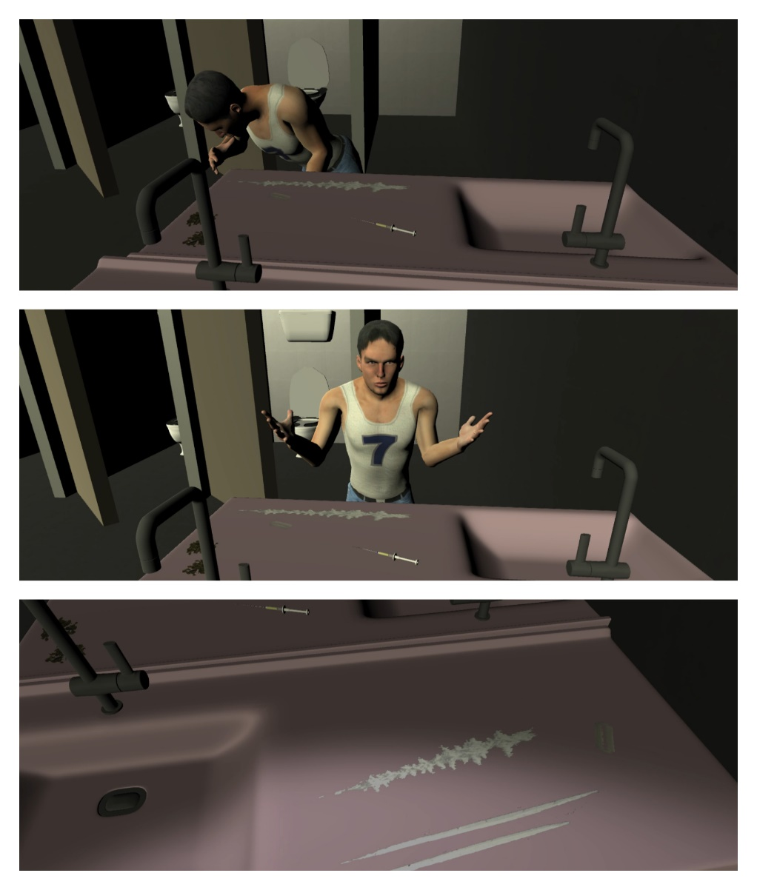
Figure S6. Additional view from Scene 6
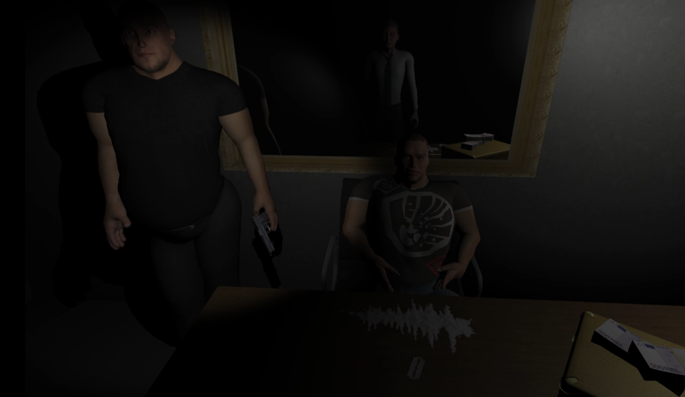
Figure S7. Additional view from Scene 7
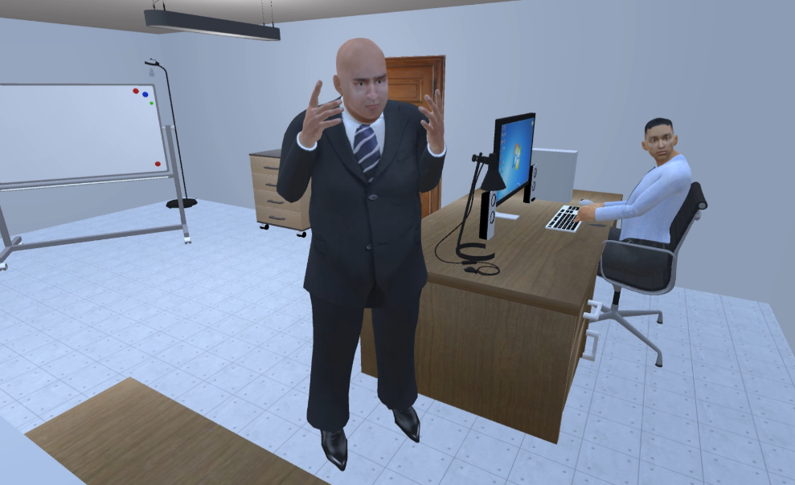

Figure S8. Additional views from Scene 8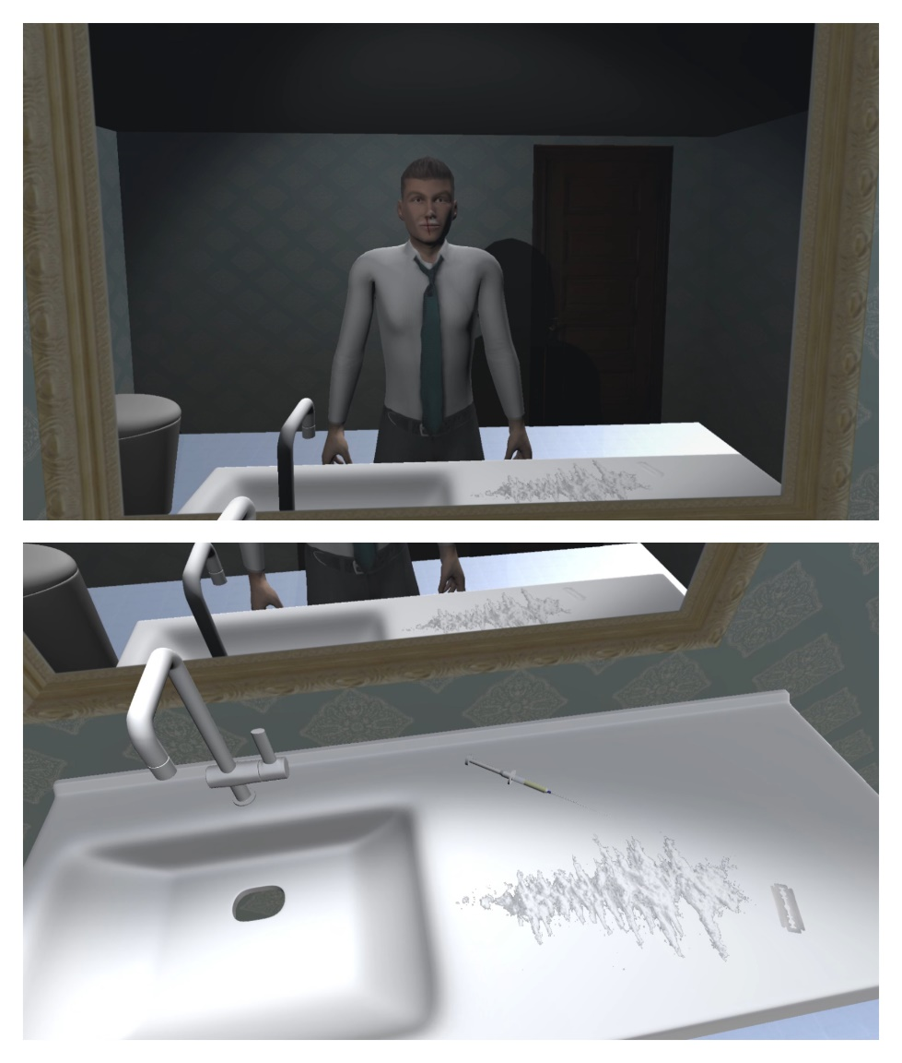
Figure S9. Additional views from Scene 9
