Supplemental Information
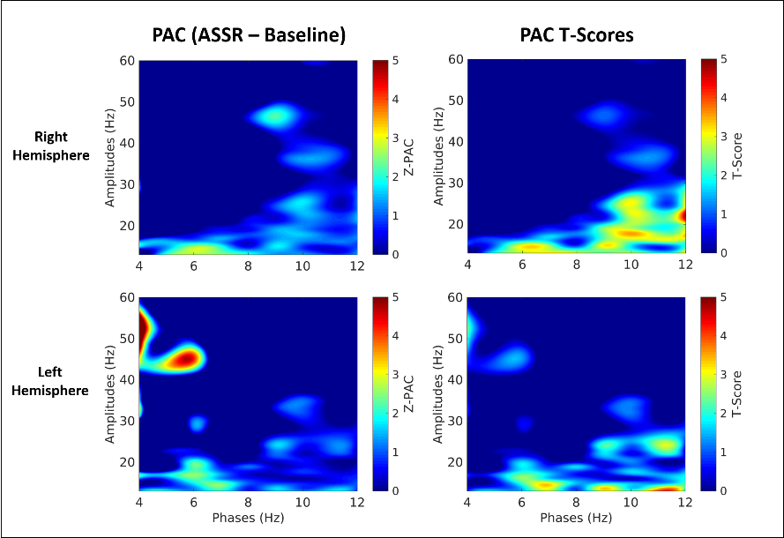
Supplement 1 – Phase-Amplitude Coupling

Figure S1, Left and right hemisphere PAC during the evoked 30 Hz ASSR condition.

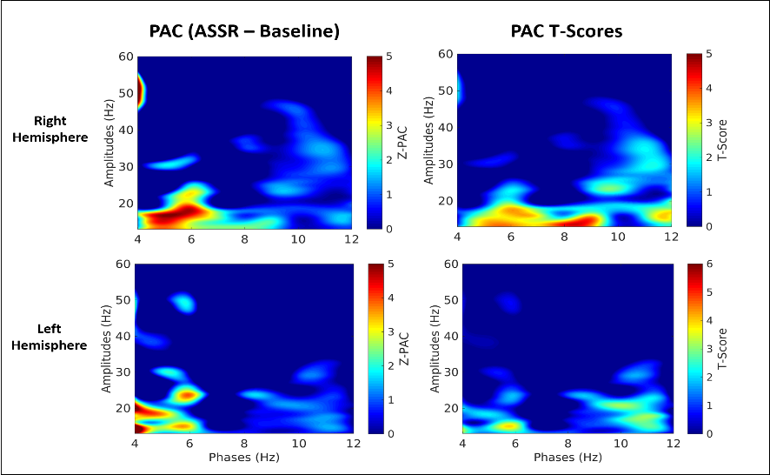

Figure S2, Left and right hemisphere PAC during the evoked 20 Hz ASSR condition.

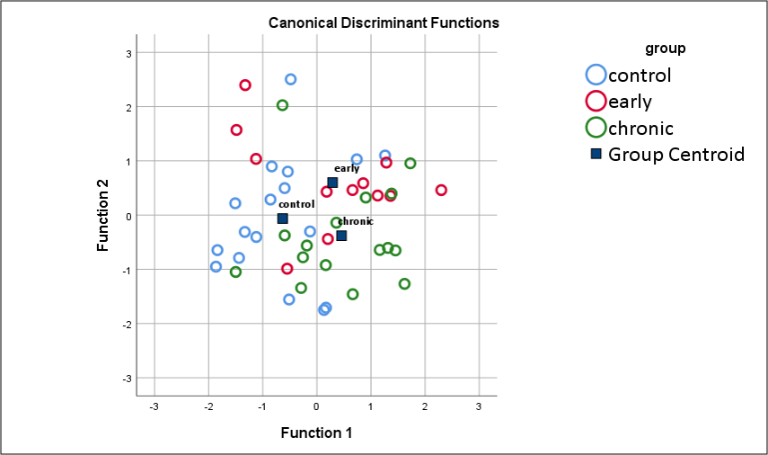
Figure S3, Distribution of the canonical discriminant functions described in the posthoc follow-up to the Multivariate Analysis of Covariance conducted on the baseline time-period PAC data.

Supplement 2 – ASSR Wavelet Power
Figure S4, Left and right hemisphere time-frequency representations of the evoked wavelet data during the 30 Hz ASSR condition.

Figure S5, Left and right hemisphere time-frequency representations of the evoked wavelet data during the 20 Hz ASSR condition.

Supplement 3 – ASSR Wavelet Inter-Trial Phase Coherence
Figure S6, Left and right hemisphere time-frequency inter-trial phase coherence during the evoked 40 Hz ASSR condition.

Figure S7, Left and right hemisphere time-frequency inter-trial phase coherence during the evoked 30 Hz ASSR condition.

Figure S8, Left and right hemisphere time-frequency inter-trial phase coherence during the evoked 20 Hz ASSR condition.

