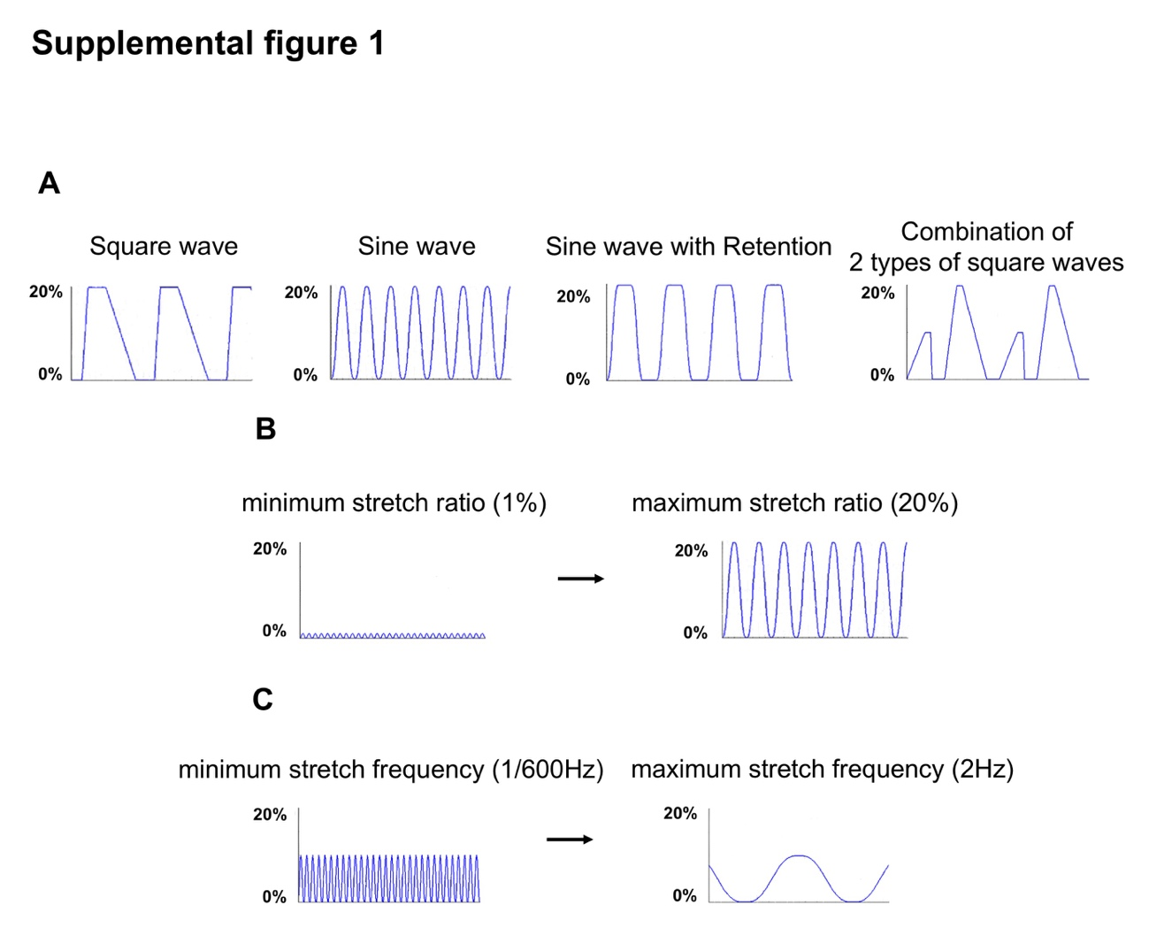
Fig. S1 Improved mechanical cell stretch system allows fine tuning of various mechanical stretch-related parameters
(A–C) Cell stretching parameters of our improved mechanical cell stretch system . (A) Stretch pattern of square wave, sine wave, sine wave with retention, combination of 2 types of square waves. (B) Minimum stretch ratio (1%) and maximum stretch ratio (20%). (C) Minimum stretch frequency (1/600 Hz) and maximum stretch frequency (2 Hz) are shown.

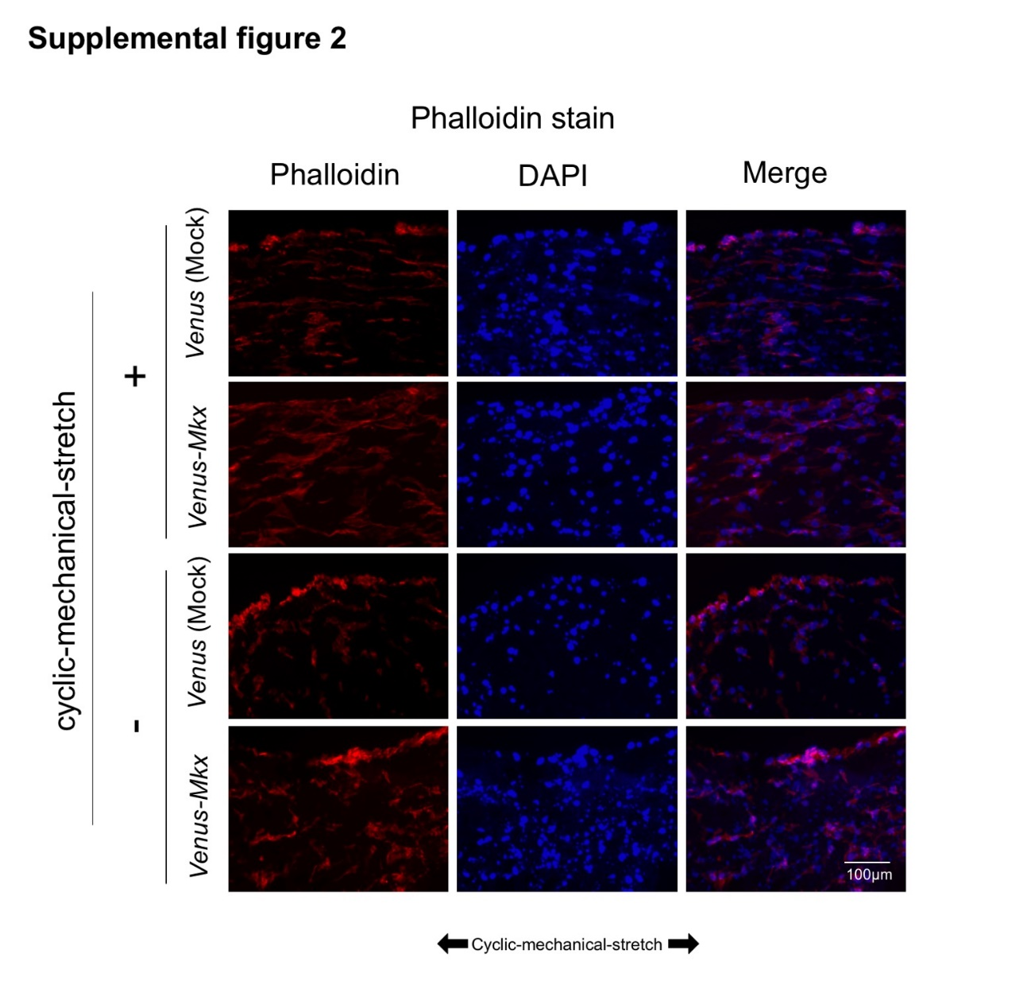

Fig. S2 Phalloidin staining of the tendon-like tissue
Representative micrographs of phalloidin/DAPI staining tissue sections. These tissues were generated under four different culture conditions: VMS+ (right top), VMS- (right bottom), VS+ (left top), and VS- (left bottom) (n = 1). The direction of the cyclic mechanical stretch load is indicated by black arrows. Scale bar: 100 μm.

Fig. S3 Picrosirius red staining of the tendon-like tissue
Representative micrographs of picrosirius red-stained tissue sections. These tissues were generated under four different culture conditions: Venus-Mkx–expressing mesenchymal stem cell (MSC) line C3H10T1/2 cells undergoing cyclic mechanical stretch (right top) (VMS+), Venus-Mkx–expressing C3H10T1/2 cells without cyclic mechanical stretch (right bottom) (VMS-), Venus (Mock)-expressing C3H10T1/2 cells undergoing cyclic mechanical stretch (left top) (VS+), and Venus (Mock)-expressing C3H10T1/2 cells without cyclic mechanical stretch (left bottom) (VS-) (n = 3). The direction of the cyclic mechanical stretch load is indicated by black arrows. Scale bar: 100 μm.

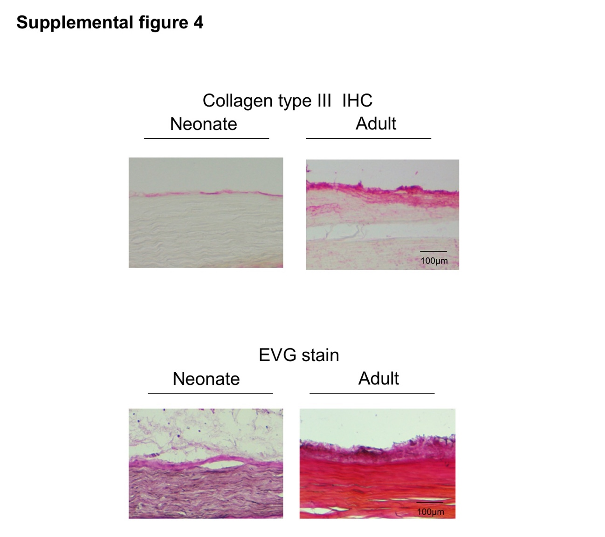
Fig. S4 histological analysis of the native mouse tendon tissue
Representative micrographs of Representative micrographs of Elastica Van Gieson (EVG) staining and immunohistochemical staining of collagen type III using mouse achilles tendon tissue section harvested from neonate (postnatal day 14: P14) or adult (3month old: 3M) (n = 1). Scale bar: 100 μm.

Table S1 Primer sequences for tendon-like tissue qRT-PCR

