Supplementary Material

Early Cretaceous Terrestrial Milankovitch Cycles in the Luanping Basin, North China and Time Constraints on Early Stage Jehol Biota Evolution

Wei Liu1,2, Huaichun Wu1,2,*, Linda A. Hinnov3, Dangpeng Xi1, Huaiyu He4, Shihong Zhang1, Tianshui Yang1

1State Key Laboratory of Biogeology and Environmental Geology, China University of Geosciences (Beijing), Beijing 100083, China

2School of Ocean Sciences, China University of Geosciences (Beijing), Beijing 100083, China

3Department of Atmospheric, Oceanic, and Earth Sciences, George Mason University, Fairfax, VA 22030, USA

4Institute of Geology and Geophysics, Chinese Academy of Sciences, Beijing 100029, China

Contents

S1. R command sequence for ASM objective testing
S2. TimeOpt and TimeOptSim objective testing in Acycle 2.1.1
S3. COCO and eCOCO objective testing in Acycle 2.1.1

S1. R command sequence for ASM objective testing

Below, the R commands are in blue text; the output is in black text. Comment line starts with #. The input data file is “dbgmsnew2.csv”.

# Open R-studio, point directory to desired folder

library(astrochron)

## PART 1: READ IN “new” AND ANALYZE WITH EHA

# Read “dbgmsnew2.csv” into “new”

new=read()
---- READ STRATIGRAPHIC SERIES FROM DATA FILE ----- The following options are selected:
* What type of column delimiter are you using?: Comma
* Does your file have column titles/headers?: auto detect

<PLEASE CHOOSE YOUR FILE>

* No column titles/headers detected

* Number of stratigraphic samples (rows)= 5892
* Number of variables (columns)= 1 (excluding depth/height/time)

* Sorting data into increasing depth/height/time order. Will remove empty entries (from either column).
* Number of samples (rows) post-sorting= 5892

* Mean sampling interval= 0.02
* Median sampling interval= 0.02
* Maximum sampling interval= 0.02
* Minimum sampling interval= 0.02

* First 3 lines of data file: V1 V2
1 0.00 -4.24e-08
2 0.02 -3.69e-08
3 0.04 -3.70e-08
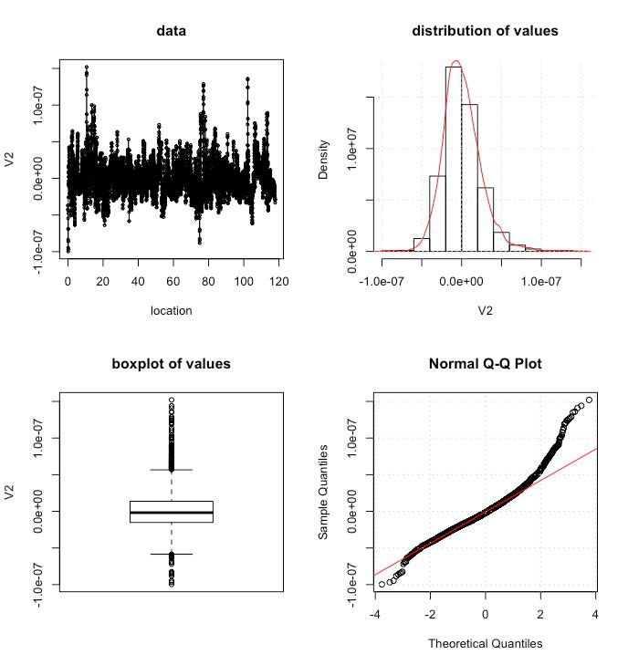

Figure S1. Top left: the plot of the Magnetic Suceptibility (MS) of Dabeigou Formation (DBG). Top right: the normal distribution of the DBG MS. Bottom left: the boxplot of all MS values. Bottom right: the normal Q-Q plot of the DBG MS.
strats(new)

---- DETERMINING SUMMARY STATISTICS FOR STRATIGRAPHIC SERIES -----
* Number of data points= 5892
* New number of data points= 5892
* Duration of stratigraphic series= 117.82
Minimum= 0
Maximum= 117.82

* SAMPLING INTERVAL / EQUIVALENT NYQUIST FREQUENCY: Mean= 0.02 / 25
Median= 0.02 / 25
Maximum= 0.02 / 25
Minimum= 0.02 / 25
* Variance of sampling interval= 2.219973e-29

* Mean data value= 6.19767e-10
* Median data value= -1.795e-09
* Minimum data value= -9.97e-08
* Maximum data value= 1.52e-07
* Variance of data values= 5.994319e-16

# Run single EHA on “new” (set window to duration of “new”)

EHAnew=eha(new,tbw=2, win=117.82, demean=T, detrend=T, sigID=T, siglevel=0.85, output=5, fmin=0., fmax=1.5, xlab="Frequency (cycles/m)",ylab="Height (m)")

----- PERFORMING EVOLUTIVE HARMONIC ANALYSIS -----
* Number of data points in stratigraphic series: 5892
* Stratigraphic series length (space or time): 117.82
* Sampling interval (space or time): 0.02
* Number of data points per window: 5891
* Moving window size (space or time): 117.8
* Window step points: 10
* Window step (space or time): 0.2
* Number of windows: 1
* Mean value for each window will be subtracted
* Linear trend for each window will be subtracted
* Nyquist frequency: 25
* Rayleigh frequency: 0.008487523
* MTM Power spectrum bandwidth resolution (halfwidth): 0.01697505
* Will use 3 DPSS tapers
* Padded to 16384 points

* Searching for significant Harmonic F-test peaks
that achive 85 % confidence level:
* Number of significant F-test peaks identified = 42

ID / Frequency / Period / Harmonic_CL
1 0.006103516 163.84 99.09266
2 0.0579834 17.24632 87.45255
3 0.07629395 13.1072 91.51055
4 0.1220703 8.192 94.95378
5 0.1403809 7.123478 94.21246
6 0.1586914 6.301538 90.45943
7 0.1831055 5.461333 95.23335
8 0.2197266 4.551111 97.15396
9 0.2380371 4.201026 92.45728
10 0.2929688 3.413333 91.82689
11 0.3204346 3.120762 92.79432
12 0.3875732 2.580157 90.44452
13 0.4180908 2.391825 97.82735
14 0.4425049 2.259862 89.11312
15 0.4638672 2.155789 96.05995
16 0.5615234 1.78087 92.46273
17 0.579834 1.724632 99.85114
18 0.5981445 1.671837 99.72052
19 0.6439209 1.552986 87.81228
20 0.6561279 1.524093 85.99387
21 0.7141113 1.400342 95.30654
22 0.7995605 1.250687 96.19337
23 0.8209229 1.218141 98.81714
24 0.8422852 1.187246 95.66488
25 0.869751 1.149754 98.32827
26 0.8911133 1.122192 94.09365
27 0.9185791 1.088638 91.90227
28 0.9552002 1.046901 91.67351
29 1.013184 0.986988 86.45853
30 1.05896 0.9443228 96.78334
31 1.107788 0.9026997 96.80415
32 1.126099 0.8880217 95.17657
33 1.16272 0.8600525 86.86812
34 1.202393 0.8316751 96.49064
35 1.254272 0.7972749 85.91012
36 1.281738 0.7801905 93.74081
37 1.303101 0.7674005 86.90999
38 1.339722 0.7464237 97.35264
39 1.370239 0.7297996 94.65716
40 1.437378 0.6957113 93.09663
41 1.461792 0.6840919 96.27012
42 1.498413 0.6673727 94.04433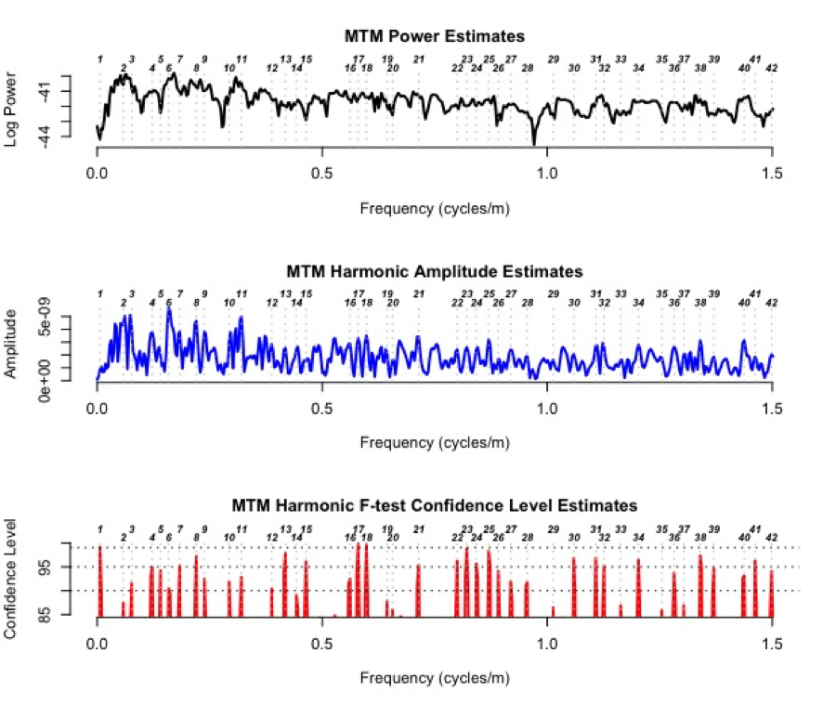
Figure S2. Harmonic analysis of dbg stratigraphic series
## PART 2: ANALYZE “new” with ASM

# ASM target in cycles/kyr, from La2004 ETP Spectral Analysis (130 – 135 Ma) (see Table 1)

# Apply ASM to “dbgmsnew2” with 10 astronomical terms

targetla=c(1/409.6, 1/132.129, 1/124.1212, 1/99.9024, 1/94.1609, 1/36.6, 1/22.14, 1/20.95, 1/18.08, 1/17.9256)

# Set up input parameters:

freq <- data.frame(EHAnew)
rayleigh <- 0.008487523
nyquist <- 1.0

# Run ASM:

asm(freq=freq,target=targetla,rayleigh=rayleigh,nyquist=nyquist,sedmin=1,sedmax=10,numsed=400,linLog=1,iter=10000,output=FALSE)

----- PERFORMING AVERAGE SPECTRAL MISFIT ANALYSIS -----

**** WARNING: No uncertainty assigned to astronomical target frequencies.

* Analysis complete:
Optimal Sedimentation Rate (cm/ka) at = 3.398821
Ho-SL (%) = 2.58
or p-value = 0.0258
ASM (cycles/ka) = 2.277076e-05
Number of Astronomical Terms Fit = 6

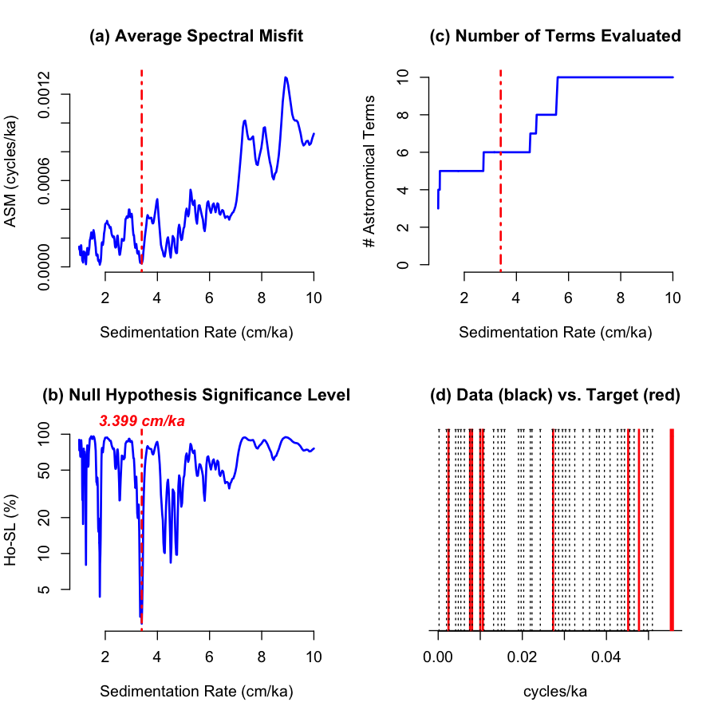

Figure S3. ASM results for “new” with 10 astronomical terms

# Apply ASM to “new” with 8 astronomical terms

targetla=c(1/409.6, 1/132.129, 1/95.25, 1/36.6, 1/22.14, 1/20.95, 1/18.08, 1/17.9256)

# Set up input parameters:

freq <- data.frame(EHAnew)
rayleigh <- 0.008487523
nyquist <- 1.0
# Run ASM:
asm(freq=freq,target=targetla,rayleigh=rayleigh,nyquist=nyquist,sedmin=1,sedmax=10,numsed=400,linLog=1,iter=10000,output=FALSE)
----- PERFORMING AVERAGE SPECTRAL MISFIT ANALYSIS -----

**** WARNING: No uncertainty assigned to astronomical target frequencies.

* Analysis complete:
Optimal Sedimentation Rate (cm/ka) at = 4.722647
Ho-SL (%) = 1.9
or p-value = 0.019
ASM (cycles/ka) = 1.93054e-05
Number of Astronomical Terms Fit = 5
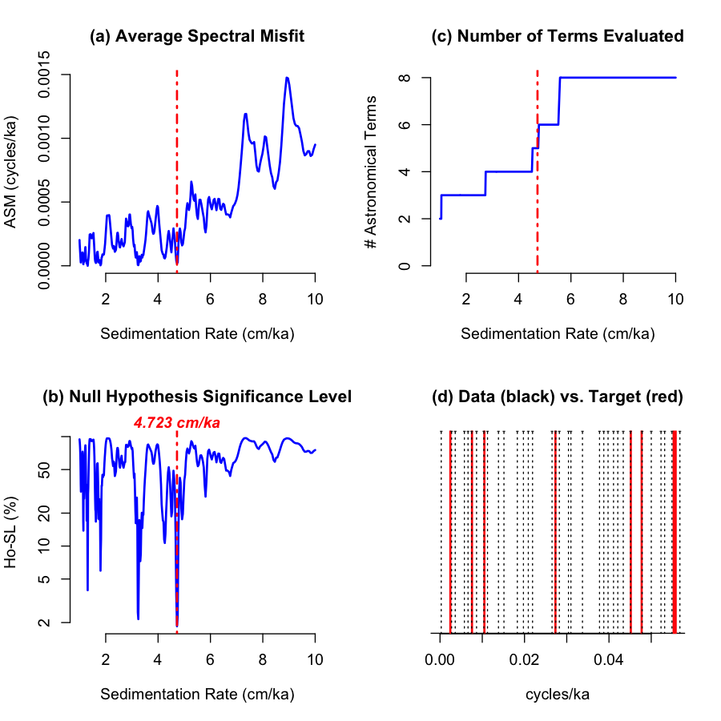

Figure S4. ASM results for “new” with 8 astronomical terms
S2. TimeOpt and TimeOptSim objective testing in Acycle 2.1.1

## ANALYZE “new” with TimeOpt and TimeOptSim
# Download Acycle 2.1.1 (Matlab compatible) and unzip the zipped file
# Open Matlab, point directory to acycle-2.1.1 folder
# Open Acycle
ac.m
# Copy “new.txt” file into the acycle-2.1.1 – data – Examples folder
# Select “new.txt” file and then press Timeseries – TimeOpt.
# All parameters setting are shown in Figure S4 as follow:
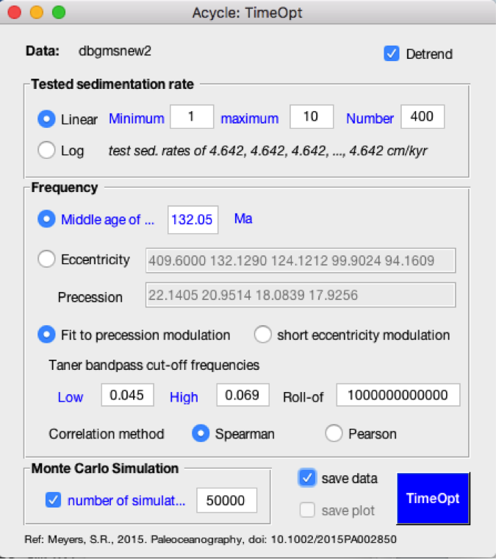

Figure S5 TimeOpt testing parameters settings

# Press the bottom right button “TimeOpt”

14-Mar-2020 19:43:00
new-timeOpt-log.txt
minimum tested sedimentation rate: 1
maximum tested sedimentation rate: 10
number of tested sedimentation rate: 400
Scaling for sedimentation rate grid spacing: Linear
Test for (1) precession amplitude modulation
Low frequency cut-off for Taner bandpass: 0.045
High frequency cut-off for Taner bandpass: 0.069
Taner filter roll-off rate, in dB/octave: 1000000000000
A vector of eccentricity periods to evaluate (in kyr):
[409.6 132.129 124.1212 99.9024 94.1609]

A vector of precession periods to evaluate (in kyr):
[22.1405 20.9514 18.0839 17.9256]

Remove linear trend from data series?: Yes
correlation method: Spearman
RESULTS:
Maximum spectral power r^2 = 0.08538
at sedimentation rate of: 6.3388 cm/kyr
Maximum envelope r^2 = 0.38323
at sedimentation rate of: 9.2239 cm/kyr
Maximum (envelope r^2) x (spectral power r^2) = 0.014757
at sedimentation rate of: 4.6416 cm/kyr

Number of Monte Carlo simulations: 50000
At sedimentation rate of 4.6416 cm/kyr
Envelope r^2 p-value = 0.05348
Spectral power r^2 p-value = 0.05348
Envelope r^2 p-value = 0.47128
(Envelope r^2) x (spectral power r^2) p-value = 0.11902

- - - - - - - - - - - - - - End - - - - - - - - - - - -

# TimeOpt and TimeOptSim outputs for “new” plots are shown in Figure 6.
S3. COCO and eCOCO objective testing in Acycle 2.1.1

## ANALYZE “new” with COCO
# Download Acycle 2.1.1 (Matlab compatible) and unzip the zipped file
# Open Matlab, point directory to acycle-2.1.1 folder
# Open Acycle
ac.m
# Copy “new.txt” file into the acycle-2.1.1 – data – Examples folder
# Select “new.txt” file and then press “Timeseries - Correlation Coefficient (COCO/eCOCO)”
# All parameters setting are shown in Figure S5 as follow:

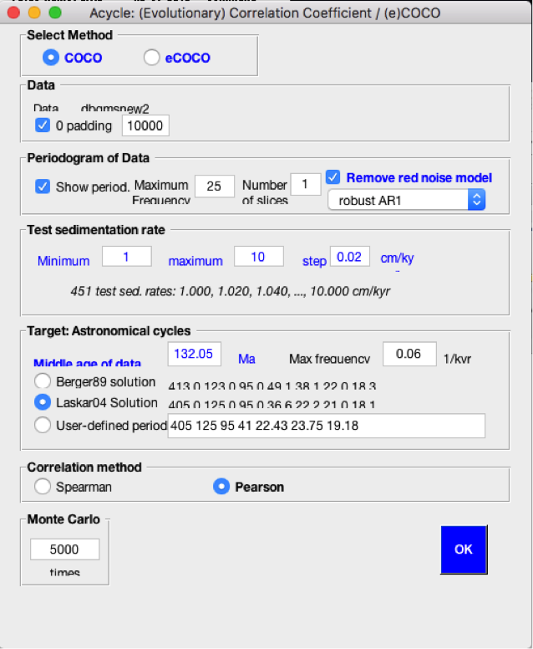

Figure S6 COCO testing parameters settings

# Press the bottom right button “OK”
- - - - - - - - - - - - - Summary - - - - - - - - - - -
15-Mar-2020 16:10:11
new-5000sim-1slice-COCO-log-1.txt
Data: 0 to 117.82m. Sampling rate: 0.02. Number of data points: 5892
Data: Number of slices is 1. Number of simulations is 5000
Data: Remove red noise model: robust AR1 removed (F - Fred). Correlation method: Pearson
Zero padding for the data is 10000
Tested sedimentation rate step is 0.02 cm/kyr from 1 to 10 cm/kyr
Target age is 132050 ka. Zero padding is 10000. Freq. is 0-0.06 cycles/kyr
Astronomical solution: Laskar04
Seven astronomical cycles are: 405, 125, 95, 36.6159, 22.1522, 21.0039, 18.1368
- - - - - - - - - - - - - - End - - - - - - - - - - - -

# COCO outputs for “new” plots are shown in Figure 7.

## ANALYZE “new” with eCOCO
# All parameters setting are shown in Figure S6 as follow:
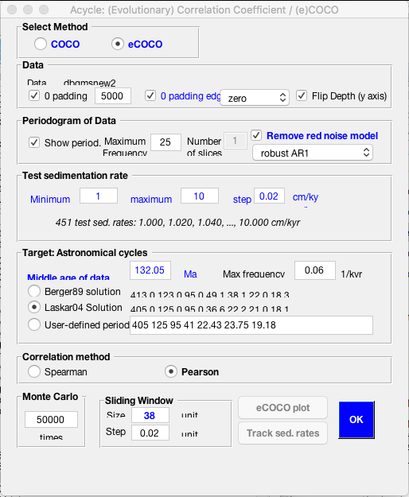
Figure S7 eCOCO testing parameters settings

# Press the bottom right button “OK”

- - - - - - - - - - - - - Summary - - - - - - - - - - -
15-Mar-2020 18:56:41
new-50000sim-1slice-38win-ECOCO-log.txt
Data: -19 to 136.82m. Sampling rate: 0.02. Number of data points: 5892
Data: Number of slices is 1. Number of simulations is 50000
Data: Remove red noise model: robust AR1 removed (F - Fred). Correlation method: Pearson
Zero padding for each window is 5000; Zero padding for the edge of data: zero
Tested sedimentation rate step is 0.02 cm/kyr from 1 to 10 cm/kyr
Target age is 132050 ka. Zero padding is 5000. Freq. is 0-0.06 cycles/kyr
Astronomical solution: Laskar04
Seven astronomical cycles are: 405, 125, 95, 36.6159, 22.1522, 21.0039, 18.1368
- - - - - - - - - - - - - - End - - - - - - - - - - - -

# eCOCO outputs for “new” plots are shown in Figure 7.

