Supplementary Figures
Supplementary Figure S1. Weed richness effects on EF-multifunctionality (A) and across functional thresholds (B) measured as the number of functions achieved in each field above thresholds (T), where T is the quantile-based ranking of each function across all fields. Lines represent the predicted relationship from the statistical models. Colors indicate the different crop type (cereals in red, oilseed rape in green and grassland in blue).
B
A
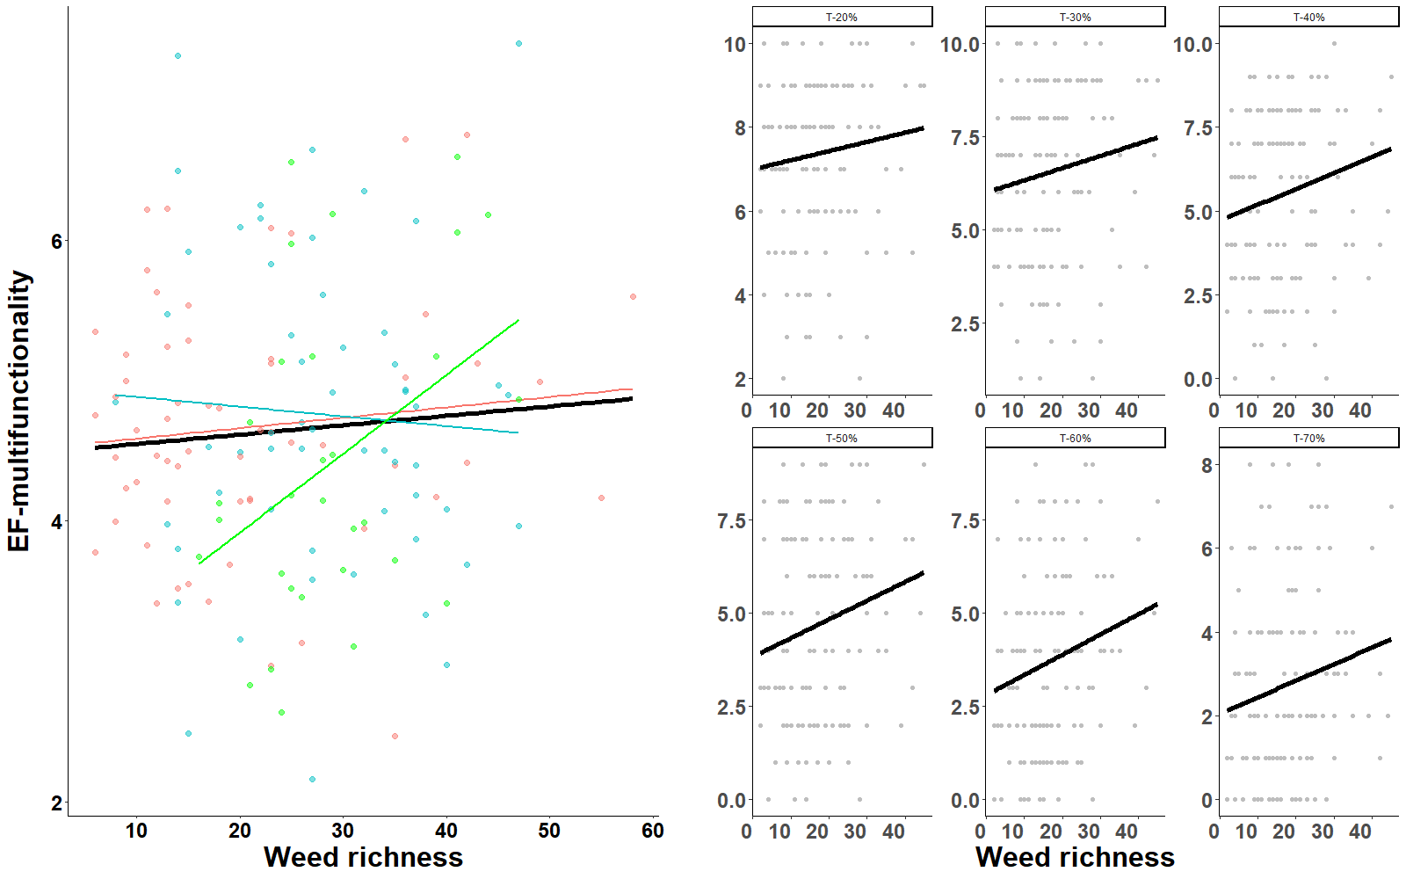

Supplementary Figure S2. Percentage of variance on EF-multifunctionality and each ecological functions explained by the number of locally abundant (blue) and rare (green) weed species which were defined using the number of species with an plant abundance greater than 80%, 70%, 60% and 50% quantile and lower than 20%, 30%, 40% and 50% quantile of the weed abundance distribution.

Supplementary Figure S3. Relationship between (A) weed diversity (richness) and groundbeetle diversity (richness) and (B) weed abundance and groundbeetle abundance in winter cereals (red), oilseed rape (green) and haylands (blue). Lines represent the predicted relationship from the statistical models and shade area the 95% confidence interval.
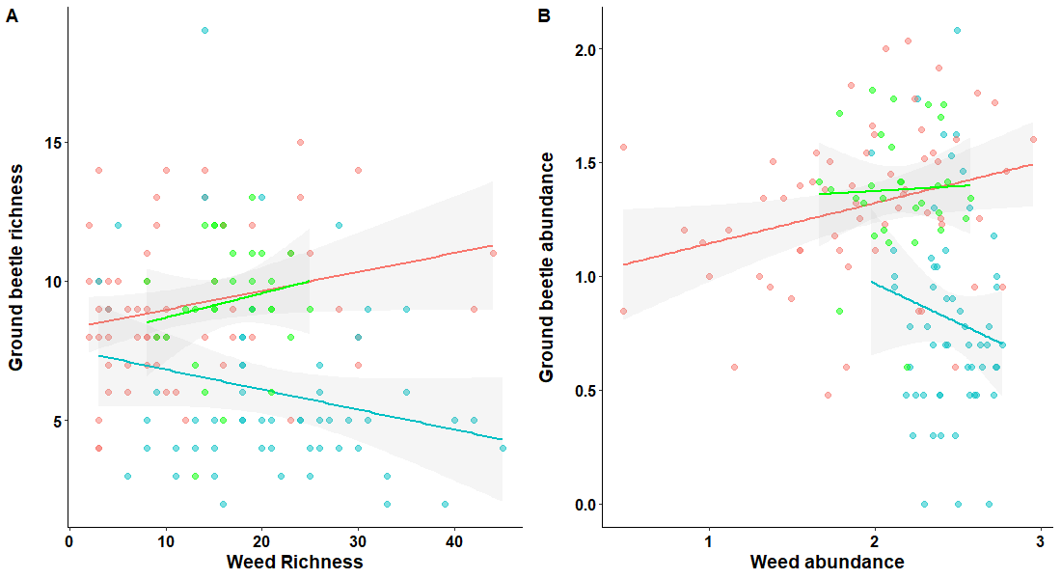

Supplementary Figure S4. Relationship bee richness and the fruiting success of oilseed rape phytometers in winter cereals (red), oilseed rape (green) and haylands (blue). Lines represent the predicted relationship from the statistical models. The black line shows the relationship across crop types and shade area the 95% confidence interval. OSR fruiting success decreased significantly with bee richness (LM: F_{1,63}=4.61, P=0.0357) similarly in the two annual crops and in grasslands (Bee richness-Crop type interaction: F_{2,63}=1.15, P=0.3248). We did not observe any effect of crop type on OSR fruiting success (Crop type: F_{1,63}=0.90, P=0.4131).

