Supplementary Appendix.
Modular plots of 11 species networks, 11 female subnetworks and 11 male subnetworks. In each bipartite matrix, visitor species are arranged on columns and plant species on rows.

Ashu 1984, Species network
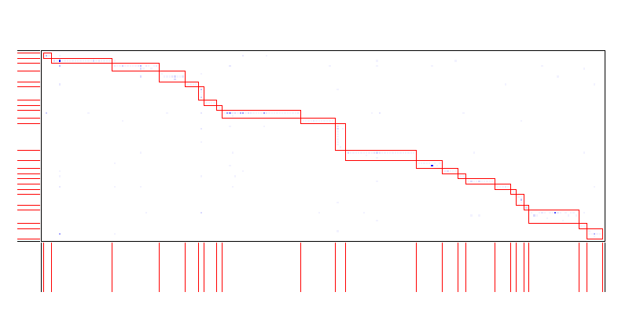
Ashu 1984, Female subnetwork
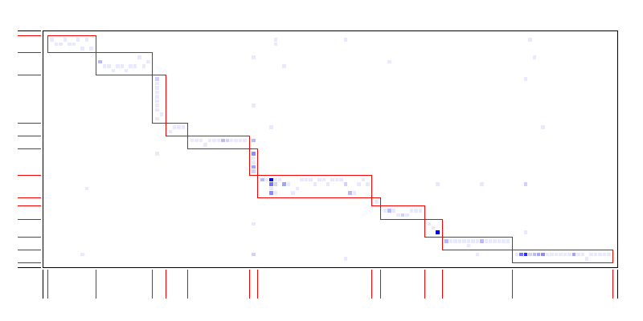
Ashu 1984, Male subnetwork
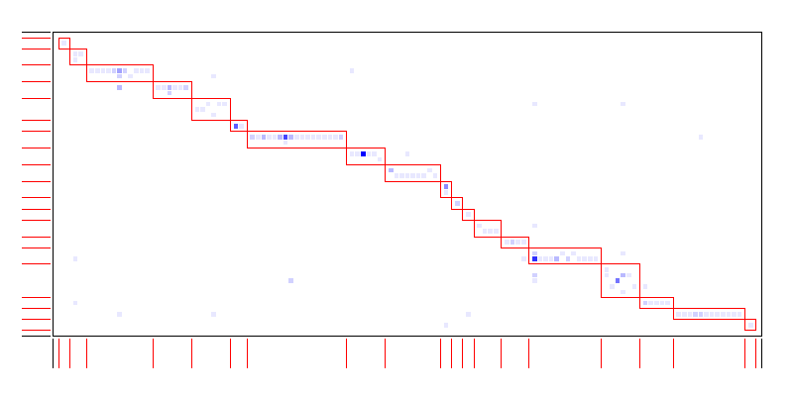

Ashu 1985, Species network
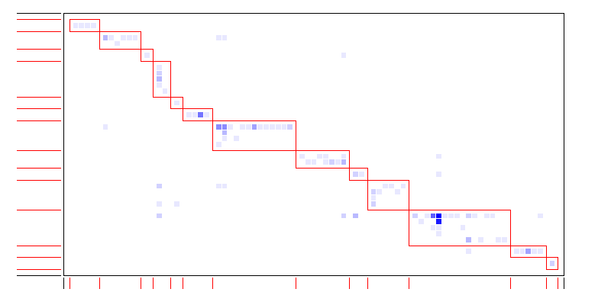

Ashu 1985, Female subnetwork
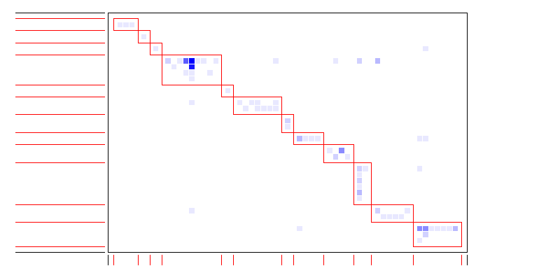

Ashu 1985, Male subnetwork
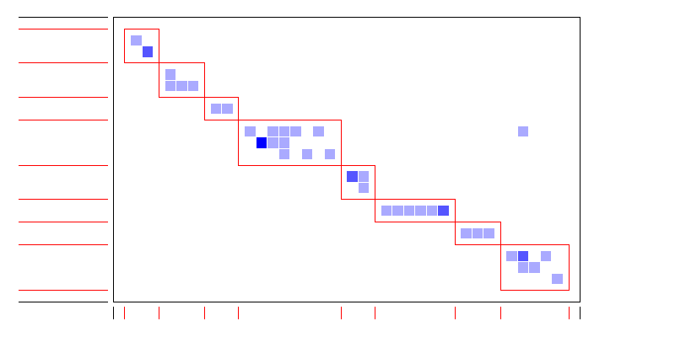

Ashu 1986, Species network
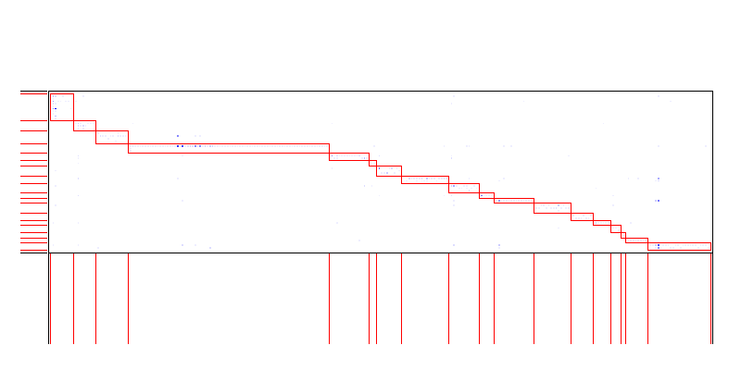

Ashu 1986, Female subnetwork
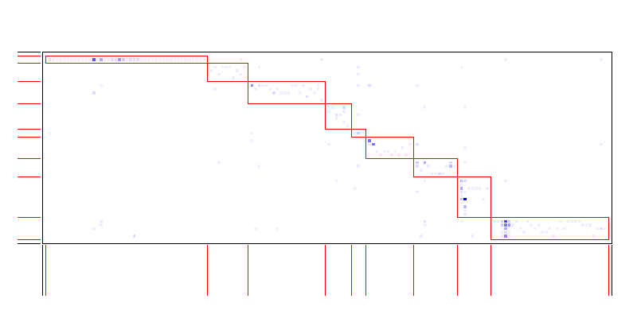

Ashu 1986, Male subnetwork
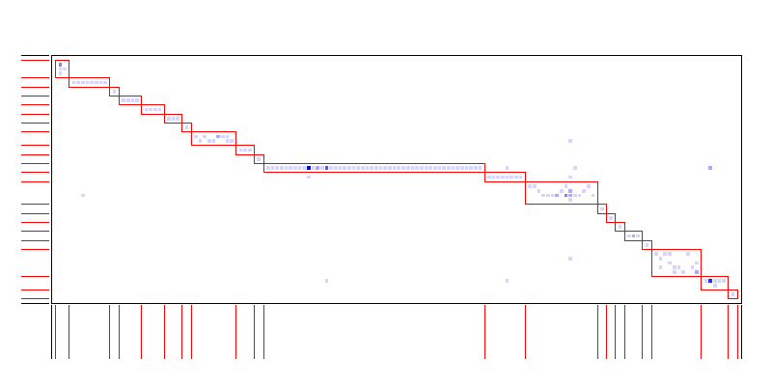

Ashu 1987, Species network
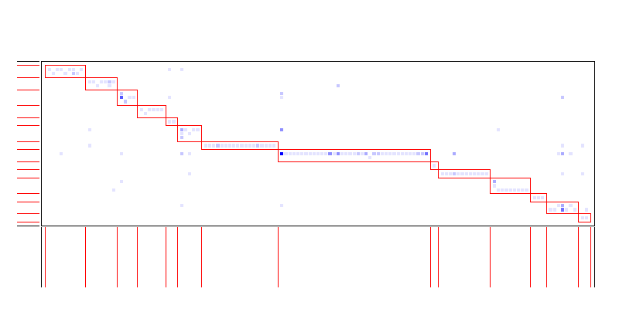

Ashu 1987, Female subnetwork
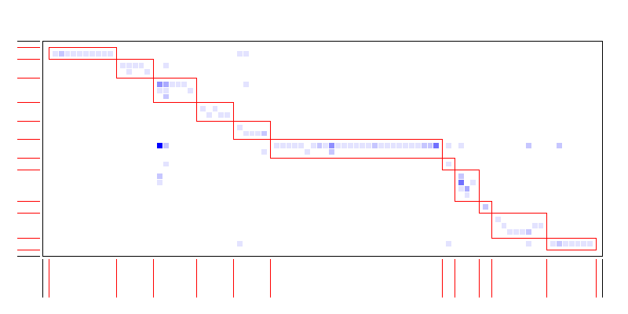

Ashu 1987, Male subnetwork
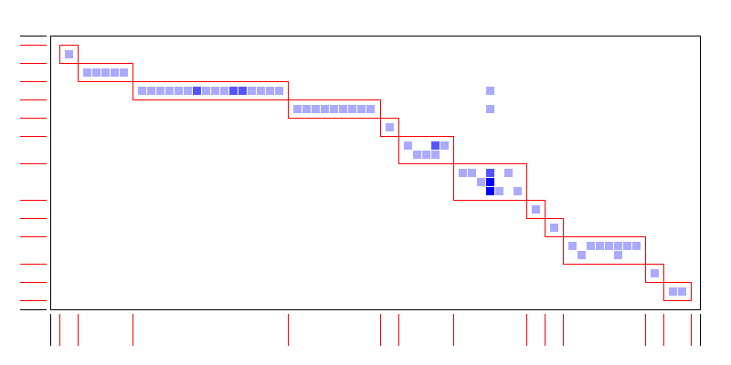

Kibune 1984, Species network
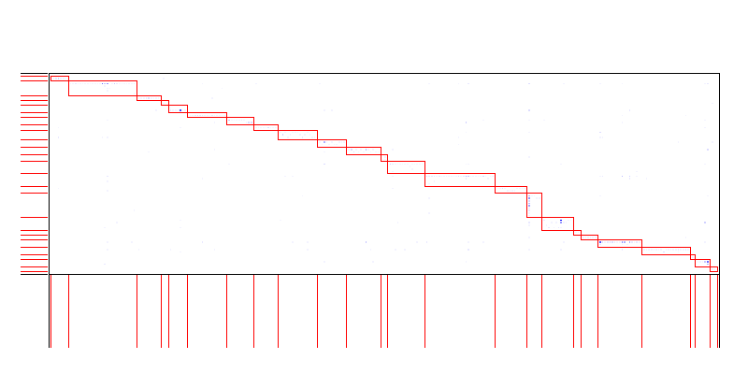

Kibune 1984, Female subnetwork
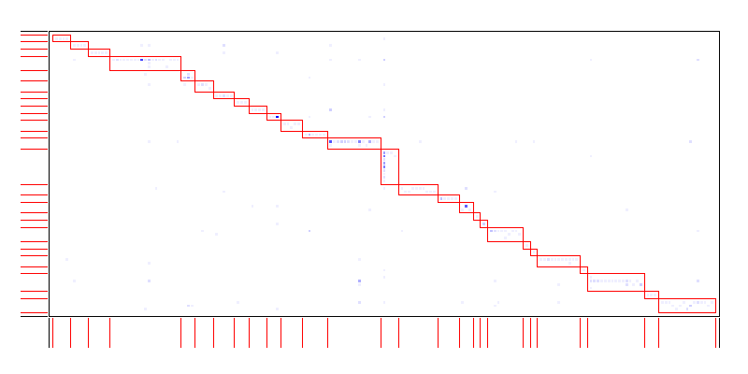

Kibune 1984, Male subnetwork
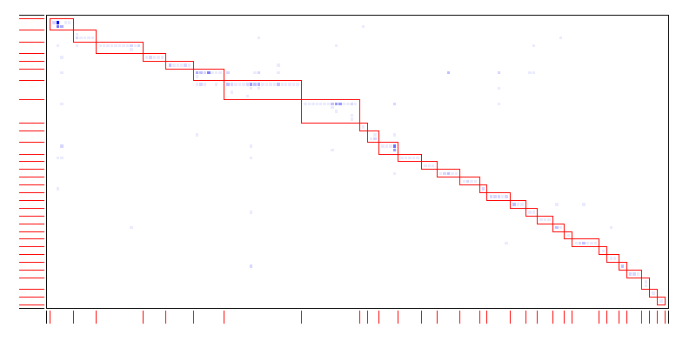

Kibune 1985, Species network
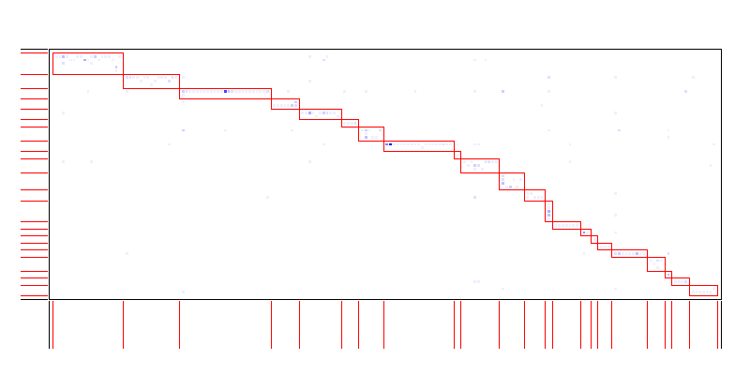

Kibune 1985, Female subnetwork
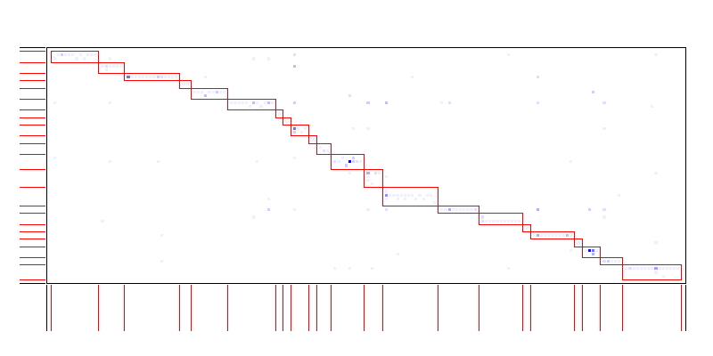

Kibune 1985, Male subnetworks
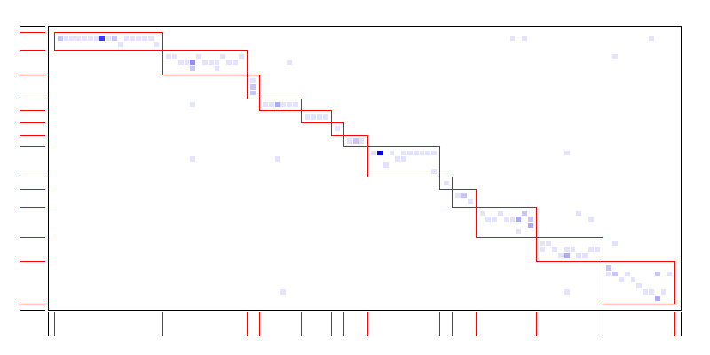

KIbune 1986, Species network
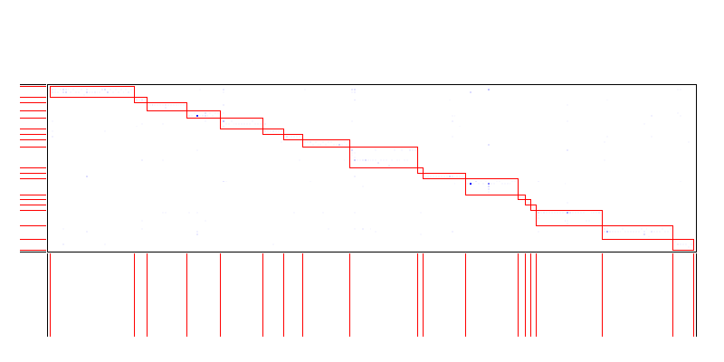

Kibune 1986, Female network

Kibune 1986, Male subnetwork
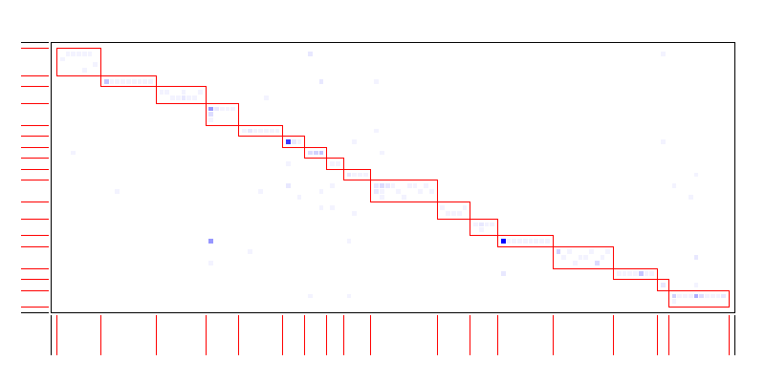

Kibune 1987, Species network
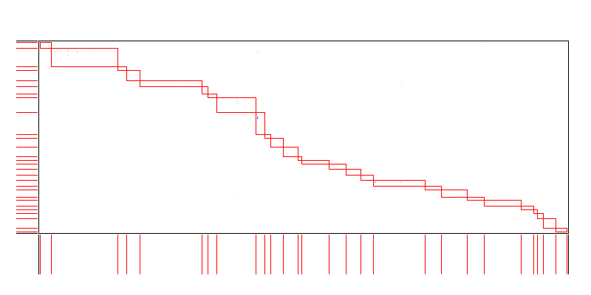

Kibune 1987, Female subnetwork
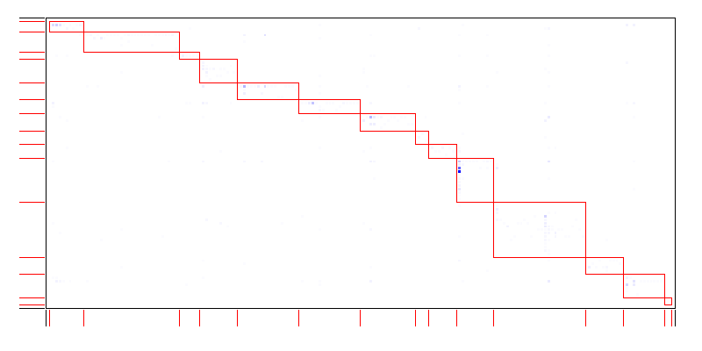

Kibune 1987, Male subnetwork
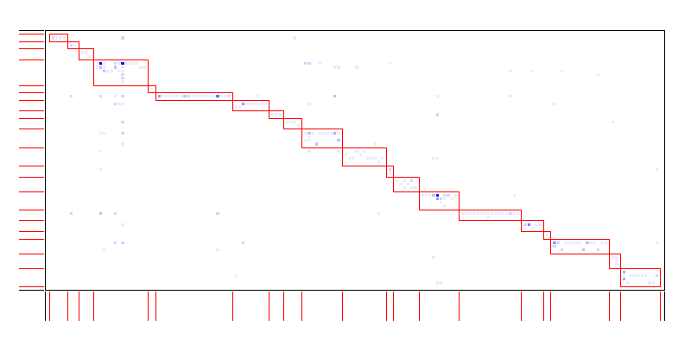

Kyoto Univ. 1985, Species network
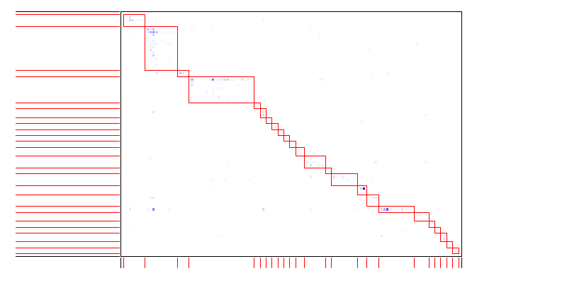

Kyoto Univ. 1985, Female subnetwork
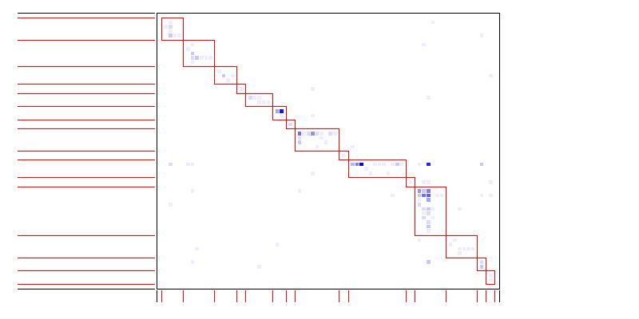

Kyoto Univ. 1985, Male subnetwork
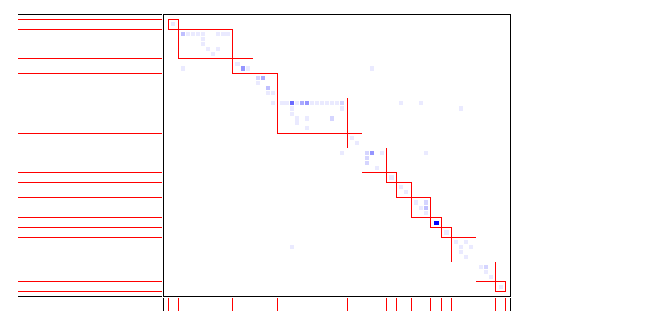

Kyoto Univ. 1986, Species network
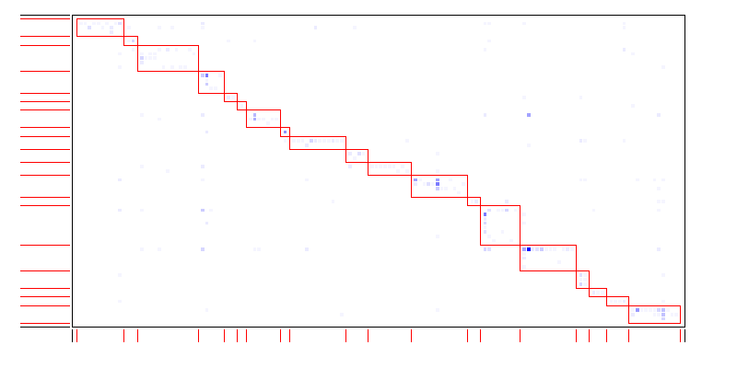

Kyoto Univ. 1986, Female subnetwork
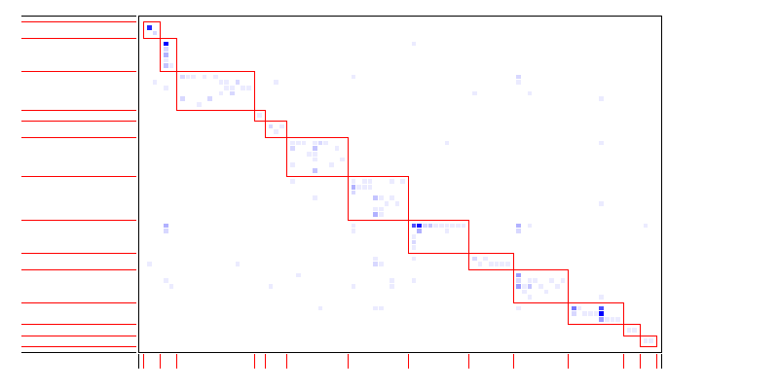

Kyoto Univ. 1986, Male subnetwork
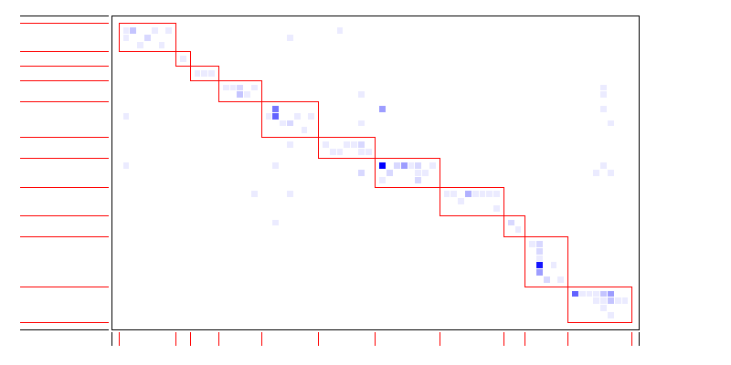

Kyoto Univ. 1987, Species network
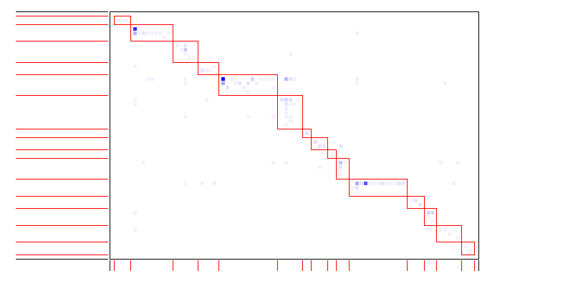

Kyoto Univ. 1987, Female network
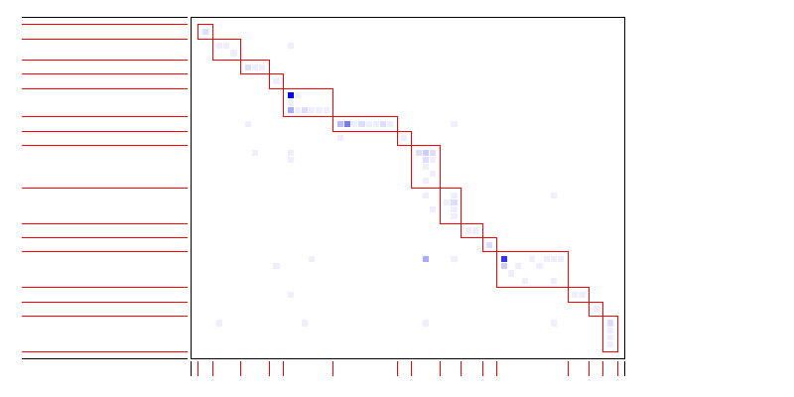

Kyoto Univ. 1987, Male subnetwork
