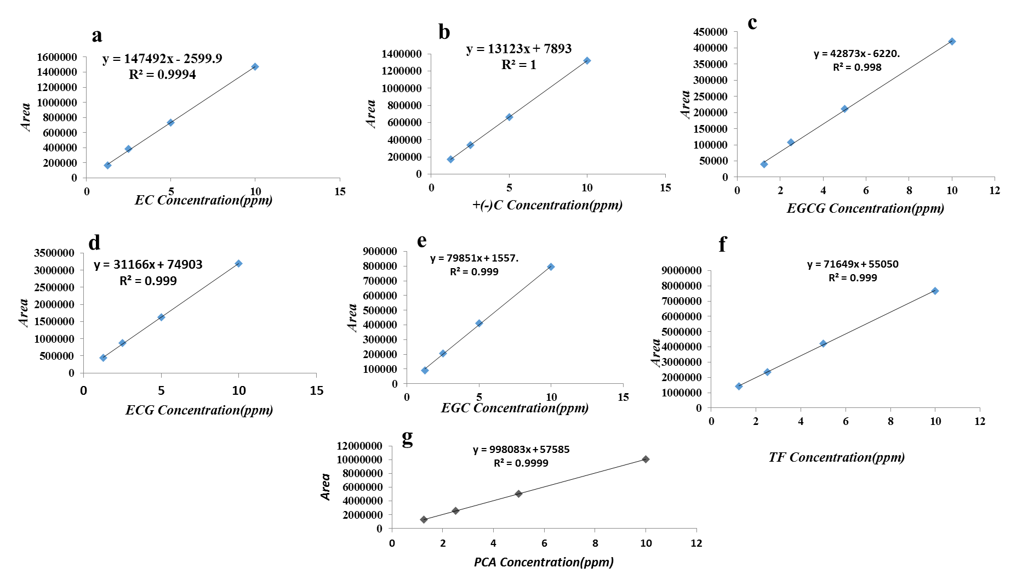
Figure S1 Standard curves of epicatechin (EC), (±)catechin, epigallocatechingallate (EGCG), epicatechingallate (ECG), epigallocatechin (EGC), taxifolin (TF) , and protocatechuic acid (PCA) respectively
.

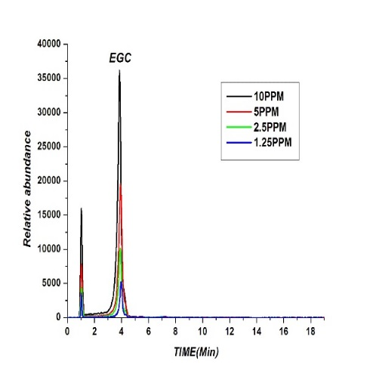
Figure S2 Different concentrations dendograms of epicatechin (EC), (±)catechin, epigallocatechingallate (EGCG), epicatechingallate (ECG), epigallocatechin (EGC), taxifolin (TF) , and protocatechuic acid (PCA) respectively.

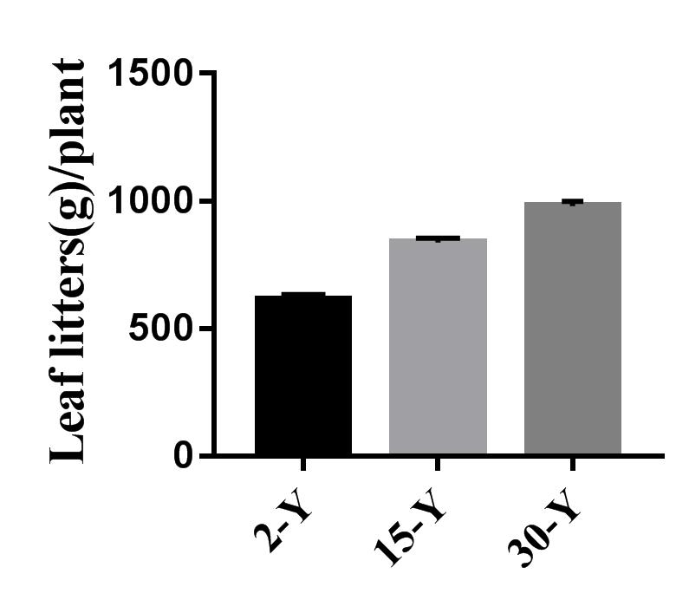
Figure S3 Leaf letters biomass in 2 year (2-Y), 15 year (15-Y) and 30 years (30-Y) tea gardens respectively
Table S1 Yield of different tea garden
 | (Hundred-buds Weight)
Treatment | (Fresh weight) | (Dry weight)
 | ----------g--------------
T2Y | 118.67±2.03 ª | 28.87±1.55 ª
T15Y | 92.13±2.31^{b} | 21.60±1.37 ^{b}
T30Y | 79.00±2.08 ^{c} | 15.95±1.34 ^{c}
Note: 2-Y, 15-Y and 30-Y represent the newly planted 2-years’ tea field, 15 years and 30 years’ monoculture tea field respectively. Letter a and b in columns show significant difference determined by Tukey’s test (p≤ 0.05, n=100).
Table S2 Enzyme activities of tea rhizosphere soil under different fertilizers
Treatment | Phenol oxidase | Peroxidase
 | --------mg·g⁻¹2h⁻¹--------
CK | 122.42±4.28 ^{c} | 22.03±0.52 ^{c}
2-Y | 139.30±0.52 ^{b} | 24.58±0.1 ^{b}
15-Y | 140.68±10.83^{b} | 24.26±0.36 ^{b}
30-Y | 185.49±4.56 ª | 25.97±0.22 ª
Note: CK, 2-Y, 15-Y and 30-Y represent the bulk soil, newly planted 2-years’ tea field, 15 years and 30 years’ monoculture tea field respectively. Letters a, b and c in columns show significant difference determined by Tukey’s test (p≤ 0.05, n=3).

