Causal Responsibility and Robust Causation

Guy Grinfeld,¹ David Lagnado,² Tobias Gerstenberg,³ James F. Woodward⁴ & Marius Usher^{1,5}

Supplementary Materials
All analysis codes and data files are uploaded on:
https://github.com/guygrinfeld/Responsibility-and-Robust-Causation-Experiments

- Additional results for Experiment-1

A.1 Non-significant results in success-cases ANOVA.
The ANOVA with number of dice rolled (one/two/three) and the ring-parity (odd vs. even) as within-subject factors, and judgment type (causation vs. responsibility) as a between-subject factor, results in non-significant effects for the ring-parity, F(1, 100) = 0.16, p = .690, η_{p} ² = .002; judgment type, F(1, 100) = 0.01, p = .914, η_{p} ² < .001) and no significant interactions (number of dice rolled and type of judgment, F(2, 200) = 0.18, p = .840, η_{p} ² = .002; number of dice rolled and ring-parity, F(2, 200) = 0.22, p = .802, η_{p} ² = .002; ring-parity and type of judgment, F(1, 100) = 0.62, p = .432, η_{p} ² = .006; number of dice rolled, ring-parity and type of judgment, F(2, 200) = 0.28, p = .754, η_{p} ² = .003 ).

A.2 Regression models for success cases in Experiment-1
The regression reported in Exp-1, is based on two mixed regression models with subjects as a random factor. The first model was done for the responsibility ratings and the second for causation ratings.

A.2.1 Regression model for responsibility rating of success:
Responsibility rating=b1*dice + b2*score + b3*ring + b_{i} *subject

 | Estimate | Std.Error | t-value |  |  |  |  |  | p-value
b_{i} | 22.744 | 11.685 | 1.946 |  |  |  |  |  | 0.052
b₁ | 13.704 | 3.145 | 4.357 |  |  |  |  |  | >0.001
b₂ | 0.492 | 0.347 | 1.418 |  |  |  |  |  | 0.157
b₃ | 1.204 | 1.471 | 0.818 |  |  |  |  |  | 0.414

This model produces the following predictions:
Table S1
Predicting responsibility rating
 | ring | dice | score | mean rating | mean prediction
1 | 6 | 3 | 6 | 68.1 | 68.01
2 | 6 | 3 | 12 | 70.15 | 70.96
3 | 5 | 3 | 6 | 69.21 | 69.21
4 | 5 | 3 | 12 | 70.1 | 72.16
5 | 4 | 2 | 6 | 56.81 | 56.71
6 | 4 | 2 | 9 | 60.15 | 58.19
7 | 3 | 2 | 6 | 57.65 | 57.92
8 | 3 | 2 | 9 | 63.17 | 59.39
9 | 2 | 1 | 6 | 44.08 | 45.42
10 | 1 | 1 | 6 | 45.17 | 46.62

A.2.1 Regression model for causation rating of success:
causation rating=b1*dice + b2*score + b3*ring + b_{i} *subject

 | Estimate | Std.Error | t-value | p-value
b_{i} | 29.387 | 11.944 | 2.460 | 0.014
b₁ | 13.803 | 3.219 | 4.287 | >0.001
b₂ | -0.213 | 0.355 | -0.601 | 0.548
b₃ | 0.472 | 1.506 | 0.313 | 0.754

This model produces the following predictions:

Table C2

Predicting causation rating
 | ring | dice | score | mean rating | mean prediction
1 | 6 | 3 | 6 | 70.6 | 69.99
2 | 6 | 3 | 12 | 68.5 | 68.71
3 | 5 | 3 | 6 | 70.7 | 70.46
4 | 5 | 3 | 12 | 68.76 | 69.18
5 | 4 | 2 | 6 | 55.98 | 57.13
6 | 4 | 2 | 9 | 55.8 | 56.49
7 | 3 | 2 | 6 | 57.04 | 57.6
8 | 3 | 2 | 9 | 58.9 | 56.96
9 | 2 | 1 | 6 | 45.7 | 44.27
10 | 1 | 1 | 6 | 43.54 | 44.74

A.3 Regression models for failure cases in Experiment-1
We carried out additional analyses for the cases of failure (in which the score was below 6).
First, we present two mixed regression models with subjects as a random factor, equivalents to the ones above. Below we present the results for the critical case of score 5, which was resulted evenly in all dice-rolled outcomes.

A.3.1 Regression model for responsibility rating of failure:
Responsibility rating=b1*dice + b2*score + b3*ring + b_{i} *subject

 | Estimate | Std.Error | t-value | p-value
b_{i} | 69.63 | 11.643 | 5.981 | >0.001
b₁ | -11.021 | 3.116 | -3.537 | >0.001
b₂ | 0.307 | 0.529 | 0.580 | 0.562
b₃ | -0.281 | 1.469 | -0.8191 | 0.848

A.3.2 Regression model for causation rating of failure:
causation rating=b1*dice + b2*score + b3*ring + b_{i} *subject

 | Estimate | Std.Error | t-value | p-value
b_{i} | 74.965 | 12.518 | 5.989 | >0.001
b₁ | -8.258 | 3.371 | -2.450 | 0.015
b₂ | -0.261 | 0.572 | -0.456 | 0.649
b₃ | -1.816 | 1.589 | -1.143 | 0.254

A 3.3 ANOVA for cases of failure
We carried out ANOVA for the causation ratings of failure cases of score 5 (Figure S1, left panel) with number of dice rolled (one/two/three) and the ring-parity (odd vs. even) as within-subject factors. We found significant effects for the number of dice rolled , F(1, 98) = 3.12, p = .046, η_{p} ² = .060, and for ring parity, F(1, 49) = 5.48, p = .024, η_{p} ² = .100. The interaction between number of dice rolled and parity was not significant, F(2, 98) = 0.78, p = .460, η_{p} ² = .016.

The ANOVA for the responsibility ratings of failure cases of score 5 (Figure S1, right panel) with same factors as above found significant effect only for the number of dice rolled , F(1, 102) = 17.24, p < .001, η_{p} ² = .253. Ring parity, F(1, 51) = 0.36, p = .550, η_{p} ² = .007, and the interaction between number of dice rolled and parity, F(2, 102) = 2.31, p = .104, η_{p} ² = .043, were not significant.

Figure S1. Evaluations of causal strength (left) and of responsibility (right panel) for failure case of score 5, as a function of the number of dice rolled and of the ring the dart hit: odd (blue) vs. even (pink). Error bars indicate within-subject +/- 1 standard error of the mean.

- Additional Materials for Exp-2 (description-condition)
Tables indicating players' kicking style and success rates as shown to the participants in this condition:
"Purple player style and success rates, based on previous two seasons":

Kick style: | Around the wall
Success rates: | 60% for a goal

"Red player style and success rates as collected from previous two seasons":

Kick style: | Through the wall
Success rates: | 30% for a goal
"Blue player style and success rates as collected from previous two seasons":
Kick style: | Through the wall
Success rates: | 60% for a goal

"Cyan player style and success rates as collected from previous two seasons":
Kick style: | Around the wall
Success rates: | 30% for a goal

- Materials in Experiment 3 and post-experimental test in Experiment 4
English translation of the text presented to participants (in Hebrew) in experiment-3.
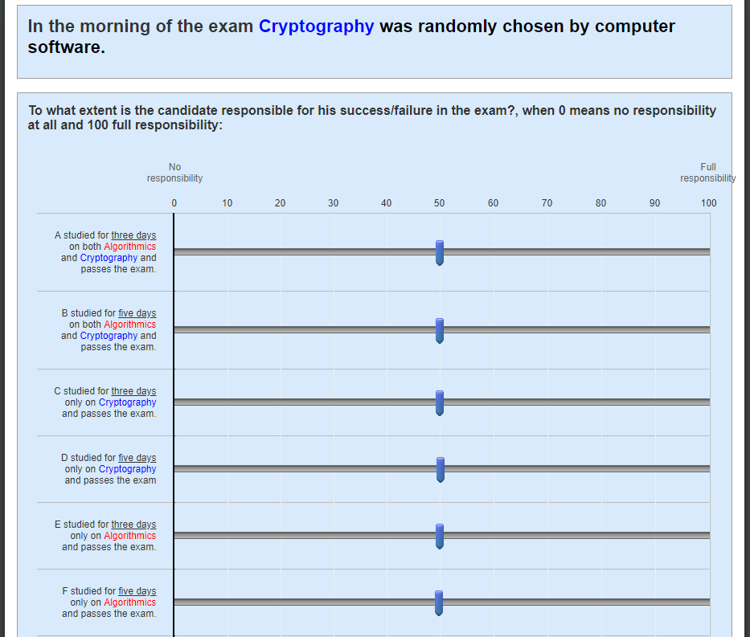

C.1 Memory post-test for success rate in experiment 4

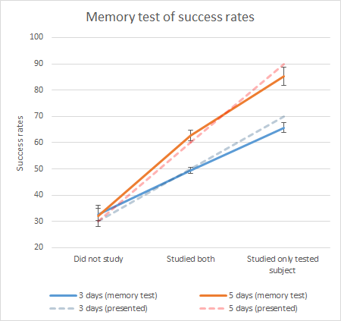
Figure S2. Results of the post-experimental memory quiz for the success rate of the exam candidates in all cases of Exp-4. Dotted lines are nominal values and solid lines are the average report (memory). Error bars correspond to SE of the Mean.

