Supplementary Materials
Supplementary Materials A
Table.

Time schedule of the day patient treatment for traumatic grief (DPT-TG).

Time schedule | Phase 1 | Phase 2 | Phase 3
10.00-10.15 | Day opening
10.15-11.30 | Psycho education | Art therapy | Psycho motor therapy
11.30-11.45 | Coffee and tea
11.34-13.00 | Art therapy | Psychotherapy BEP-TG | Social orientation
13.00-13.30 | Lunch
13.30-14.30 | Psycho motor therapy | Socio therapy | Clinical and social check ups
14.30-15.30 | Clinical and social check ups | Clinical and social check ups | Socio therapy
Note. BEP-TG = brief eclectic psychotherapy for traumatic grief.

Supplementary Materials B

Table.
Conceptualization of the post-migration stressors.

Social stressors | Conceptualization
Language | In need of an interpreter vs. not in need of an interpreter.
Legal status | Differentiation between having a permanent permit, a temporary permit (5 years or 1 year), pending (waiting for the verdict about the status), or undocumented (having  the permit request denied)
Time in NL | Months since arrival in The Netherlands until start of the treatment.
Time of asylum period | Duration in months between arrival in The Netherlands and receiving a temporal status.
Housing problems | Not having housing problems versus having housing problems (defined as living on the streets, in an asylum center and/or a high dissatisfaction with current housing situation).
Work | Being employed, on sick leave, disabled, or unemployed at the start of treatment.
Family separation | Not being separated from family vs. being separated from partner and/or children, or when there is/are no partner/children, being separated from parents and/or  siblings
Ongoing conflict | The presence of a current ongoing conflict. (currently  is during treatment period). Information retrieved from:  https://www.crisisgroup.org/, https://www.cfr.org/, http://isdp.eu/, http://www.bbc.com/,  https://www.nederlandwereldwijd.nl/reizen/reisadviezen, https://www.state.gov/,  https://www.britannica.com, https://diplomatie.belgium.be/nl
Living situation | Living alone, living with partner and/or children, living separated from partner and/or children.
Change in legal status | Having a change in the legal status (during the treatment period). This can be the change from pending to a temporary permit or the loss of a temporary permit

Supplementary Materials C
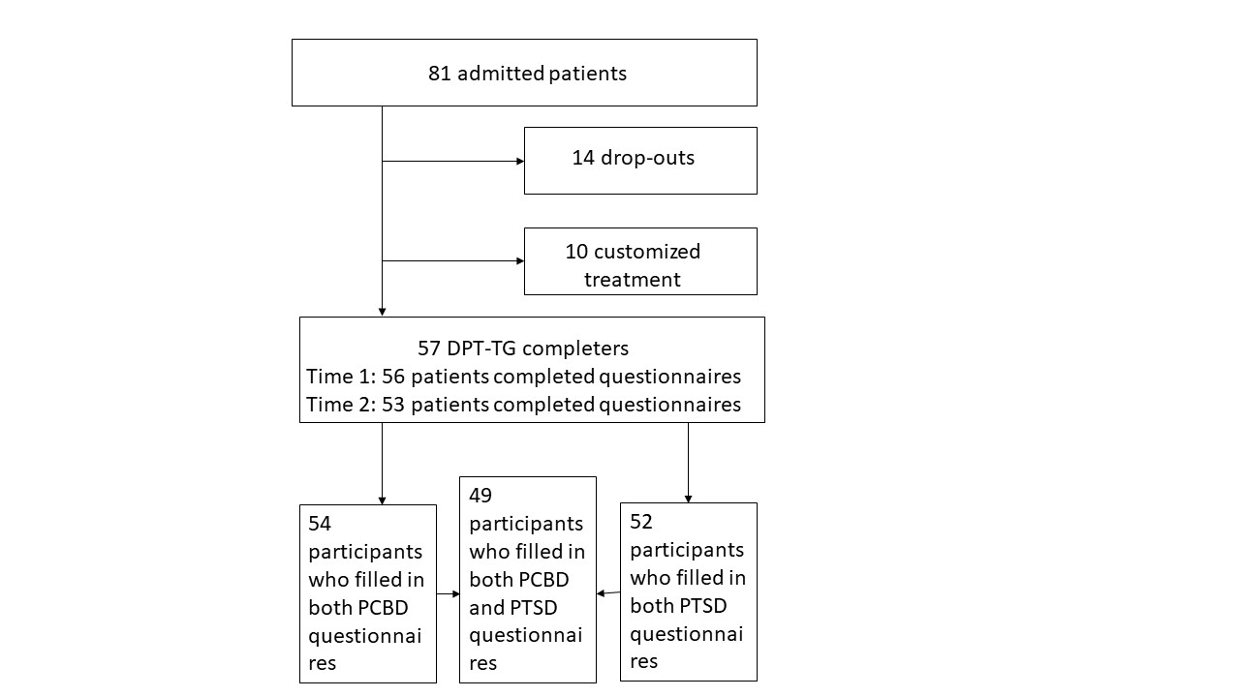
Figure. Flow chart day patient treatment for traumatic grief (DPT-TG). PCBD = Persistent complex bereavement disorder. PTSD = Posttraumatic Stress Disorder. DPT-TG = day patient treatment for traumatic grief.

