Supplementary Material

Designing uniformly layered FeTiO3 assemblies consisting of fine nanoparticles enabling high-performance quasi-solid-state sodium-ion capacitors

Lei Liu1#, Zhongchen Zhao2#, Zhengqiang Hu2, Xiangjun Lu1*, Shijia Zhang2, Ling Huang2, Yi Zheng2, Hongsen Li2*

1 Key Laboratory of Functional Materials and Applications of Fujian Province, School of Material Science and Engineering, Xiamen University of Technology, Xiamen, 361024, China

2 College of Physics, Center for Marine Observation and Communications, Qingdao University, Qingdao, 266071, China

**\* Correspondence:**Hongsen Li, [hsli@qdu.edu.cn](mailto:hsli@qdu.edu.cn)

## Xiangjun Lu, luxiangjun0531@163.com

## Supplementary Figure

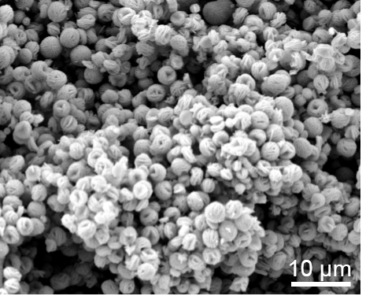

**Figure S1.** SEM image of the precursors.

## Supplementary Figure

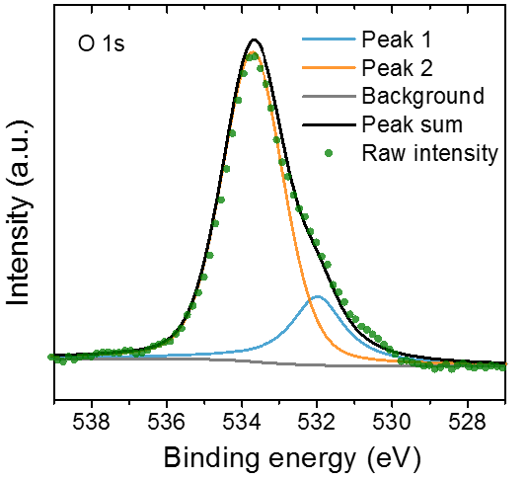

**Figure S2**. Detailed XPS spectra of O 1s.

## Supplementary Figure

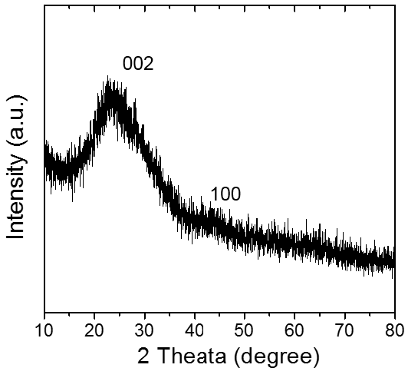

**Figure S3**. XRD pattern of AC.

## Supplementary Figure

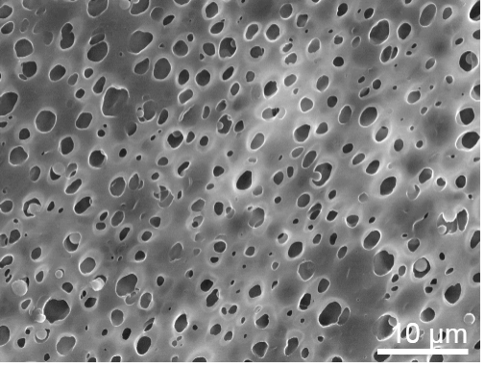

**Figure S4**. FESEM image of the prepared porous P(VDF-HFP) membrane.

## Supplementary Figure



**Figure S5**. CV curve of AC at scan rate of 0.5 mV s-1.



**Figure S6.** The corresponding rate capability of AC at different current densities from 0.1 to 10 A g-1.

## Supplementary Figure



**Figure S7**. Cycling performance of AC at a current rate of 1 A g-1 for 2000 cycles.