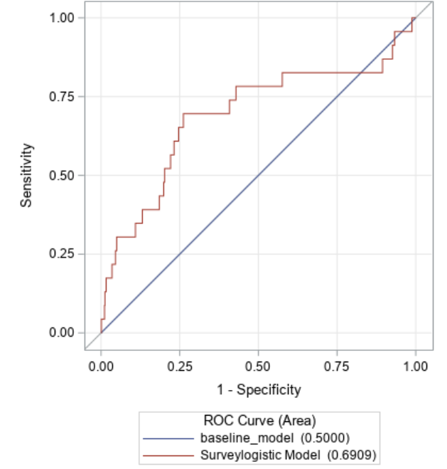
Supplemental Figure 1. ROC Curve for Multivariate Logistic Regression Model

