Table S1. Sequences and reaction efficiencies of quantitative RT-PCR primer pairs.
Gene | Primer | Sequence 5'=>3' | Reaction efficiency | Standard deviation RE
At1g18050 | Fwd | CCATTCTACTTTTTGGCGGCT | 1.964 | 0.020
 | Rev | TCAATGGTAACTGATCCACTCTGATG
UBQ10 | Fwd | GGCCTTGTATAATCCCTGATGAATAAG | 1.936 | 0.028
 | Rev | AAAGAGATAACAGGAACGGAAACATAGT
AtEF1α | Fwd | TGAGCACGCTCTTCTTGCTTTCA | 1.939 | 0.023
 | Rev | GGTGGTGGCATCCATCTTGTTACA
AtZIP9 | Fwd | CCATCACTACTCCGATCGGTGT | 1.869 | 0.018
 | Rev | CACCAATGCTGCAACGCTATAA
AtIRT3 | Fwd | AGTCATCCTCCTGGTCATGATT | 1.967 | 0.023
 | Rev | GAGCATGACCAATGTCGAT
AtIRT1 | Fwd | CCCCGCAAATGATGTTACCTT | 1.951 | 0.024
 | Rev | GGTATCGCAAGAGCTGTGCAT

RE: reaction efficiency

Table S2. Elemental profiling of the root and shoot tissues of wild-type (Col-0), hma2hma4 mutant and hma2hma4 expressing AtHMA4 or AtHMA4CCAA plants upon growth in control conditions (Ctrl, 1 µM Zn, no Cd) or exposed for 3 weeks to 0.05 µM Cd. Values (in µg/g DW) are mean±SD of 3 biological replicates each consisting of pools of 3 plants from 2 independent lines per genotype. The data were analyzed with one-way ANOVA followed by Tukey’s multiple comparison test. Statistically significant differences (P<0.05) between means within tissues and treatments are indicated by different letters. DW: dry weight; CCAA: di-Cys --> di-Ala motifs; n.d.: not detected.
Samples | Ca | Cd | Cu | Fe | K | Mg | Mn | Mo | Zn
Ctrl - Shoot
Col-0 | 41590 ±1856ª | n.d. | 36±1.5ª | 99±9.0ª | 48807±3231ª | 7011±178ª | 181±16.3ª | 9±6.2ª | 104±4.8ª
hma2hma4 | 45193±1170^{b} | n.d. | 41±1.0ª | 98±5.5ª | 45016±5449^{b} | 7220±157^{b} | 200±12.3ª | 30±6.1^{b} | 37±6.5^{c}
AtHMA4 | 45932±2080^{b} | n.d. | 27±0.7^{b} | 77±4.6^{b} | 49394±1303ª | 7042±287ª | 205±16.5ª | 7±4.5ª | 93±2.6ª
AtHMA4CCAA | 47750±3246^{c} | n.d. | 25±1.7^{b} | 88±7.3ª | 47674±2205ª | 7041±395ª | 219±22.0ª | 3±3.0ª | 56±2.5^{b}
Ctrl - Root
Col-0 | 7964±602ª | n.d. | 192±8.9ª | 2041±145ª | 32105±3721ª | 2453±82ª | 108±12.4ª | 71±15ª | 540±28ª
hma2hma4 | 7060±122ª | n.d. | 251±3.1^{b} | 1932±24.2ª | 53266±6708^{b} | 2590±77^{b} | 75±6.7ª | 175±2.6^{b} | 782±5.7^{b}
AtHMA4 | 6529±234ª | n.d. | 229±15^{b} | 1677±67ª | 39177±2593ª | 2418±37ª | 167±19.9^{b} | 85±9.6ª | 495±23ª
AtHMA4CCAA | 6986±764ª | n.d. | 222±25^{b} | 1833±186ª | 48340±2555^{b} | 2729±139^{c} | 292±48.8^{c} | 89±11.4ª | 971±61^{c}
0.05 µM Cd - Shoot
Col-0 | 46605±1639ª | 23±1.9ª | 35±2.1ª | 99±9.4ª | 48865±2057ª | 7317±204ª | 178±13.1ª | 21±4.3ª | 112±4.6ª
hma2hma4 | 54468±2999^{b} | 6±0.1^{b} | 45±0.2^{b} | 79±0.6^{b} | 48844±971ª | 7848±315^{b} | 206±14.1ª | 11±5.9^{b} | 53±3.0^{b}
AtHMA4 | 55345±15176^{b} | 27±7.8ª | 43±10^{b} | 99±8.7ª | 51688±12559^{b} | 8599±2360^{c} | 215±63ª | 31±8.7^{c} | 114±27ª
AtHMA4CCAA | 53038±3049^{b} | 19±2.9^{c} | 34±4.2ª | 80±5.6^{b} | 45200±2177^{c} | 7651±456^{b} | 226±15.7ª | 27±2.9^{c} | 65±7.2^{b}
0.05 µM Cd - Root
Col-0 | 6428±155ª | 32±1.1ª | 211±7.3ª | 1827±111ª | 48655±2553ª | 2213±65ª | 110±4.1ª | 129±14ª | 640±32ª
hma2hma4 | 9037±333^{b} | 204±7.0^{b} | 256±34ª | 3129±270^{b} | 27152±9779^{b} | 2605±263ª | 50±8.3^{b} | 139±11ª | 1229±34^{b}
AtHMA4 | 8369±397^{b} | 47±3.4ª | 243±6.5ª | 2707±309^{b} | 47657±4467ª | 2589±187ª | 110±6.7ª | 109±23^{b} | 830±58ª
AtHMA4CCAA | 7451±383^{b} | 148±11^{b} | 204±13.5ª | 2681±196^{b} | 39013±2558ª | 2700±80ª | 172±40.2^{c} | 126±6.2ª | 1548±69^{c}

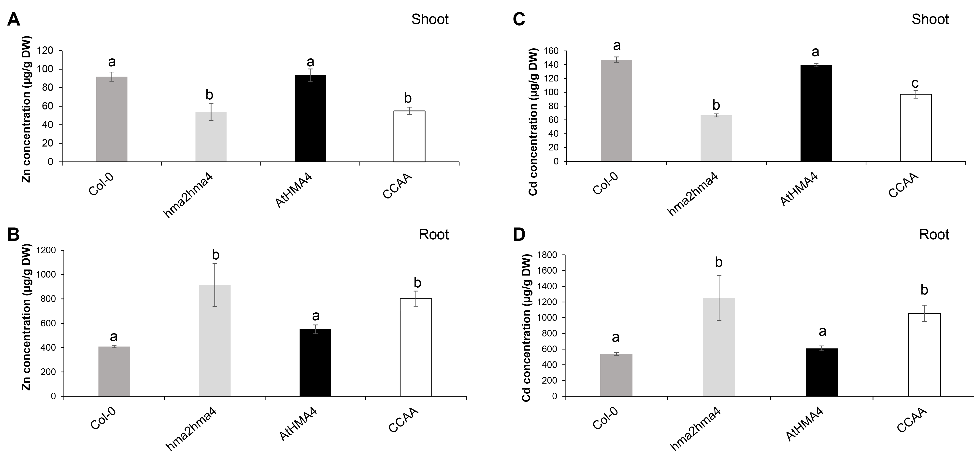

Figure S1. Zinc and cadmium accumulation in shoot (A, C) and root (B, D) tissues of wild-type (Col-0), hma2hma4 mutant and hma2hma4 expressing AtHMA4 or AtHMA4CCAA plants upon hydroponic growth exposed for 3 weeks to 1 µM Cd. Values (in µg/g DW) are means ± SD of 3 biological replicates each consisting of pools of 3 plants from 2 independent lines per genotype. The data were analyzed with one-way ANOVA followed by Tukey’s multiple comparison test. Statistically significant differences (P<0.05) between means are indicated by different letters. DW: dry weight; CCAA: di-Cys --> di-Ala motifs.

