Table S1. Five-days GLM and GRM forecasts of SARS-CoV-2 new infections in Lombardy, Emilia Romagna and Veneto (observed data: Feb 25th to April 30th), and Piedmont (observed data: Feb 28th to April 30th).
Region | GLM |  | GRM
Region | Parameters | Estimates (95% CIs) | Parameters | Estimates (95% CIs)
Lombardy | r  p  K (10⁻⁵) | 5.30 (95% CI: 5.10, 5.60)  0.61 (95% CI: 0.61, 0.62)  0.84 (95% CI: 0.83, 0.85) | r  p  K (10⁻⁵)  a | 2.60 (95% CI: 2.40, 3.10)  0.72 (95% CI: 0.69, 0.73)  0.85 (95% CI: 0.84, 0.86)  0.53 (95% CI: 0.50, 0.65)
Emilia Romagna | r  p  K (10⁻⁵) | 1.80 (95% CI: 1.70, 1.90)  0.70 (95% CI: 0.69, 0.70)  0.27 (95% CI: 0.26, 0.27) | r  p  K (10⁻⁵)  a | 1.10 (95% CI: 0.99, 1.20)  0.81 (95% CI: 0.77, 0.82)  0.27 (95% CI: 0.26, 0.27)  0.53 (95% CI: 0.50, 0.67)
Veneto | r  p  K (10⁻⁵) | 1.60 (95% CI: 1.50, 1.70)  0.69 (95% CI: 0.68, 0.70)  0.20 (95% CI: 0.19, 0.20) | r  p  K (10⁻⁵)  a | 1.00 (95% CI: 0.90, 1.30)  0.79 (95% CI: 0.74, 0.81)  0.20 (95% CI: 0.20, 0.20)  0.56 (95% CI: 0.50, 0.77)
Piedmont | r  p  K (10⁻⁵) | 2.20 (95% CI: 2.10, 2.40)  0.65 (95% CI: 0.63, 0.66)  0.36 (95% CI: 0.35, 0.37) | r  p  K (10⁻⁵)  a | 1.50 (95% CI: 1.40, 1.90)  0.72 (95% CI: 0.68, 0.74)  0.37 (95% CI: 0.36, 0.39)  0.56 (95% CI: 0.50, 0.79)

Fig. S1. Five-day Generalized Richard’s Model forecasts of SARS-CoV-2 new infections in Lombardy, Emilia Romagna and Veneto (observed data: Feb 25th to April 30th), and Piedmont (observed data: Feb 28th to April 30th).
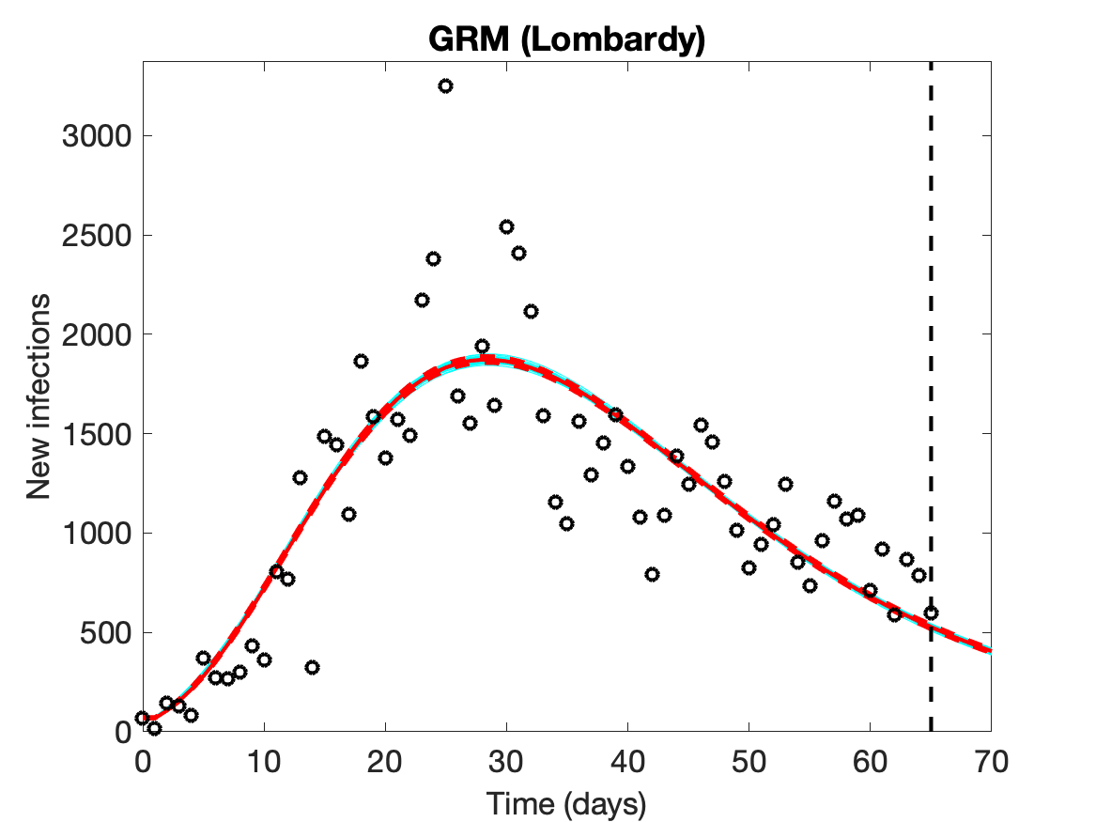 | 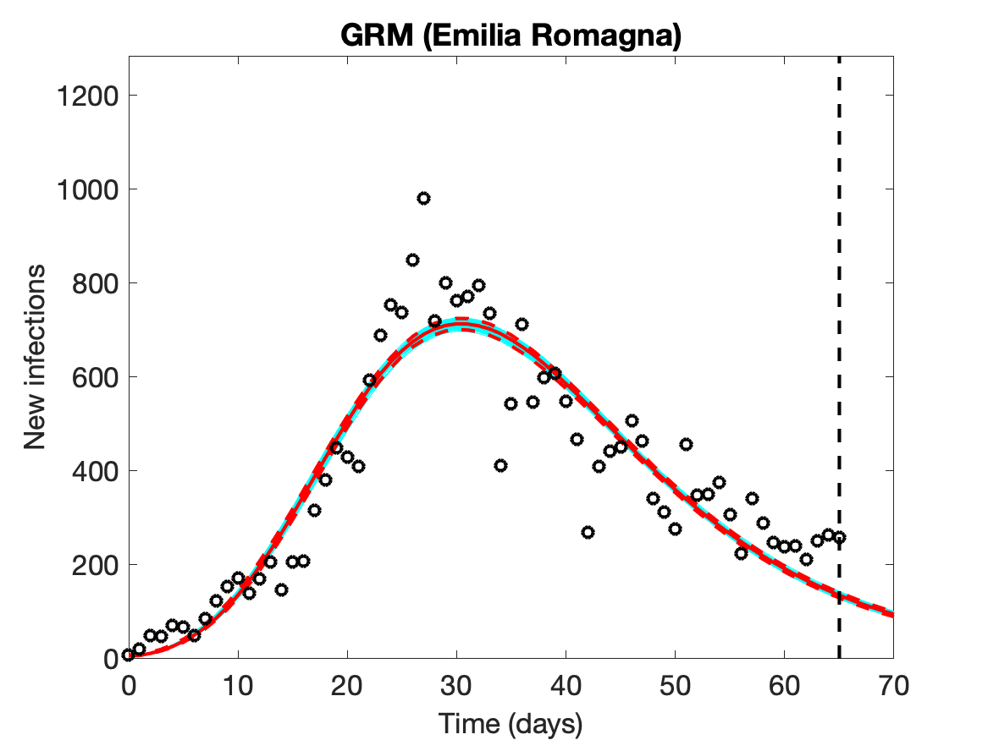
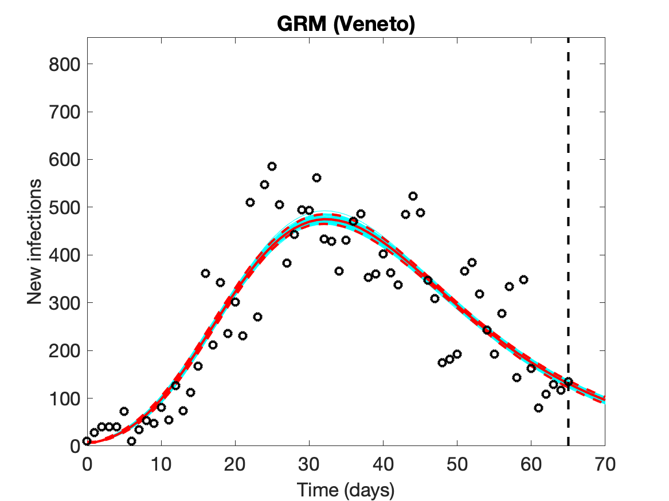 | 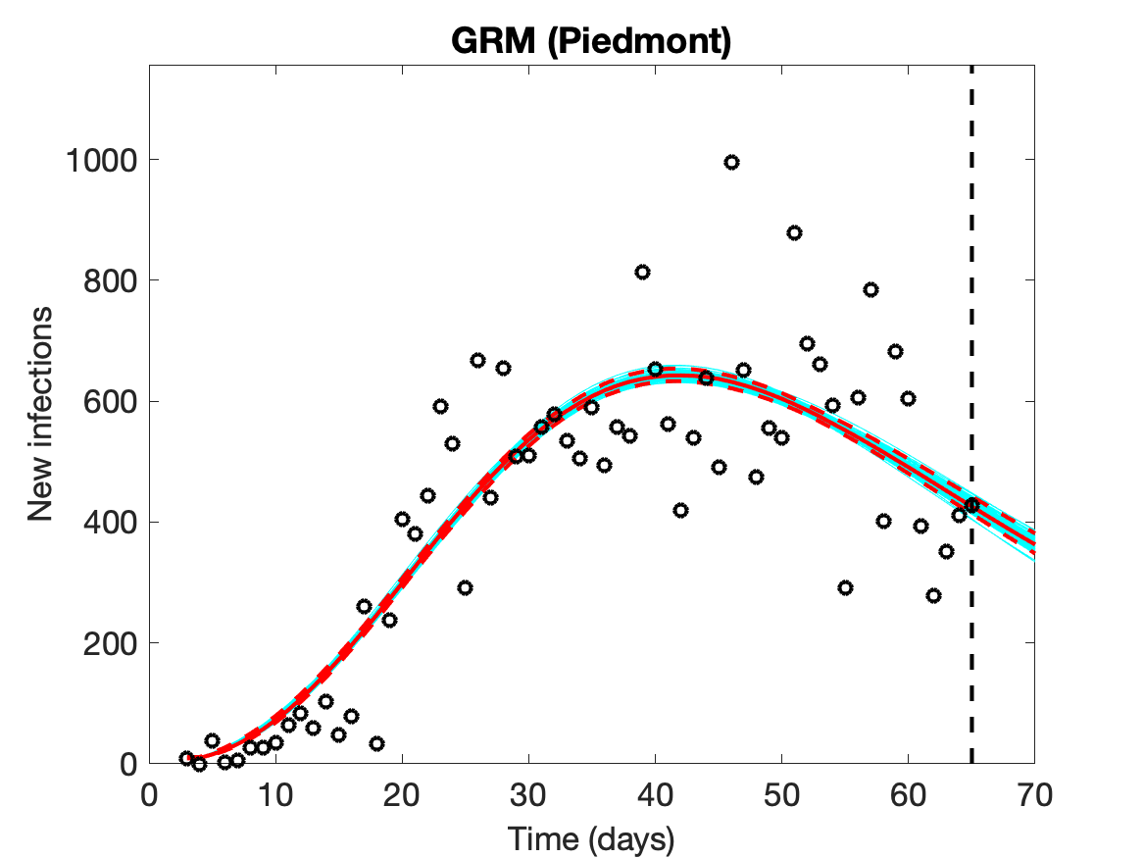

Empty circles represent new observed cases, the vertical dashed line indicates where the real observations stop, the red continuous line the best prediction of the epidemic in the following 5 days, the red dashed lines the 95% confidence bands, and the blue lines the bundle of models estimated by the prediction algorithm. Bootstrap size was set to 100.

Fig. S2. Consecutive five-days GLM forecasts of SARS-CoV-2 new infections in Lombardy (observed data: Feb 28th - March 20th up to Feb 28th – March 29th).
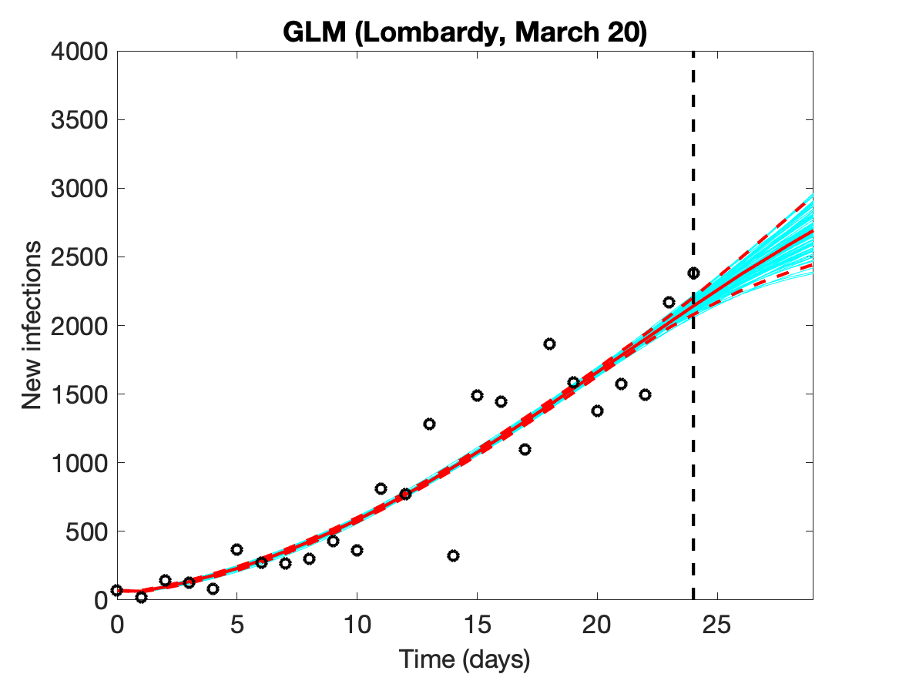 | 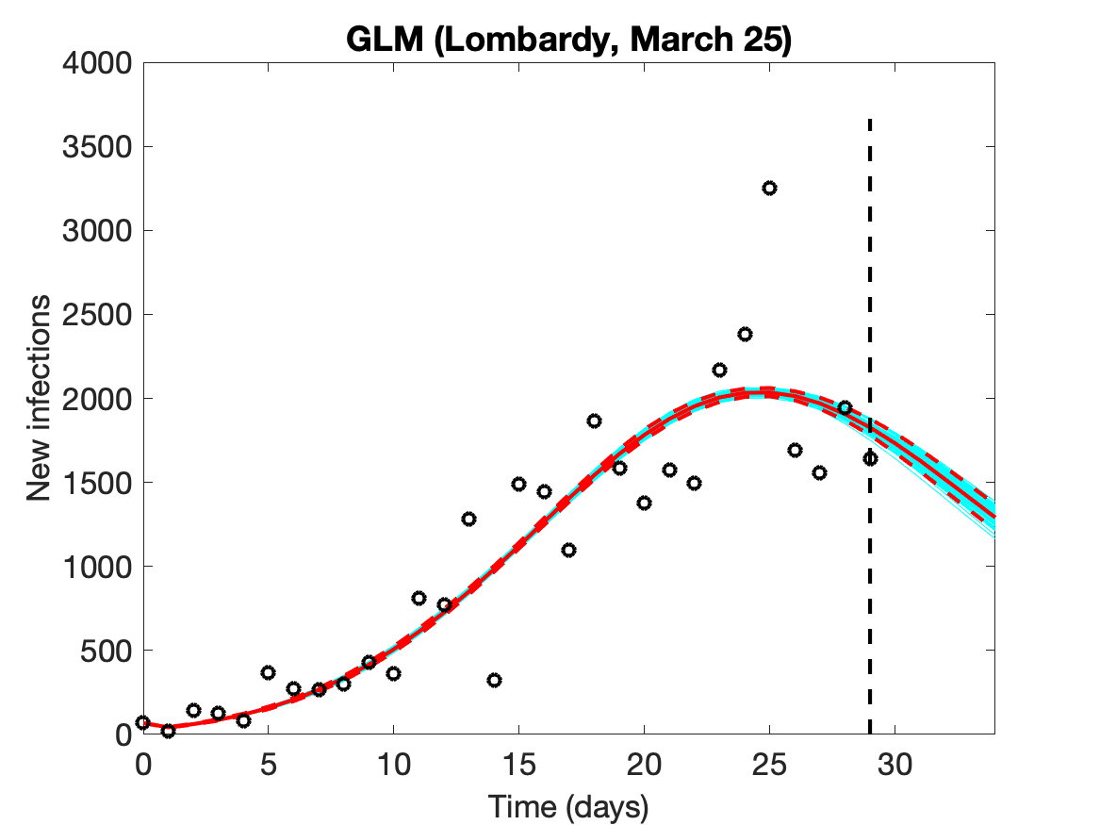
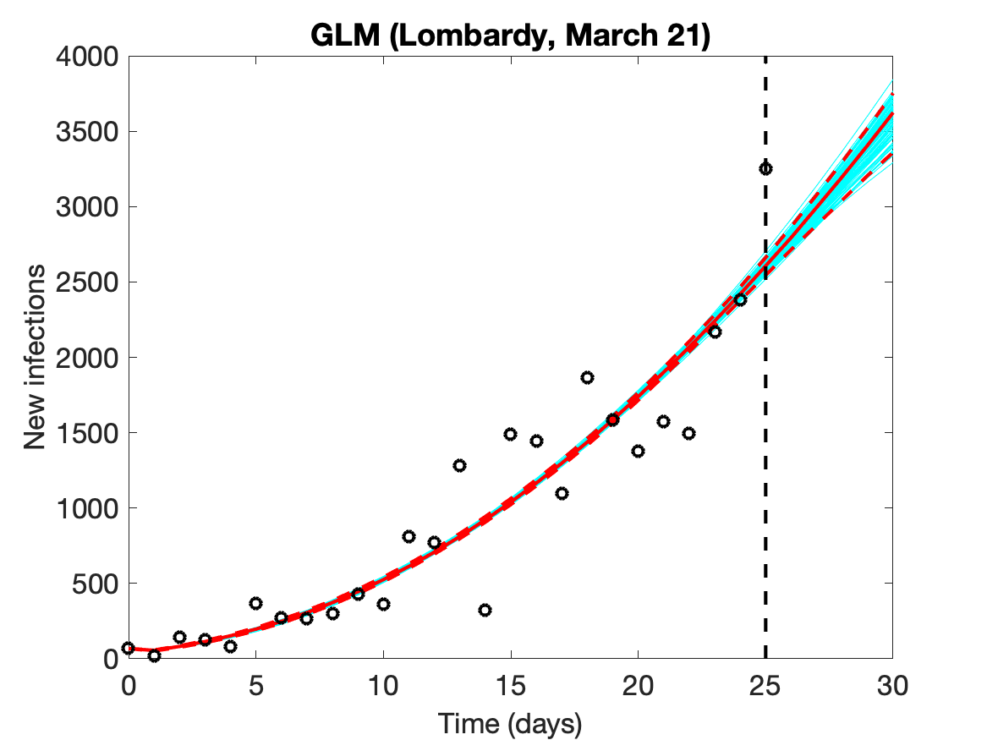 | 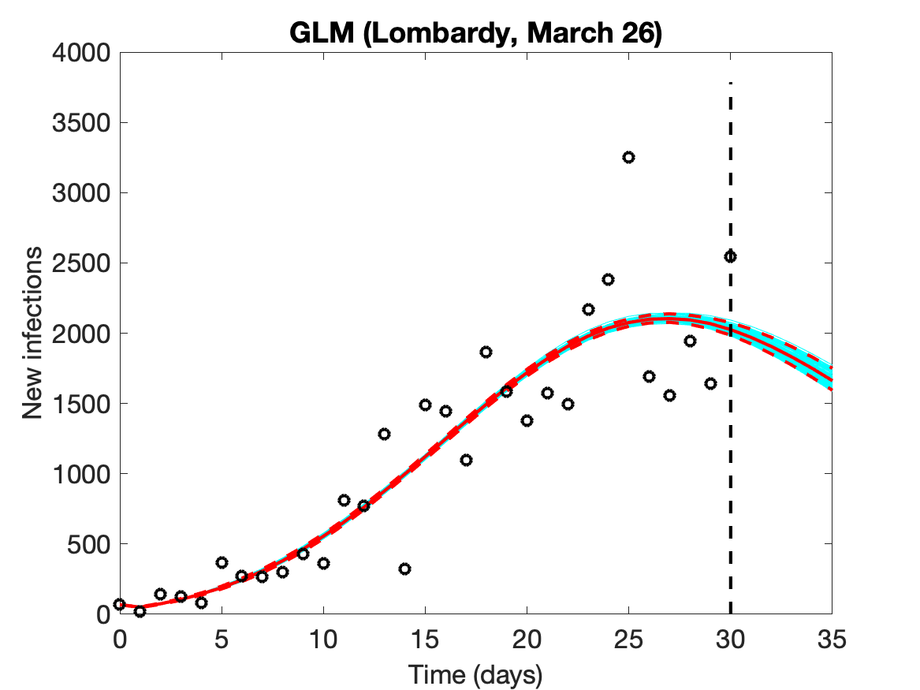
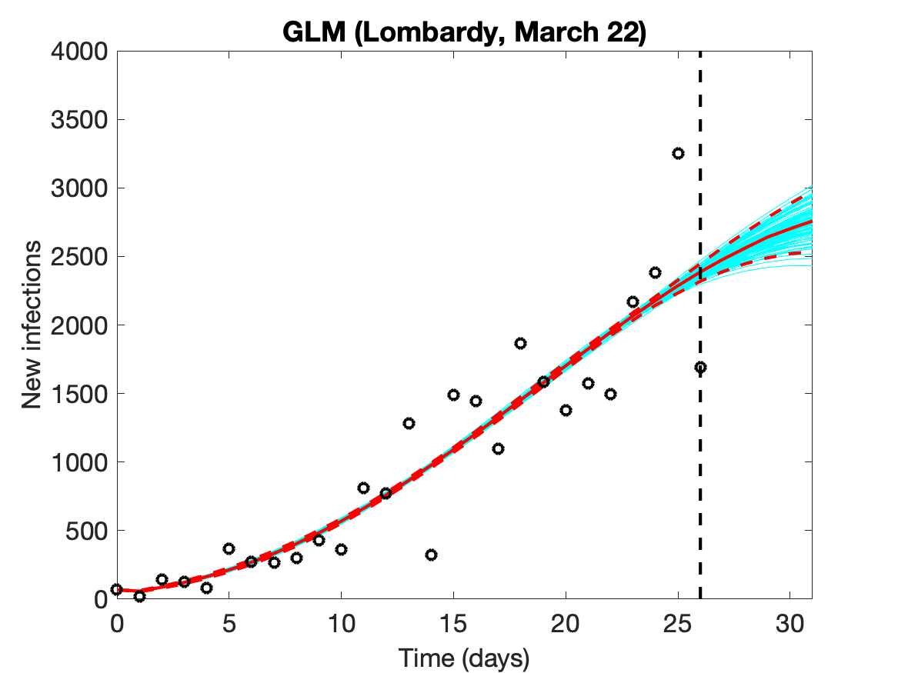 | 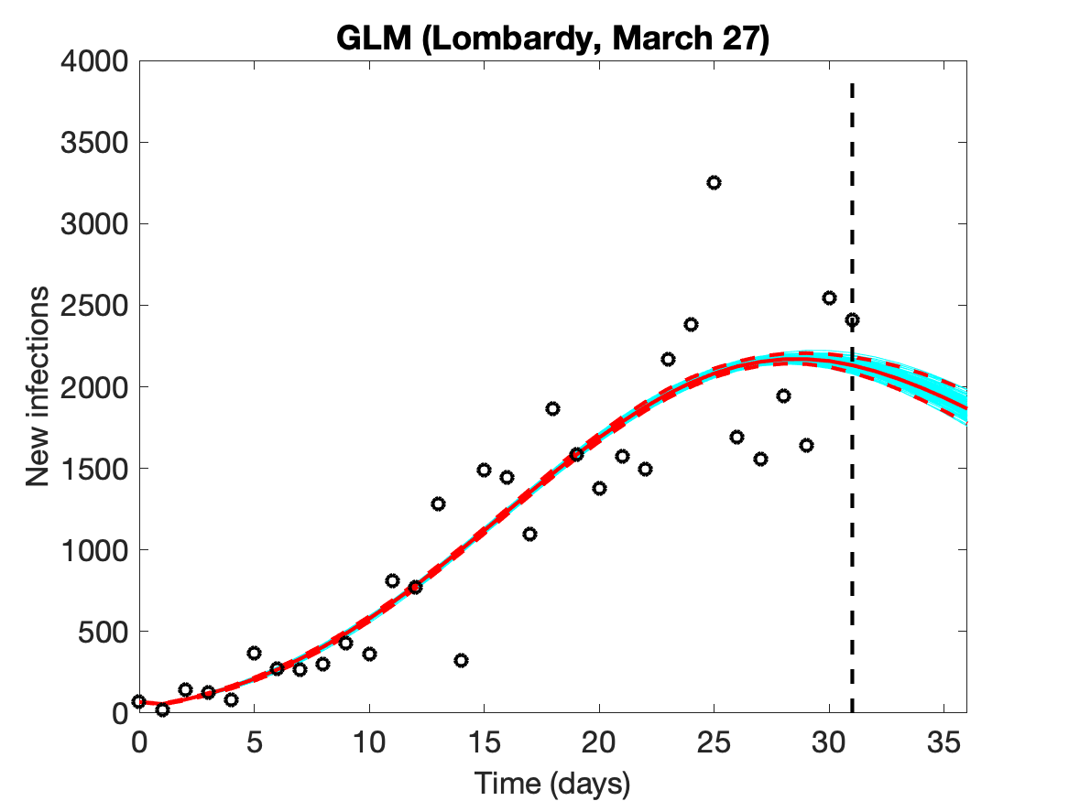
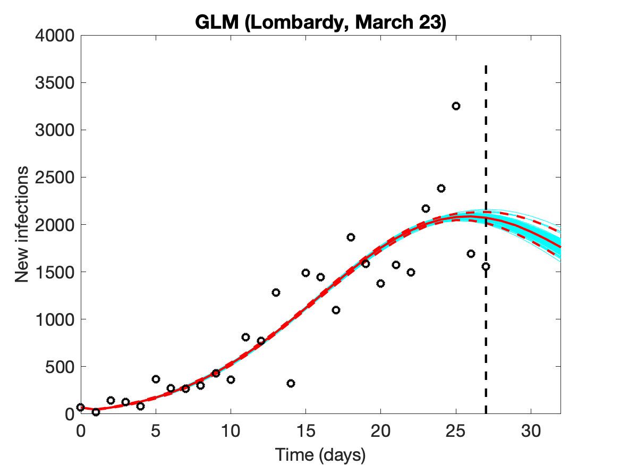 | 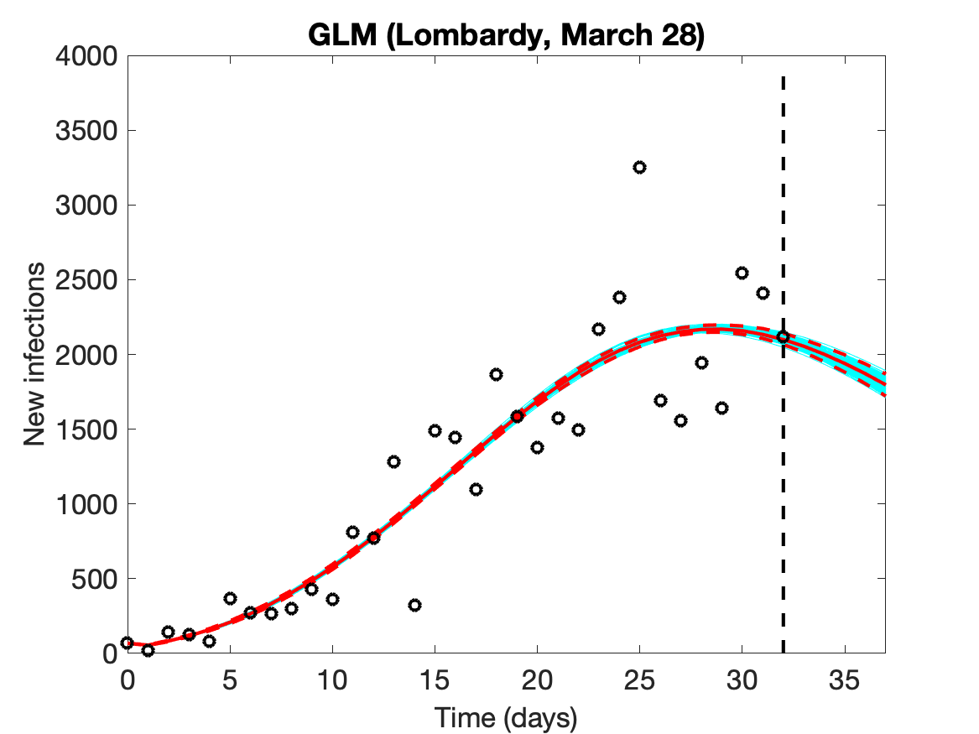
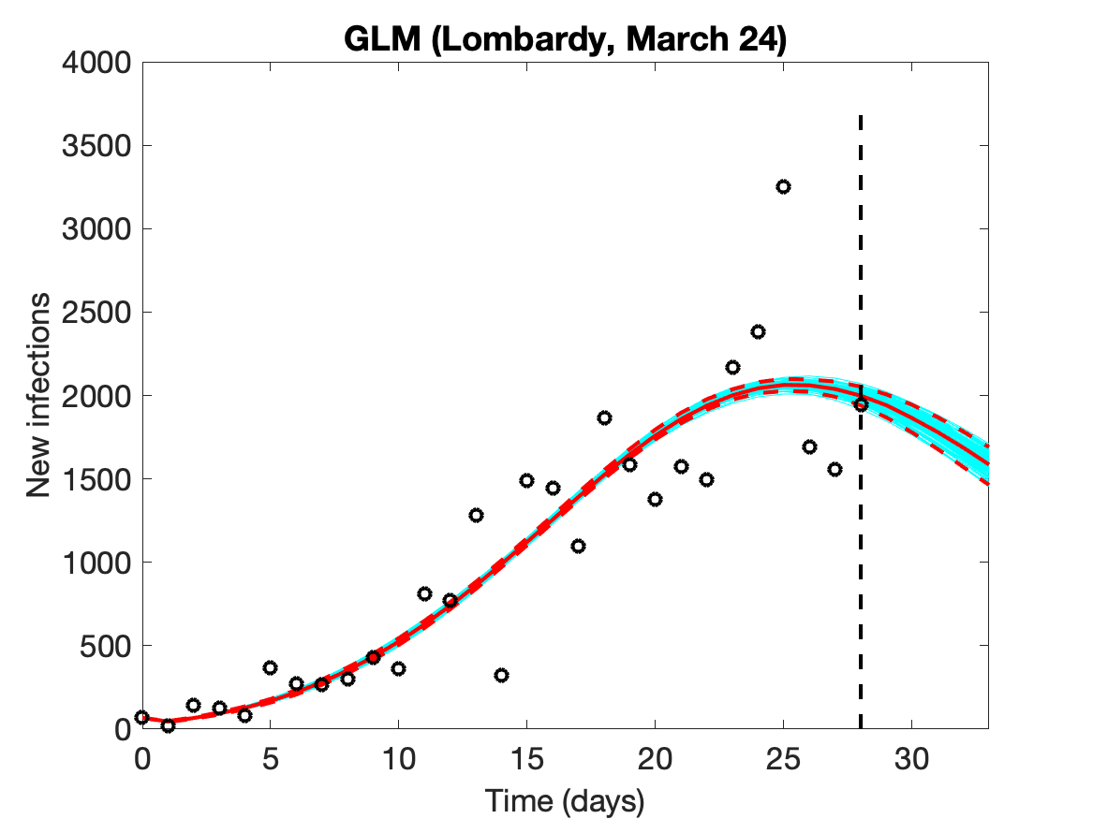 | 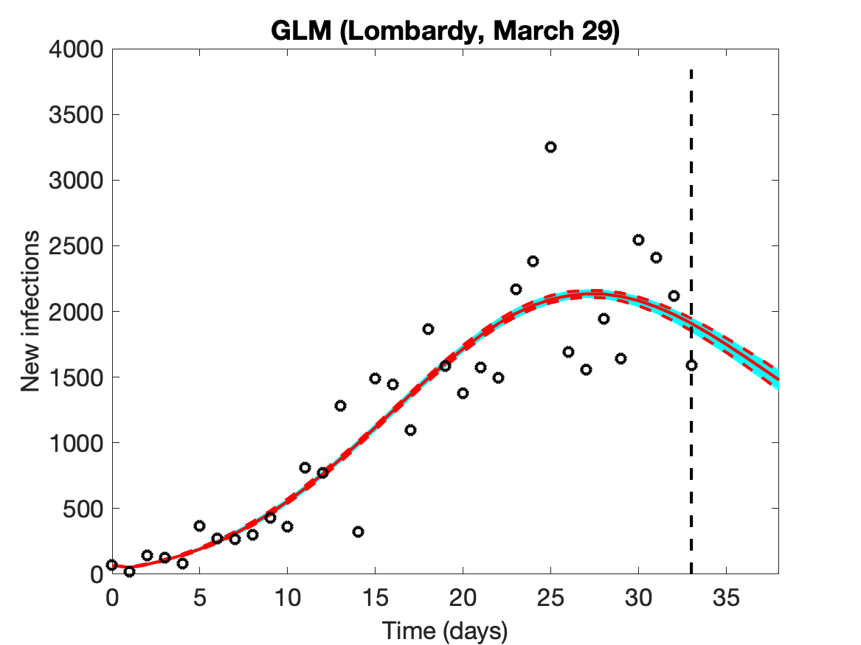

Fig. S3. Evolution of the epidemic predictions in Emilia Romagna based on the Generalized Logistic Model (GLM). An increasing amount of epidemic data (black circles) are used, starting from Feb 25th until March 21st (day of the total lockdown) and then extending the data by 5 days until April 30th.
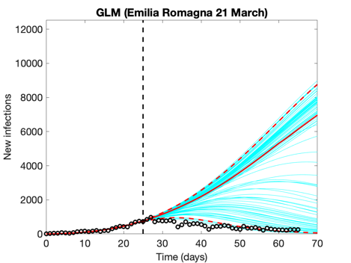 | 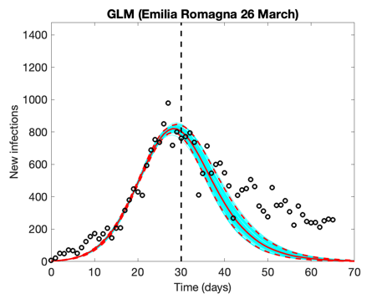 | 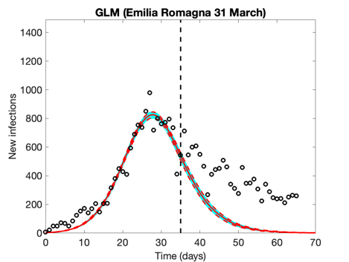
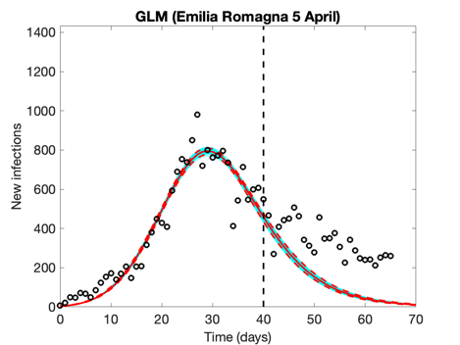 | 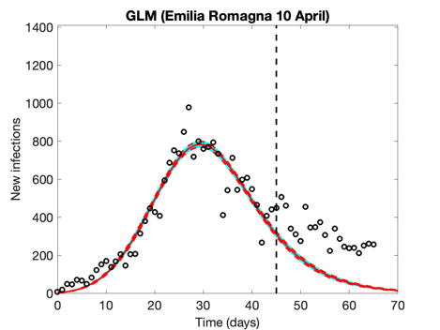 | 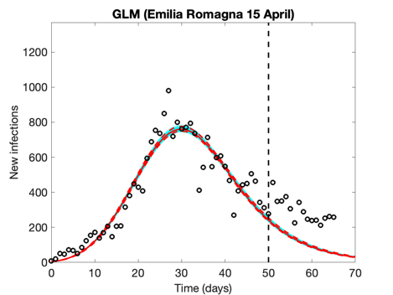
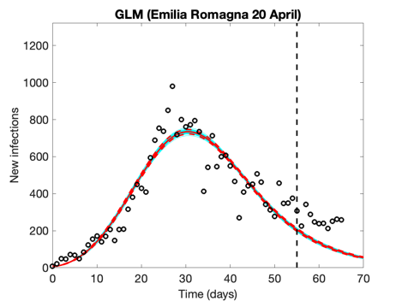 | 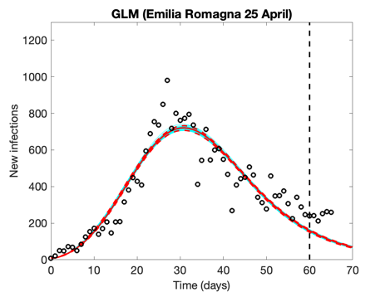 | 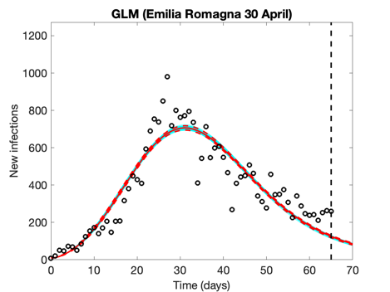
Empty circles represent observed cases, the vertical dashed line indicates where the real observations stop, the red continuous line the best prediction of the epidemic up to May 5th (day 70 of the epidemic), the red dashed lines the 95% confidence bands, and the blue lines the bundle of models estimated by the prediction algorithm. Bootstrap size was set to 100.

Fig. S4. Evolution of the epidemic predictions in Veneto based on the Generalized Logistic Model (GLM). An increasing amount of epidemic data (black circles) are used, starting from Feb 25th until March 21st (day of the total lockdown) and then extending the data by 5 days until April 30th.
.
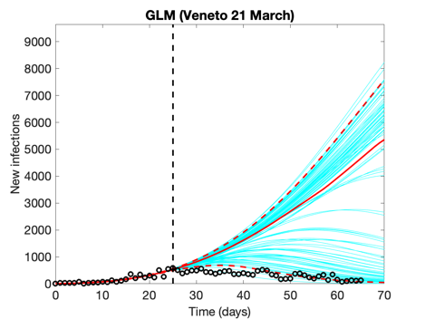 | 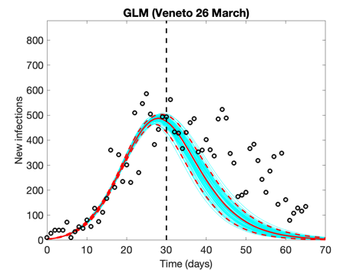 | 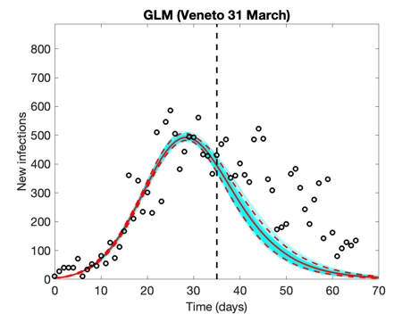
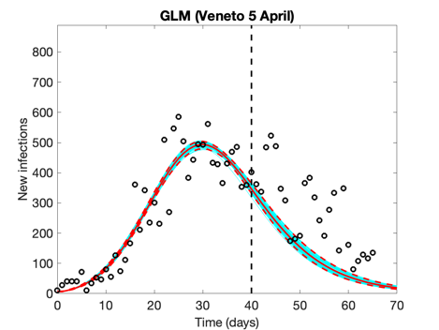 | 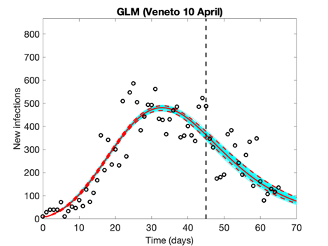 | 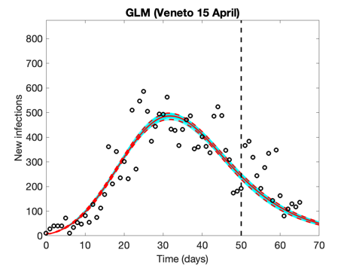
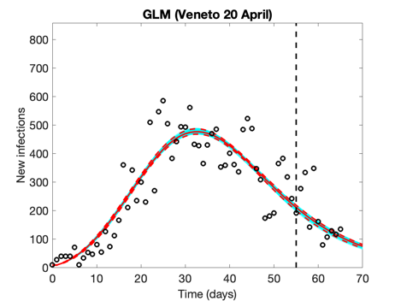 | 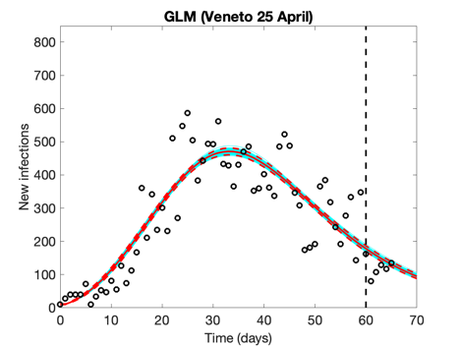 | 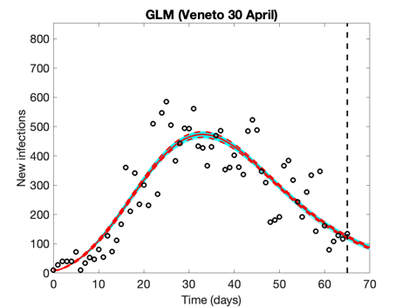
Empty circles represent observed cases, the vertical dashed line indicates where the real observations stop, the red continuous line the best prediction of the epidemic up to May 5th (day 70 of the epidemic), the red dashed lines the 95% confidence bands, and the blue lines the bundle of models estimated by the prediction algorithm. Bootstrap size was set to 100.

Fig. S5. Evolution of the epidemic predictions in Piedmont based on the Generalized Logistic Model (GLM). An increasing amount of epidemic data (black circles) are used, starting from Feb 28th until March 21st (day of the total lockdown) and then extending the data by 5 days until April 30th.

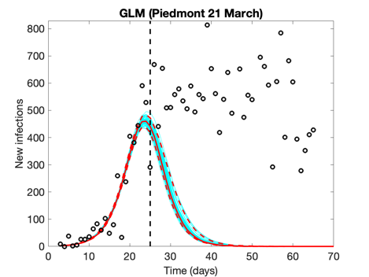 | 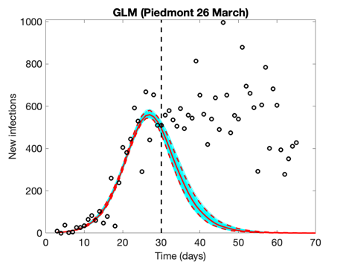 | 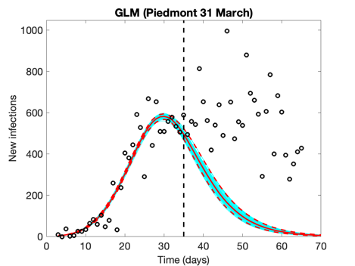
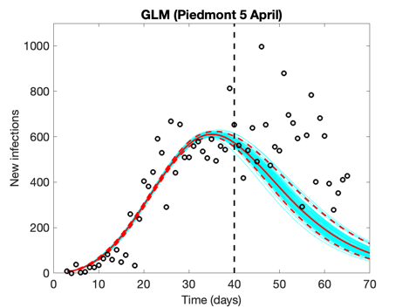 | 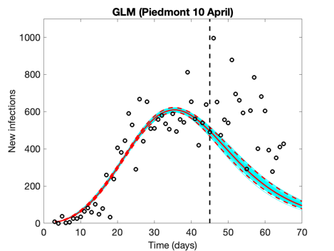 | 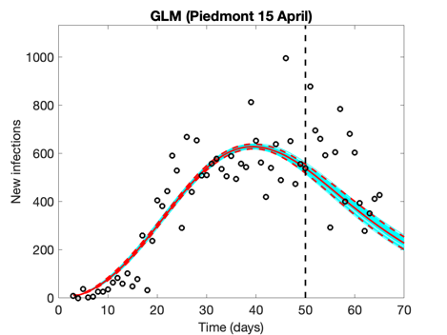
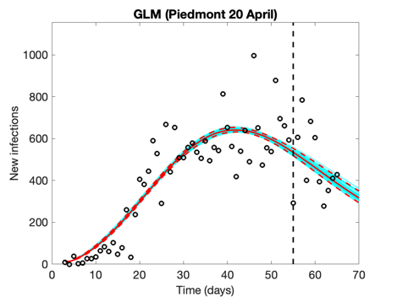 | 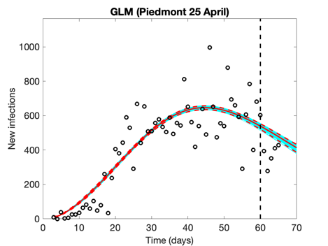 | 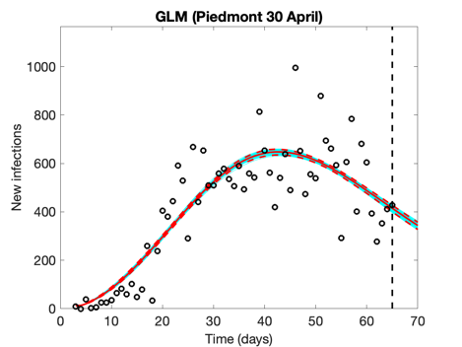
Empty circles represent observed cases, the vertical dashed line indicates where the real observations stop, the red continuous line the best prediction of the epidemic up to May 5th (day 70 of the epidemic), the red dashed lines the 95% confidence bands, and the blue lines the bundle of models estimated by the prediction algorithm. Bootstrap size was set to 100.

