Supplementary Figure S3
Bayesian independent samples t test with country as an independent variable and scores on the Learning subscale as a dependent measure

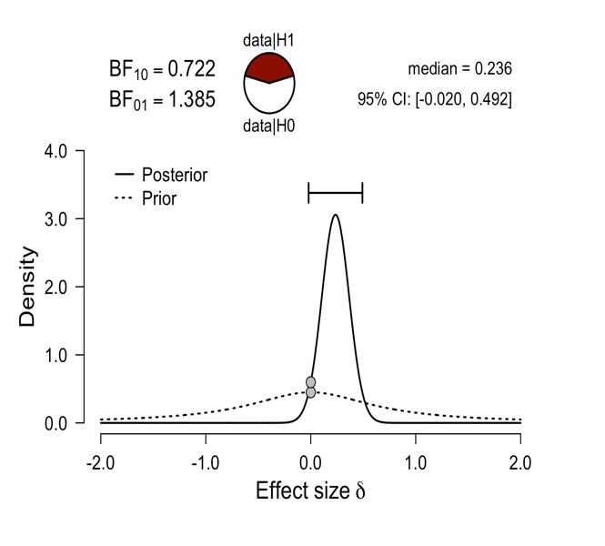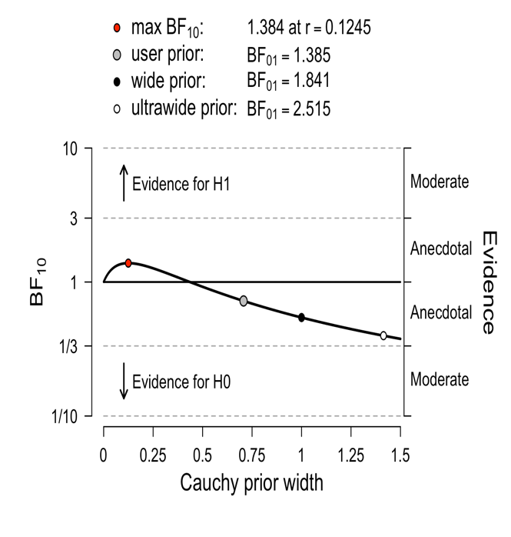

Supplementary Figure S4
Bayesian independent samples t test with country as an independent variable and scores on the Evaluation subscale as a dependent measure

