Supplementary Figure S1
Bayesian independent samples t test with gender as an independent variable and with scores on the Learning subscale as a dependent measure

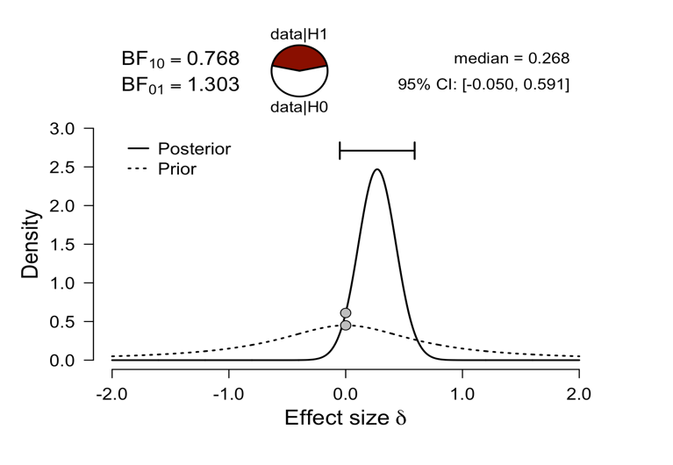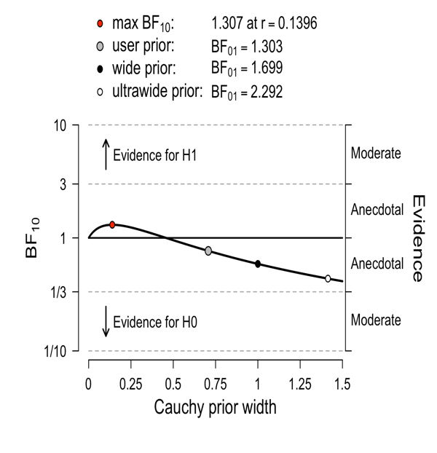

Supplementary Figure S2
Bayesian independent samples t test with gender as an independent variable and scores on the Evaluation subscale as a dependent measure

