Supplementary Material

Figure S1
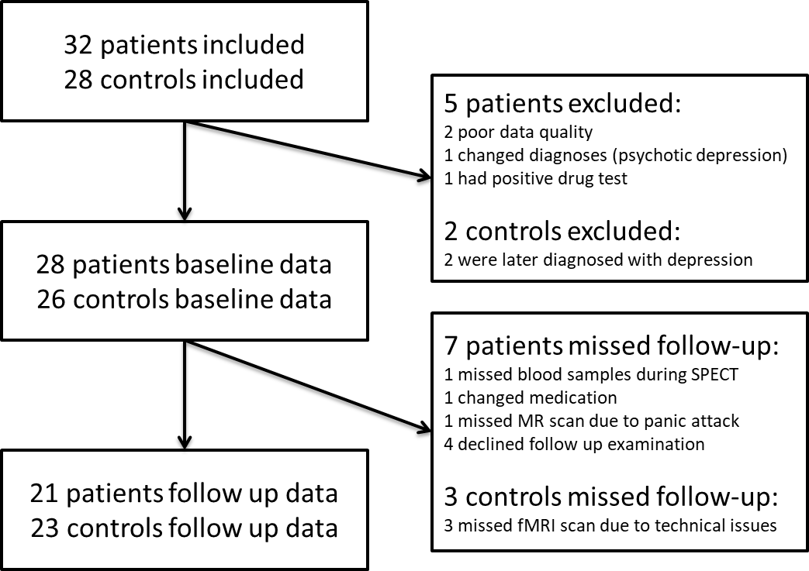
Figure S1: Consort Flow Diagram. Adapted from (Wulff et al., 2015).

Table S1
Multiple Regression Model |  | Standardized Coefficients | t-value | p-value
 |  | Beta
 | (Constant) |  | -.855 | .404
 | Dose | .553 | 2.394 | .028
 | Receptor occupancy | -.017 | -.070 | .945
 | PANSS positive | .244 | 1.251 | .228
 | Model regression |  |  | 0.026

Table S1: Multiple regression model coefficients. The model significantly predicted volume increase (p=0.026) with dose as the only unique, predictive variable (p=0.028).

