Supplementary Material
Supplementary Table 1.

Medication types used during the intervention period
 | Placebo  (n=48) | LF  (n=53)
Antitussive/ Expectorant, n | 34 | 33
Bronchodilator, n | 18 | 16
Anti-allergy/ Anti-histamine, n | 22 | 20
Probiotics, n | 20 | 19
Antidiarrheal, n | 0 | 1
Antiemetic, n | 0 | 3
Antibiotics, n | 22 | 21
Influenza antiviral drugs, n | 7 | 10
Antipyretics, n | 12 | 9
Others, n | 6 | 2

Supplementary Table 2.

Medication types used in the post-intervention period
 | Placebo  (n=48) | LF  (n=53)
Antitussive/ Expectorant, n | 7 | 7
Bronchodilator, n | 3 | 2
Anti-allergy/ Anti-histamine, n | 6 | 4
Probiotics, n | 1 | 3
Antidiarrheal, n | 0 | 0
Antiemetic, n | 0 | 0
Antibiotics, n | 3 | 4
Influenza antiviral drugs, n | 1 | 1
Antipyretics, n | 2 | 0
Others, n | 3 | 1

Supplementary Table 3.

Influenza diagnosed during the intervention period
 | Placebo  (n=48) | LF  (n=53) | RD (95% CI) | p
Influenza
Prevalence, n (%) | 7 (14.6) | 10 (18.9) | -0.043 (-0.188, 0.102) | 0.605
Total days | 0 (0, 0) | 0 (0, 0) |  | 0.569
Duration, days/episode | 7 (6, 7) | 6 (5.75, 7.25) |  | 0.887
Medication, n (%) | 7 (100) | 10 (100) |  | -
Abbreviations: RD, risk difference; CI, confidence interval.
Values represent the number (%) or the median (interquartile range).
Prevalence represents the number of participants diagnosed with influenza..
Total days is defined as the cumulative number of symptomatic days.
Duration is defined as the mean of consecutive days per episodes.
Risk difference is calculated by subtracting the prevalence in the LF group from the prevalence in the placebo group.

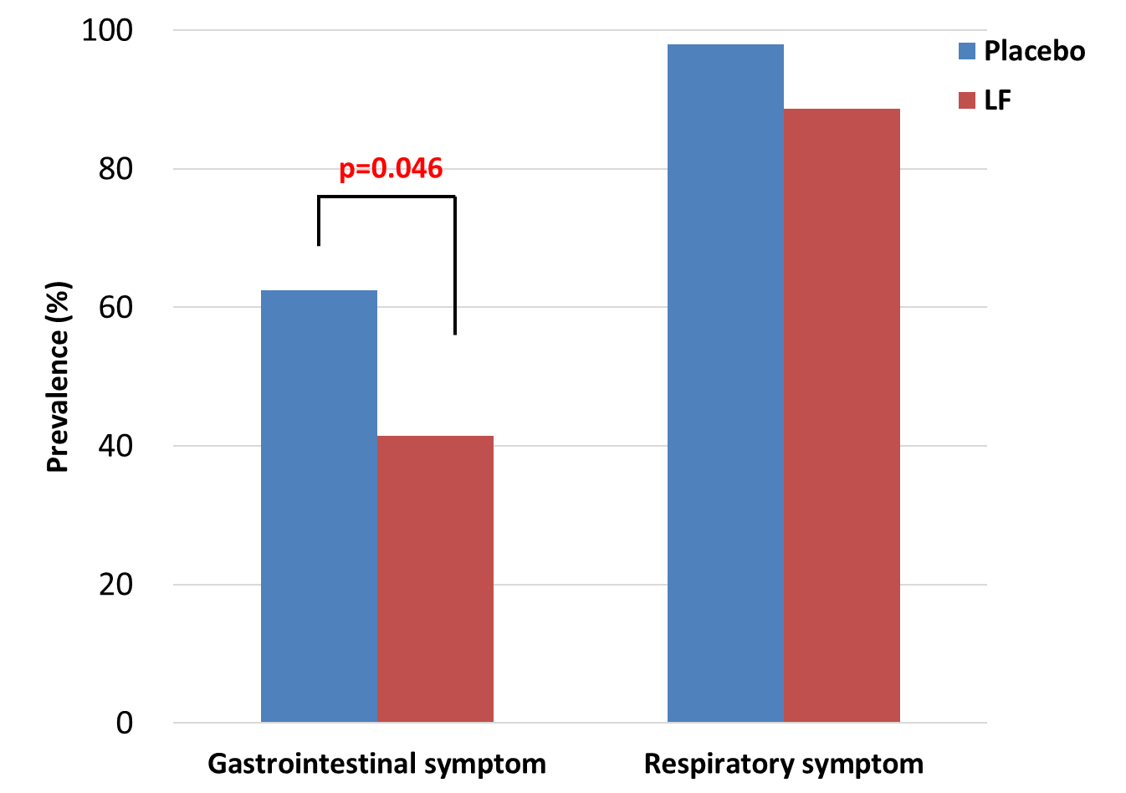

Supplementary Figure 1.

Prevalence of acute gastrointestinal and respiratory symptom during the intervention period

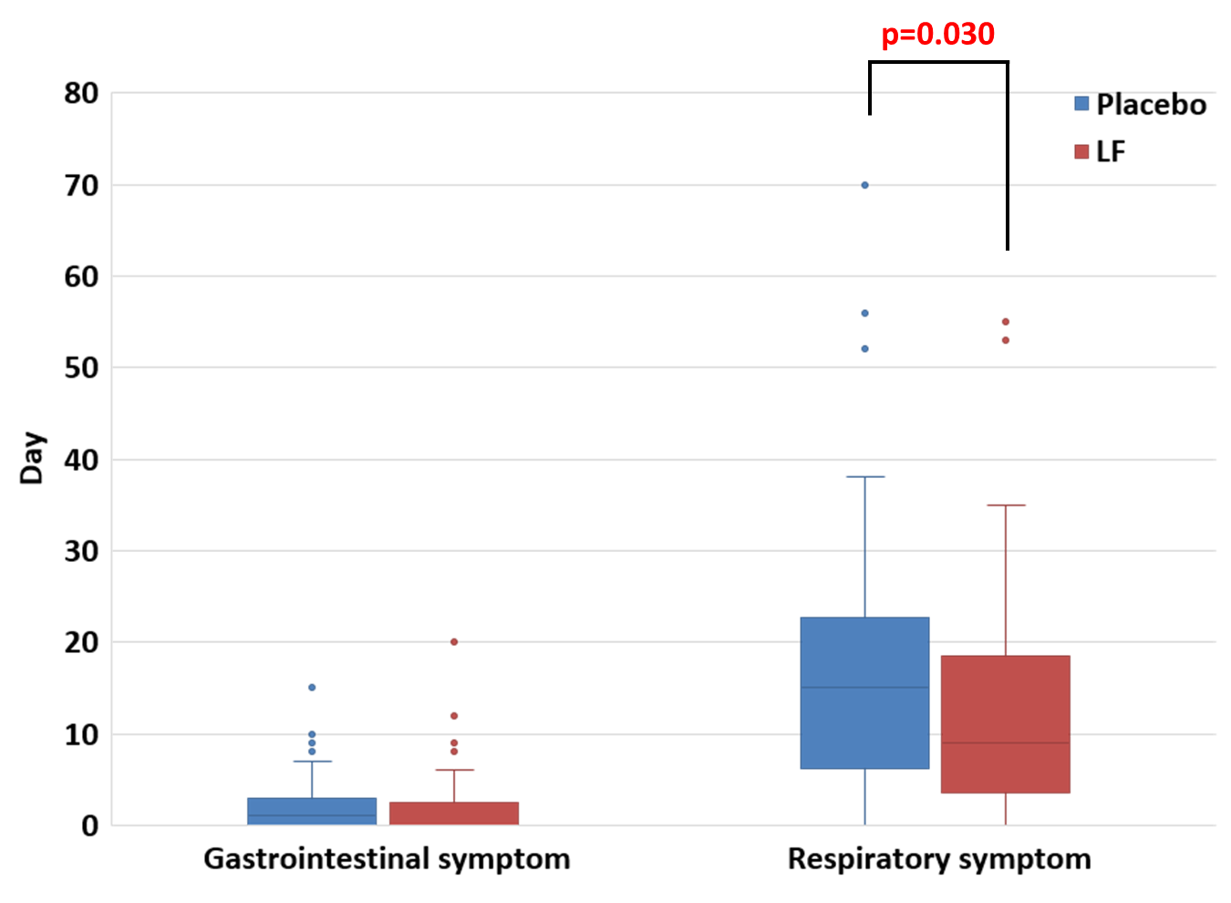
Supplementary Figure 2.
Total number of days of acute gastrointestinal and respiratory symptom during the intervention period

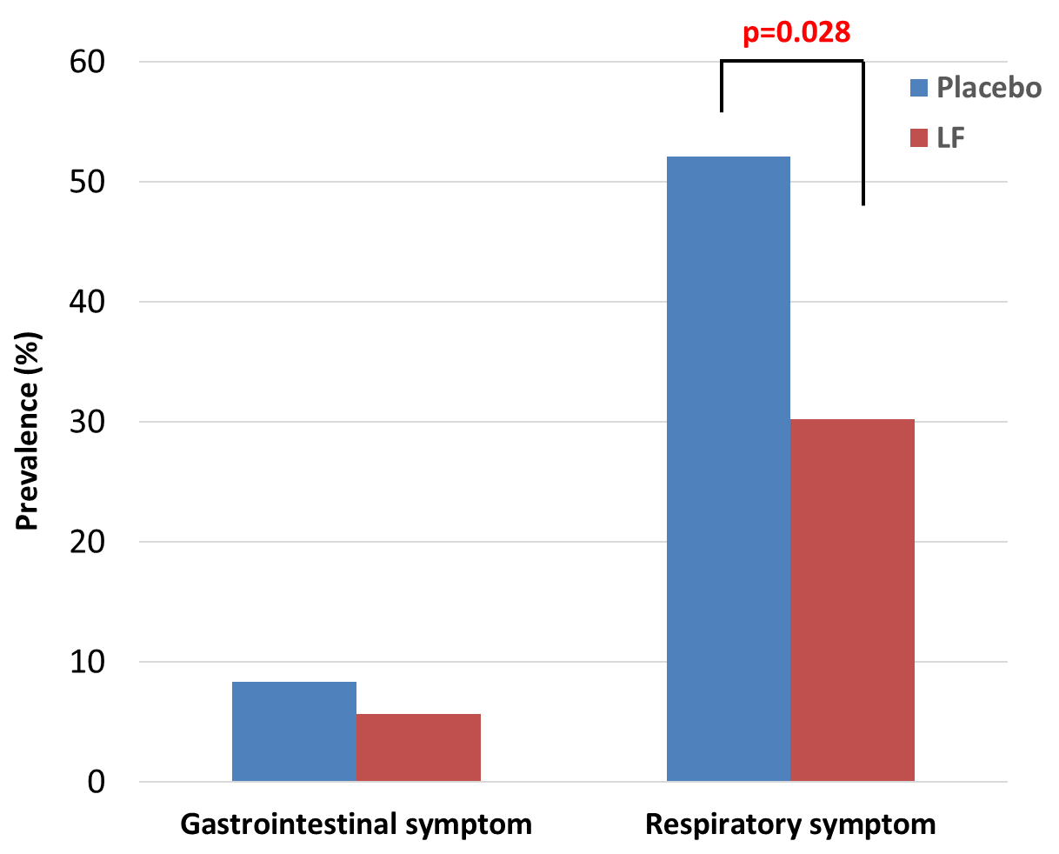

Supplementary Figure 3.

Prevalence of acute gastrointestinal and respiratory symptom in the post-intervention period

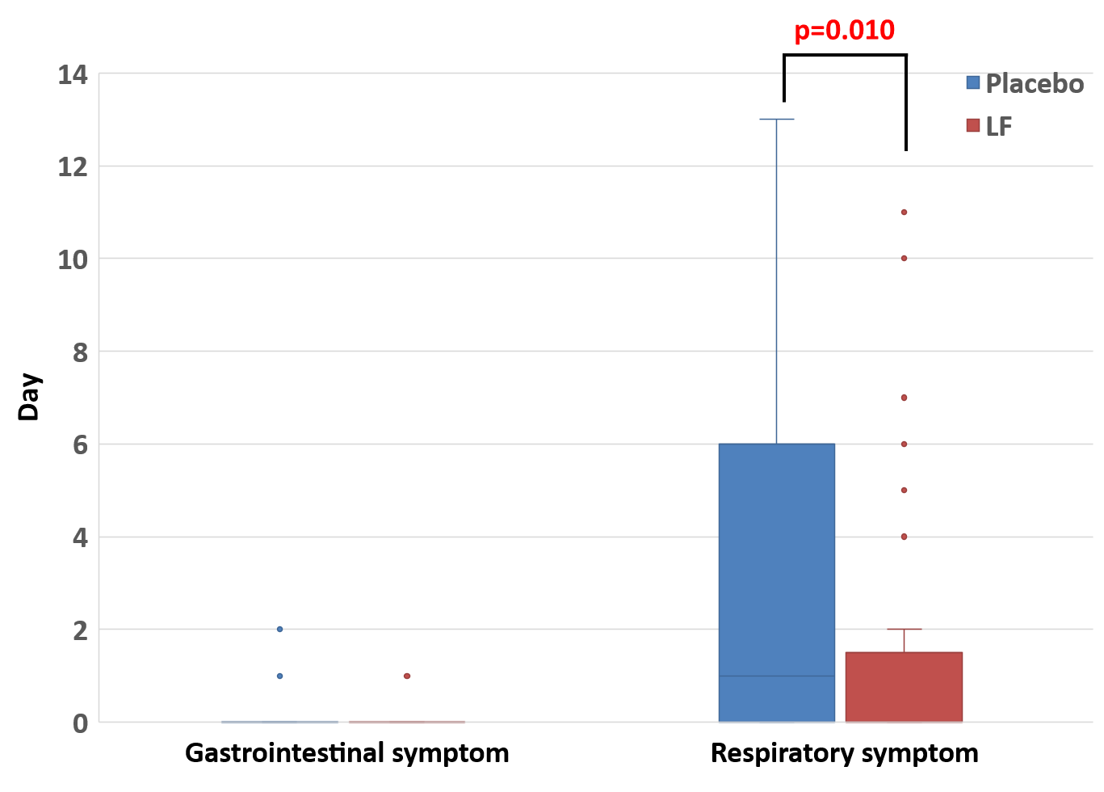

Supplementary Figure 4.
Total number of days of acute gastrointestinal and respiratory symptom in the post-intervention period

