Supplementary Material

Supplementary Information - Material and Methods

Microscopic investigations of sponge fragments - Epifluorescence microscopy
Quantification of bacterial abundances in sponge fragments was performed by SG-I staining. Sponge fragments (approx. 100 mg) were washed with autoclaved and 0.2 µm-filtered ambient water (AW), cut in small pieces using a sterile scalpel, and homogenized in 4 mL AW in a paddle blender (Stomacher® 80 Biomaster, Seward Limited, Worthing, UK) at 300 rpm for 4 min. The homogenate was fixed overnight with 3.7% (v/v) methanol free formaldehyde (Carl Roth, Karlsruhe, Germany) at 4°C and serially diluted up to 10⁻⁴ in 0.2 µm-filtered artificial seawater (ASW). A volume of 0.9 mL was vacuum-filtered onto black 0.2 µm membrane filters (WhatmanTM Cyclopore® track etched membranes, 25 mm) supported by 5.0 µm WhatmanTM cellulose nitrate membrane filters (25 mm; GE Healthcare, Little Chalfont, UK) and subsequently stained with SYBR® Green I moviol staining solution as described by Lunau et al. (2005) containing 340x SYBR® Green I (v/v, final conc.) (Sigma-Aldrich, St. Louis, USA) and 1.4x ascorbic acid (v/v, final conc.). Bacterial numbers were assessed in three independent samples by counting of ten randomly selected fields of view per sample.
Catalyzed Reporter Deposition Fluorescence In-Situ Hybridization (CARD-FISH) was done according to Bižić-Ionescu et al. (2015). Therefore, the general bacterial probe mix EUBI-III (Amann et al., 1990; Daims et al. 1999), the reverse-complementary negative control probe non-EUB (Wallner et al., 1993) and tyramides conjugated with the fluorescent dye Alexa Fluor® 488 (λ_{ex} 490 nm; λ_{em} 525 nm) were used. Counterstaining of DNA was performed using DAPI (4',6-diamidino-2-phenylindole, λ_{ex} 358 nm; λ_{em} 461 nm).
Samples were inspected with a Leica DM5000B epifluorescence microscope equipped with filters for SybrGreen-I and Alexa Fluor® 488 dye (excitation filter, EX: 480/40; dichromatic mirror, DC: 505; emission filter, EM: 527/30), DAPI (EX: 350/50, DC: 400, EM: 460/50), and autofluorescence (EX: 538/45, DC: 580, EM: 590) (Leica Microsystems, Wetzlar, Germany). Images were acquired with a Leica DFC3000G camera and processed with LASX 1.5.1.13187 (Leica Microsystems, Wetzlar, Germany).

Microscopic investigations of sponge fragments - Transmission electron microscopy (TEM)
Sponge fragments were washed with AW and fixed in 2.5% glutaraldehyde and 1.5% formaldehyde in 0.1M phosphate buffer (PB, pH 8.0) containing 0.3 M NaCl, for 3 hrs at RT. Cross sections of sponge fragments were prepared with a sterile razor blade, washed with PB, post-fixed in 2% osmium tetroxide in PB and washed again first in PB and then in double distilled water. After dehydration through a graded ethanol series samples were embedded in resin using the Modified SPURR embedding Kit (Serva Electrophoresis, Heidelberg, Germany) according to the manufacturer’s protocol. After curing by heat blocks were immersed in 20% (v/v) hydrofluoric acid for 15 minutes in order to dissolve spiculae. Ultra-thin cross sections (60 nm) were cut with an ultramicrotome (Reichert Ultracut S, Leica Microsystems, Wetzlar, Germany). Sections were mounted on copper slot grids supported by 1.25% Formvar film and contrasted with 4% uranyl acetate (30 minutes) and Reynolds lead citrate (8 minutes). Ultrathin sections were inspected in an EM912AB (Zeiss, Oberkochen, Germany) transmission electron microscope (accelerating voltage 120 kV) and images were recorded at slight under focus using a 2kx2k ssCCD camera (TRS “Tröndle Restlichtverstärkersysteme”, Moorenweis, Germany).

Supplementary Information - Results

Disconnection of tanks of the closed circulating water system and impact of experimental treatments caused specific bacterial community shifts
The presence of a typical sponge microbiota was supported by the observed bacterial community stability over time as determined by the assessment of the Haliclona cnidata in two different years. The stability of sponge-associated microbiota in artificial long-term maintenance was previously described for sponges in several studies (Friedrich et al., 2001; Thoms et al., 2003; Gerçe et al., 2009; Bergman et al., 2011). Despite this stability of the bacterial microbiota of the Haliclona cnidata over time, the disconnection of the small tanks used for the experiments from the closed-circulating system (Fig. S1) strongly affected the relative abundance of the sponge associated microbiota including many highly abundant SCC taxa. After 14 days of acclimation in the tanks, the experimental treatment started and the tanks of the closed-circulating water system were disconnected to prevent the distribution of antibiotics (Fig. S1). Following this disconnection prior to the initial sampling (sponge 2012, t₀), the richness (higher Chao1-bc values) and diversity (Shannon index H) of the bacterial communities increased in the untreated sponge fragments (LN). Additionally, phylogenetic groups in LN sponge fragments were more equally distributed (lower dominance) compared to sponges cultured in the closed-circulating tank system (t₀) (Fig. 6E).
Such effects on the sponge microbiota were already described before. Webster et al. (2011), for example, showed that the stability of the microbiota of the sponge Rhopaloeides odorabile depended on the kind of aquatic systems. They found that the sponge microbiota was stable in small flow-through aquaria but changed strongly in composition compared to wild type sponges, if the sponges were cultivated in large scale mesocosms (Webster et al., 2011).

Supplementary Figures and Tables

Supplementary Figures
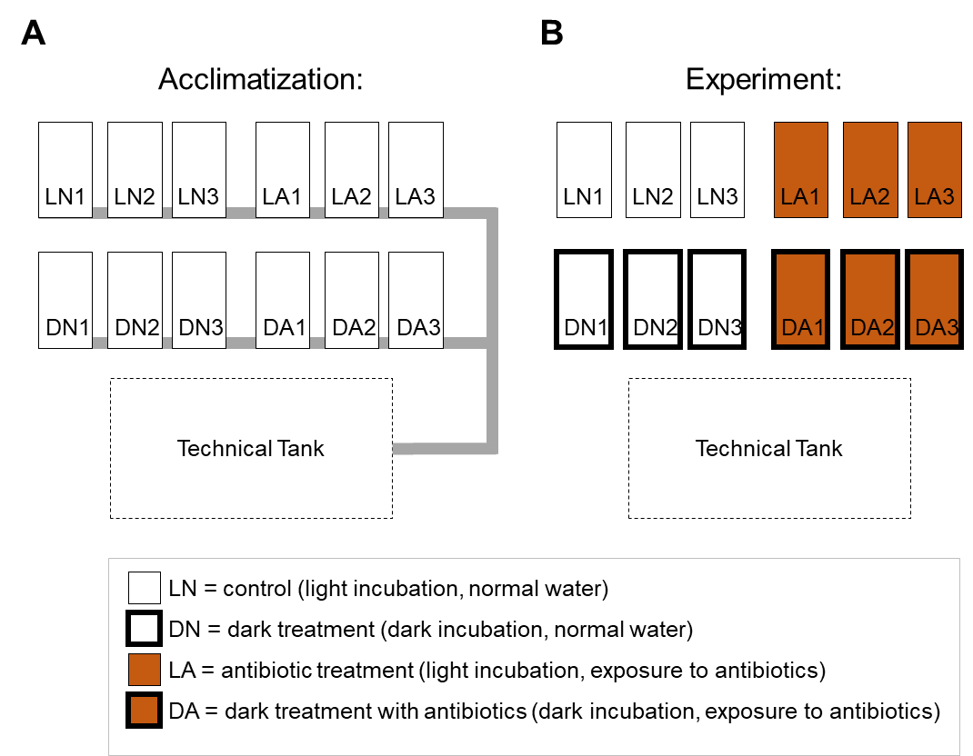
Supplementary Figure 1. Setup of the resilient community generating experiment. To reduce the associated microbiota to a resilient community, sponge specimens were exposed to antibiotics (to remove most of the host-associated bacterial symbionts) and dark incubated (to reduce the phototrophic symbionts). The respective experiment was performed in a closed-circulating water system at the aquarium facilities of the Justus Liebig University Giessen. Three replicated 12-liter tanks (26°C) were used per treatment each containing three sponge fragments. T5 luminescent tubes were used as light source to generate a 10:14 light:dark photoperiod. Water parameters (hardness, salinity, phosphate, temperature, and light intensity) were monitored in a time interval of five minutes using a Hobo® Pendant Temperature/Light Data Logger. Every second day, one-third of the water-volume was renewed from the adjacent technical tank and antibiotics were replenished. Experimental treatments were control (LN), exposure to antibiotics (LA), dark incubation (DN), and a combination of dark incubation plus exposure to antibiotic (DA). Antibiotic treatments contained ampicillin and gentamicin (each 100 mg L⁻¹). The specific antibiotics were chosen because of their acid stability, low toxicity and broad antimicrobial activity against both Gram-negative and Gram-positive bacteria (Suwanrumpha and Freas, 1989; Weinstein et al., 1967). (A) After 14 days of acclimation in the tanks, (B) the experiment started and the tanks of the closed-circulating water system were disconnected to prevent the distribution of antibiotics. Every second day during the experimental treatment, one-third of the water volume was renewed from the adjacent technical tank and antibiotics were replenished.

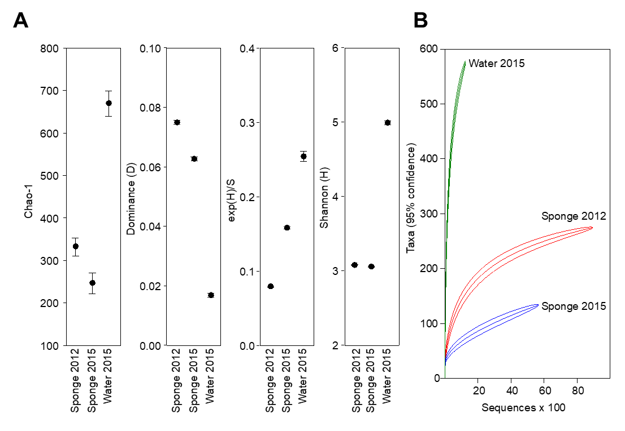
Supplementary Figure 2. Bacterial community analysis by 16S rRNA gene amplicon Illumina MiSeq sequencing. Alpha diversity (A) and Rarefaction (B) analysis of the associated bacterial communities of the samples sponge 2012, sponge 2015 and water 2015. Analysis based on total number of 16S rRNA gene amplicon data obtained by Illumina sequencing of pooled experimental replicates. Analysis was performed in PAST3.

Supplementary Figure 3. Principal component analysis (PCA) on the level of bacterial phyla. 16S rRNA gene amplicon data was subjected to PCA to determine phyla contributing most to community dissimilarity between Haliclona cnidata (Sponge 2012, Sponge 2015) and ambient water (Water 2015). To enhance visualization, only most contributing phyla are labelled. Analysis was performed in PAST3.

Supplementary References
Amann, R.I., Binder, B.J., Olson, R.J., Chisholm, S.W., Devereux, R., and Stahl, D.A. (1990). Combination of 16S rRNA-targeted oligonucleotide probes with flow cytometry for analyzing mixed microbial populations. Appl. Environ. Microbiol. 56, 1919–1925.
Bergman, O., Haber, M., Mayzel, B., Anderson, M.A., Shpigel, M., Hill, R.T., et al. (2011). Marine-based cultivation of diacarnus sponges and the bacterial community composition of wild and maricultured sponges and their larvae. Mar. Biotechnol. 13, 1169–1182. doi: 10.1007/s10126-011-9391-6.
Friedrich, A.B., Fischer, I., Proksch, P., Hacker, J., and Hentschel, U. (2001). Temporal variation of the microbial community associated with the mediterranean sponge Aplysina aerophoba. FEMS Microbiol. Ecol. 38, 105–115. doi: 10.1111/j.1574-6941.2001.tb00888.x.
Gerçe, B., Schwartz, T., Voigt, M., Rühle, S., Kirchen, S., and Putz, A. et al. (2009). Morphological, bacterial, and secondary metabolite changes of Aplysina aerophoba upon long-term maintenance under artificial conditions. Microb. Ecol. 58, 865–878. doi: 10.1007/s00248-009-9560-6.
Lunau, M., Lemke, A., Walther, K., Martens-Habbena, W., and Simon, M. (2005). An improved method for counting bacteria from sediments and turbid environments by epifluorescence microscopy. Environ. Microbiol. 7, 961–968. doi: 10.1111/j.1462-2920.2005.00767.x.
Suwanrumpha, S., and Freast, R.B. (1989). Identification of metabolites of ampicillin using liquid chromatography/thermospray mass spectrometry and fast atom bombardment tandem mass spectrometry. Biomed. Environ. Mass Spectrom. 18, 983–994. doi: 10.1002/bms.1200181106.
Thoms, C., Horn, M., Wagner, M., Hentschel, U., and Proksch, P. (2003). Monitoring microbial diversity and natural product profiles of the sponge Aplysina cavernicola following transplantation. Mar. Biol. 142, 685–692. doi: 10.1007/s00227-002-1000-9.
Wallner, G., Amann, R., and Beisker, W. (1993). Optimizing fluorescent in situ hybridization with rRNA-targeted oligonucleotide probes for flow cytometric identification of microorganisms. Cytometry 14, 136–143. doi: 10.1002/cyto.990140205.
Webster, N.S., Cobb, R.E., Soo, R., Anthony, S.L., Battershill, C.N., and Whalan, S. et al. (2011). Bacterial community dynamics in the marine sponge Rhopaloeides odorabile under in situ and ex situ cultivation. Mar. Biotechnol. 13, 296–304. doi: 10.1007/s10126-010-9300-4.
Weinstein, M.J., Wagman, G.H., Oden, E.M., and Marquez, J.A. (1967). Biological activity of the antibiotic components of the gentamicin complex. J. Bacteriol. 94, 789–799.

