Supplementary Material

Supplementary Data
Supplementary Data Sheet 1: Total data on all included isolates (See Excel sheet). Information includes year of isolation, production site of origin, phenotype, minimum inhibitory concentrations values, sequence types, amino acid substitutions in GyrA, GyrB, ParC and ParE, and all detected plasmid mediated resistance genes.

Supplementary Tables and Figures

Supplementary Tables
Supplementary Table 1: Complete E. coli genomes used with Prokka. The table presents the complete reference genomes used when annotating the draft genomes. These were selected as references since they are regarded as highly curated E. coli genomes, and were complete assemblies.
Accession number | Information
GCF_000005845.2_ASM584v2 | E. coli K12
GCF_000008865.2_ASM886v2 | E. coli O157:H7 Sakai
GCF_000026345.1_ASM2634v1 | E. coli IAI39
GCF_000183345.1_ASM18334v1 | E. coli O83:H1 NRG 857C
GCF_000299455.1_ASM29945v1 | E. coli O104:H4 2011C-3493

Supplementary Figures
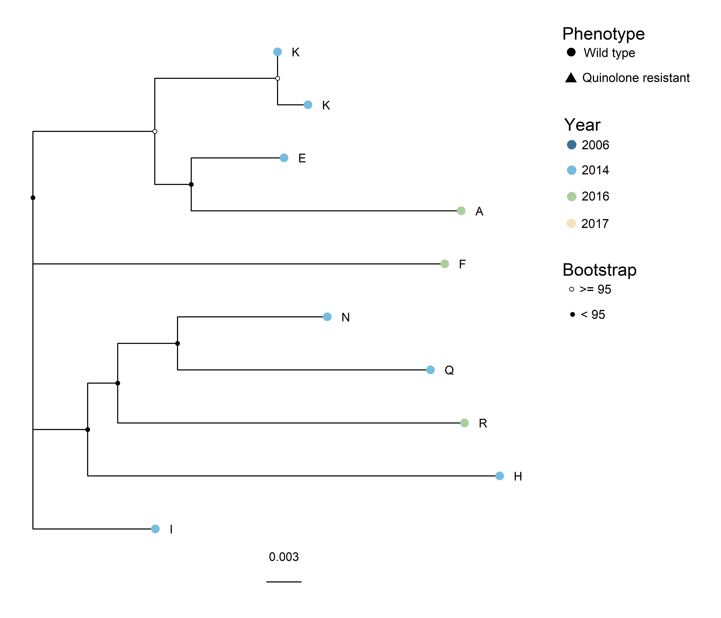
Supplementary Figure 1: Maximum likelihood core genome SNP tree generated with IQTree for clade B (ST5825). Core genome SNPs were identified with ParSNP, and recombinant sites were removed with Gubbins. Phenotype is represented by the tip point shapes, and year of isolation represented by the tip point colour. Bootstrap values are represented as black and white circles on the nodes. Median SNP distance for whole tree: 18 SNPs, with a range of 1 – 28 SNPs. Evolutionary model: K2P+ASC. Shared genome: 91.7%.

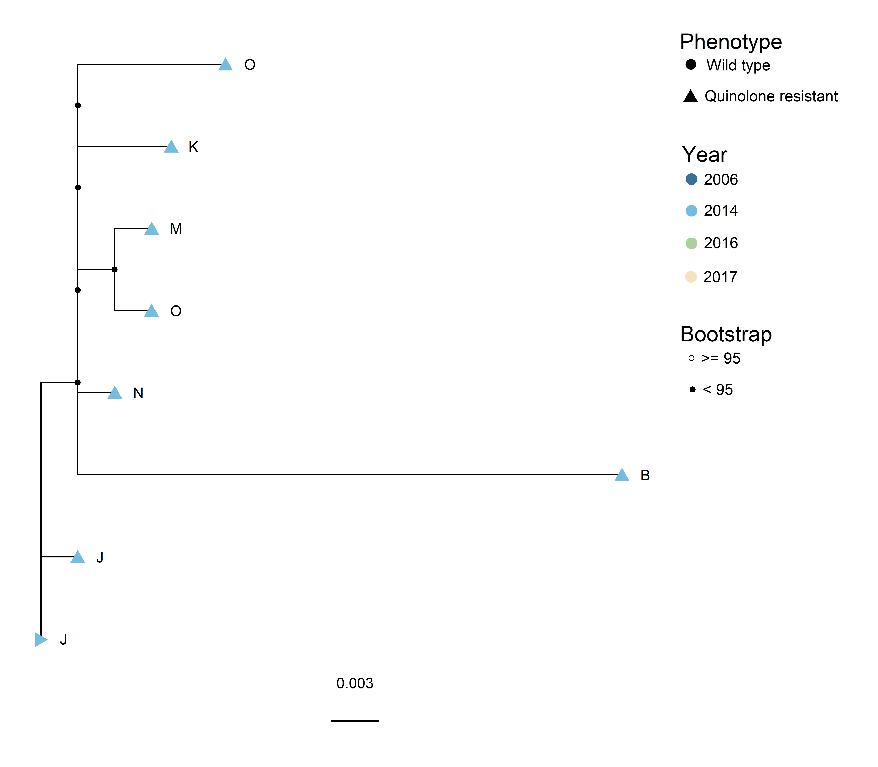
Supplementary Figure 2: Maximum likelihood core genome SNP tree generated with IQTree for clade D (ST349). Core genome SNPs were identified with ParSNP, and recombinant sites were removed with Gubbins. Phenotype is represented by the tip point shapes, and year of isolation represented by the tip point colour. Bootstrap values are represented as black and white circles on the nodes. Median SNP distance for whole tree: 9 SNPs, with a range of 2 – 37 SNPs. Evolutionary model: TIM3e+ASC. Shared genome: 92.4%.

