**Supplementary files**

**Figure S1**

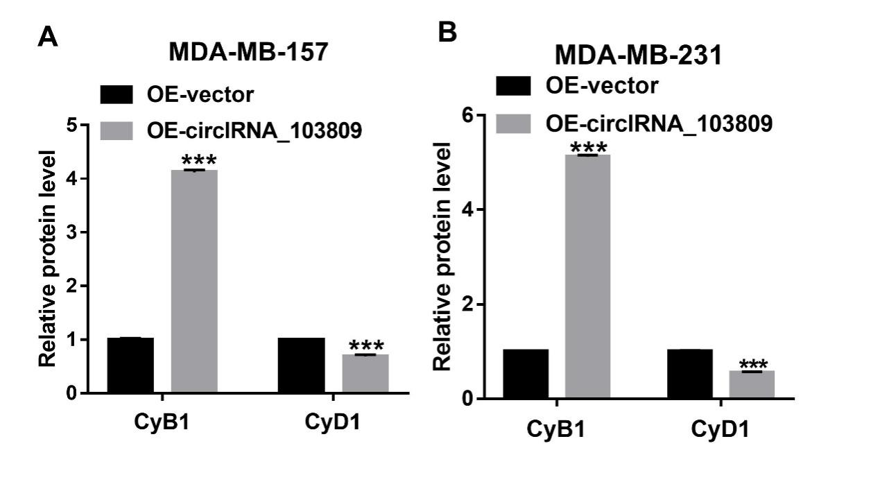

**Figure S2**

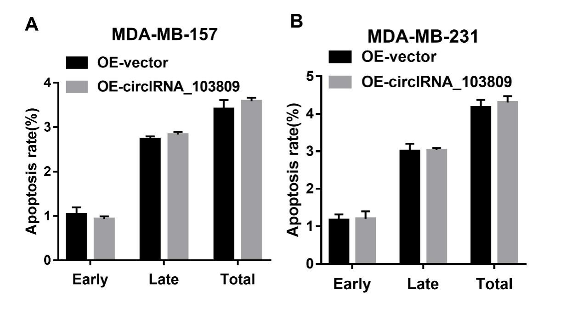

**Figure S3**

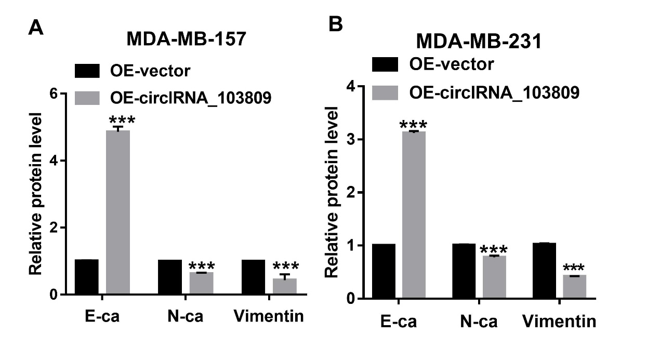

**Figure S4**

**Fig. S4 (2)**

**Figure S5**

