Supplementary Material

Table S1. Primers used in this study
Primer name | Size of amplicons | Forward/Reverse primer sequence (5’-3’)
qRT-PCR (10 µM)
VvCCD1-F | 73 bp | AGCTACACTGGCAGGAAACAAC
VvCCD1-R |  | TAATGCCCGTCACCTTGGCTATG
VvCCD4a-F | 73 bp | TGAAGCTGGACGTGTCCCAAAC
VvCCD4a-R |  | TAGCACCCTGGTCCATACATCCTG
VvCCD4b-F | 100 bp | GTTGGAATCATCCCTCGTT
VvCCD4b-R |  | CCTCGTCCCAGGCGTTA
VvMADS4-F | 257 bp | TGAAGCAGATCAGGTCAACGC
VvMADS4-R |  | ATCGGGCTGGTATCCGATTTG
VvUbiquitin-F | 105 bp | CAGCCTTCTGGTAAACATAGGTGAG
VvUbiquitin-R |  | AGGAGTGTCCGAATGCTGAGTG
RT-PCR (10 µM)
AtActin8-F* | 320 bp | GCTGAGAGATTCAGGTGCCC
AtActin8-R |  | GAGATCCACATCTGCTGG
GUS-F | 255 bp | TAATGTTCTGCGACGCTCAC
GUS-R |  | CCAGCCATGCACACTGATAC
Gene cloning (10 µM)
P_{CCD4b}-F | 1055 bp | TCACGACTTTATTGTTTCCC
P_{CCD4b}-R |  | AAAGGTGGAGTGGAGTTTAT
T-VvMADS4-F | 729 bp | ATGGGGAGAGGTAGGGTTGA
T-VvMADS4-R |  | TCATGGCAACCATCCCGGCA
T-VvMYBCS1-F | 963 bp | ATGAGAAATCCGGCATCTGC
T-Vv MYBCS1-R |  | TCAGGGAGACATGGAGTGTT
T-VvMYB1R1-F | 903 bp | ATGTCTCGTTCCTGCTCTCA
T-Vv MYB1R1-R |  | TTACGCGACACTAATGATGT
T-VvPCL1-F | 936 bp | ATGGGCGAAGAAGTGAGGA
T-Vv PCL1-R |  | TTATTGATCATTAGGACCGA
T-VvbHLH47-F | 735 bp | ATGGTTTCGGAGGTTCCTTC
T-Vv bHLH47-R |  | TTAGTCTCCCCTGCTGCTGG
T-VvWRKY4-F | 936 bp | ATGCCTATGGATAGTTCTAAT
T-VvWRKY4-R |  | TCACCATTTTTCAGTTTGAT
T-VvbZIP-F | 438 bp | ATGGGTGGCCCAAGGCAAAC
T-VvbZIP-R |  | TCAGAACTGCAACATGTCTGA
T-VvGATA24-F | 900 bp | ATGGATGGAATCCATGGAAA
T-VvGATA24-R |  | TCACGCTTGATCACTAACAT
T-VvMYB4-F | 618 bp | ATGGTGAGGACTCCTTGTTG
T-VvMYB4-R |  | CTAGGTAGTTTCTCTCTCGC
Promoter activity analysis (10 µM)
pCambia1300-P_{CCD4b}-LUC-F | 1092 bp | GGAAATTCGAGCTCGGTACTCACGACTTTATTGTTTCCC
pCambia1300-P_{CCD4b}-LUC-R |  | GCAGATCTCGAGCCCGGGAAAGGTGGAGTGGAGTTTAT
Transgenic A. thaliana construct (10 µM)
pCambia1381-P_{CCD4b}-GUS-F | 1086 bp | CGCCGAATTCCCGGGTCACGACTTTATTGTTTCCC
pCambia1381-P_{CCD4b}-GUS-F |  | TTGGCTGCAGGTCGACAAAGGTGGAGTGGAGTTTAT
Y1H screening assay (10 µM)
pAbAi-P_{VvCCD4b}-F | 688 bp | TCACGACTTTATTGTTTCCC
pAbAi-P_{VvCCD4b}-R |  | TATATGGGCCGTTTGTTCATCTTCC
pGADT7-F |  | TAATACGACTCACTATAGGGC
pGADT7-R |  | AGATGGTGCACGATGCACAG
Subcellular localization (10 µM)
pEZS-NL-VvMADS4-F | 770 bp | TTTGGAGAGGACACGCTCGAGATGGGGAGAGGTAGGGTTGA
pEZS-NL-VvMADS4-R |  | GGATCCCGGGCCCGCGGTACCCTTGGCAACCATCCCGGCA
Dual luciferase assay (10 µM)
pGreen II 0800-P_{CCD4b}-F | 912 bp | AAAACTGCAGTCACGACTTTATTGTTTCCC
pGreen II 0800-P_{CCD4b}-R |  | CGCGGATCCTTCCTTGCCTTCCACTCTGCCT
pCambia1301-VvMADS4-F | 746 bp | CTAGTCTAGAATGGGGAGAGGTAGGGTTGA
pCambia1301-VvMADS4-R |  | CGAGCTCTCATGGCAACCATCCCGGCA
pCambia1301-VvMYBCS1-F | 980 bp | CTAGTCTAGAATGAGAAATCCGGCATCTGC
pCambia1301-Vv MYBCS1-R |  | CGAGCTCTCAGGGAGACATGGAGTGTT
pCambia1301-VvMYB1R1-F | 920 bp | CTAGTCTAGAATGTCTCGTTCCTGCTCTCA
pCambia1301-Vv MYB1R1-R |  | CGAGCTCTTACGCGACACTAATGATGT
pCambia1301-VvbHLH47-F | 752 bp | CGCGGATCCATGGTTTCGGAGGTTCCTTCA
pCambia1301-Vv bHLH47-R |  | CGAGCTCTTAGTCTCCCCTGCTGCTGG
pCambia1301-VvWRKY40-like-F | 953 bp | CTAGTCTAGAATGCCTATGGATAGTTCTAA
pCambia1301-VvWRKY40-like-R |  | CGAGCTCTCACCATTTTTCAGTTTGAT
pCambia1301-VvbZIP-F | 455 bp | CTAGTCTAGAATGGGTGGCCCAAGGCAAAC
pCambia1301-VvbZIP-R |  | CGAGCTCTCAGAACTGCAACATGTCTG
pCambia1301-VvGATA24-F | 917 bp | CTAGTCTAGAATGGATGGAATCCATGGAAA
pCambia1301-VvGATA24-R |  | CGAGCTCTCACGCTTGATCACTAACAT
pCambia1301-VvMYB4-F | 635 bp | CTAGTCTAGAATGGTGAGGACTCCTTGTTG
pCambia1301-VvMYB4-R |  | CGAGCTCCTAGGTAGTTTCTCTCTCGC
Overexpression construct in callus (10 µM)
pCXSN-VvMADS4-F | 771 bp | GGGAAATTCGCTAGTGGATCCATGGGGAGAGGTAGGGTTGA
pCXSN-VvMADS4-R |  | AACGATACTCGAGGGGGATCCTCATGGCAACCATCCCGGCA
HygromycinB detection (10 µM)
Hyg-F | 1026 bp | ATGAAAAAGCCTGAACTCACCG
Hyg-R |  | CTATTTCTTTGCCCTCGGACGA
*AtAcin8-F/R, GUS-F/R were the primers of AtACT8 and GUS referred to Tanabe N, Tamoi M , Shigeoka S . The sweet potato RbcS gene (IbRbcS1) promoter confers high-level and green tissue-specific expression of the GUS reporter gene in transgenic Arabidopsis. Gene, 2015, 567(2):244-250.

Table S2. The norisoprenoids detected in grapes from Changli (CL) and Gaotai (GT) in two years
 | CL region |  |  |  |  | GT region
 | 2013 |  | 2016 |  |  | 2013 |  | 2016
Compounds | Free-form | Bound-form | Free-form | Bound-form |  | Free-form | Bound-form | Free-form | Bound-form
6-methyl-5-hepten-2-one | √ |  | √ |  |  | √ |  | √
TCH | √ |  | √ |  |  | √ |  | √
cis-theaspirane | √ |  | √ |  |  | √ |  | √
trans-theaspirane | √ |  | √ |  |  | √ |  | √
Dihydroedulan I | √ |  | √ |  |  | √ |  | √
VitispiraneA | √ | √ | √ | √ |  | √ | √ | √ | √
VitispiraneB | √ | √ | √ | √ |  | √ | √ | √ | √
β-cylcocitral | √ |  | √ |  |  | √ |  | √
Riesling acetal | √ |  | √ |  |  | √ |  | √
TDN | √ | √ | √ | √ |  | √ | √ | √ | √
β-damascenone-E | √ | √ | √ | √ |  | √ | √ | √ | √
β-damascenone-Z | √ | √ | √ | √ |  | √ | √ | √ | √
Geranylacetone | √ |  | √ |  |  | √ |  | √
β-ionone | √ |  | √ |  |  | √ |  | √
TPB | √ | √ | √ | √ |  | √ | √ | √ | √

Table S3. The concentration of norisoprenoids in grapes from Changli (CL) and Gaotai (GT) in 2013 and 2016 (unit: μg/berry).
Sample nameª | 6-methyl-5-hepten-2-one | TCH | Cis-theaspirane | dihydroedulan I | Vitispirane A | Vitispirane B | β-cyclocitral | Riesling acetal | TDN | β-damascenone-E | geranylacetone | β-ionone | Trans-theaspirane | TPB | β-damascenone-Z | Total
CL 2016 E-L31 | 0.76±0.21^{b} | 0.12±0.03 | 0.09±0.01 | 0.01±0.00 | 4.14±0.31 | 1.94±0.09 | 0.06±0.01 | 0.15±0.01 | 13.14±0.90 | 18.40±0.59 | 0.33±0.03 | 0.06±0.01 | 0.12±0.00 | 0.14±0.01 | 1.97±0.02 | 41.55±2.23
CL 2016 E-L35 | 0.59±0.01 | 0.11±0.00 | 0.41±0.01 | 0.03±0.00 | 9.62±0.58 | 4.91±0.29 | 0.13±0.01 | 0.44±0.05 | 21.29±0.61 | 35.42±0.67 | 0.46±0.00 | 0.17±0.01 | 0.54±0.02 | 0.36±0.11 | 3.40±0.06 | 78.42±2.44
CL 2016 E-L37 | 1.04±0.06 | 0.09±0.01 | 0.12±0.01 | 0.10±0.00 | 8.25±0.12 | 4.41±0.04 | 0.10±0.00 | 0.09±0.00 | 42.80±0.52 | 51.66±0.91 | 0.85±0.01 | 0.24±0.02 | 0.20±0.02 | 0.64±0.02 | 5.28±0.17 | 116.07±1.93
CL 2016 E-L38 | 0.91±0.20 | 0.08±0.01 | 0.02±0.00 | 0.06±0.00 | 9.44±0.88 | 5.14±0.54 | 0.06±0.01 | 0.02±0.01 | 62.02±7.61 | 54.92±4.76 | 0.98±0.03 | 0.19±0.02 | 0.03±0.01 | 0.97±0.12 | 6.15±0.47 | 141.03±14.67
GT 2016 E-L31 | 0.20±0.03 | 0.06±0.00 | 0.04±0.00 | 0.00±0.00 | 0.65±0.00 | 0.28±0.00 | 0.02±0.00 | 0.02±0.01 | 3.87±1.02 | 5.56±0.02 | 0.16±0.01 | 0.03±0.01 | 0.05±0.01 | 0.02±0.00 | 0.77±0.01 | 11.75±0.02
GT 2016 E-L35 | 0.63±0.02 | 0.12±0.01 | 0.20±0.01 | 0.02±0.00 | 5.28±0.15 | 2.36±0.03 | 0.12±0.01 | 0.30±0.04 | 17.06±2.29 | 26.06±0.90 | 0.45±0.01 | 0.18±0.02 | 0.27±0.02 | 0.17±0.03 | 2.80±0.13 | 56.00±1.74
GT 2016 E-L37 | 0.85±0.09 | 0.08±0.00 | 0.20±0.02 | 0.10±0.02 | 3.66±0.09 | 2.08±0.02 | 0.12±0.01 | 0.07±0.02 | 22.74±7.22 | 42.57±0.57 | 0.87±0.05 | 0.30±0.06 | 0.22±0.02 | 0.31±0.01 | 4.93±0.07 | 79.10±1.00
GT 2016 E-L38 | 0.67±0.00 | 0.09±0.00 | 0.15±0.00 | 0.07±0.00 | 7.17±1.54 | 3.84±0.78 | 0.12±0.00 | 0.13±0.01 | 36.19±3.37 | 51.31±4.48 | 0.75±0.00 | 0.26±0.01 | 0.20±0.01 | 0.40±0.11 | 5.43±0.35 | 106.77±13.96
CL 2013 E-L34 | 0.40±0.10 | 0.04±0.01 | 0.15±0.04 | 0.00±0.00 | 2.52±0.15 | 1.02±0.07 | 0.05±0.01 | 0.10±0.03 | 8.68±0.22 | 11.37±0.15 | 0.29±0.01 | 0.06±0.02 | 0.20±0.05 | 0.07±0.01 | 1.52±0.01 | 26.48±0.40
CL 2013 E-L35 | 0.62±0.10 | 0.07±0.02 | 0.31±0.07 | 0.03±0.01 | 7.65±1.29 | 3.56±0.55 | 0.10±0.02 | 0.16±0.04 | 20.14±2.26 | 24.08±3.01 | 0.43±0.03 | 0.19±0.04 | 0.36±0.08 | 0.14±0.03 | 2.59±0.19 | 60.42±7.74
CL 2013 E-L36 | 0.47±0.13 | 0.04±0.02 | 0.11±0.03 | 0.00±0.00 | 4.95±0.26 | 1.94±0.07 | 0.05±0.02 | 0.12±0.03 | 12.15±1.87 | 14.11±1.12 | 0.29±0.02 | 0.07±0.01 | 0.15±0.04 | 0.12±0.01 | 1.71±0.06 | 36.29±3.09
CL 2013 E-L37 | 0.71±0.14 | 0.04±0.01 | 0.41±0.05 | 0.07±0.01 | 11.89±0.76 | 6.40±0.59 | 0.10±0.03 | 0.18±0.07 | 35.52±1.98 | 43.22±9.43 | 0.75±0.14 | 0.28±0.08 | 0.49±0.07 | 0.61±0.09 | 4.49±0.59 | 105.15±14.06
CL 2013 E-L38 | 0.80±0.00 | 0.03±.00 | 0.23±0.04 | 0.08±0.01 | 5.87±0.15 | 2.93±0.06 | 0.08±0.01 | 0.02±0.02 | 26.37±0.967 | 31.91±1.11 | 0.70±0.00 | 0.27±0.02 | 0.25±0.04 | 0.25±0.01 | 3.88±0.10 | 73.68±2.42
GT 2013 E-L34 | 0.83±0.00 | 0.23±0.01 | 0.01±0.00 | 0.00±0.00 | 0.91±0.06 | 0.40±0.02 | 0.11±0.01 | 0.05±0.00 | 4.35±0.52 | 3.95±0.25 | 0.19±0.00 | 0.08±0,01 | 0.01±0.00 | 0.03±0.01 | 0.71±0.03 | 11.86±0.85
GT 2013 E-L35 | 0.71±0.04 | 0.14±0.01 | 0.02±0.00 | 0.00±0.00 | 1.55±0.03 | 0.77±0.01 | 0.08±0.01 | 0.08±0.00 | 5.32±0.16 | 3.88±0.03 | 0.18±0.01 | 0.08±0.02 | 0.03±0.00 | 0.03±0.00 | 0.64±0.00 | 13.50±0.22
GT 2013 E-L36 | 1.31±0.10 | 0.37±0.01 | 0.25±0.01 | 0.04±0.01 | 13.07±0.77 | 7.14±0.49 | 0.33±0.02 | 0.56±0.05 | 37.99±1.06 | 21.09±1.66 | 0.43±0.01 | 0.31±0.03 | 0.34±0.02 | 0.36±0.00 | 2.45±0.13 | 86.04±1.73
GT 2013 E-L37 | 1.67±0.19 | 0.44±0.04 | 0.14±0.01 | 0.02±0.01 | 5.20±0.07 | 3.08±0.04 | 0.35±0.01 | 0.11±0.00 | 21.67±0.21 | 33.41±0.26 | 0.74±0.03 | 0.61±0.01 | 0.14±0.00 | 0.32±0.00 | 3.93±0.02 | 71.82±0.33
GT 2013 E-L38 | 1.56±0.06 | 0.33±0.02 | 0.09±0.01 | 0.04±0.00 | 3.42±0.47 | 2.09±0.27 | 0.35±0.02 | 0.03±0.01 | 13.31±1.07 | 26.99±2.41 | 0.57±0.01 | 0.51±0.06 | 0.09±0.01 | 0.19±0.03 | 3.31±0.16 | 52.88±4.62
ª Sample name: region-vintage-E-L stage.
^{b} The concentration shown in this table is the sum of the free-form and bound-form concentration of each compound. The data are expressed as means ± SD from three biological replicates with two technical replicates, respectively. SD is standard deviation.

Figure S1. Alignment of the promoter sequences of VvCCD4b in Cabernet Sauvignon (CS) and Pinot noir (Pinot).

Table S4. Cis-acting elements predicted in the VvCCD4b promoter from Cabernet Sauvignon
Cis-acting element | Sequence | Start (From TSS) | End (From TSS) | Description
Box 4 | ATTAAT | -764 | -759 | Light-responsive element
W-box | TTGACT | -648 | -643 | Binding site for WRKY family
GT1 motif | GGTTAA | -549 | -544 | Light-responsive element
MYC binding site | CATATG | -501 | -496 | Binding site for Myc family
ERE | ATTTTAAA | -367 | -360 | Ethylene-responsive element
CCA1 binding site | AAAAATCT | -297 | -290 | Binding site for CCA1 protein
I box | gGATAAGGTG | -285 | -276 | Light-responsive element
Box-L like | ACCTTCC | -241 | -235 | Binding site for Myb family
CArG motif | CAAATTTAAG | -171 | -162 | Binding site for MADS family
CAAT | ATTTG | -97 | -93 | Binding site for CTF/NF-1
TCA-element | CCATCTTTTT | -56 | -47 | Salicylic acid responsiveness
TATA box | TCATTATAAAA | -33 | -23 | Binding site for RNA polymerase
G-box | CACGTG | -22 | -17 | Light-responsive element
ABRE | ACGTG | -21 | -17 | Abscisic acid responsiveness

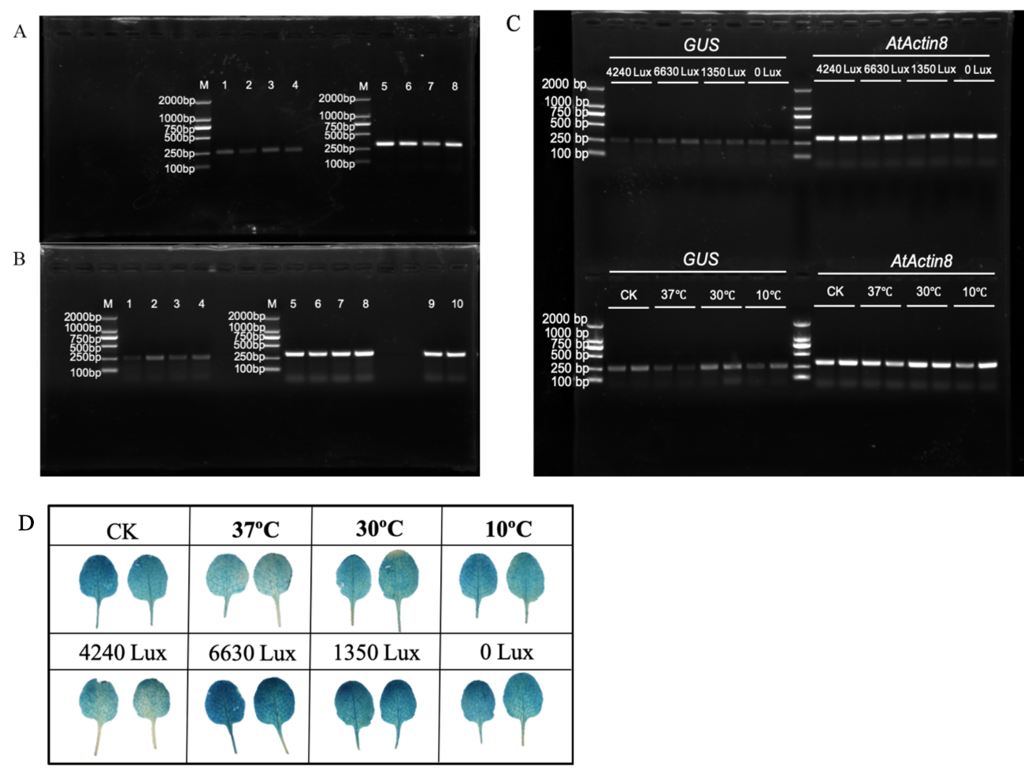
Figure S2. The original gel of GUS and AtActin8 gene expression detection and GUS staining of transgenic A. thaliana. A: The original gel of the agarose gel in Figure 3C. M: marker DL2000. Lane 1-4: Identification of GUS gene expression in VvCCD4b promoter transgenic A. thaliana treated by different temperatures (CK, 37℃, 30℃ and 10℃). Lane 5-8: Identification of AtActin8 gene expression in VvCCD4b promoter transgenic A. thaliana treated by different temperatures (CK, 37℃, 30℃ and 10℃). B. The original gel of the agarose gel in Figure 3D. M: marker DL2000. Lane 1-4: Identification of GUS gene expression in VvCCD4b promoter transgenic A. thaliana treated by different illuminations (4240 Lux, 6630 Lux, 1350 Lux and 0 Lux). Lane 5-8: Identification of AtActin8 gene expression in VvCCD4b promoter transgenic A. thaliana treated by different illuminations (4240 Lux, 6630 Lux, 1350 Lux and 0 Lux). Lane 9,10: replicates of AtActin8 gene detection in VvCCD4b promoter transgenic A. thaliana treated by light intensities. C. The agarose gel of GUS and AtActin8 detection in two additional biological replicates of transgenic A. thaliana treated by different light or temperature. D. GUS staining of two additional biological replicates of transgenic A. thaliana treated by light or temperature.

Table S5 A list of interacting transcription factors identified by Y1H screening
Number | Accession ID | Description
1 | NM_001281179.1 | Vitis vinifera Myb transcription factor (MYBCS1), mRNA
82 | NM_001281185.1 | Vitis vinifera MADS-box protein 4 (MADS4), mRNA
180 | XM_010654506.2 | PREDICTED: Vitis vinifera transcription factor MYB1R1 (LOC100253576), mRNA
190 | XM_010652695.2 | PREDICTED: Vitis vinifera transcription factor PCL1 (LOC100253567), transcript variant X2, mRNA
206 | XM_002283248.4 | PREDICTED: Vitis vinifera transcription factor bHLH47 (LOC100259339), transcript variant X1, mRNA
221 | NM_001280990.1 | Vitis vinifera probable WRKY transcription factor 40-like (LOC100253480), mRNA
270 | XM_002282159.4 | PREDICTED: Vitis vinifera bZIP transcription factor 53 (LOC100244279), mRNA
304/429* | XM_010657000.2 | PREDICTED: Vitis vinifera GATA transcription factor 24 (LOC100251358), transcript variant X3, mRNA
396 | XM_010661926.2 | PREDICTED: Vitis vinifera myb-related protein Myb4 (LOC100251790), mRNA
*two numbers mean the GATA24 was screened out twice.

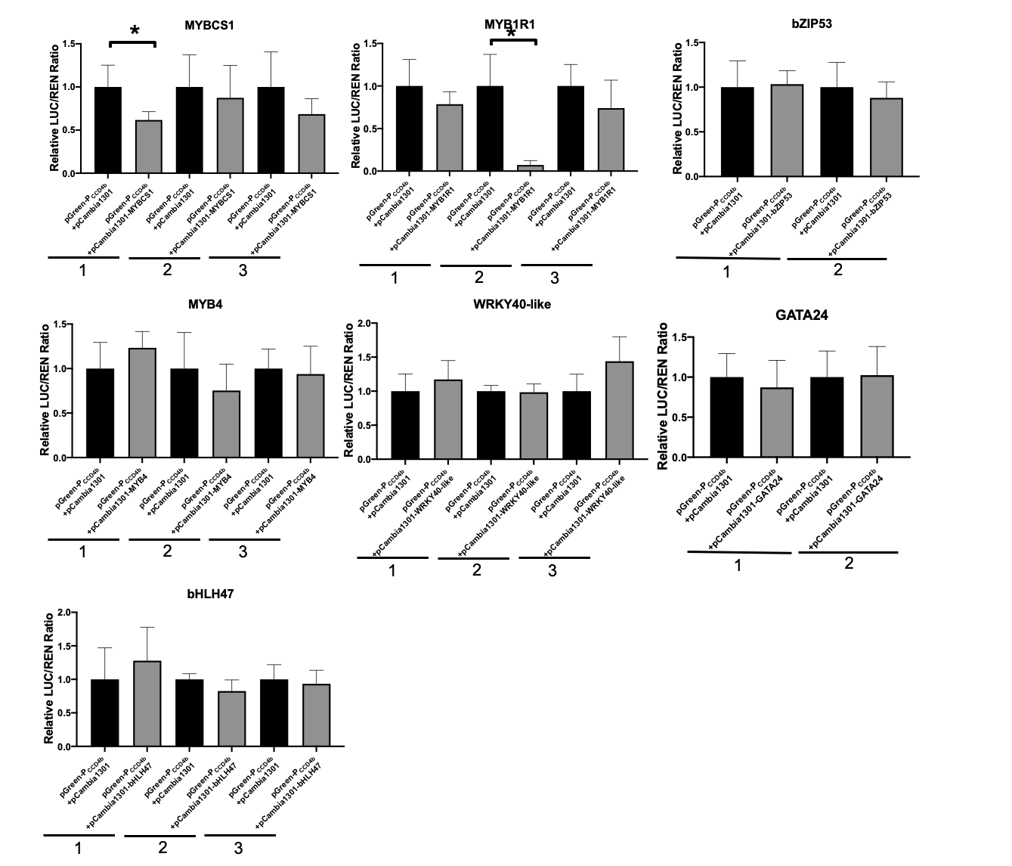
Figure S3 Regulation of transcription factors (TF) on the activity of VvCCD4b promoter. The dual-luciferase assay used tobacco transient expression system. pGreen-P_{CCD4b}+pCAMBIA 1301 was control group, and pGreen-P_{CCD4b}+pCAMBIA1301-TF was experimental group. The data were normalized by the average relative LUC/REN ratio of corresponding control group, expressed as the means ± SD from at least six biological replicates each independent experiment. The independent experiment of MYBCS1, MYB1R1, MYB4, WRKY40-like and bHLH47 was repeated for three times, respectively. The independent experiment of bHLH47 and bZIP53 was repeated for twice, respectively. The numbers below the bar chart represent repeat times of independent experiment. * indicates significant difference at 0.05.
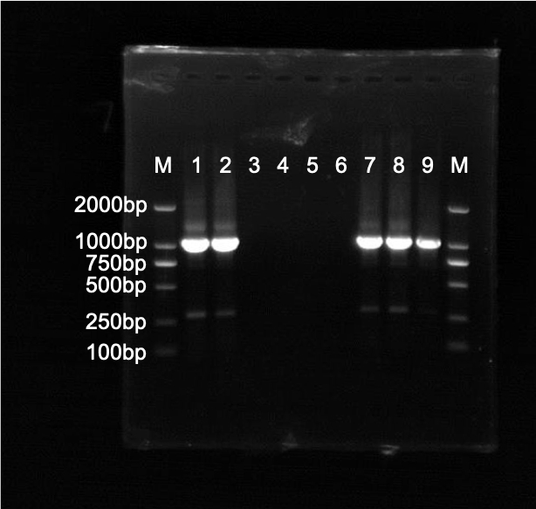
Figure S4. The original gel of hygromycin gene expression detection. M: marker DL2000. Lane 1-2: VvMADS4 overexpression transgenic calli, Line1 and Line 2. Lane 3-6: WT. Lane 7-9: replicates of VvMADS4 overexpression transgenic calli.

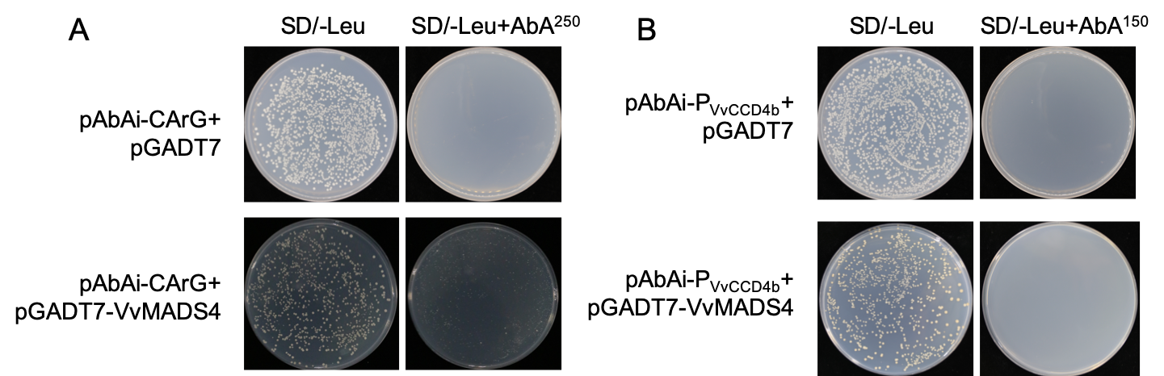
Figure S5. Interaction of the VvMADS4 protein with the VvCCD4b promoter.A.Y1H-hybrid assay proved the binding of VvMADS4 to the tandem CArG-box sequence. The sequence of CArG-box was the same with that on the VvCCD4b promoter. pAbAi-CArG+pGADT7 was control. SD/-Leu+ABA²⁵⁰ means SD/-Leu medium with 250 mg/L ABA. B. Y1H-hybrid system showing that VvMADS4 could not bind to the short fragment of VvCCD4b promoter which contained a CArG-box. pAbAi-P_{VvCCD4b}+pGADT7 was control. SD/-Leu+ABA¹⁵⁰ means SD/-Leu medium with 150 mg/L ABA.

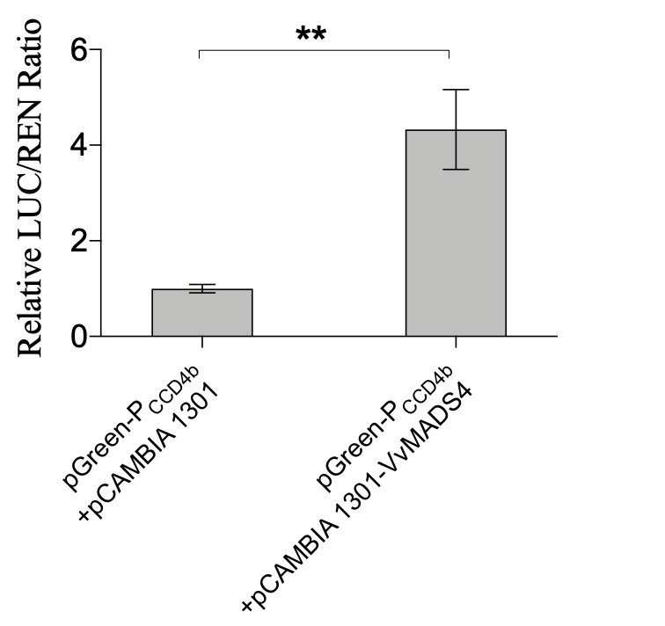
Figure S6. Transcriptional regulation of VvMADS4 on the activity of the VvCCD4b promoter in the Arabidopsis protoplast. Dual-luciferase assay showing VvMADS4 activation on the promoter activity of VvCCD4b. This experiment was performed using Arabidopsis protoplast expression system. The data are expressed as the means ± SD from at least six biological replicates. Significant difference was analyzed by AVONA. **, p<0.01.

