Supporting Information
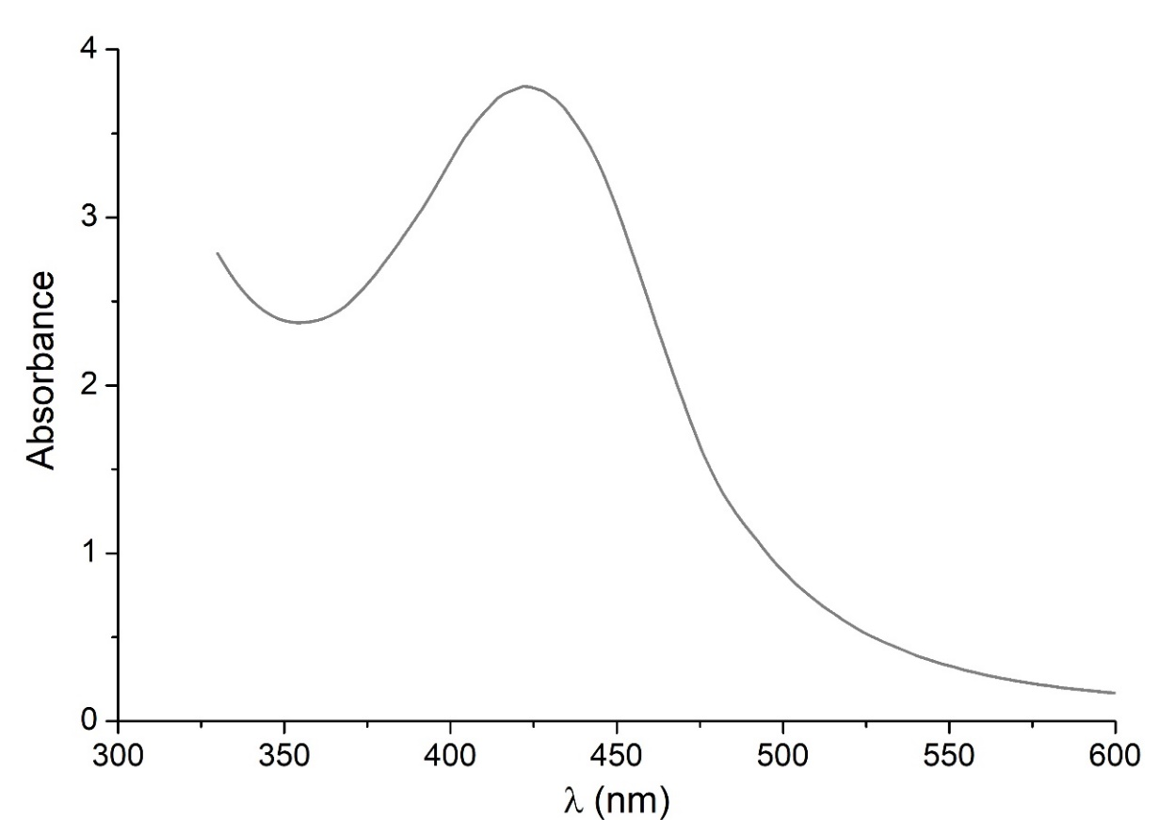
Figure S1. UV–vis spectra of AgLNPs
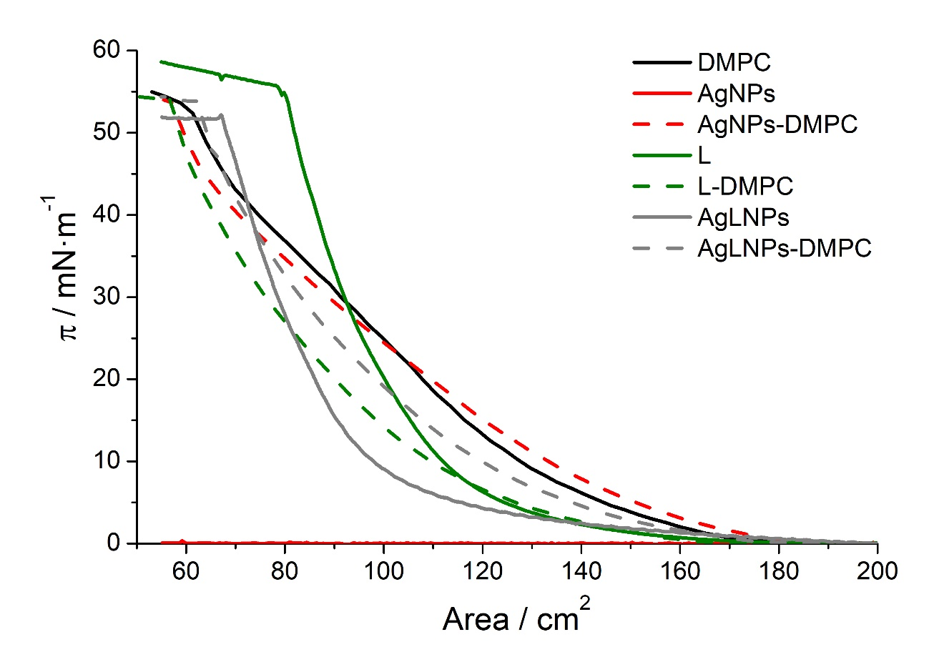
Figure S2. Surface pressure-area isotherm in buffer of monolayers of AgLNPs, their pristine compounds and their interaction with DMPC.
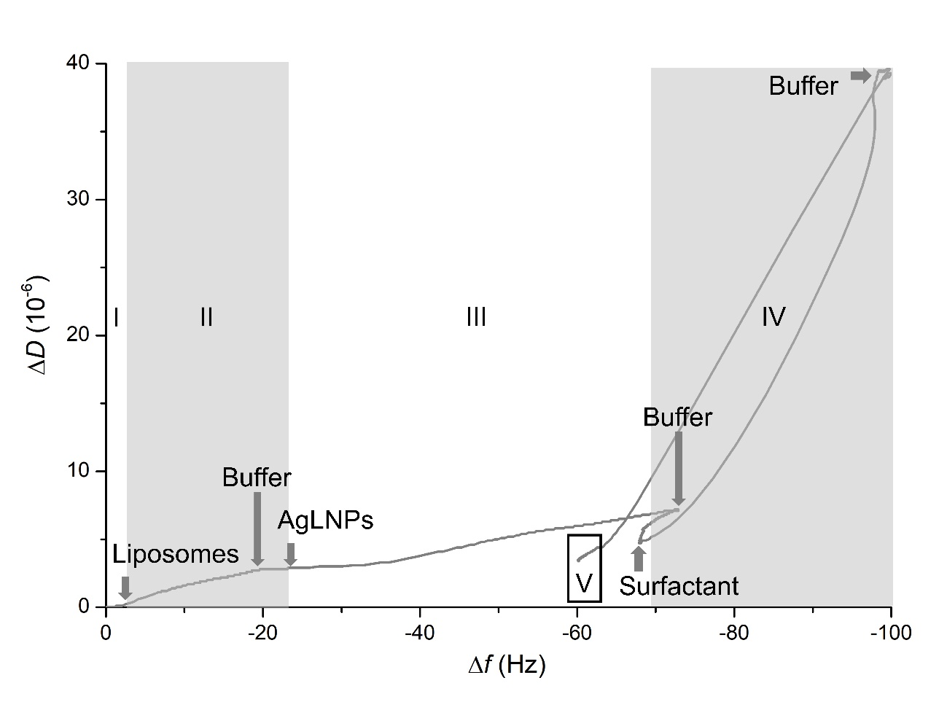
Figure S3. Plot of ΔD₅-Δf₅ -sensorgram presented in Fig 3- obtained during the formation of the model biomembrane and its interaction with AgLNPs. Arrows indicate the circulation of a new fluid.

