Supplemental information

Title: Pre-treatment ongoing cortical oscillatory activity predicts improvement of tinnitus after partial peripheral reafferentation with hearing aids

Authors:
Jae Joon Han, MD, Dirk De Ridder, MD, PhD, Sven Vanneste, PhD, Yu-Chen Chen, Ja-Won Koo, MD, PhD, Jae-Jin Song, MD, PhD*
*corresponding. jjsong96@gmail.com

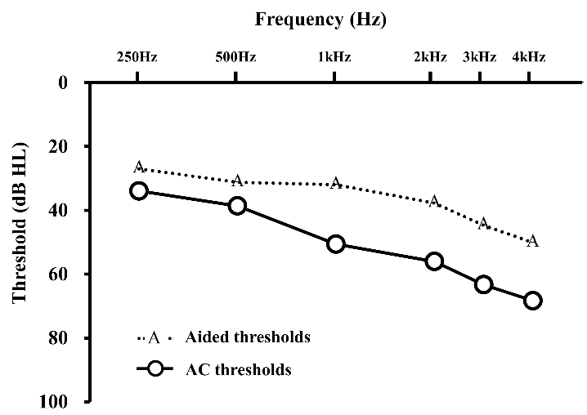

Supplementary Figure S1. Unaided air conduction thresholds and aided hearing thresholds with hearing aids. The hearing thresholds of the participants are successfully improved after wearing hearing aids, and the functional gain are about 7 dB at low frequencies (250, 500 Hz) and 18 dB at mid and high frequencies (1, 2, 3, 4 kHz).

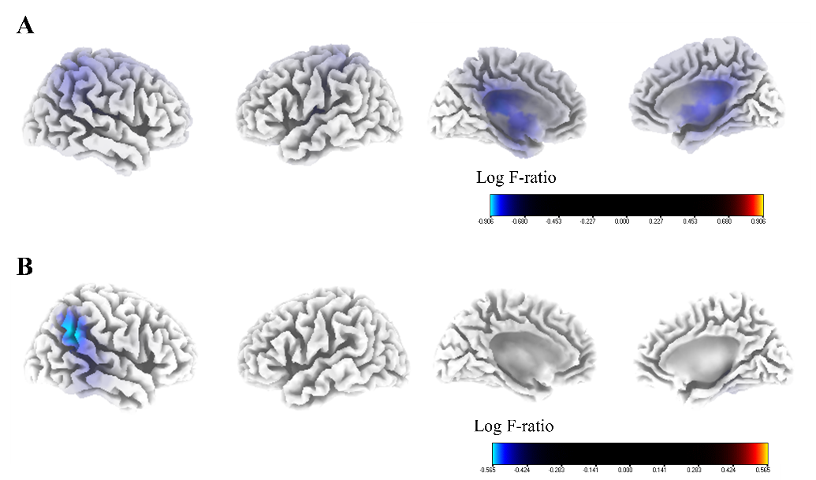
Supplementary Figure S2. Source-localized correlation analysis between the percentage improvements in the numerical rating scale (NRS) of tinnitus-related distress and the resting-state quantitative electroencephalography data before wearing hearing aids (HAs) in subgroup analysis. In both subgroups (A and B) divided by the odd- or even-number of enrollment order, the percentage improvements in NRS tinnitus-related distress correlated negatively with the pre-HA source-localized activities at the right inferior parietal lobule, right parahippocampus, and right posterior cingulate cortex for the gamma frequency band.

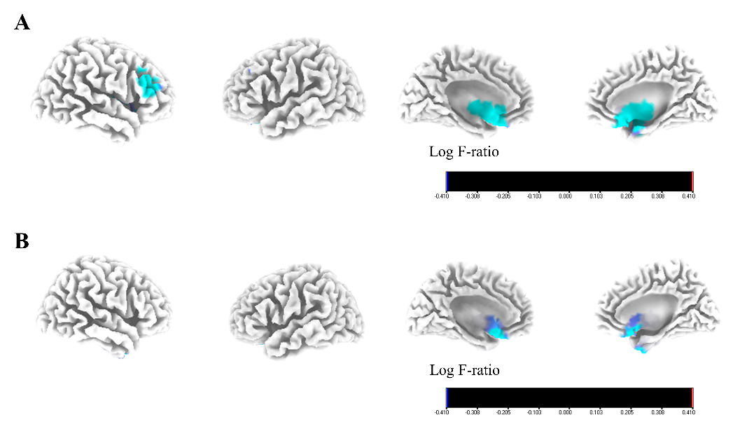
Supplementary Figure S3. Source-localized correlation analysis between the percentage improvements in the numerical rating scale (NRS) of tinnitus perception and the resting-state quantitative electroencephalography data before wearing hearing aids (HAs) in subgroup analysis. In both subgroups (A and B) divided by the odd- or even-number of enrollment order, the activities of the bilateral subgenual anterior cingulate cortex exhibited marginally significant negative correlations with the percentage improvements in NRS tinnitus perception for the beta 3 frequency band.

