Supplementary Material

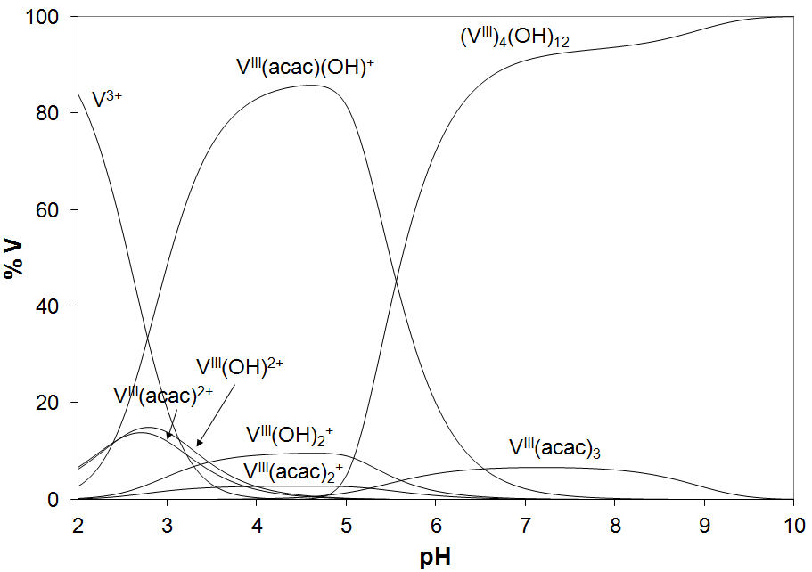
Fig. S1. Distribution diagram of the species as a function of pH in a solution containing V³⁺ ion and acac (V^{III}/acac = 1/3, V^{III} = 1.50 × 10^{–4} M). The stability constants of the V^{III}–acac complexes were taken from (Brito et al., 2009).

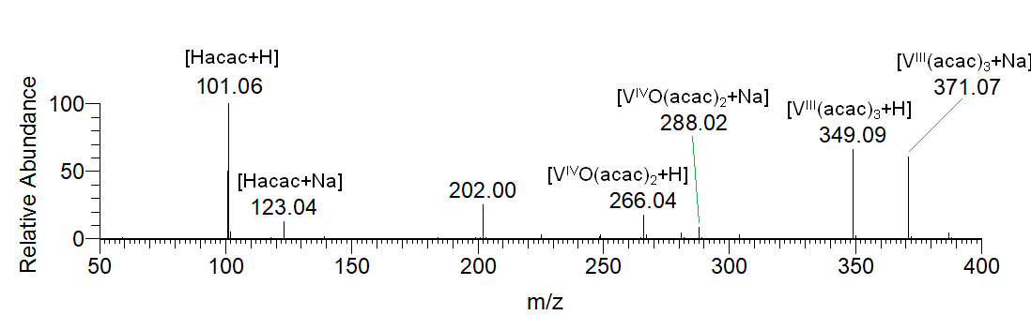
Fig. S2. ESI-MS spectrum recorded in ultrapure water on the systems containing V^{III}(acac)₃ with V concentration of 150 μM, pH 6.3. At these experimental conditions, V^{III} species partly oxidizes to V^{IV}O.

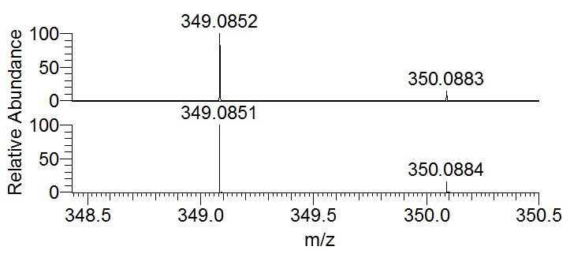
Fig. S3. Experimental (above) and calculated (below) isotopic pattern of the species [V^{III}(acac)₃+H⁺].

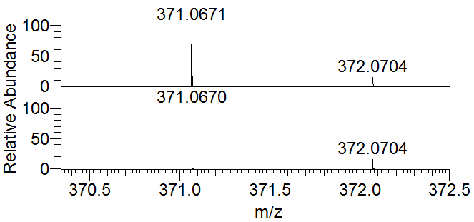
Fig. S4. Experimental (above) and calculated (below) isotopic pattern of the species [V^{III}(acac)₃+Na⁺].

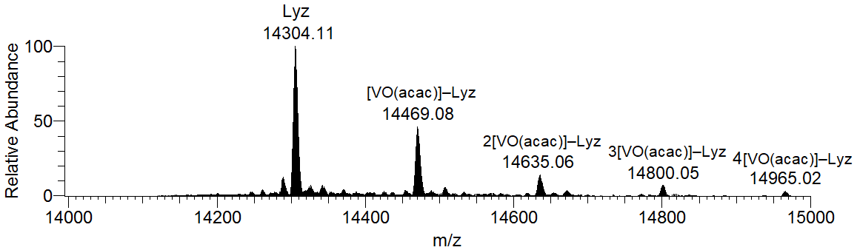
Fig. S5. Deconvoluted ESI-MS spectrum recorded on the systems containing V^{III}(acac)₃ and lysozyme with the molar ratio V^{III}/Protein 3/1 and Protein concentration 5 μM, pH 6.5. Under these experimental conditions, V^{III} species fully oxidizes to V^{IV}O

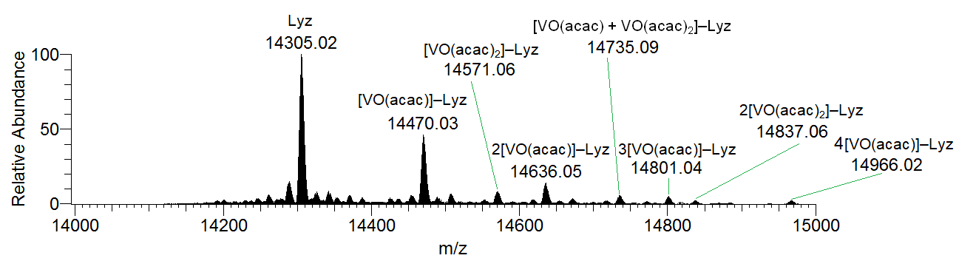
Fig. S6. Deconvoluted ESI-MS spectrum recorded on the systems containing V^{IV}O(acac)₂ and lysozyme with the molar ratio V^{IV}/Protein 3/1 and Protein concentration 50 μM, pH 6.8.

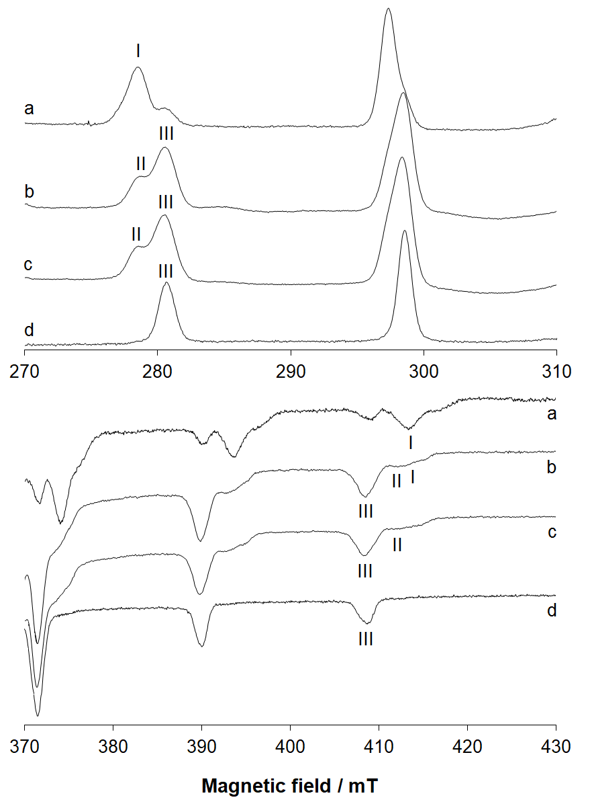
Fig. S7. Low and high-field region of the EPR spectra recorded on frozen solutions (120 K) of the systems: a) V^{IV}O/acac 1/2, pH 4.40; b) V^{III}(acac)₃/Lyz 3/1, pH 4.95; c) V^{III}(acac)₃/Lyz 2/1, pH 5.05 and d) V^{IV}O/acac 1/2, pH 5.75. V concentration was 1 mM. With I, II and III the M_{I} = -7/2, +7/2 resonances of the species V^{IV}O(acac)⁺, [V^{IV}O(acac)]–Lyz and [V^{IV}O(acac)₂]–Lyz, are indicated, respectively.

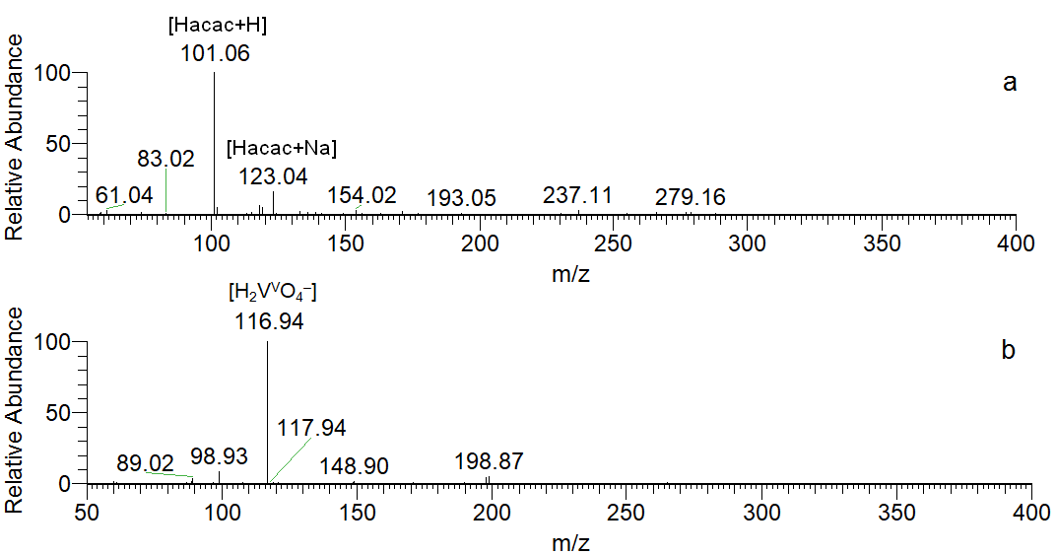
Fig. S8. ESI-MS spectra recorded in ultrapure water on the systems containing V^{V}/acac with molar rario 1/2 and with V concentration of 150 μM, pH 7.0: a) positive-ion mode and b) negative-ion mode.

References

Brito, F., Araujo, M. L., Martínez, J. D., Hernández, Y., Moh, A., and Lubes, V. (2009). Speciation of the vanadium(III)–acetylacetone system in 3.0 M KCl ionic medium at 25°C. J. Coord. Chem. 62, 52-62. doi: 10.1080/00958970802474763.

