**Supplementary Material**

**A novel fungal lipase with methanol tolerance and preference for macaw palm oil**

**Letícia L. Rade1, Melque N. P. da Silva1, Plínio S. Vieira1, Natalia Milan1,2, Claudia M. de Souza1, Ricardo R. de Melo1, Bruno C. Klein1, Antonio Bonomi1, Heizir F. de Castro2, Mário T. Murakami1 and Leticia M. Zanphorlin1**

1 Brazilian Biorenewables National Laboratory (LNBR), Brazilian Center for Research in Energy and Materials (CNPEM), 13083-970, Campinas, São Paulo, Brazil

2 Department of Chemical Engineering, Engineering School of Lorena, University of São Paulo, 12602-810, Lorena, São Paulo, Brazil

**\*Correspondence:**

Dr. Leticia Zanphorlin

[leticia.zanphorlin@lnbr.cnpem.br](mailto:leticia.zanphorlin@lnbr.cnpem.br)

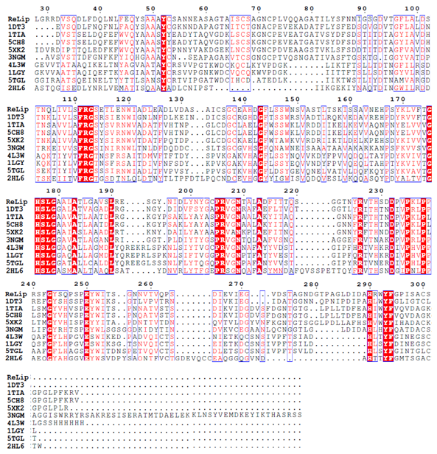**Figure S1**- Multiple amino acid sequence alignment of fungal lipase sequences using Clustal Omega and ESPript 3.0. PDB accession numbers of the aligned sequences for the following organisms: (**1DT3:** *Thermomyces lanuginosus* lipase, 62.08% identity; **1TIA:** *Penicillium camemberti* lipase, 49.26% identity; **5CH8:** *Penicillium cyclopium* lipase, 48.90% identity; **5XK2:** *Aspergillus oryzae* lipase, 42.35% identity; **3NGM:** *Fusarium graminearum* lipase, 45.76% identity; **4L3W:** *Rhizopus microsporus var. chinensis* lipase, 29.92% identity; **1LGY:** *Rhizopus Niveus* lipase, 31.65% identity; **5TGL:** *Rhizomucor miehei* lipase, 34.53% identity; **2HL6:** *Aspergillus niger* feruloyl esterase, 30.85% identity). High consensus regions are indicated inside red boxes and low consensus regions are in unfilled boxes. The numbers above the sequences represent amino acid positions.

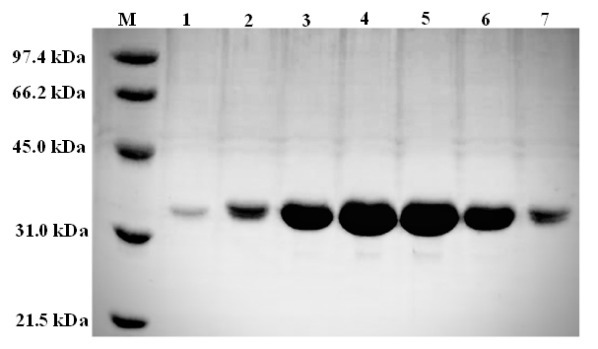**Figure S2** – Analysis of purified *Re*Lip (12% SDS-PAGE). Lane M, molecular weight marker; Lanes 1-7, *Re*Lip fractions obtained after molecular exclusion chromatography.



**(A)**

**(B)**

**(C)**

**Figure S3** – Functional analysis of *Re*Lip using macaw oil (5 wt%), 16 h of reaction and enzyme concentration of 0.6 mg/mL. (A) The effect of temperature on the hydrolysis degree, from 25 °C to 60 °C, at pH 4.0. (B) The effect of pH on the hydrolysis degree, from 3.0 to 6.0, at 35°C. The experiments were done in duplicate. (C) Thermal stability of *Re*Lip. Temperature stability was analyzed after pre-incubated pure *Re*Lip at 35 °C, 45 °C and 50 °C. The enzyme was incubated from 0 to 24 h and the hydrolysis reactions were conducted as described in Item 2.4.

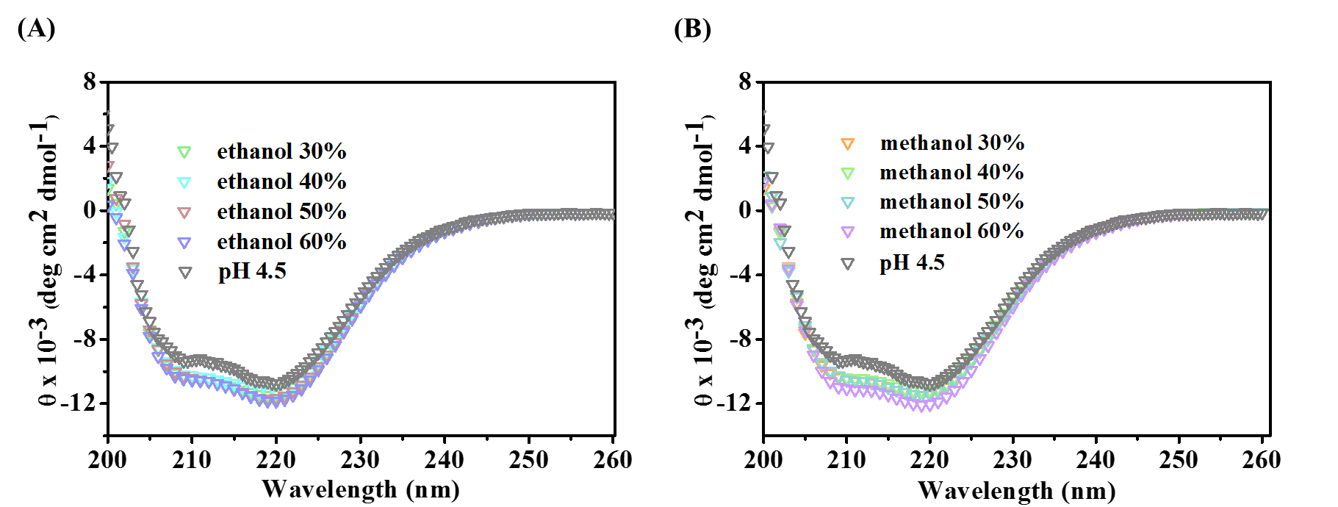

**Figure S4** – The far-UV averaged circular dichroism spectra of *Re*Lip, monitored at 20 ºC in different concentrations of (A) ethanol and (B) methanol.

**(B)**

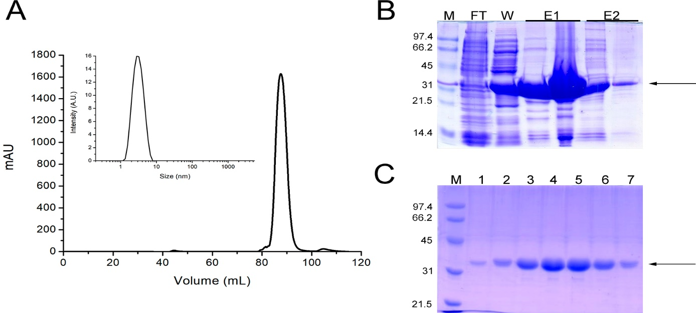

**(A)**

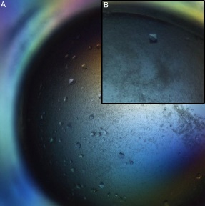

**Figure S5** – (A) Chromatogram obtained in the purification of *Re*Lip by size exclusion chromatography. The inset shows the hydrodynamic radius of the protein after the purification, obtained from DLS experiments, with a single peak at approximately 3 nm. (B) Single crystal obtained (30 x 30 µm). The purified protein was crystalized by sitting drop method at 18 °C, using the following condition: 100 mmol.L-1 MgCl2, 20% PEG 8000, 20% PEG 400, 100 mmol.L-1 Tris pH 8.5.



**Figure S6** – (A) Small Angle X-ray Scattering (SAXS) measurements of *Re*Lip. (B) Distance distribution function P(r). (C) SAXS ab initio envelopes with the crystallographic structure fitted, confirming the monomeric globular form that corroborates the three-dimensional structure obtained by X-ray crystallography.

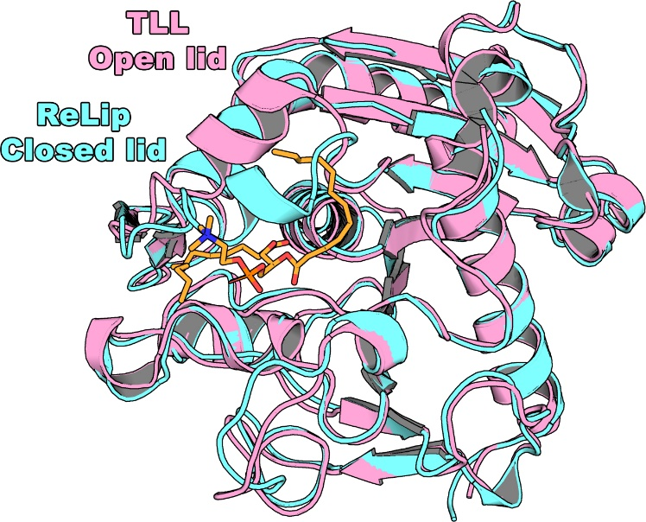

**Figure S7** - Superpositioning of *Re*Lip on TLL in complex with diundecyl phosphatidyl choline (PDB code: 1EIN) highlighting that in the closed conformation of the *lid* in *Re*Lip, the substrate could not be accommodated in the active-site cleft.

**Table S1–** Free fatty acid content and fatty acid profile of vegetable oils (wt%)

|  |  |  |  |  |  |  |  |  |  |  |  |
| --- | --- | --- | --- | --- | --- | --- | --- | --- | --- | --- | --- |
| Vegetable oil | Acidity (%) | C8:0 | C10:0 | C12:0 | C14:0 | C16:0 | C18:0 | C18:1 | C18:2 | C18:3 | Others |
| Soybean | 2.35 | - | - | - | 0.03 | 13.31 | 2.37 | 22.20 | 58.08 | 3.79 | 0.22 |
| Sunflower | 2.20 | - | - | - | 0.02 | 6.44 | 2.98 | 26.99 | 63.30 | - | 0.27 |
| Corn | 2.24 | - | - | - | - | 15.39 | 1.37 | 33.35 | 49.77 | - | 0.11 |
| Olive | 2.63 | - | - | - | - | 14.79 | 2.24 | 77.45 | 4.66 | 0.15 | 0.15 |
| Coconut | 2.05 | 6.95 | 4.49 | 58.95 | 17.55 | 6.52 | 0.60 | 3.49 | 1.08 | - | - |
| Rapesseed | 2.49 | - | - | - | - | 4.47 | 1.83 | 68.97 | 18.26 | 5.67 | 0.80 |
| Palm | 5.86 | - | - | 0.79 | 0.93 | 51.52 | 3.29 | 37.53 | 5.95 | - | - |
| Macaw | 23.54 | - | - | 0.32 | 0.42 | 21.18 | 1.67 | 67.22 | 8.04 | - | 1.67 |

**Table S2** – Parameters of central composite design, with coded and uncoded levels

|  |  |  |  |  |  |  |
| --- | --- | --- | --- | --- | --- | --- |
| Parameters | Symbol | Coded levels | | | | |
|  | -1.21 | -1 | 0 | +1 | +1.21 |
| Catalyst concentration (mg/mL)  Time of reaction (hours) | XC  Xt | 0.5  1 | 0.61  2.2 | 1.15  8 | 1.69  13.8 | 1.8  15 |

**Table S3** – Crystallization conditions

|  |  |
| --- | --- |
| Method | Robot HoneyBee 963 system |
| Plate type | Sitting-drop Corning 3552 |
| Temperature (K) | 291.15 |
| Protein concentration | 16.5 mg.mL-1 |
| Buffer composition of protein solution | 50 mmol.L-1 phosphate pH 7.4, 150 mmol.L-1 NaCl |
| Composition of reservoir solution | 100 mmol.L-1 MgCl2, 20% PEG 8000, 20% PEG 400, 100 mmol.L-1 Tris pH 8.5 |
| Volume and ratio of drop | 1.0 μL, 2:1 |
| Volume of reservoir | 80 μL |

**Table S4** – Data collection, processing and refinement statistics

|  |  |
| --- | --- |
| **Data collection** |  |
| Space Group | *I*422 |
| Cell dimensions |  |
| a, b, c (Å) | 90.98 90.98 115.99 |
| α, β, γ (°) | 90.0 90.0 90.0 |
| Resolution (Å) | 50.00 – 3.00 (3.17 – 3.00) |
| Rmeas | 21.2 (123.2) |
| *I*/*Iσ* | 15.02 (2.83) |
| Completeness (%) | 99.7 (98.5) |
| Redundancy | 24.41 (26.09) |
| CC1/2 | 99.8 (80.0) |
| **Refinement** |  |
| Resolution (Å) | 35.58 – 3.00 |
| N° Reflections | 5129 |
| Rwork/Rfree | 0.27/0.32 |
| **N° atoms** |  |
| Protein | 1980 |
| Ligand/Ion | 0 |
| Water | 0 |
| **B-factor (Å²)** |  |
| Protein | 79.53 |
| Ligand/Ion | - |
| Water | - |
| r.m.s.d. |  |
| Bond length (Å) | 0.002 |
| Bond angle (°) | 0.537 |
| **Ramachandran Plot** |  |
| Favoured (%) | 93.75 |
| Allowed (%) | 6.25 |
| Outlier (%) | 0 |
| PDB Code | 6UNV |

**Table S5** – Analysis of variance (ANOVA) for response surface quadratic model for the hydrolysis degree of macaw pulp oil, using 95% of confidence interval

|  |  |  |  |  |  |  |
| --- | --- | --- | --- | --- | --- | --- |
|  | Sum of squares | Degrees of freedom | Mean square | F-value | p-value | Significance |
| Model | 1360.378 | 5 | 272.076 | 19.29 | 0.000000 |  |
| XC | 217.586 | 1 | 217.586 | 15.43 | 0.007732 | Significant |
| XC.XC | 2.981 | 1 | 2.981 | 0.21 | 0.661886 | Not Significant |
| Xt | 992.496 | 1 | 992.496 | 70.37 | 0.000156 | Significant |
| Xt.Xt | 147.262 | 1 | 147.262 | 10.44 | 0.017880 | Significant |
| XC.Xt | 0.053 | 1 | 0.053 | 0.00 | 0.953154 | Not Significant |
| Error | 84.620 | 6 | 14.103 |  |  |  |

XC: variable for enzyme concentration and Xt: variable for time reaction