Supplementary Material

Supplementary Data
All of the figures and tables below are based on 100 iterations of added Gaussian noise.

Supplementary Figures and Tables

Supplementary Figures
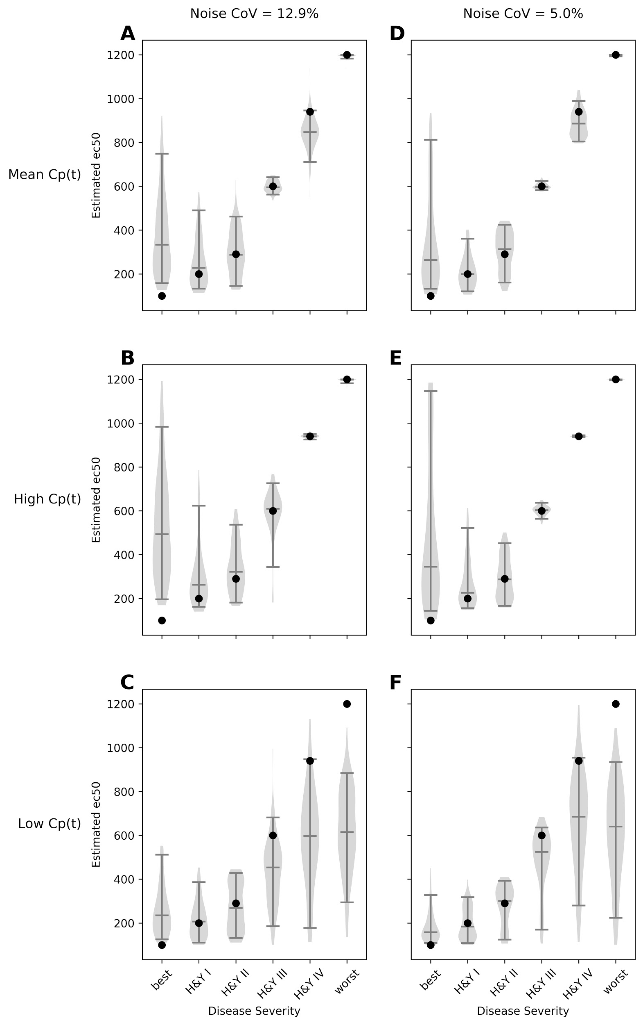
Supplementary Figure 1. Accuracy of EC₅₀, noiseCoV = 12.9% or 5%. Width of plot is proportional to frequency of output of the given magnitude. Filled circle: input EC₅₀. Horizontal lines note the 5th, 50th and 95th percentiles.

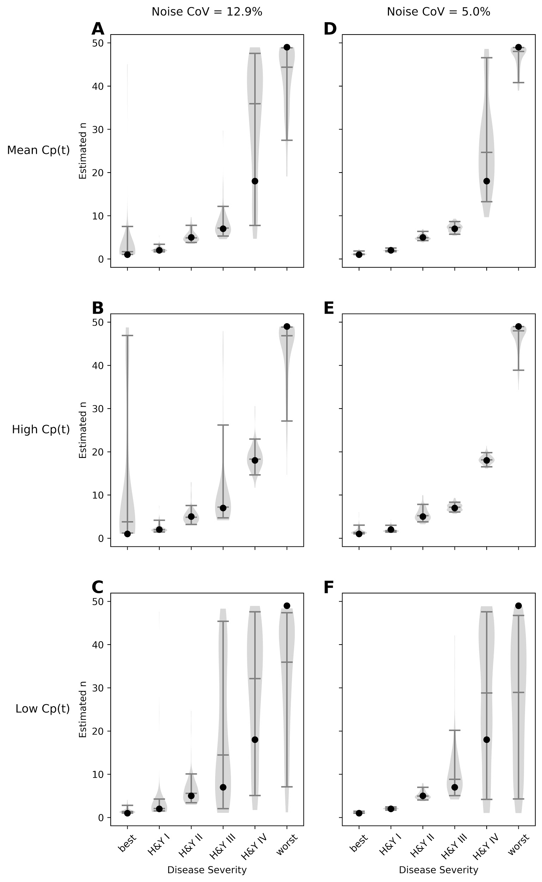
Supplementary Figure 2. Accuracy of n, noiseCoV = 12.9% or 5%. Width of plot is proportional to frequency of output of the given magnitude. Filled circle: input n. Horizontal lines note the 5th, 50th and 95th percentiles.

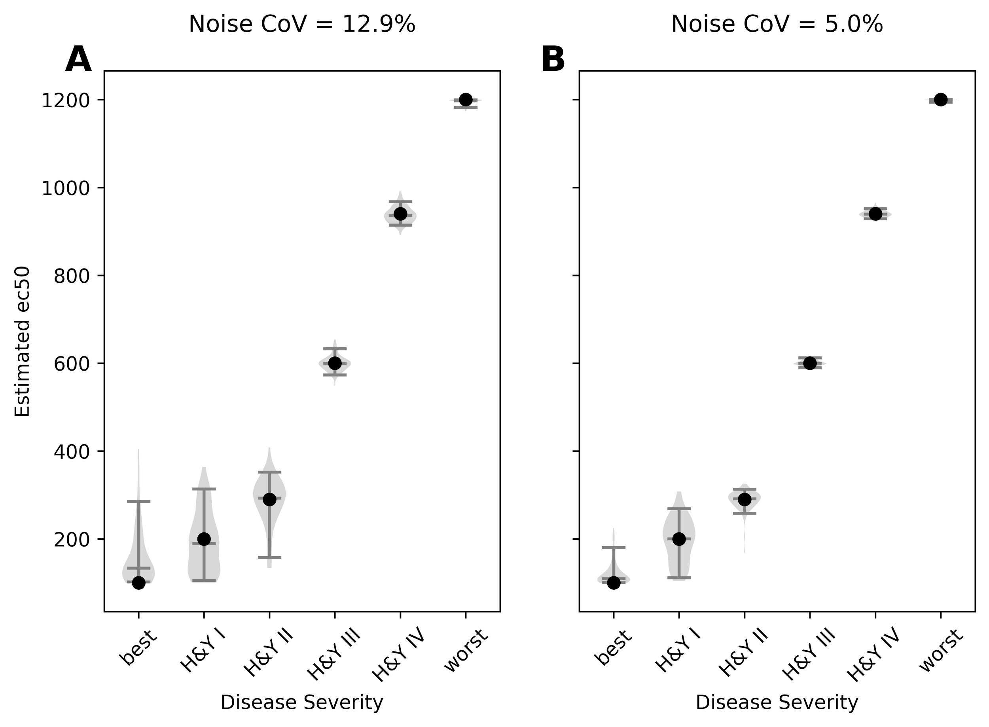
Supplementary Figure 3. Accuracy of EC₅₀, “slow” concentration curve. Width of plot is proportional to frequency of output of the given magnitude. Filled circle: input EC₅₀. Horizontal lines note the 5th, 50th and 95th percentiles.

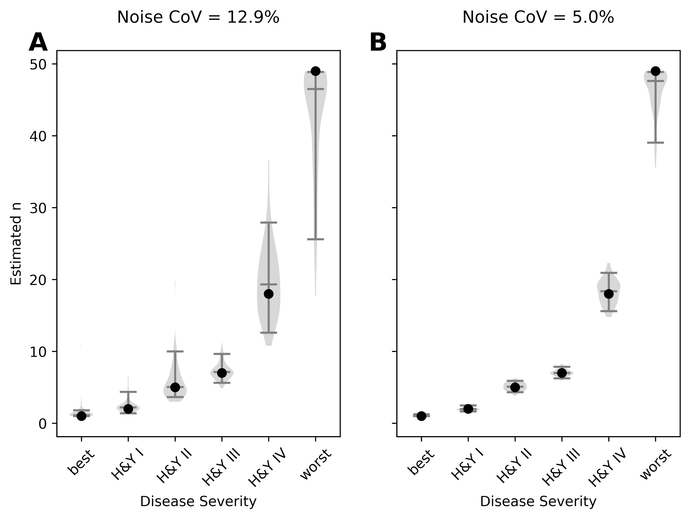
Supplementary Figure 4. Accuracy of n, “slow” concentration curve. Width of plot is proportional to frequency of output of the given magnitude. Filled circle: input EC₅₀. Horizontal lines note the 5th, 50th and 95th percentiles.

2.2 Supplementary Tables

H&Y | Cp | target | median | 5th %tile | 95th %tile
best | mean | 0.0025 | 0.0068 | 0.0034 | 0.0173
I | mean | 0.0052 | 0.0059 | 0.0030 | 0.0131
II | mean | 0.0089 | 0.0091 | 0.0033 | 0.0152
III | mean | 0.0248 | 0.0247 | 0.0231 | 0.0269
IV | mean | 0.0347 | 0.0349 | 0.0291 | 0.0747
worst | mean | 0.1386 | 0.1374 | 0.1317 | 0.1385
best | hi | 0.0025 | 0.0089 | 0.0033 | 0.0358
I | hi | 0.0052 | 0.0069 | 0.0040 | 0.0129
II | hi | 0.0089 | 0.0105 | 0.0038 | 0.0196
III | hi | 0.0248 | 0.0251 | 0.0119 | 0.0306
IV | hi | 0.0347 | 0.0346 | 0.0334 | 0.0363
worst | hi | 0.1386 | 0.1381 | 0.1321 | 0.1386
best | lo | 0.0025 | 0.0074 | 0.0029 | 0.0175
I | lo | 0.0052 | 0.0054 | 0.0027 | 0.0146
II | lo | 0.0089 | 0.0081 | 0.0031 | 0.0167
III | lo | 0.0248 | 0.0230 | 0.0069 | 0.0296
IV | lo | 0.0347 | 0.0529 | 0.0099 | 0.1357
worst | lo | 0.1386 | 0.0656 | 0.0099 | 0.1333
Supplementary Table 1. Accuracy of k_{e}, noise CoV = 12.9%. “Mean,” “hi,” and “lo” are the three time–activity curves described in the Pharmacokinetics section of Methods. Roman numerals refer to the mean pharmacodynamic values from the Hoehn and Yahr categories in M Contin et al., 2001. “Best” and “worst” refer to the extreme pharmacodynamic values from the same reference.

H&Y | Cp | target | median | 5th %tile | 95th %tile
best | mean | 0.0025 | 0.0046 | 0.0029 | 0.0100
I | mean | 0.0052 | 0.0052 | 0.0029 | 0.0093
II | mean | 0.0089 | 0.0097 | 0.0039 | 0.0137
III | mean | 0.0248 | 0.0248 | 0.0241 | 0.0256
IV | mean | 0.0347 | 0.0350 | 0.0325 | 0.0380
worst | mean | 0.1386 | 0.1385 | 0.1364 | 0.1386
best | hi | 0.0025 | 0.0047 | 0.0029 | 0.0101
I | hi | 0.0052 | 0.0061 | 0.0030 | 0.0115
II | hi | 0.0089 | 0.0087 | 0.0030 | 0.0168
III | hi | 0.0248 | 0.0249 | 0.0232 | 0.0265
IV | hi | 0.0347 | 0.0348 | 0.0343 | 0.0353
worst | hi | 0.1386 | 0.1385 | 0.1363 | 0.1386
best | lo | 0.0025 | 0.0039 | 0.0028 | 0.0074
I | lo | 0.0052 | 0.0047 | 0.0028 | 0.0092
II | lo | 0.0089 | 0.0093 | 0.0031 | 0.0140
III | lo | 0.0248 | 0.0245 | 0.0073 | 0.0264
IV | lo | 0.0347 | 0.0587 | 0.0059 | 0.1293
worst | lo | 0.1386 | 0.0492 | 0.0086 | 0.1346
Supplementary Table 2. Accuracy of k_{e}, noise CoV = 5%. “Mean,” “hi,” and “lo” are the three time–activity curves described in the Pharmacokinetics section of Methods. Roman numerals refer to the mean pharmacodynamic values from the Hoehn and Yahr categories in M Contin et al., 2001. “Best” and “worst” refer to the extreme pharmacodynamic values from the same reference.

