Catabolic Division of Labor Enhances Production of D-Lactate and Succinate from Glucose-Xylose Mixtures in Engineered Escherichia coli Coculture Systems

Supplementary Data
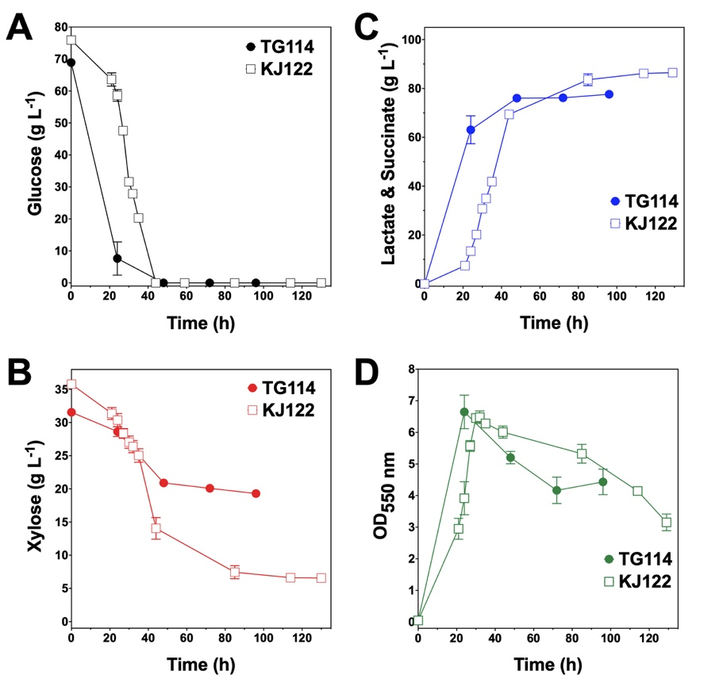

Figure S1. Fermentation of glucose-xylose mixtures by lactic acid-producing E. coli TG144 and succinogenic E. coli KJ122. Concentrations of (A) glucose, (B) xylose, (C) succinate and (D) OD_{550nm} measured in the fermentation broth for TG114 (closed circles), KJ122 (open squares). All fermentations were performed in batch mode and in mineral salts media. Data points represent the arithmetic mean of three replicates and error bars represent one standard deviation

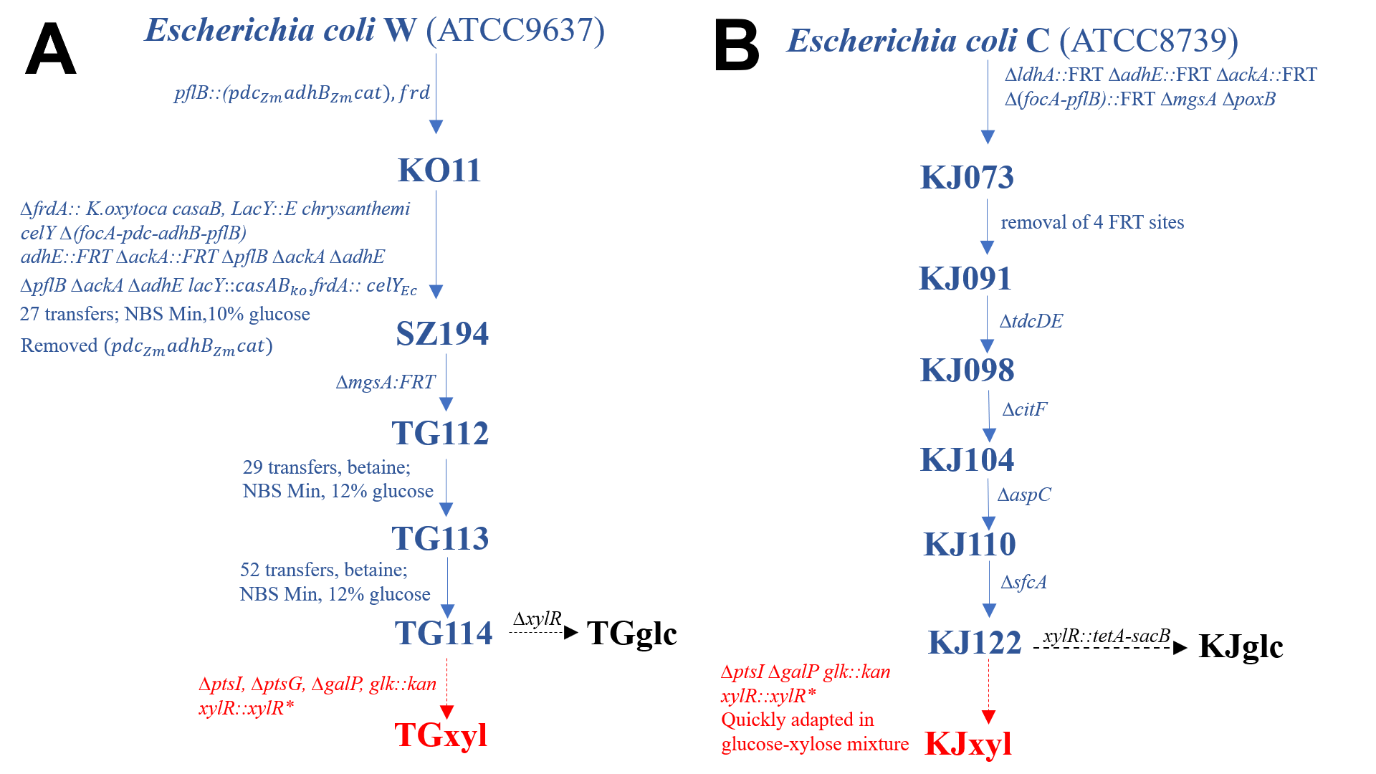Figure S2. Strain lineage for the specialists developed and used in this study. (A) Strain lineage for D-lactate producing sugar specialists. (B) Strain lineage for succinate producing sugar specialists. Previously engineered strains are indicated by blue font. And solid arrows Glucose specialists are indicated by black font and dashed arrows. Xylose specialists are indicated by red font and dashed arrows.

Table S1. List of primers used in this study.
Primer Name | Primer Sequence
ptsI deletion
cat-sacB F | GAGTAATTTCCCGGGTTCTTTTAAAAATCAGTCACAAGTAAGGTAGGGTTTCGAGTGTGACGGAAGATCA
cat-sacB R | ACAAACCCATGATCTTCTCCTAAGCAGTAAATTGGGCCGCATCTCGTGGATTAGCCATTTGCCTGCTTTT
ptsI H1F | AATCAGTCACAAGTAAGGTAGGGTTTCCACGAGATGCGGCCCAAT T
ptsI H1 R | CCGGAGTCAGGGTAGACTTG
ptsI H2 F | AATTGGGCCGCATCTCGTGGAAACCCTACCTTACTTGTGACTGAT
ptsI H2 R | ACTGTATTGCGCTCTTCGTG
ptsG deletion
cat-sacB F | CACGCGTGAGAACGTAAAAAAAGCACCCATACTCAGGAGCACTCTCAATTTCGAGTGTGACGGAAGATCA
cat-sacB R | GTAAAAAAGGCAGCCATCTGGCTGCCTTAGTCTCCCCAACGTCTTACGGATTAGCCATTTGCCTGCTTTT
ptsG H1F | CGGTTACTGGTGGAAACTGACTCAC
ptsG H1 R | CTTAGTCTCCCCAACGTCTTACGGAAATTGAGAGTGCTCCTGAGTATGGGT
ptsG H2 F | ACCCATACTCAGGAGCACTCTCAATTTCCGTAAGACGTTGGGGAGACTAAG
ptsG H2 R | GACAGTCAGTAAAGGGGTGGAATTTGAAC
galP deletion
cat-sacB F | TACTCACCTATCTTAATTCACAATAAAAAATAACCATATTGGAGGGCATCTCGAGTGTGACGGAAGATCA
cat-sacB R | GATGACTGCAAGAGGTGGCTTCCTCCGCGATGGGAGGAAGCTTGGGGAGATTAGCCATTTGCCTGCTTTT
galP H1F | GGTCGTGAACATTTCCCGTGG
galP H1 R | TGGGAGGAAGCTTGGGGAGAGATGCCCTCCAATATGGTTATTTTTTATTGTGAAT
galP H2 F | ATTCACAATAAAAAATAACCATATTGGAGGGCATCTCTCCCCAAGCTTCCTCCCA
galP H2 R | CGGTAAGCTGATGCTCCTGG
xylR deletion & replacement
cat-sacB F | TCTCAAAGCCGGTTACGTATTACCGGTTTTGAGTTTTTGCATGATTCAGCTCGAGTGTGACGGAAGATCA
cat-sacB R | GATAAGGCTTTTGCTCGCATCAGGTGGCTGTGCTGAGTTCCCTGATGTGACCTTAGCCATTTGCCTGCT
tetA-sacB F | TTTGAGTTTTTGCATGATTCAGCAGGAAAAGAACCTCCTAATTTTTGTTGACACTCTATC
tetA-sacB R | GTTACCTGATGTGACGCCGACAATTCTCATCATCGATCAAAGGGAAAACTGTCCATATGC
xylR H1F | CTGTTACTCGGCGGAATGTT
xylR H1 R | GACGCCGACAATTCTCATCATCGGGTTCCTTTTCCTGCTGAATCATGC
xylR H2 F | GCATGATTCAGCAGGAAAAGAACCCGATGATGAGAATTGTCGGCGTC
xylR H2 R | CTTGCTTGAACGCGTAGACA
lacZ replacement
cat-sacB F | TCACACAGGAAACAGCTATGACCATGATTACGGATTCACTGGCCGTCGTTTCGAGTGTGACGGAAGATCA
cat-sacB R | CATTCGCCATTCAGGCTGCGCAACTGTTGGGAAGGGCGATCGGTGCGGGCCCTTAGCCATTTGCCTGCT
glk replacement
kan F | ATTTACAGTGTGAGAAAGAATTATTTTGACTTTAGCGGAGCAGTTGAAGAGTGTAGGCTGGAGCTGCTTC
kan R | TGATTTAAAAGATTATCGGGAGAGTTACCTCCCGATATAACAGGAAGGATCATATGAATATCCTCCTTAGT
F, forward primer; R, reverse primer; H1 corresponds to 500 bp upstream of the gene of interests; H2 corresponds to 500 bp downstream of the gene of interests.

