Supplemental table 1. Serum 25(OH)D and NfL levels during the study
Study month | NfL (pg/mL) |  |  | 25(OH)D (nmol/L)
 | Samples (N) | Mean (SD) | p-value  0 vs 24* | Samples (N) | Mean (SD) | p-value  0 vs 24*
0 | 85 | 40.2 (22.4) | <0.01 | 87 | 61.2 (19.3) | 0.29
3 | 84 | 38.5 (22.9) |  | 87 | 69.1 (26.0)
6 | 85 | 36.5 (18.6) |  | 88 | 75.1 (27.6)
12 | 82 | 32.8 (18.7) |  | 87 | 66.6 (24.7)
24 | 79 | 28.2 (12.5) |  | 85 | 63.6 (21.8)
N: Number; SD: Standard deviation *Calculated with a paired sample t-test

Supplemental table 2. Serum 25(OH)D and NfL levels during the whole study stratified by calendar month
Calendar month | NfL (pg/mL) |  | 25(OH)D (nmol/L)
 | Samples (N) | Mean (SD) | Samples (N) | Mean (SD)
1 | 24 | 38.0 (20.0) | 55 | 60.2 (17.2)
2 | 40 | 43.5 (27.7) | 69 | 59.5 (19.5)
3 | 51 | 32.1 (13.1) | 84 | 50.3 (16.8)
4 | 22 | 34.6 (20.6) | 41 | 53.5 (20.9)
5 | 59 | 38.1 (24.5) | 75 | 63.3 (19.5)
6 | 47 | 31.7 (15.1) | 88 | 72.9 (21.9)
7 | 20 | 35.3 (27.1) | 41 | 84.8 (25.6)
8 | 40 | 39.6 (21.8) | 73 | 102.3 (33.7)
9 | 26 | 28.9 (11.6) | 61 | 84.7 (23.1)
10 | 16 | 33.7 (13.4) | 46 | 72.1 (26.4)
11 | 23 | 37.4 (16.5) | 59 | 71.1 (26.8)
12 | 47 | 30.7 (14.0) | 88 | 61.4 (20.4)
N: Number; SD: Standard deviation

Supplemental table 3. Serum 25(OH)D and NfL levels prior to IFN-β therapy stratified by calendar month
Calendar month | NfL (pg/mL) |  | 25(OH)D (nmol/L)
 | Samples (N) | Mean (SD) | Samples (N) | Mean (SD)
1 | 12 | 40.8 (21.0) | 25 | 59.1 (14.6)
2 | 14 | 54.8 (31.6) | 21 | 55.8 (19.1)
3 | 28 | 35.9 (12.3) | 43 | 55.4 (18.3)
4 | 11 | 38.0 (24.6) | 21 | 52.4 (24.2)
5 | 33 | 44.1 (29.3) | 41 | 61.5 (19.1)
6 | 29 | 34.8 (16.9) | 48 | 68.1 (20.3)
7 | 18 | 37.5 (27.7) | 23 | 86.0 (25.0)
8 | 33 | 42.0 (22.9) | 36 | 93.2 (28.8)
9 | 20 | 30.5 (11.0) | 24 | 77.6 (23.4)
10 | 10 | 31.1 (11.0) | 14 | 71.4 (29.9)
11 | 20 | 37.2 (14.3) | 21 | 65.3 (20.7)
12 | 26 | 33.9 (15.9) | 31 | 59.7 (18.4)
N: Number; SD: Standard deviation

Supplemental table 4. Serum 25(OH)D and NfL levels during IFN-β therapy stratified by calendar month
Calendar month | Samples (N) | NfL (pg/mL) | 25(OH)D (nmol/L)
 |  | Mean (SD) | Samples (N) | Mean (SD)
1 | 12 | 35.2 (19.4) | 30 | 61.2 (19.2)
2 | 26 | 37.5 (23.9) | 48 | 61.1 (19.7)
3 | 23 | 27.5 (12.7) | 41 | 44.9 (13.2)
4 | 11 | 31.2 (16.0) | 20 | 54.8 (17.3)
5 | 26 | 30.3 (13.6) | 34 | 65.4 (20.0)
6 | 18 | 26.7 (10.1) | 40 | 78.7 (22.6)
7 | 2 | 15.4 (7.7) | 18 | 83.2 (26.9)
8 | 7 | 28.2 (10.3) | 37 | 111.1 (36.1)
9 | 6 | 23.8 (13.1) | 37 | 89.2 (22.1)
10 | 6 | 38.1 (16.8) | 32 | 72.4 (25.2)
11 | 3 | 38.6 (32.4) | 38 | 74.2 (29.4)
12 | 21 | 26.7 (10.0) | 57 | 62.4 (21.5)
N: Number; SD: Standard deviation
Supplemental table 5. Change in serum NfL concentration with every 10 nmol/L increase of 25(OH)D
Study period | % (CI)* | p-value*
Before IFN-β | 1.2 (-0.4 - 2.7) | 0.14
IFN-β: Interferon beta-1a; CI: 95% confidence interval *Calculated with linear regression models with random intercepts for each patient and inclusion of 25(OH)D measurements paired with NfL measurements three months later

Supplemental figure. Baseline serum NfL and 25(OH)D levels
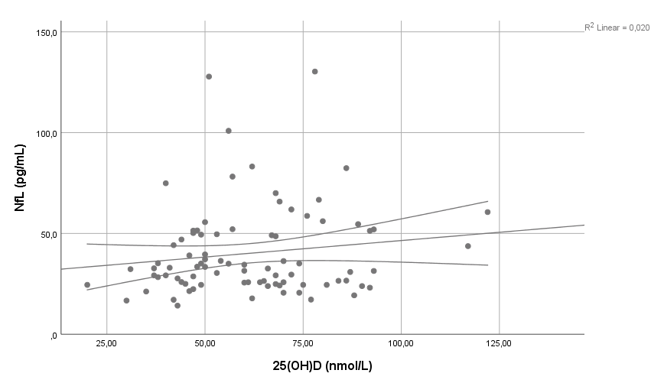
Correlation between baseline serum NfL and 25(OH)D concentrations (Pearson's correlation coefficient (r) of 0.124, p-value=0.19)

