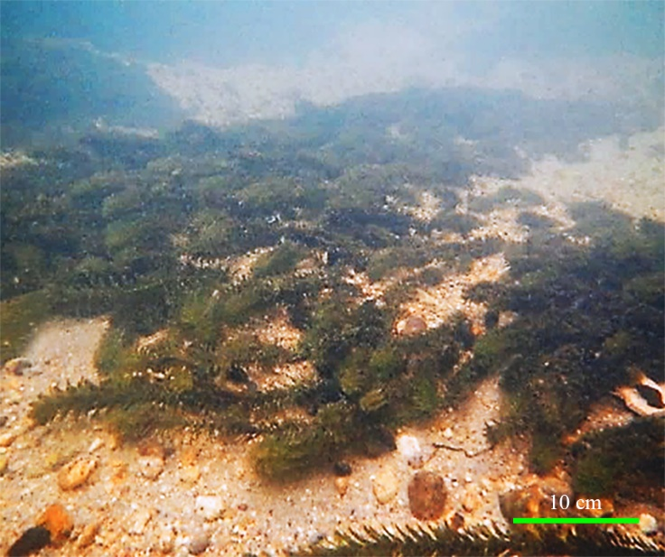
Supplementary figure 2. A representative image of the Yahagi riverbed occupied by E. densa at a depth of 80–100 cm.

