Parameters and Constants |  | Value | Units
α_{ice} | Albedo of ice | 0.30 | -
α_{fi} | Albedo of firn | 0.40 | -
α_{fs} | Albedo of fresh snow | 0.85 | -
t* | e-folding time constant for the effect of aging on snow | 21.9 | days
d* | e-folding constant for snow depth | 3.2 | cm
σ | Stefan-Boltzmann constant | 5.67 x 10⁻⁸ | W m⁻² K⁻⁴
ε_{s} | Emissivity of the glacier surface | 1 | -
ρ_{a} | Density of air at sea level | 1.29 | kg m⁻³
c_{p} | Specific heat capacity of the air | 1010 | J kg⁻¹ K⁻¹
L_{v} | Latent heat of vaporization for water | 2.514 | MJ kg⁻¹
k₀ | von Karman constant | 0.4 | -
z | Measurement height above the surface | 2 | m
z_{0m} | Roughness length for wind (snow/ice) | 0.001/0.016 | m
z_{0T} | Roughness length for temperature (snow/ice) | 0.001/0.004 | m
z_{0q} | Roughness length for vapor pressure (snow/ice) | 0.001/0.004 | m
g | Gravity constant | 9.808 | m s⁻²
ρ_{s} | Density of snow | 250 | kg m³
c_{w} | Specific heat of water | 4181.3 | J kg⁻¹ K⁻¹
κ_{i} | Thermal conductivity of ice | 2.10 | W m⁻¹ K⁻¹
Δz_{i} | Ice depth where temperature is constant | 10 | m
R_{d} | Universal gas constant for dry air | 287.06 | J kg⁻¹ K⁻¹
Ԑ | Ratio of gas constants for air and water vapor | 0.622 | -
d₀ | Initial snow depth | 0.5 | m
P_{pt} | Precipitation phase transition threshold | 2 | °C
Γ | Temperature lapse rate | 6.5 | K km⁻¹

Table S1. Parameters, constants, and their values, used in the model

 |  | Variable | Units
Q_{m} | Energy available to melt |  | W m⁻²
S_{net} | Net shortwave radiation |  | W m⁻²
L_{net} | Net longwave radiation |  | W m⁻²
Q_{S} | Sensible heat flux |  | W m⁻²
Q_{L} | Latent heat flux |  | W m⁻²
Q_{P} | Heat flux from precipitation |  | W m⁻²
Q_{G} | Heat flux conducted from the ice |  | W m⁻²
S_{in} | Incoming shortwave radiation |  | W m⁻²
α | Surface albedo |  | -
α_{s} | Albedo of snow on day (i) |  | -
i | Day |  | days
d | Snow depth |  | cm
s | Day of last snowfall |  | days
L_{in} | Incoming longwave radiation |  | W m⁻²
L_{out} | Outgoing longwave radiation |  | W m⁻²
ε_{a} | Effective emissivity of the atmosphere |  | -
T_{a} | Temperature of the atmosphere |  | K
T_{s} | Temperature of the surface |  | K
β | Slope of the surface |  | °
ε_{c} | Clear sky emissivity |  | -
c | Cloudiness (fractional) |  | -
e | Vapor pressure of the air |  | hPa
f_{rh} | Relative humidity (fractional) |  | -
P_{a} | Air pressure |  | hPa
k_{H} | Bulk transfer coefficient for sensible heat |  | -
U | Wind speed |  | m s⁻¹
k_{E} | Bulk transfer coefficient for latent heat |  | -
Δe | Surface-air vapor pressure differential |  | hPa
c_{sc} | Stability correction term |  | -
R_{b} | Bulk Richardson number |  | m s⁻¹
P | Precipitation rate |  | kg s⁻¹ m⁻²
ΔT | Temperature forcing |  | K
Δh | Change in elevation |  | m
ρ | Air density |  | kg m⁻³
T_{v} | Virtual temperature |  | K
G | System gain due to feedbacks |  | -
Δm | Change in melt |  | m w.e. a⁻¹
Δm_{Ref} | Change in melt of the reference system |  | m w.e. a⁻¹
m_{T0} | Melt with no temperature forcing |  | m w.e. a⁻¹
m_{T1} | Melt with a temperature forcing |  | m w.e. a⁻¹
m_{T1F} | Melt with a temperature forcing with feedbacks off |  | m w.e. a⁻¹

Table S2. Variables used and calculated in the model, presented in the order that they appear in the text.

 | Summer (JJAS) |  | Annual
 | HAR | Azam et al. | HAR | Azam et al.
Air Temperature (°C) | 2.5 | 2.5 | -7.8 | -5.8
Incoming Shortwave Radiation (W m⁻²) | 279 | 266 | 241.54 | 221
Wind Speed (m s⁻¹) | 3.7 | 2.8 | 6.13 | 4.1
Relative Humidity (%) | 79.73 | 68 | 73.22 | 52
Precipitation (m w.e.) | 148 | 117 | 1024 | 976
Incoming Longwave Radiation (W m⁻²) | 246 | 289 | 200 | 221

Table S3. Comparison of HAR climatology to weather station (4863 m a.s.l.) data summaries from Azam et al., 2016. HAR data were averaged over the same time periods as data from the weather station (hydrological years 2009-2012 for air temperature, incoming shortwave radiation, wind speed, and relative humidity; 1 June 2010 – 30 September 2013 for incoming longwave radiation; and hydrological year 2012 for precipitation). Air temperature and incoming longwave radiation were corrected were adjusted to the elevation of the weather station using a fixed lapse rate (6.5°C km⁻¹).

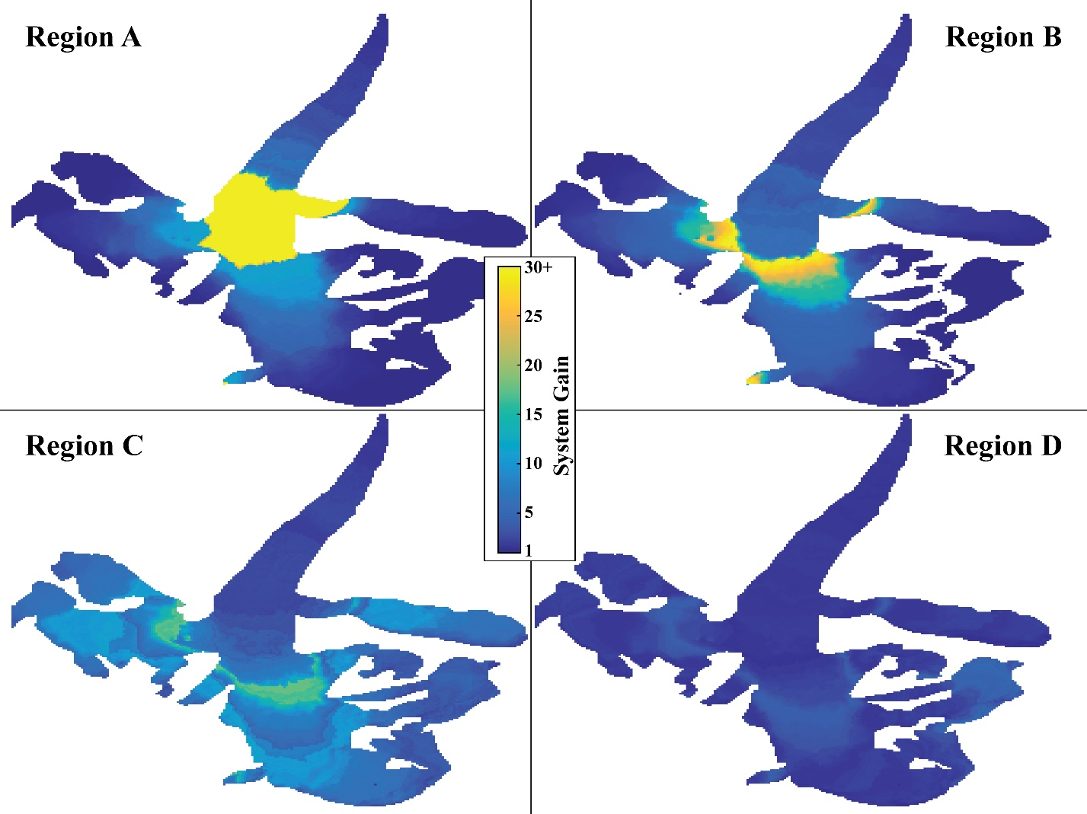

Figure S1. Distribution of total system gains (with all three feedback switches off) across the glacier surface in each region. The area around the ELA tends to have the highest overall system gains. Note that in Region A, the map is saturated (for improved visibility in the other regions), with local gains reaching ~60.

